As a database developer, there are several key topics and skills you should focus on to enhance your expertise and stay current with industry standards. Here’s a comprehensive list of topics for database developers to learn:

**Core Database Concepts**

**Database Design and Normalization**

Entity-Relationship Diagrams (ERD)

Normalization (1NF, 2NF, 3NF, BCNF)

Denormalization for performance

**SQL (Structured Query Language)**

Basic CRUD operations (INSERT, SELECT, UPDATE, DELETE)

Advanced SQL queries (JOINs, subqueries, UNION, etc.)

Indexing and Query Optimization

Transactions and Concurrency Control

Stored Procedures and Functions

Triggers and Views

**Database Architecture and Storage**

Understanding how databases store data

Table structures and data types

Data storage and retrieval mechanisms

**Performance Tuning and Optimization**

**Query Optimization**

Analyzing and optimizing slow queries

Using EXPLAIN and other profiling tools

**Indexing**

Types of indexes (primary, unique, composite, full-text)

Index creation and maintenance

**Database Performance Monitoring**

Tools and techniques for monitoring database performance

Identifying and resolving bottlenecks

**Database Security**

**Access Control**

User roles and permissions

Authentication and authorization mechanisms

**Data Encryption**

Encrypting data at rest and in transit

Using encryption functions in SQL

**Backup and Recovery**

Backup strategies and tools

Recovery models and procedures

**Advanced SQL and Programming**

**Complex SQL Queries**

Window functions, Common Table Expressions (CTEs)

Recursive queries

**Database Programming**

Writing and optimizing stored procedures, functions, and triggers

Using database-specific programming languages (e.g., PL/SQL, T-SQL)

**Dynamic SQL**

Creating and executing dynamic SQL queries

**Database Management Systems (DBMS)**

**Relational Database Management Systems (RDBMS)**

MySQL, PostgreSQL, Oracle, SQL Server, etc.

**NoSQL Databases**

Key-Value Stores (Redis, Memcached)

Document Stores (MongoDB, CouchDB)

Column-Family Stores (Cassandra, HBase)

Graph Databases (Neo4j, Amazon Neptune)

**Database Migration and Integration**

Data migration strategies and tools

ETL (Extract, Transform, Load) processes

**Data Modeling and Analysis**

**Data Warehousing**

Design and implementation of data warehouses

Star Schema, Snowflake Schema

**Data Modeling Tools**

Using tools like ER/Studio, Microsoft Visio, or Lucidchart

**Business Intelligence (BI) Integration**

Integrating databases with BI tools (e.g., Power BI, Tableau)

**Emerging Trends and Technologies**

**Cloud Databases**

Understanding cloud-based database solutions (AWS RDS, Azure SQL Database, Google Cloud SQL)

**Database-as-a-Service (DBaaS)**

Managing and using cloud-based databases

**Big Data Technologies**

Hadoop, Spark, and their integration with databases

**Database Administration**

**Database Backup and Recovery**

Implementing and managing backup strategies

Disaster recovery planning

**Database Maintenance**

Regular maintenance tasks (vacuuming, rebuilding indexes, etc.)

**Capacity Planning**

Estimating and planning for database growth

**Tools and Best Practices**

**Database Tools and IDEs**

Familiarity with tools like MySQL Workbench, pgAdmin, SQL Server Management Studio (SSMS)

**Version Control for Database Changes**

Using tools like Liquibase or Flyway

**Documentation and Best Practices**

Documenting database designs, changes, and procedures

**Index**

DATATYPE

DIFFERENCE BETWEEN NVARCHAR AND VARCHAR

COMMANDS

OPERATOR

DATE FUNCTION

TEXT FUNCTION

VIEWS

HOW TO FIGURED THE COLUMN ON WHICH THE INDEX CAN BE MADE

USER DEFINE TABLE TYPE

USER DEFINE FUNCTION

ORDER OF EXECUTION

STORE PROCEDURE

CURSOR

RECURSIVE CTE

**DATATYPE**

**1.Integer : -** A whole number without a fractional part. E.g., 1, 156, 2012412

2. **Decimal : -** A number with a fractional part. E.g., 3.14, 3.141592654, 961.1241250

In SQL, the DECIMAL data type is used to store fixed-point numbers with a specified precision and scale. It is commonly used for financial and monetary data where precision and accuracy are crucial. Here's a detailed explanation of the DECIMAL data type:

Syntax:

DECIMAL(p, s)

p is the precision, which represents the total number of digits in the number (both before and after the decimal point).

s is the scale, which represents the number of digits after the decimal point.

* Example:

DECIMAL(10, 2)

This defines a decimal number with a precision of 10 digits (including digits before and after the decimal point) and a scale of 2 digits after the decimal point. For example, 12345.67 would be a valid value for this DECIMAL(10, 2) data type.

* Storage:

The DECIMAL data type stores numbers as fixed-point values. It does not approximate values like floating-point data types (FLOAT, REAL, DOUBLE) but maintains exact precision and scale.

Internally, DECIMAL values are stored in a way that ensures accuracy and avoids rounding errors common in floating-point arithmetic.

* Precision and Scale:

Precision (p) determines the maximum number of digits that can be stored in the number, both before and after the decimal point.

Scale (s) determines the maximum number of digits allowed after the decimal point.

The scale cannot be greater than the precision. For example, DECIMAL(5, 3) is valid, but DECIMAL(3, 5) is not.

* Usage:

DECIMAL is suitable for storing monetary values, quantities with fixed decimal places, and any data where precision is critical.

It is often used in financial applications, accounting systems, and databases where accurate numerical representation is required.

* Comparison with Other Numeric Data Types:

Unlike FLOAT or REAL data types, DECIMAL does not suffer from rounding errors and provides exact precision for decimal calculations.

However, DECIMAL typically requires more storage space compared to floating-point data types, especially for large precision and scale values.

**3. Boolean : -** A binary value. It can be either TRUE or FALSE.

**4. Date : -** Speaks for itself. You can also choose the format. E.g., 2017-12-31

**5. Time : -** You can decide the format of this, as well. E.g., 23:59:59

**6. Timestamp : -**The date and the time together. E.g., 2017-12-31 23:59:59

**7. Text : -**This is the most general data type. But it can be alphabetical letters only,

or a mix of letters and numbers and any other characters. E.g., hello, R2D2,

Tomi, 124.56.128.41

**8) varchar**

**9) nvarchar**

**10) char**

**11) float**

**DIFFRENCE BETWEEN nvarchar and varchar**

The main difference between **varchar** and **nvarchar** in SQL Server is the way they store character data.

Storage Size:

**varchar**: It is a variable-length non-Unicode character data type. It can store alphanumeric characters and symbols. Each character in **varchar** takes 1 byte of storage.

**nvarchar**: It is a variable-length Unicode character data type. It can store alphanumeric characters, symbols, and characters from various languages and scripts. Each character in **nvarchar** takes 2 bytes of storage.

* Character Encoding:

**varchar**: It uses the ASCII character encoding, which can represent a limited set of characters from the English language and some symbols.

**nvarchar**: It uses the Unicode character encoding (UTF-16), which can represent a wide range of characters from different languages and scripts, including non-ASCII characters.

* Storage Limit:

**varchar**: It has a maximum storage limit of 8,000 characters.

**nvarchar**: It has a maximum storage limit of 4,000 characters.

* Memory Usage:

**varchar**: It consumes less memory compared to **nvarchar** because it uses a single byte per character.

**nvarchar**: It consumes more memory compared to **varchar** because it uses two bytes per character.

In summary, **varchar** is suitable for storing ASCII characters and has a smaller storage footprint, while **nvarchar** is suitable for storing Unicode characters and can handle a wider range of languages and scripts. The choice between **varchar** and **nvarchar** depends on the specific requirements of your data and the languages/scripts you need to support.

**Difference Between Decimal And Float**

The main difference between the **FLOAT** and **DECIMAL** data types in SQL lies in how they store and handle numeric values, particularly in terms of precision, storage size, and rounding behavior:

* **Precision and Scale:**

**DECIMAL** (also known as **NUMERIC**) is a fixed-point data type that allows you to specify both the precision (total number of digits) and scale (number of digits after the decimal point).

**FLOAT** is a floating-point data type that stores approximate numeric values. It does not require specifying precision and scale explicitly; instead, it uses a binary representation to store the values.

* **Accuracy and Rounding:**

**DECIMAL** provides exact precision and avoids rounding errors common in floating-point arithmetic. It is suitable for applications where accuracy is critical, such as financial calculations.

**FLOAT** is approximate and may introduce rounding errors, especially when dealing with decimal numbers that cannot be precisely represented in binary form. It is suitable for scientific and engineering calculations where absolute precision is less critical.

* **Storage Size:**

**DECIMAL** requires fixed storage based on the specified precision and scale. For example, a **DECIMAL(10, 2)** would require 12 bytes (10 digits + 2 digits for the scale).

**FLOAT** uses variable storage size based on the value being stored. The storage size depends on the floating-point precision (single precision or double precision). Single precision (**FLOAT**) typically uses 4 bytes, while double precision (**DOUBLE**) uses 8 bytes.

* **Range of Values:**

**DECIMAL** can represent a wide range of values with exact precision, including integers and decimal numbers with a fixed number of decimal places.

**FLOAT** can represent a larger range of values compared to **DECIMAL**, but it sacrifices some precision for this extended range. It is better suited for handling very large or very small numbers.

* **Usage:**

Use **DECIMAL** when precise decimal calculations and exact representation of values are required, such as financial applications, monetary values, and quantities with fixed decimal places.

Use **FLOAT** when working with scientific calculations, engineering data, or scenarios where a wide range of values and approximate precision are acceptable.

**SQL COMMANDS**

* **DDL (DATA DEFINATION LANGUAGE)**
  + **create**
  + **alter**
  + **modify**
  + **rename**
  + **drop**
  + **truncate:-delete all the record and reset the structure**
* **DML (DATA MANUPULATION LANGUAGE)**
  + **Insert**
  + **Update**
  + **Delete**
* **TCL (TRANSACTION CONTROL LANGUAGE)**

**SET TRANSACTION=0**

* + **Rollback**
  + **Commit**
  + **Savepoint**

* **DQL (DATA QUARY LANGUAGE)**
  + **Select**

**SQL Clauses**

* + **Select**
  + **Where**
  + **Group by**
  + **Having :- always use with group by clause**
  + **Order by**
  + **From**

**SQL 0PERATOR**

* **Logical operator**
  + AND
  + OR
  + NOT
  + IN
  + LIKE

The LIKE operator in SQL is used for pattern matching in strings. It allows you to search for values that match a specific pattern, and it is commonly used with wildcard characters to define these patterns. Here's a breakdown of how LIKE works and the symbols used:

**Common Symbols Used in LIKE Patterns:**

**% (Percent Sign)**:

**Purpose**: Represents zero, one, or multiple characters.

**Example**:

'A%': Matches any string that starts with 'A', followed by any number of characters (e.g., 'Apple', 'America').

'%a': Matches any string that ends with 'a' (e.g., 'Pizza', 'Maria').

'%test%': Matches any string that contains 'test' anywhere (e.g., 'unittest', 'mytestcase').

**_ (Underscore)**:

**Purpose**: Represents exactly one character.

**Example**:

'A_': Matches any two-character string where the first character is 'A' (e.g., 'Ab', 'Ax').

'H_llo': Matches 'Hello', 'Hillo', but not 'Hillo!' (because the _ matches exactly one character).

**[] (Square Brackets)**:

**Purpose**: Matches any single character within the specified range or set.

**Example**:

'[A-C]%': Matches any string that starts with 'A', 'B', or 'C' (e.g., 'Apple', 'Banana', 'Cat').

'[abc]%': Matches any string that starts with 'a', 'b', or 'c' (case-sensitive in some databases).

**[^] (Caret Inside Square Brackets)**:

**Purpose**: Represents a negation (i.e., matches any character **except** the ones listed inside the brackets).

**Example**:

'[^A-C]%': Matches any string that does **not** start with 'A', 'B', or 'C' (e.g., 'Dog', 'Elephant').

**Escape characters (e.g., \)**:

**Purpose**: Used to escape special characters (like %, _, or square brackets) when you want to treat them as literal characters.

**Example**:

To search for a string that contains an actual underscore _, you can escape it like this:

SELECT * FROM yourTable WHERE yourColumn LIKE '%\_%' ESCAPE '\';

This matches strings that contain the underscore character literally.

**Example Scenarios Using LIKE:**

**Basic pattern matching**:

Query: Find all names that start with "J":

SELECT * FROM employees WHERE name LIKE 'J%';

This will match names like "John", "James", "Julia".

**Pattern matching with exact character count**:

Query: Find all names that are exactly five characters long and start with "A":

SELECT * FROM employees WHERE name LIKE 'A____';

This matches names like "Alice" or "Amira" (exactly 5 characters).

**Range of characters**:

Query: Find all employees whose names start with letters between "B" and "D":

SELECT * FROM employees WHERE name LIKE '[B-D]%';

This matches names like "Ben", "Carl", and "David".

**Excluding characters**:

Query: Find all names that don’t start with the letters "A", "B", or "C":

SELECT * FROM employees WHERE name LIKE '[^A-C]%';

This excludes names like "Alice", "Brian", and "Cathy".

**Searching for special characters**:

Query: Find all items that contain a literal underscore (_):

SELECT * FROM files WHERE filename LIKE '%\_%' ESCAPE '\';

This will find filenames like "file_name.txt".

**Summary of LIKE Wildcards and Symbols:**

**%**: Matches zero or more characters.

**_**: Matches exactly one character.

**[]**: Matches any single character within the brackets.

**[^]**: Matches any single character **not** within the brackets.

**Escape**: Use ESCAPE clause to define an escape character if you need to search for % or _ as literals.

These symbols allow you to create flexible and powerful string searches in SQL queries using LIKE.

6.any

7.between

8.all

**B) Arithmetic operator**

+,-,*,/,%

**C) Comparison operator**

=,!=,<,>,<=,>=,!<,!>

**DATE FUNCTION**

**A) BASIC DATE FUNCTION**

a) CURRENT_DATE()/CURDATE(): Give current date

b) NOW():- give date and time

c) DATE():- give date and time

d) MONTH():- extract month from date

e) MONTHNAME():- give month name

f) YEAR():- extract year

g) QUARTER()

h) DAY():- extract day from date

I ) DAYNAME()

J) DAYOFWEEK():- give number

k) DAYOFYEAR():- give day no of year like from 1-365

l) WEEK():- give week no of year

m) WEEKDAY():- give week day 1-7

n) LAST_DAY(():- give last date of that month like for jan 31-01-2019

o) EXTRACT():- syntax=EXTRACT(["ANYTHING LIKE MONTH ,DAY"] FROM DATE)

p) datepart(day,’2022-01023’) :- it will give the week ,month ,year etc

q) dateadd(week,2, ’2022-01023’) :- add day ,week etc based on the no (2) and datepart (week )

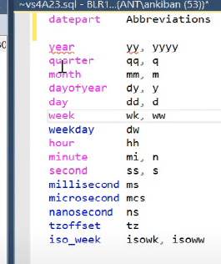

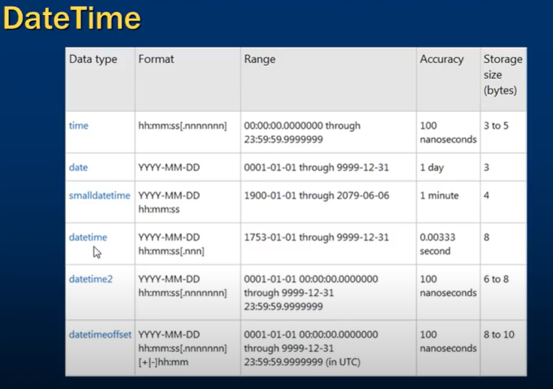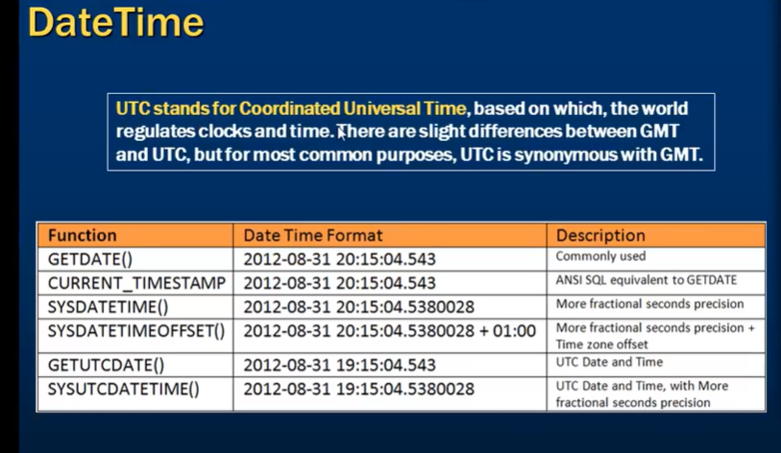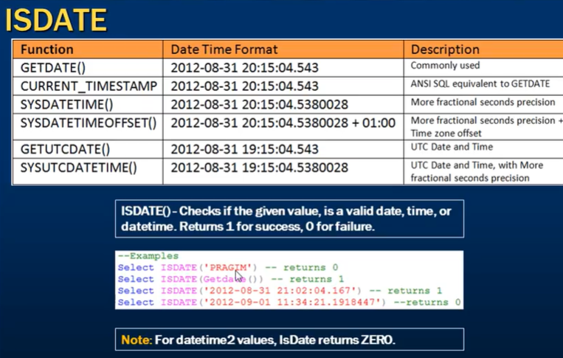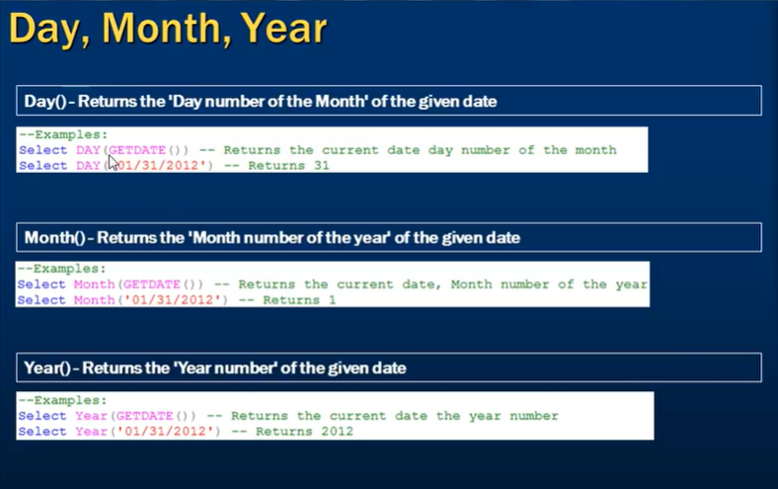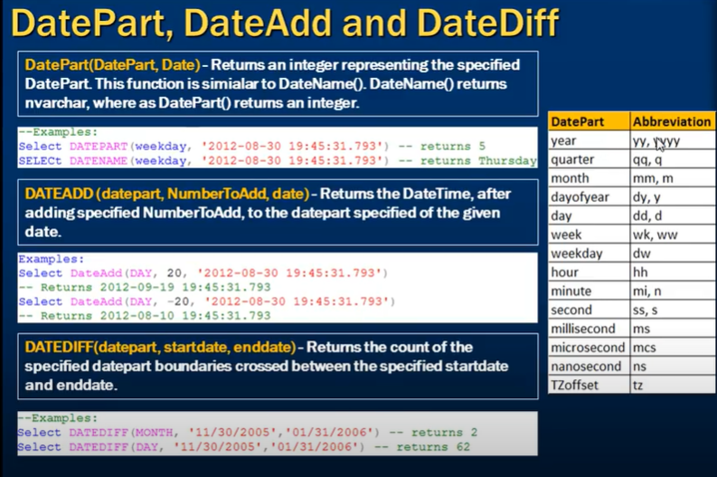

**B) ADVANCE DATE FUNCTION**

a) ADDDATE: syntax=ADDDATE(DATE,INTERVAL 10 DAY) give the date after 10 day we can use month as well in place of day

b) SUBDATE():- same as ADDDATE() instead of add it subtract the date syntax=(SUBDATE("DATE",INTERVAL 1 DAY)

c) DATEDIFF():- syntax=DATEDIFF(YEAR,STARTDATE,ENDDATE)

d) DATE_FORMAT():- Most Useful function syntax=DATE_FORMAT("DATE",%D-%C-%Y) FORMAT IN THIS TYPE

FORMAT IN SSMS

SELECT FORMAT(CAST('2024-08-13 20:32:25.500' AS datetime), 'dd-yyyy') AS FormattedDate;

e) STR_TO_DATE():- Convert the date into MySQL date format syntax=STR_TO_DATE("JULY 10 2019","%m %d %y)

IN SSMS

SELECT PARSE('JULY 10 2019' AS DATE USING 'en-US') AS ParsedDate;

f) DATETRUNC()

This function is particularly useful when you want to group or aggregate data by a certain time period, such as day, month, or year.

DATETRUNC( datepart, date )

SELECT DATETRUNC(hour, '2024-07-01 15:30:00') AS TruncatedDate;

SELECT DATETRUNC(month, '2024-07-02') AS TruncatedDate;

**TEXT FUNCTION**

a) UCASE()/UPPER()

b) LCASE()/LOWER()

C) LENGTH()

d) LEFT()

e) MID()/SUBSTRING()/SUBSTR():-write character from mid .in SSMS stuff instead of this.

f) INSTR():-return the location of the character.in SSMS CHARINDEX.

g) LTRIM():-remove space of left side of string.

h) RTRIME():-remove space of right side of string.

I) TRIM() :- SELECT TRIM(',' FROM ',,,Hello, World,,,') AS TrimmedString;

J)RIGHT()

K)PATINDEX() :- In SQL Server, The **PATINDEX** Function Is Used To Search For A Pattern Within A String And Return The Starting Position Of The First Occurrence Of The Pattern. Its Syntax Is As Follows:

SYNTAX :- PATINDEX ( '%pattern%' , expression )

EXAMPLE :-

DECLARE @string NVARCHAR(100) = 'The quick brown fox jumps over the lazy dog.'

DECLARE @pattern NVARCHAR(50) = 'brown'

SELECT PATINDEX('%' + @pattern + '%', @string)

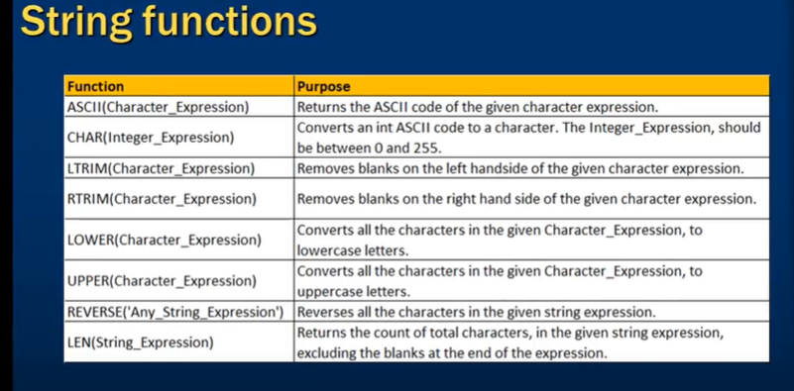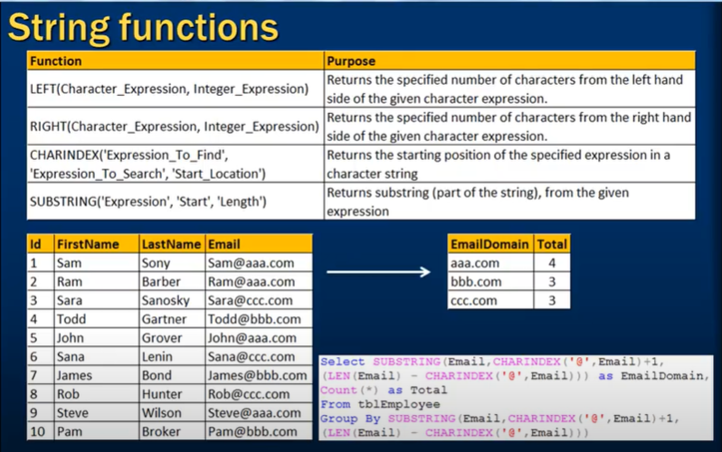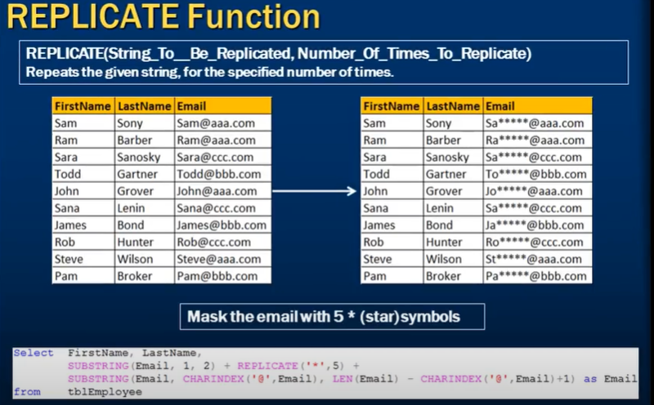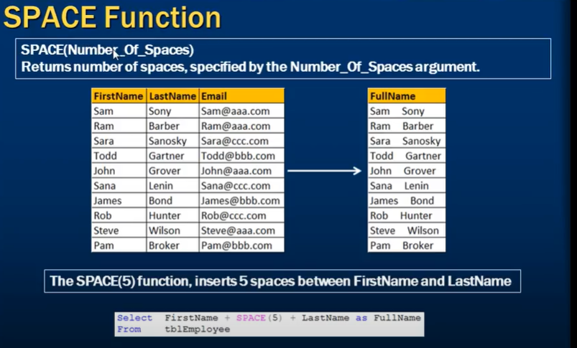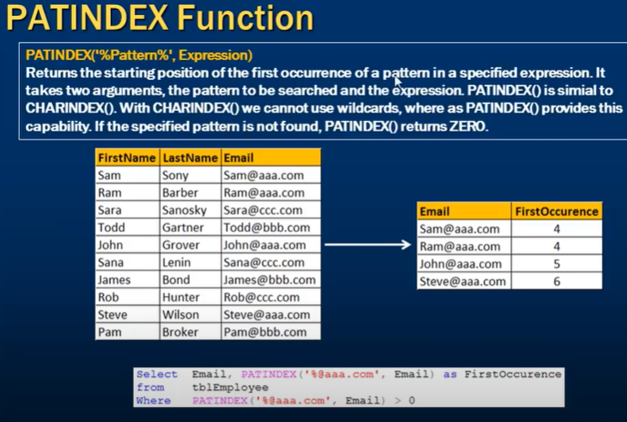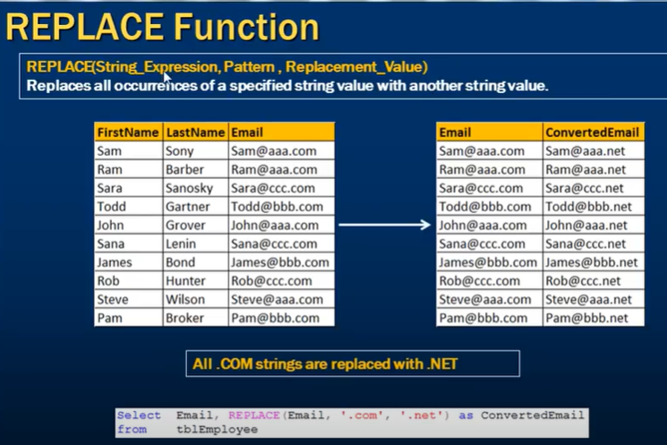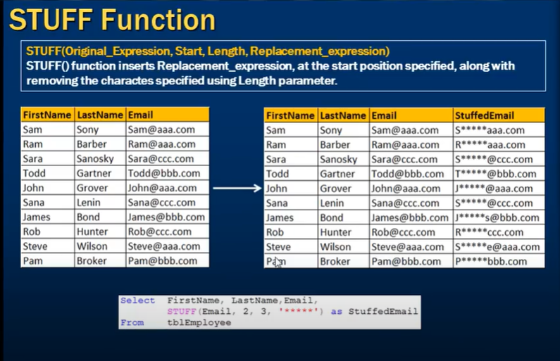

**VIEWS**

view is a virtual table. provide row level and column level security. also reduce the complexity of code. it will not improve the performance but materialized view improves the performance.

when the view is created it store the structure not the data .

for ex :-if you create view =create view vw_name as select * from emp;

but if you add new column to emp it will not show that column in the view when you call that view because that new column not present in the structure at the time you create that view and if you want to see that column in view you have to refresh the view but if you add new row to emp table it will show .

Updatable view:- the view can be updated ,inserted ,deleted it means that we can do update, insert and delete on view .means we can perform DML operation on view. But there are some rule \which is given below.

Updatable view rules: -

a)view should be created using one table\view only.

b)view should not have distinct clause.their are some other way to update that type of view.

c)if query contain group by then can not update such view.

d)if query contain with clause then cannot update such view.

e)if query contain window function then cannot update such view.

WITH CHECK OPTION:-during updatable action it will check the where condition and if the condition satisfy only then perform the updatable option on view.

for ex:- create view apple_product as select name, product, price from smartphone where product ="apple" with check option ;

and if we try to do updatable option\DML Operation first it will check the where condition and if the condition matches then only do the changes.

like if we do :- insert into apple_product (name, product, price) values("note","samsung",3000) ;it will through error because view has with check option it will check the where condition. without with check option it will execute the above query. and insert this row into the smartphone table. but if we do select * from apple_product; it will not show that record but added in smartphone table so to avoid that we use with check option.

TYPE OF VIEW

**1) simple view**:-when the data retrieve from one base table\view called simple view.

SYNTAX:= Create view view_name as select * from table_name;

**2)complex view**:-complex view contain sub-queary where sub-query contain query. The view which is constructed with the help of more than one base table then it is called complex view. Contain group by ,join ,union ,aggregate function. We can not perform DML operation on it.

SYNTAX: =Create view view_name as select * from table_1 UNION select * from table_2;

**3)read only view:** -it only allow to perform read operation on base table .it restrict to perform write operation. Not able to perform DML Operation on view.in SSMS read only option is not available.

SYNTAX: =create view view_name select * from table_name with read only;

**4)with check option** :-only if the where condition is satisfy then only able to perform the DML Operation. Updatable operation not update data in view as well as table if condition not satisfy.

SYNTAX:=create view view_name as select * from table_name where col_name="condition" with check option;

**MATERIALIZED VIEW**  (Not present in MySQL and MariaDB)/ it is called INDEX VIEW IN SSMS instead of materialized view it uses the WITH SCHEMABINDING AS keyword

a)store the query.

b)also store the data return from the SQL query. that’s the reason it improve the performance of the view.

to create index view in ssms syntax:= create view view_name with schemabinding as select sum(isnull(age,0)) as total from dbo.practice

there are few rule while creating index view

1.the view should be created with schemabending option .

2.if an aggregate function in select list, reference an expression, and if there is possibility for that expression to become null, then replacement value should be specified like isnull or colease.

3.if group by is specified, the view select list must contain count_big(*) expression.

4.the base table in the view, should be refrence with two part name (dbo.practice)

Ex :- create view view_name with schemabinding as select name, sum(isnull(quantity*unitprice),0) as totalsales, count_big(*) as total from dob.practice group by name

isnull because their is possibility of null in value,count_big(*) because group by name ,two part name (dbo.practice)

**limitation to materialized view**

the performance of a materialized view (MV) can be affected when the underlying table is updated. A materialized view is a database object that contains the results of a query executed against one or more tables. When you create a materialized view, the query is executed and the results are stored in the materialized view, which can then be queried like a table.

If the underlying table is updated, the materialized view can become stale and may need to be refreshed to reflect the changes. Depending on the frequency of updates and the complexity of the query used to create the materialized view, refreshing the materialized view can have an impact on performance.

For example, if you have a materialized view that summarizes data from a large table and the table is frequently updated, refreshing the materialized view may take a long time and can impact the performance of other queries that use the materialized view. In this case, you may need to carefully tune your refresh strategy to balance the need for up-to-date data with the performance impact of refreshing the materialized view.

That being said, materialized views can still provide significant performance benefits over running the query against the underlying tables each time, especially if the query is complex or involves joining multiple tables. By precomputing the results and storing them in the materialized view, you can reduce the amount of work required to execute the query, potentially improving query response times.

**Limitation of View** 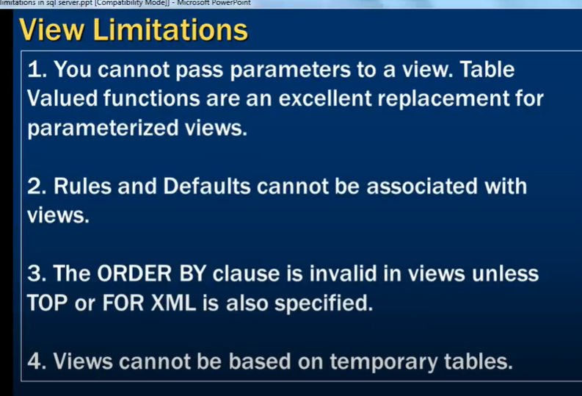

XML is a structured format for storing and exchanging data, using custom tags to describe the meaning of the data.

**MySQL View limitation**

In MySQL, views are a powerful tool for simplifying complex queries, encapsulating logic, and providing a level of abstraction over the underlying database tables. However, there are some limitations and restrictions associated with using views. Here are the key limitations of views in MySQL:

**1. No Support for INSERT, UPDATE, DELETE in Certain Views**

**Updatable Views**: Not all views are updatable. A view is updatable if it meets specific criteria, such as referencing only one table, not using aggregate functions, DISTINCT, GROUP BY, HAVING, UNION, or JOIN.

**Non-Updatable Views**: Views that contain subqueries, joins, group functions, or set operations (UNION, INTERSECT) are generally non-updatable, meaning you cannot use INSERT, UPDATE, or DELETE on them.

**2. Performance Limitations**

**Query Optimization**: Views do not store data; they store the SQL query that defines them. Each time a view is queried, the underlying query is executed. Complex views may result in performance degradation because of repeated query execution.

**No Indexes**: You cannot create indexes directly on a view. Indexes apply to the underlying tables, but complex views that use joins or subqueries may not benefit from these indexes as effectively.

**3. Restrictions on Using Certain Clauses**

**ORDER BY Clause**: You cannot use ORDER BY within a view definition unless you also include LIMIT. The sorting must be done in the query that selects from the view.

**LIMIT Clause**: Similar to ORDER BY, you cannot use LIMIT in a view definition unless it is combined with ORDER BY.

**Temporary Tables**: Views cannot reference temporary tables.

**Prepared Statements**: Views cannot be used within a prepared statement if the prepared statement involves dynamic SQL.

**4. Algorithm Restrictions**

MySQL provides two algorithms for processing views: MERGE and TEMPTABLE. The MERGE algorithm is used whenever possible, where the view's query is merged with the outer query. The TEMPTABLE algorithm is used when MERGE is not possible. However, TEMPTABLE has its own restrictions:

You cannot use ORDER BY in a view defined using the TEMPTABLE algorithm.

TEMPTABLE cannot be used with views that are involved in a JOIN.

**5. Limitations with CREATE OR REPLACE VIEW**

When you use CREATE OR REPLACE VIEW, the view is dropped and re-created, which can lead to issues if the view is referenced by other database objects (such as triggers or stored procedures).

**6. View Definition Size**

The maximum length of a view's definition (its underlying SQL query) is constrained by the max_allowed_packet system variable. If your view's SQL query is too large, you may need to increase this setting or simplify the query.

**7. Privileges and Permissions**

The user who creates the view must have the appropriate privileges on the underlying tables and must retain those privileges for the view to remain functional. If the privileges are revoked, the view will no longer work.

Views can be affected by changes in the permissions of the underlying tables.

**8. No Trigger or Stored Procedure Invocation**

Views cannot have triggers associated with them, and you cannot define stored procedures or functions within a view.

**9. No Full-Text Search**

MySQL does not support full-text search within views.

**10. Materialized Views**

MySQL does not support materialized views (which are views that store the result of the query physically), unlike some other databases (e.g., Oracle, PostgreSQL). All views in MySQL are virtual, meaning they are just stored queries and do not hold data.

**index**

indexes are used to find data from tables quickly. Indexes are created on tables or view, is very similar to an index that we find in book. If there is no index to help the query, then the query engine, checks every row in the table from the beginning to the end. This is called table scan. table scan is bad for performance. 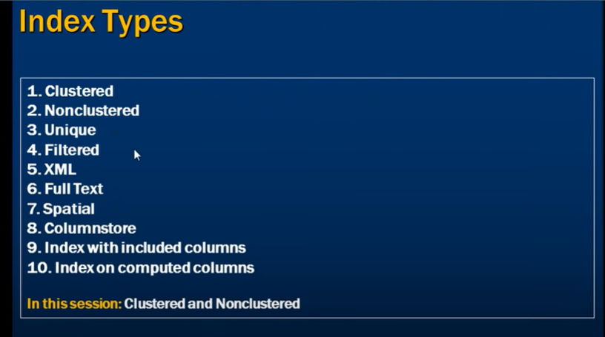

SYNTAX:=create index index_name on table_name (coloum_name asc)

To drop index:=drop index table_name_index_name.

to find the index on the table :-SYNTAX:=Execute sp_helpindex table_name

Type of index

**1) clustered index** :- A clustered index determines the physical order of data in a table. it is not store in the another place for this reason a table can have only one clustered index but could be contain more than one column. cluster index faster than a non clustered index.

Note that, primary key constraint create clustered indexes automatically if no clustered index already exists on the table.to create clustered index on two column use composite key. we can create clustered index on more than one column using composite primary key.

Note :- if you create the clustered index on name column it will store the data in acending overed by that name and nothe identiry column.

For ex :- 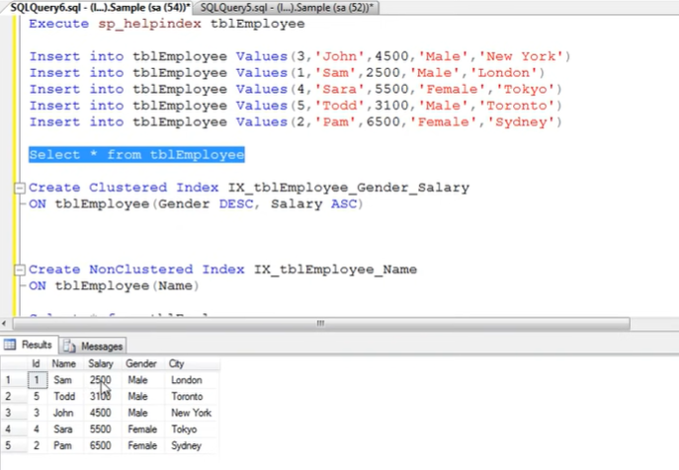 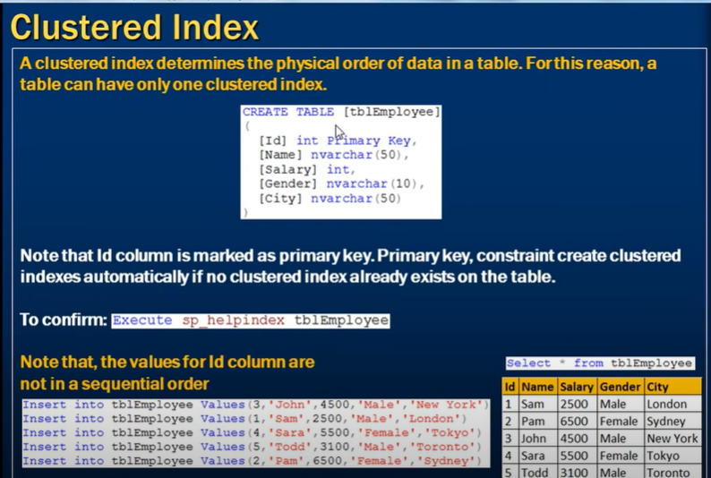 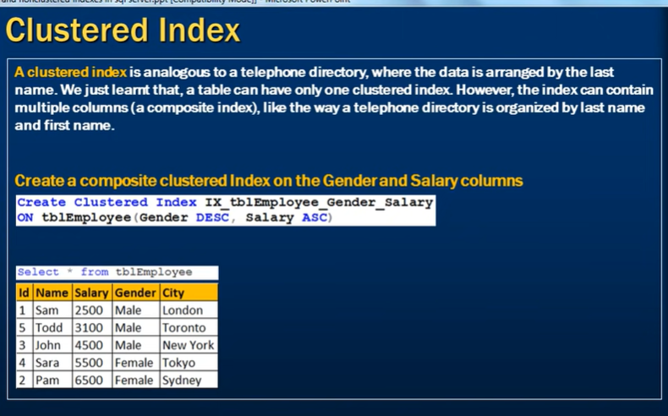

To confirm:=Execute sp_helpindex table_name

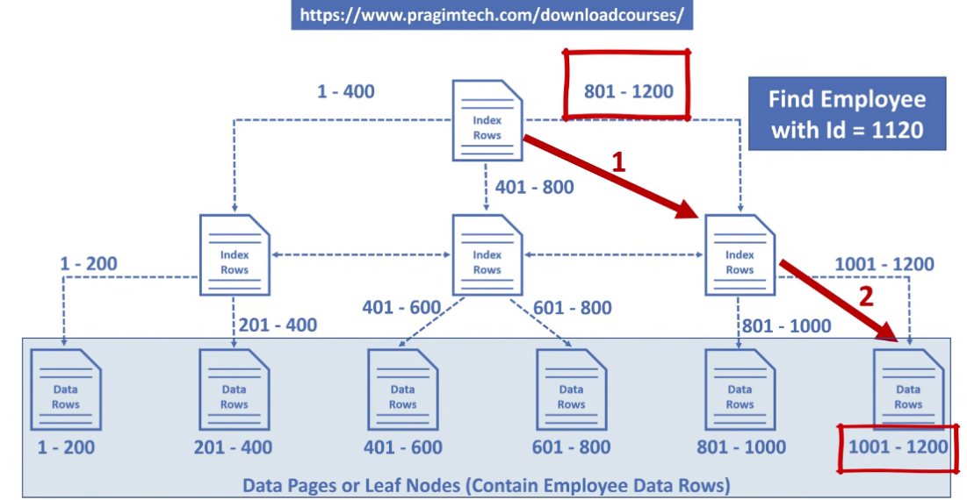

**2)Non Clustered index** :- a non-clustered index is analogous to an index in a textbook. The data/table is store in one place, the index in another place. The index will pointer to the storage location of the data. Since the non clustered index is stored separately from the actual data, a table have more than one non clustered index. non clustered index is stored separately from the table, additional storage space is required.

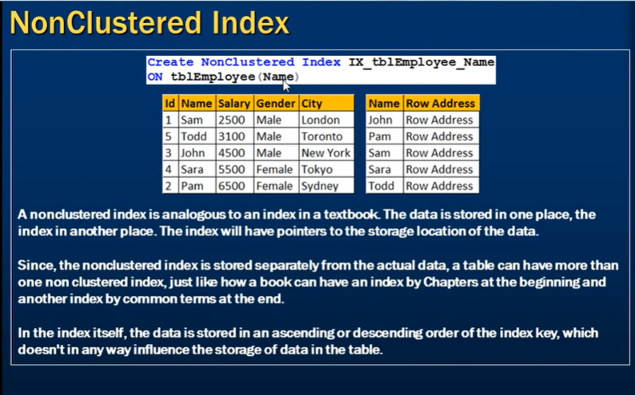 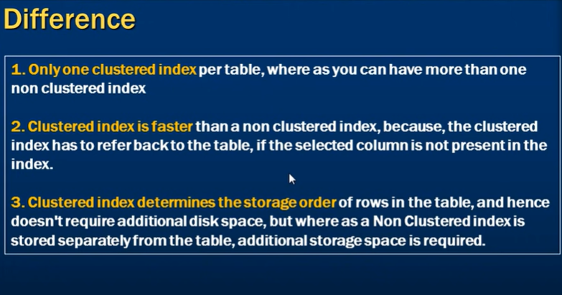

**3)Unique index**:- Unique index is nothing more than unique key.it create unique non clustered index.

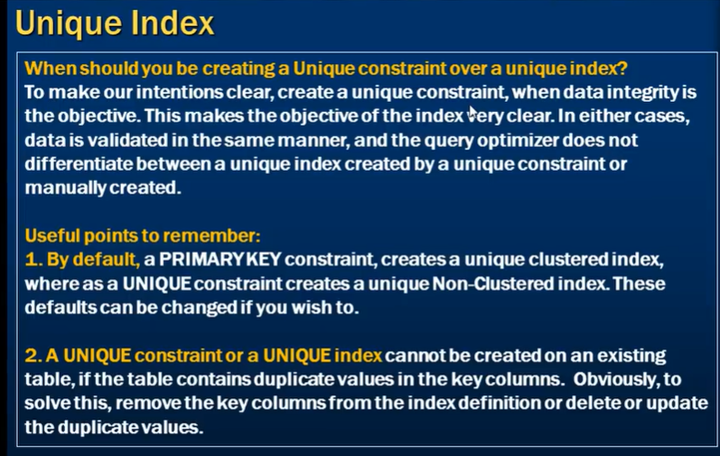

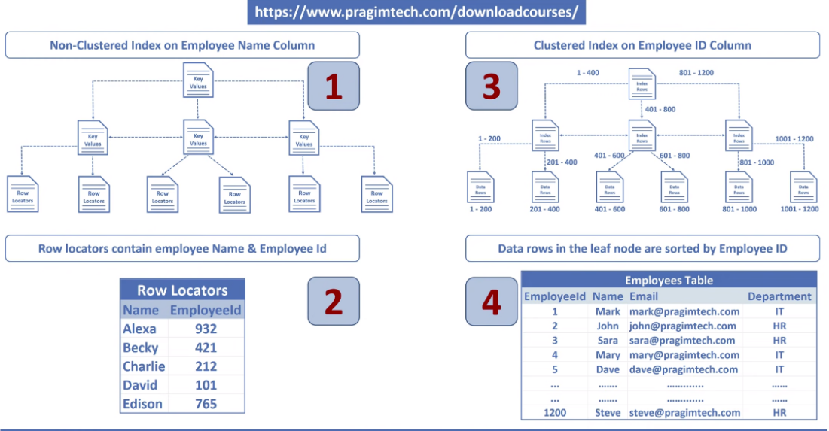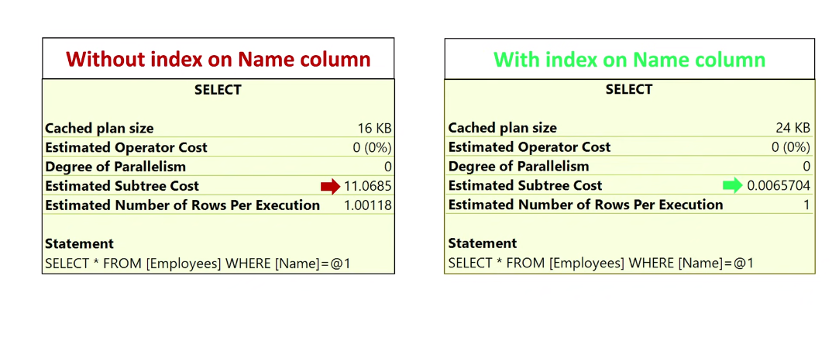

**Disadvantages of index**

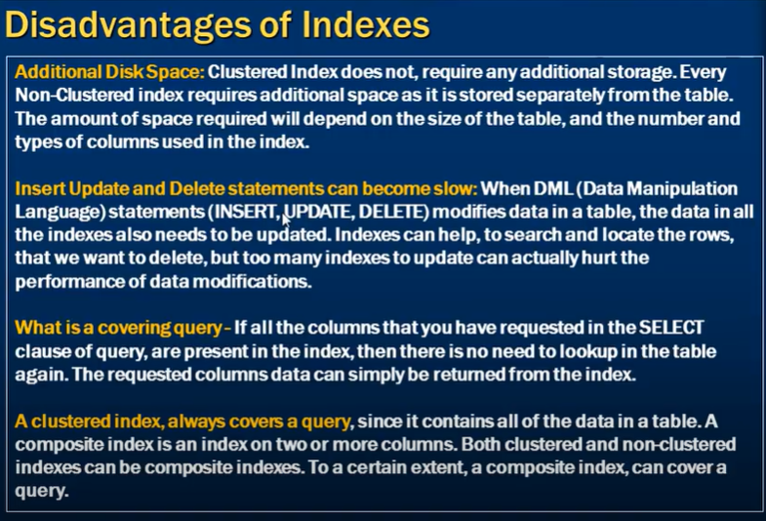

**How non-clustered index store in database**

A **non-clustered index** in SQL Server is a type of database index that improves the speed of data retrieval operations on a table at the cost of additional storage and maintenance. It does not affect the physical order of the data within the table, unlike a clustered index.

**How a Non-Clustered Index is Stored:**

**Index Structure**:

A non-clustered index is stored in a separate structure from the table data. It consists of a **B-tree** structure.

The **root** of the B-tree is the top node, and from it, the tree branches out to intermediate levels (if necessary), leading down to **leaf nodes** at the bottom.

**Leaf Nodes**:

The leaf nodes of a non-clustered index contain the index keys (the column or columns defined in the index) and a **pointer** to the actual data row in the table.

If the table has a **clustered index**, the leaf nodes of the non-clustered index store the **clustered index key** as the pointer.

If the table does not have a clustered index (i.e., it's a heap), the leaf nodes store the **row identifier (RID)**, which includes the file, page, and slot number where the data is located.

**Intermediate and Root Nodes**:

Intermediate nodes contain index keys and pointers to the next level in the B-tree, leading either to more intermediate nodes or to the leaf nodes.

The root node is the entry point to the index and contains pointers to the intermediate nodes (if they exist) or directly to the leaf nodes.

**Pointer to Data**:

When a query uses a non-clustered index to find data, the database engine traverses the B-tree from the root to the leaf nodes to find the relevant index key.

Once the leaf node is reached, the pointer (either the RID or the clustered index key) is used to retrieve the actual data row from the table.

**Key Points:**

**Separate Structure**: Unlike clustered indexes, non-clustered indexes are stored separately from the actual table data.

**Efficiency**: The B-tree structure allows for efficient searching, insertion, and deletion operations within the index.

**Overhead**: Non-clustered indexes add overhead to the database in terms of storage and maintenance, especially on large tables or tables with frequent updates.

**Example:**

Consider a table Employees with a non-clustered index on the LastName column. The non-clustered index will store the LastName values in a B-tree structure, with pointers to the actual rows in the Employees table. If a query searches for an employee by LastName, the index can quickly locate the relevant row without scanning the entire table.

This separation of the index from the actual data allows for quick lookups, but at the cost of additional storage and complexity in maintaining the index, especially during insert, update, and delete operations.

What is RID

In SQL Server, an **RID** (Row Identifier or Row ID) is a unique identifier used internally by the database engine to locate a specific row in a **heap table**. A heap table is a table that does not have a clustered index, meaning the rows are stored in no particular order.

**Components of an RID:**

An RID is composed of the following parts:

**File ID**: Identifies the file within the database where the row is stored.

**Page Number**: Identifies the page within the file where the row is stored.

**Slot Number**: Identifies the specific row on the page.

**How RID is Used:**

**Heap Tables**: In a table without a clustered index (a heap), SQL Server uses the RID to find rows when a non-clustered index is used. The non-clustered index stores the key value along with the corresponding RID, which points to the actual row in the heap.

**Index Lookup**: When a query uses a non-clustered index to locate a row, SQL Server follows the RID from the index to retrieve the row data.

**Example of RID Usage:**

Imagine you have a table called Customers without a clustered index (a heap table). If you create a non-clustered index on the LastName column, the index will store the LastName values along with the RIDs pointing to the specific rows in the Customers table.

If you execute a query to find a customer by LastName, SQL Server will:

Search the non-clustered index for the LastName.

Use the RID stored in the index to directly locate the row in the Customers table.

**Importance of RID:**

**Efficiency in Heaps**: RIDs are essential for efficiently locating rows in heap tables, especially when using non-clustered indexes.

**Non-Clustered Indexes**: In tables with a clustered index, non-clustered indexes store the clustered index key instead of the RID, since the clustered index defines the physical order of the data.

RIDs are a fundamental part of SQL Server's internal mechanisms for data storage and retrieval in heap tables.

**Covering index**

A **covering index** in SQL Server (and other relational database systems) is a non-clustered index that includes all the columns required to satisfy a query, meaning that the query can be fulfilled entirely by the index without needing to access the underlying table (also known as the **base table** or **heap**).

**How a Covering Index Works:**

When a query is executed, the database engine typically uses indexes to quickly locate rows in a table. However, if a query requires columns that are not included in the index, the engine must perform a lookup (either a **key lookup** for a clustered index or a **RID lookup** for a heap) to retrieve the additional columns from the table.

A covering index, by including all the columns needed by the query, eliminates the need for these additional lookups, which can significantly improve query performance.

**Example:**

Suppose you have a table Sales with the following columns:

sql

Copy code

Sales (SaleID, SaleDate, ProductID, Quantity, TotalAmount)

And you often run the following query:

sql

Copy code

SELECT SaleDate, ProductID, TotalAmount

FROM Sales

WHERE ProductID = @ProductID;

If you create a non-clustered index on ProductID:

sql

Copy code

CREATE NONCLUSTERED INDEX idx_ProductID ON Sales(ProductID);

The query optimizer can use this index to quickly find rows where ProductID = @ProductID. However, since the index only contains the ProductID column, SQL Server would still need to look up the SaleDate and TotalAmount columns in the table, potentially leading to slower performance.

To create a covering index for this query, you can include the additional columns:

sql

Copy code

CREATE NONCLUSTERED INDEX idx_ProductID_Covering

ON Sales(ProductID)

INCLUDE (SaleDate, TotalAmount);

**Key Points:**

**Key Columns**: The columns in the ON clause (ProductID in this case) are the **index key columns**, which define the order of the index.

**Included Columns**: The columns in the INCLUDE clause (SaleDate, TotalAmount) are **non-key columns** that are stored in the index but not part of the index key.

**Benefits of a Covering Index:**

**Reduced I/O**: Since the query can be satisfied entirely by the index, there’s no need to access the base table, reducing I/O operations.

**Improved Query Performance**: By eliminating additional lookups, the overall performance of the query is improved, especially for read-heavy operations.

**Efficient Data Retrieval**: For frequently executed queries, covering indexes can provide a significant boost in performance by efficiently retrieving only the necessary data.

**When to Use Covering Indexes:**

For **frequently executed queries** that involve filtering, joining, or sorting on specific columns.

When **query performance** is critical, and the overhead of maintaining a more extensive index is outweighed by the performance gains.

To optimize **read-heavy workloads**, especially in reporting or analytical applications where specific queries are run repeatedly.

Covering indexes can be a powerful tool in query optimization, but they should be used judiciously, as maintaining large indexes with many included columns can increase storage costs and the overhead of data modifications (INSERT, UPDATE, DELETE operations).

**Full-text index**

A **Full-Text Index** is a special type of index in a database that allows for efficient searching of text data within large datasets. Unlike regular indexes that are used to speed up queries on specific columns, full-text indexes are designed to facilitate complex search queries, such as those involving words, phrases, or natural language queries, across large amounts of text.

**Key Features of Full-Text Indexes**

**Word-Based Searching:** Full-text indexes break down the text data into individual words and store them in a way that makes searching for specific words or phrases much faster. This allows for searching within text fields, like articles, comments, or descriptions.

**Advanced Search Capabilities:** Full-text searches support various search capabilities, such as:

**Boolean Searches:** Using operators like AND, OR, NOT.

**Phrase Searches:** Searching for exact phrases within the text.

**Proximity Searches:** Finding words near each other.

**Relevance Ranking:** Returning search results ordered by relevance based on the frequency and significance of the search terms.

**Efficient Text Searching:** Full-text indexes are optimized for searching large volumes of text, making them much more efficient than performing a LIKE search on a standard indexed column.

**Implementation in Different Databases**

**MySQL:**

Full-text indexes can be created on columns of type CHAR, VARCHAR, or TEXT.

Full-text searches in MySQL are performed using the MATCH and AGAINST keywords.

**Example:**

CREATE FULLTEXT INDEX idx_fulltext_content ON articles(content);

You can then perform a full-text search using:

SELECT * FROM articles

WHERE MATCH(content) AGAINST('database optimization' IN NATURAL LANGUAGE MODE);

**SQL Server:**

Full-text indexes in SQL Server can be applied to CHAR, VARCHAR, TEXT, NVARCHAR, NTEXT, or XML columns.

Full-text searches are done using the CONTAINS or FREETEXT predicates.

**Example:**

CREATE FULLTEXT INDEX ON Products(ProductDescription)

KEY INDEX PK_ProductID;

Then you can perform a search like:

SELECT * FROM Products

WHERE CONTAINS(ProductDescription, 'bicycle AND helmet');

**PostgreSQL:**

Full-text search is built into PostgreSQL and can be applied to TEXT or VARCHAR columns.

PostgreSQL uses the to_tsvector and to_tsquery functions for full-text search.

**Example:**

CREATE INDEX idx_fulltext_content ON articles USING gin(to_tsvector('english', content));

Then you can search using:

SELECT * FROM articles

WHERE to_tsvector('english', content) @@ to_tsquery('database & optimization');

**Use Cases for Full-Text Indexes**

**Search Engines:** Full-text indexes are commonly used in search engines to provide fast and relevant search results across large collections of documents or web pages.

**Content Management Systems (CMS):** They are used to allow users to search articles, blog posts, or documentation by keywords or phrases.

**E-commerce Platforms:** Full-text searches enable users to search product catalogs by name, description, or other text fields.

**Considerations**

**Performance:** While full-text indexes greatly improve the performance of text searches, they can consume significant storage and may slow down insert, update, and delete operations on the indexed columns.

**Stopwords and Stemming:** Many full-text search engines use "stopwords" (common words that are ignored) and "stemming" (reducing words to their root form) to improve search efficiency. These can sometimes lead to unexpected results, so it's important to understand how they are handled in your database.

**Summary**

A full-text index is a powerful tool for performing efficient and advanced text searches within a database. It is especially useful when working with large amounts of text data, enabling features like word searches, phrase searches, and relevance ranking. Each database management system has its own implementation of full-text indexing, but the core principles remain the same across platforms.

**How to figure the column on which the index can be made**

**Analyse Query Patterns**: Identify the most common and performance-critical queries that are executed against your database. Examine the columns used in the **WHERE**, **JOIN**, and **ORDER BY** clauses of these queries. These columns are strong candidates for indexing.

**Identify Filtering Columns**: Columns used in equality or range conditions (e.g., **WHERE column = value** or **WHERE column BETWEEN value1 AND value2**) are good candidates for indexing. These indexes can quickly filter and locate specific rows.

**Consider Joins**: Columns involved in join conditions (**JOIN** clauses) can benefit from indexing. Indexing foreign key columns used in joins can speed up query performance when fetching related data from another table.

**Evaluate Sorting and Grouping**: If your queries involve sorting or grouping, consider indexing the columns used in **ORDER BY** and **GROUP BY** clauses. This can improve performance when retrieving ordered or aggregated results.

**Look at Composite Indexes**: A composite index includes multiple columns. Consider creating composite indexes for queries that filter or sort based on multiple columns. However, be cautious not to create too many composite indexes, as they have overhead and can lead to index fragmentation.

**Avoid Over-Indexing**: While indexing improves read performance, each index consumes disk space and impacts write operations. Avoid indexing columns with low selectivity (columns with a small number of unique values) or columns that are rarely queried.

**Covering Indexes**: Consider creating covering indexes that include all columns needed for a query. These indexes can eliminate the need to access the actual table data, improving performance.

**Watch for Updates and Deletes**: Be cautious when indexing columns frequently updated or deleted. Indexes need to be updated during these operations, which can impact write performance.

**Review Execution Plans**: Use query execution plans to analyze how queries are being processed by the database engine. Look for potential performance bottlenecks and consider creating indexes to address those.

**Use Indexing Tools**: Some database management systems provide tools that can suggest potential indexes based on query patterns. Utilize these tools to help you make informed decisions.

**Consider Cardinality**: Cardinality refers to the number of unique values in a column. High cardinality columns are better candidates for indexing because they can quickly narrow down data. Low cardinality columns may not benefit as much.

**Test and Monitor**: After creating indexes, test query performance to ensure that the indexes are indeed improving performance as expected. Monitor the overall performance of your database over time to make adjustments if needed.

**user define table type**

purpose :- we cannot directly use a simple table as a parameter in a stored procedure. That’s why we create the user define table and then pass it as a parameter in procedure.

helps to store temporary data. they are used as parameter when you pass tabular data into stored procedure or use defined function.

table valued parameter: - Table valued parameter allows a table to passed as a parameter to a stored procedure from T-SQL CODE or from an application.

note: -Table valued parameters must be passed as read-only to stored procedures, function etc. This means that you cannot perform DML operations like insert, update, delete on a table valued parameter in the body of a function, store procedure etc.

3 steps to pass multiple rows to a stored procedure using table valued parameter 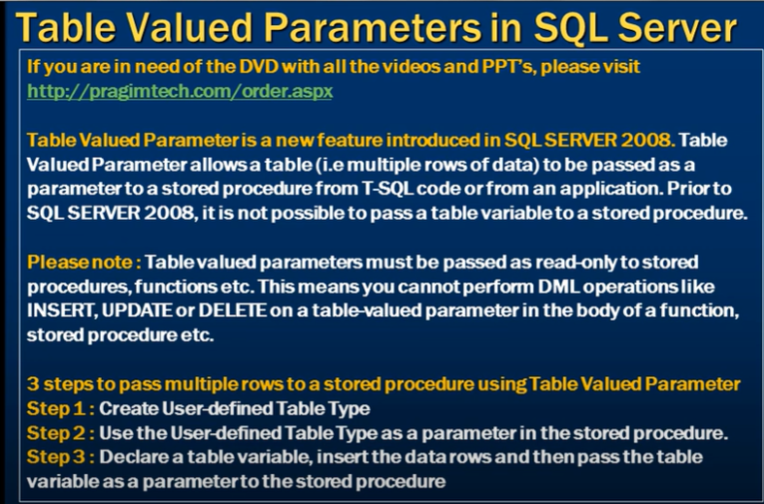

step 1: create user define table type.

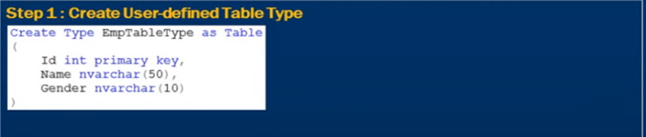

step 2:use the user-defined table type as a parameter in the store procedure.

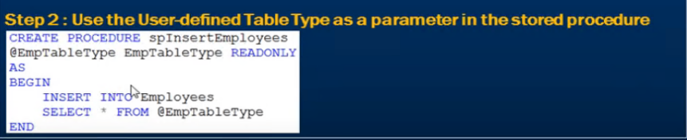

step 3:declare a table variable, insert the data rows and then pass the table variable as a parameter to the stored procedure.

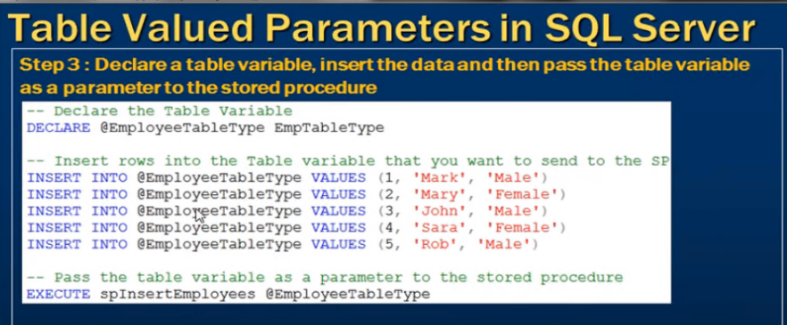

Creating the user define table type using the procedure and then use that user define table type as parameter in another procedure as a parameter.

**USER DEFINE FUNCTION**

A **function in a database** is a reusable piece of code that accepts input, performs an operation, and returns a value (or table).

**Imp :-**

**Inside a function, you cannot insert (or modify) data in permanent tables.**

That means:

* You **cannot** do INSERT, UPDATE, or DELETE on a **physical table** (like dbo.Employees)
* You **cannot** call EXEC, sp_executesql, or dynamic SQL that would modify data
* You **cannot** use MERGE either

Functions in SQL Server are:

* **Deterministic** (no side effects)
* **Read-only**
* Meant to **compute and return values**, not change database state.

Can not create the temporary table inside the function but you can declare variable or table.

======================================================================================

type of user define function

A) scalar functions

B) inline table-valued function

C) Multi-statement table-valued function

A) scalar function:-RETURN A SCALAR VALUE

scaler function may or may not have parameter, but always return a single (scalar)value. the returned value can be of any data type ,except text, ntext, image ,cursor and timestamp.

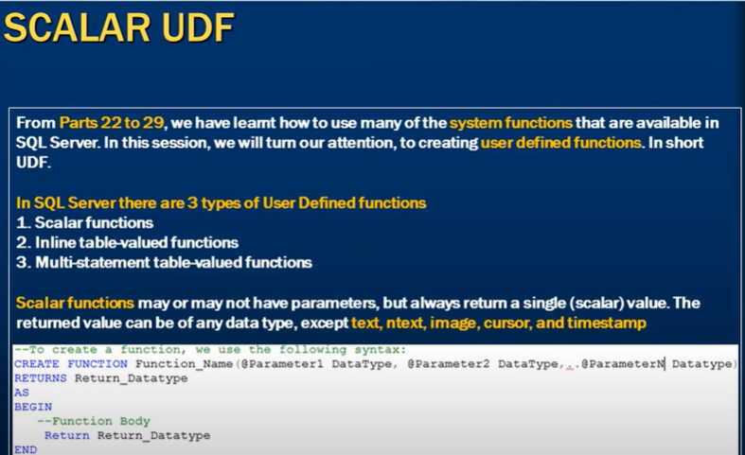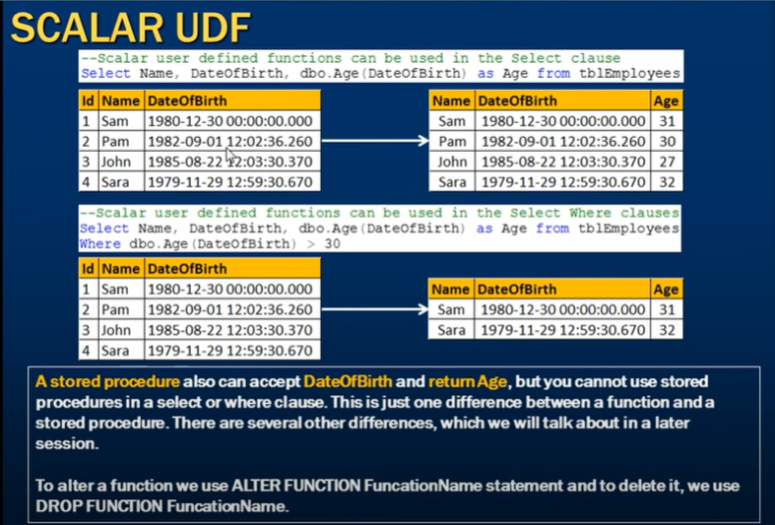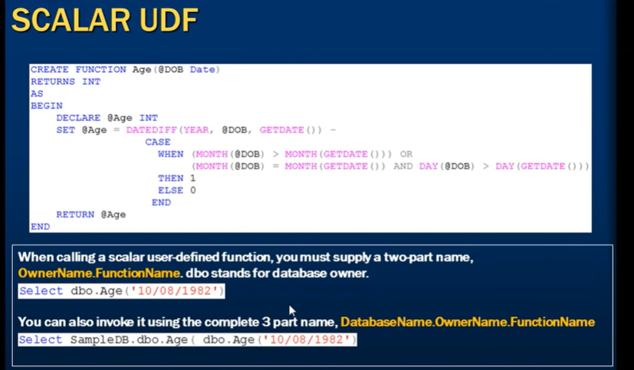

--To create a functiion we use following syntax

CREATE FUNCTION Function_Name(@parameter1 datatype,@parameter2 datatype)

RETURNS Return_datatype

AS

BEGIN

--function body

RETURN Return_datatype

END

TO CALL FUNTION USE TWO PART NAME AND ALSO USE IN SELECT AND WHERE CLAUSE

EX:-SELECT columnname1,dbo.function_name(Column_name2) from table_name.

B)INLINE TABLE FUNCTION:-RETURN A TABLE

Note :- even you can update the value in table using this inline table function but can not update using multi-statment table value functions.

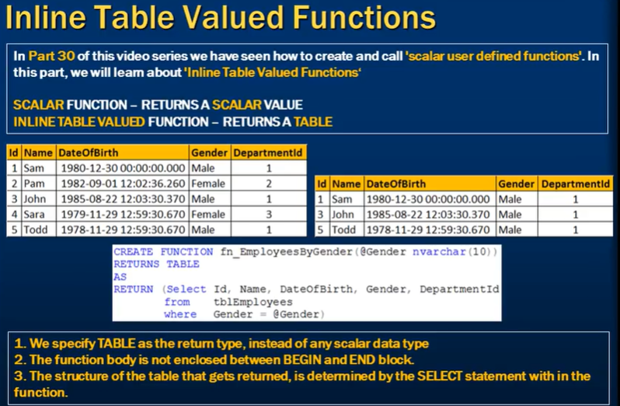

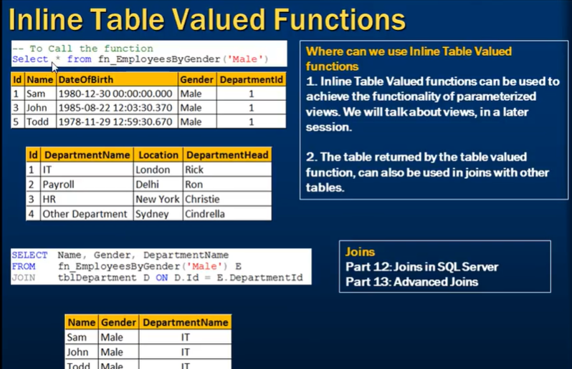

SYNTAX:-CREATE FUNCTION Function_name(@gender nvarchar(10))

RETURN TABLE

AS

RETURN(Select id,name ,dateofbirth,gender from emp_table where gender=@gender)

to call the function

select * from function_name("male")

RULES FOR INLINE TABLE FUNCTION

1)we specify TABLE as the return type, instead of any scalar data type.

2)the function body is not enclosed between BEGIN and END block.

3)the structure of the table that get returned ,is determined by the select statement with in the function.

where can we use inline table valued functions

1)inline table valued functions can be used to achieve the functionality of parameterized view.

2)the table returned by the inline table valued function, can also be used in joins with other tables.

C)multi-statment table value functions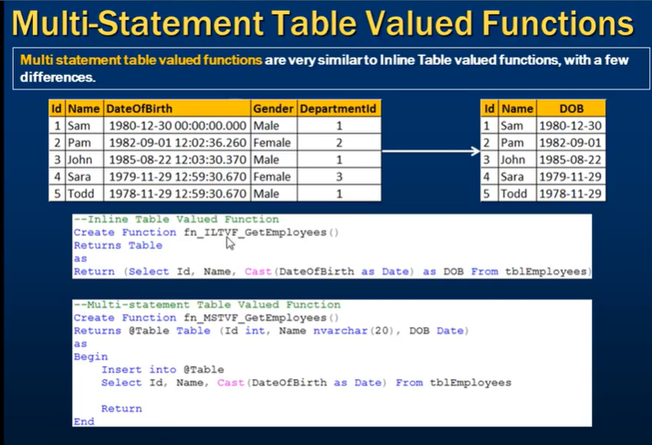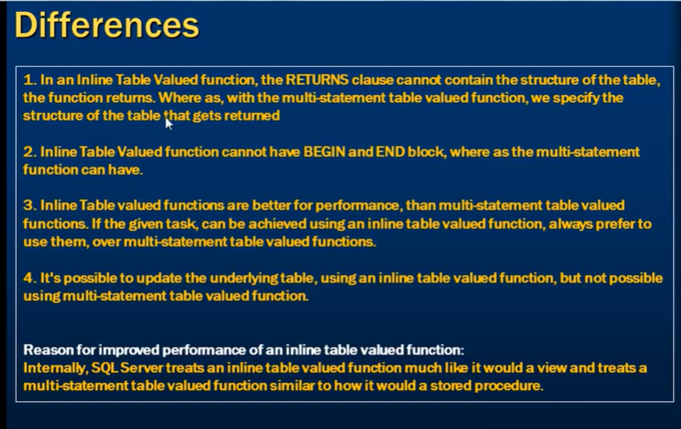

give the same output as inline table value function but we specify the table structure in RETURN Statment

SYNTAX:-

CREATE FUNCTION function_name()

RETURNS @Table TABLE (id int,name nvarchar(20),DOB Date)

AS

BEGIN

INSERT INTO @Table

select id,name,cast(dateofbirth as date) from table_name

RETURN

END

difference between multi-stament table value function and inline table value function

1)IN inline table value function we are not specify the table structure in RETURN STATMENT but in multi-statment table value function we specify the table structure in RETURN statment

2)Inline tabel valued function cannot have BEGIN and END block,where as the multi-statment function can have.

3)Inline table valued function are better for performance.

4) Its possible to update underlying table, using inline table valued function, but not possible using multi-statement table valued function.

**Difference between function and procedure**

1)we can use function in select and where clause but we can not use procedures in select and where clause.

2)we can pass function to procedure but can not pass procedure to function.

3)In procedure we have input and output parameter but in function we have input parameter only.

4)The function must return a value but in store procedure it is optional.

5)function always return value.

6) can not create temporary table in function.

7) Can not do the insert, update and delete in function.

8) can not use try catch block in function.

**Concept related to the function**

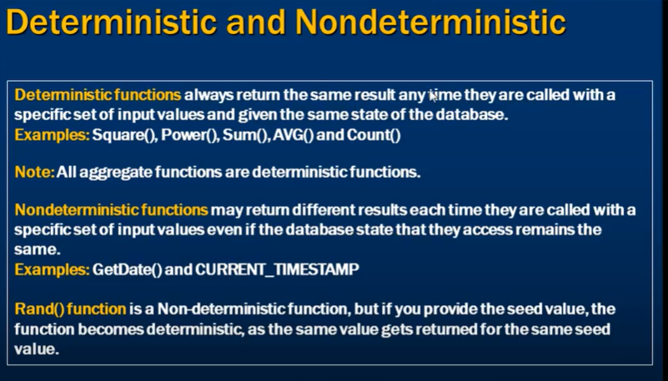

Encryption In function 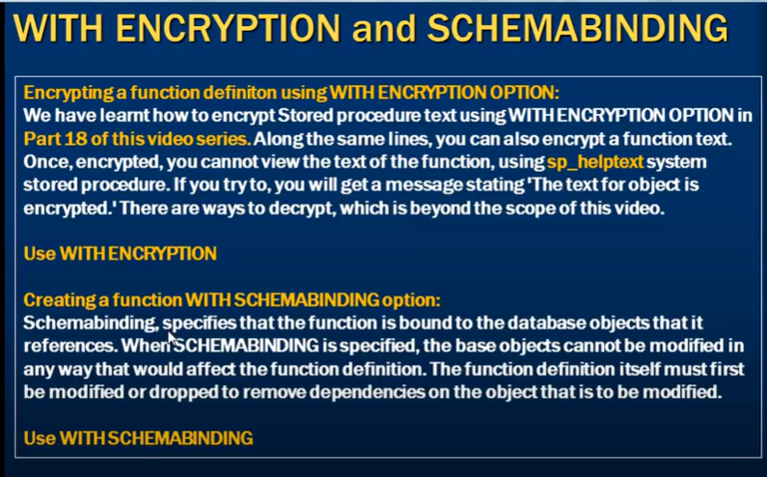

Using WITH ENCRYPTION :- when we use this option no one can see the defination of the function .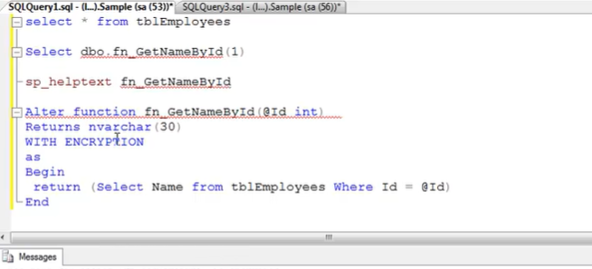

Using WITH SCHEMABINDING :- when we use this option and we have table present in that function and someone try to drop or change the defination of the table which affect the function it prevent it from that table to be modified that way.

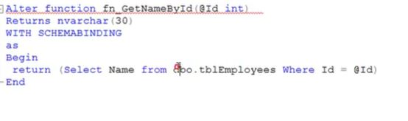 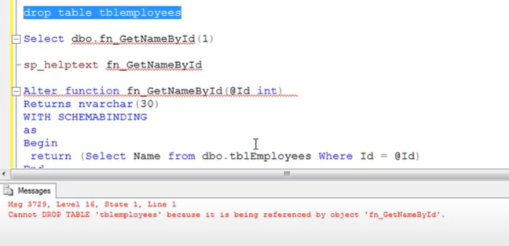

**Triggers**

Limitation of triggers in MySQL

Triggers in MySQL are a powerful feature that allows you to automatically execute a predefined set of operations in response to specific changes in a database table. However, triggers come with certain limitations that you should be aware of when designing your database and writing triggers. Here are the key limitations:

**1. Limited Trigger Types**

MySQL supports only the following types of triggers:

BEFORE INSERT

AFTER INSERT

BEFORE UPDATE

AFTER UPDATE

BEFORE DELETE

AFTER DELETE

There is no support for INSTEAD OF triggers (which are available in some other databases like SQL Server) or s for other types of operations, such as TRUNCATE, ALTER, or DROP.

**2. No Triggers on Views**

Triggers can only be defined on tables, not on views. This means you cannot create a trigger that automatically executes when a view is queried or modified.

**3. Trigger Recursion and Limits**

**Recursive Triggers**: MySQL does not support recursive triggers. This means a trigger cannot call itself either directly or indirectly. If you need recursive behavior, you will have to implement it in the application layer or through stored procedures with careful control flow.

**Trigger Nesting**: MySQL supports nested triggers, where one trigger can cause another trigger to fire. However, there is a limit to the depth of nesting (64 levels by default). Exceeding this limit will result in an error.

**4. No Transaction Control**

You cannot commit, roll back, or start a new transaction within a trigger. If an error occurs during trigger execution, it will cause the entire triggering statement to fail and any changes to be rolled back, but you cannot manage transactions manually within a trigger.

This limitation means you cannot use triggers to manage complex transaction logic that might involve committing or rolling back at specific points.

**5. No Parameters or Return Values**

Triggers do not accept parameters or return values. They are automatically executed in response to a triggering event and cannot be called directly or passed arguments.

**6. Limited Use of Certain SQL Statements**

Some SQL statements are not allowed within triggers:

**Statements that return a result set**: For example, SELECT ... INTO that returns multiple rows.

**Dynamic SQL**: You cannot use PREPARE, EXECUTE, or dynamic SQL inside a trigger.

**Locking Statements**: Statements like LOCK TABLES or UNLOCK TABLES cannot be used within a trigger.

**Stored Procedure/Function Calls**: While you can call stored procedures and functions within triggers, these calls are subject to the same limitations (no dynamic SQL, no transaction control).

**7. Trigger Execution Order**

MySQL does not provide a way to explicitly define the order of execution for triggers that fire on the same table and event (e.g., multiple BEFORE INSERT triggers on the same table). The order of execution is determined by MySQL and may not be predictable, so relying on a specific order can lead to unexpected results.

**8. Limited Error Handling**

Error handling within triggers is minimal. If an error occurs during trigger execution, the entire statement that caused the trigger to fire will fail, and all changes will be rolled back. However, you cannot catch and handle specific errors within the trigger itself.

**9. Resource Consumption and Performance**

Triggers can increase the complexity of your database operations and may lead to performance issues if not carefully managed. Since triggers are executed automatically, they can potentially introduce significant overhead, especially in high-throughput systems or when performing complex operations within the trigger.

**Debugging**: Debugging triggers can be challenging because they execute automatically in response to other operations, and you cannot step through them like you can with stored procedures or application code.

**10. Replication Issues**

If you are using MySQL replication, triggers can sometimes cause issues:

**Statement-Based Replication**: Triggers may cause different results on the master and slave if they rely on non-deterministic functions or external resources.

**Row-Based Replication**: Triggers are generally safer with row-based replication, but care must still be taken to ensure consistent results.

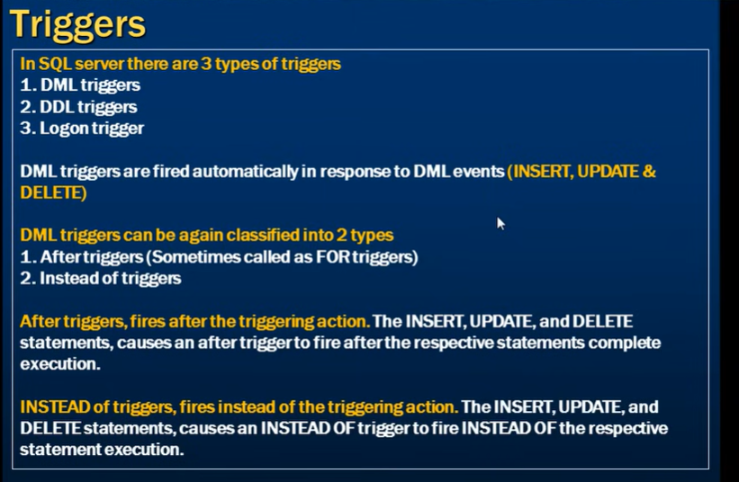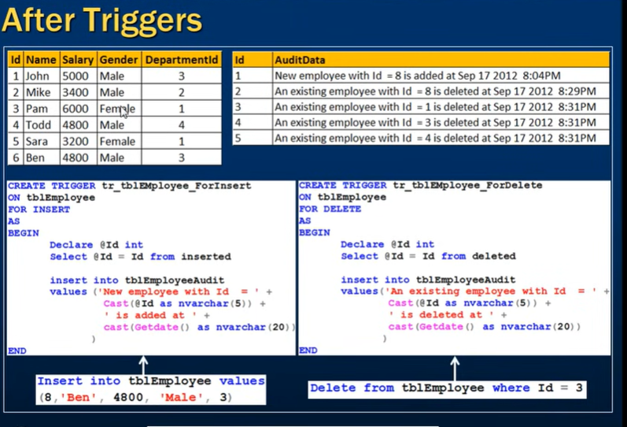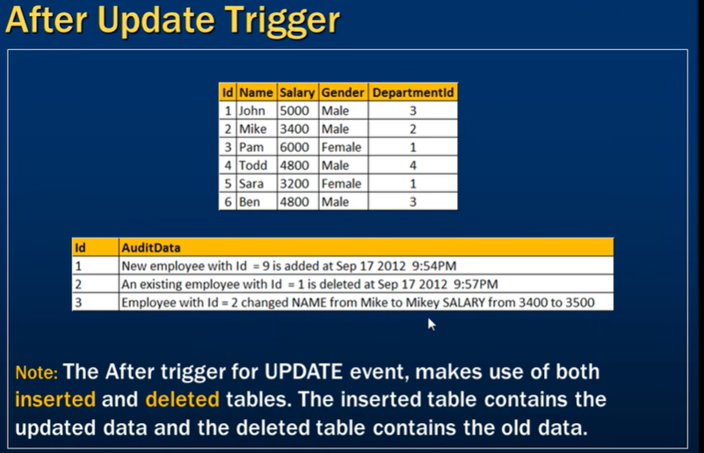

UPDATE TRIGGER CODE

ALTER trigger [Purchasing].trg_afterUpdate

on [AdventureWorks2019].[Purchasing].[Vendor]

after update

as

begin

declare @BusinessEntityID int,

@AccountNumberNew nvarchar(100),

@NameNew nvarchar(1000),

@PurchasingWebServiceURLNew nvarchar(2000),

@AccountNumberOld nvarchar(100),

@NameOld nvarchar(1000),

@PurchasingWebServiceURLOld nvarchar(2000),

@AuditString varchar(2000)

select * into #temp

from inserted

while exists(select * from #temp)

begin

set @AuditString = ''

select top 1 @BusinessEntityID = BusinessEntityID,

@AccountNumberNew = AccountNumber,

@NameNew = Name,

@PurchasingWebServiceURLNew = PurchasingWebServiceURL

from #temp

select

@AccountNumberOld = AccountNumber,

@NameOld = Name,

@PurchasingWebServiceURLOld = PurchasingWebServiceURL

FROM deleted WHERE BusinessEntityID = @BusinessEntityID

set @AuditString = 'BusinessEntityID ' + cast(@BusinessEntityID AS varchar)

if @AccountNumberOld <> @AccountNumberNew

begin

set @AuditString = @AuditString +' ' + 'AccountNumber change from' + @AccountNumberOld + ' TO ' + @AccountNumberNew

END

if @NameOld <> @NameNew

begin

set @AuditString = @AuditString +' '+ 'Name change from' + @NameOld + ' TO ' + @NameNew

end

if @PurchasingWebServiceURLOld <> @PurchasingWebServiceURLNew

begin

set @AuditString = @AuditString +' '+ 'PurchasingWebServiceURL change from' + @PurchasingWebServiceURLOld + ' TO ' + @PurchasingWebServiceURLNew

END

INSERT INTO AuditLog(Logs) values (@AuditString)

DELETE FROM #temp WHERE BusinessEntityID = @BusinessEntityID

END

end

INSTEAD OF INSERT TRIGGER

When we have view with more than one table we can not insert row using that view so in that case we can use instead of insert trigger to insert the value in underline table but when you have the only on table inside the view it update without error.

Imp :- 1. The trigger fires immediately.

2. The row is **not inserted** unless you explicitly insert it in the tsrigger:

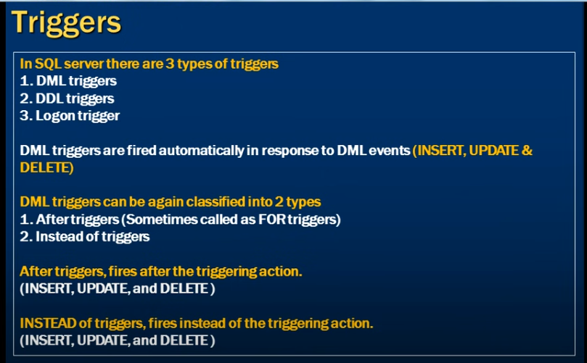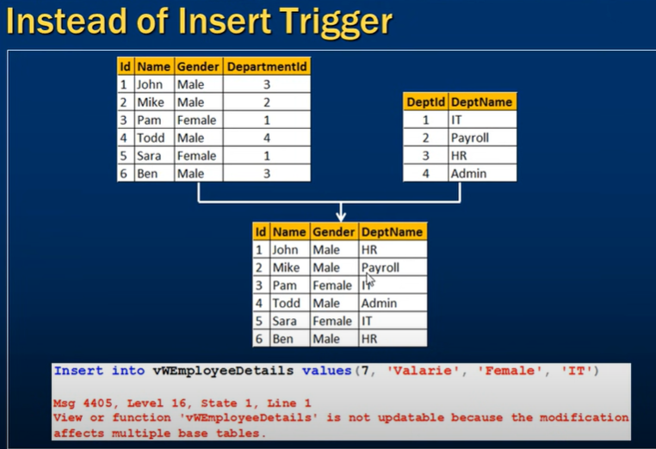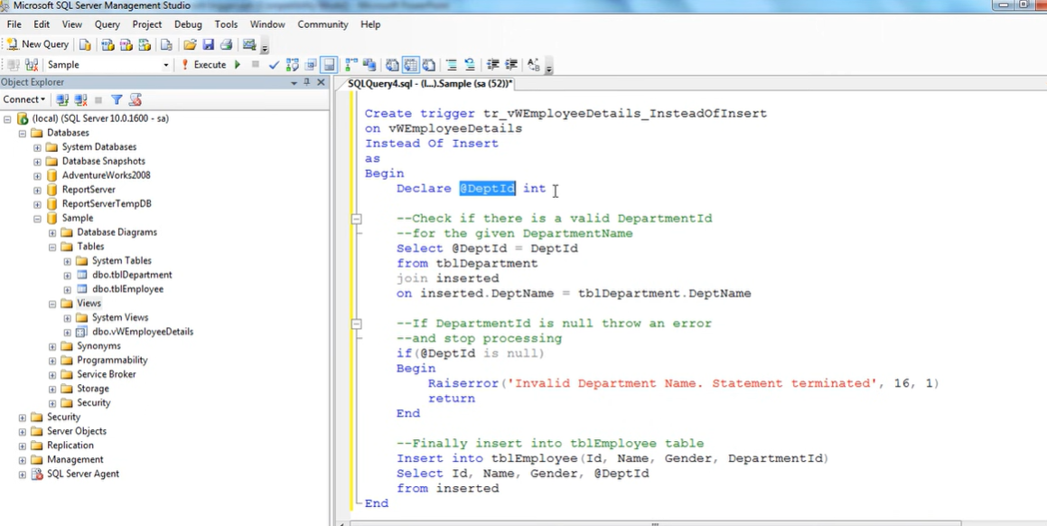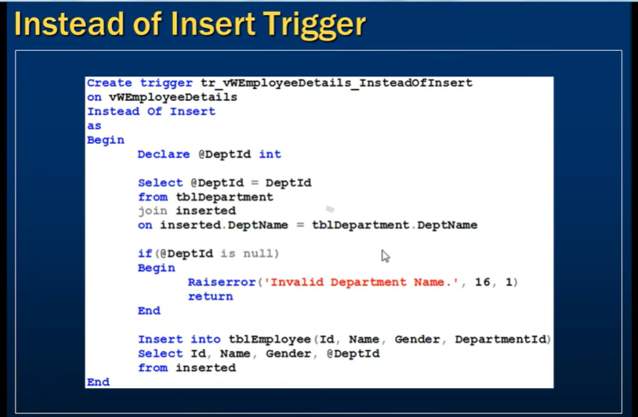

INSTEAD OF UPDATE TRIGGER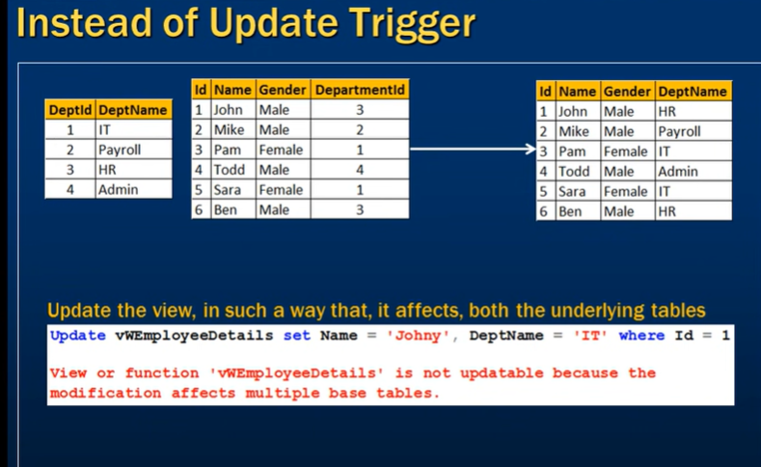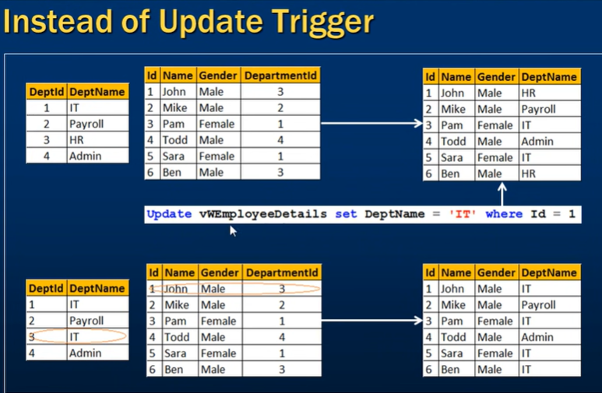

Update function use to know if that particular column value get change or not. It will give true if the column is specified in set clause.

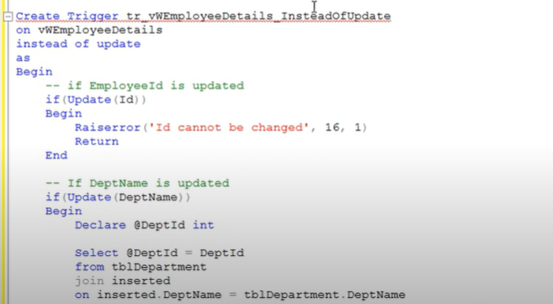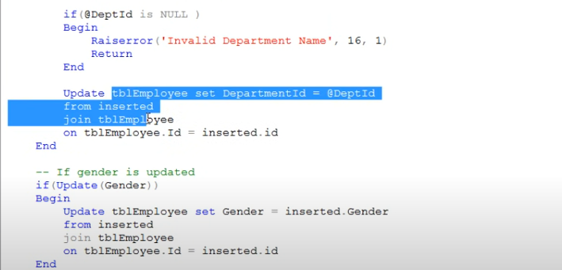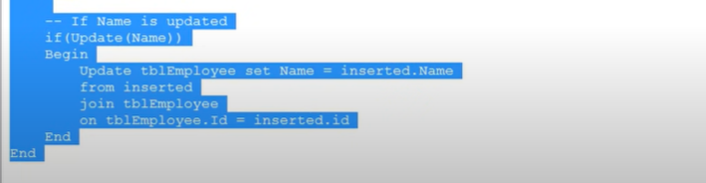

INSTEAD OF DELETE TRIGGER

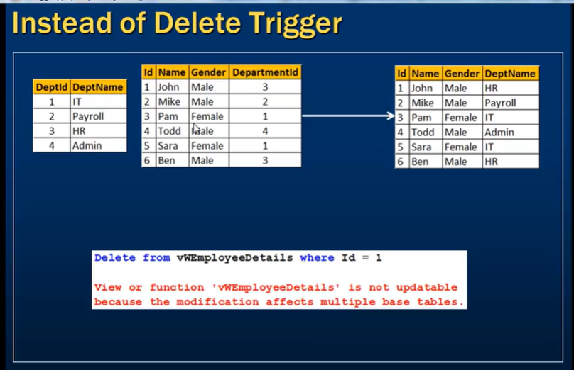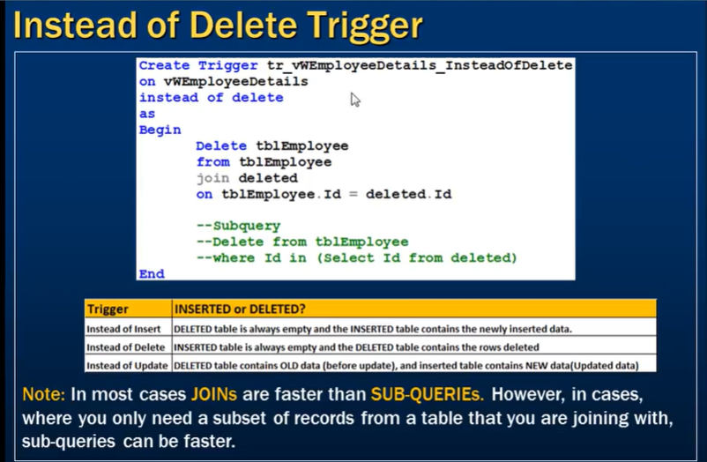

DDL TRIGGER

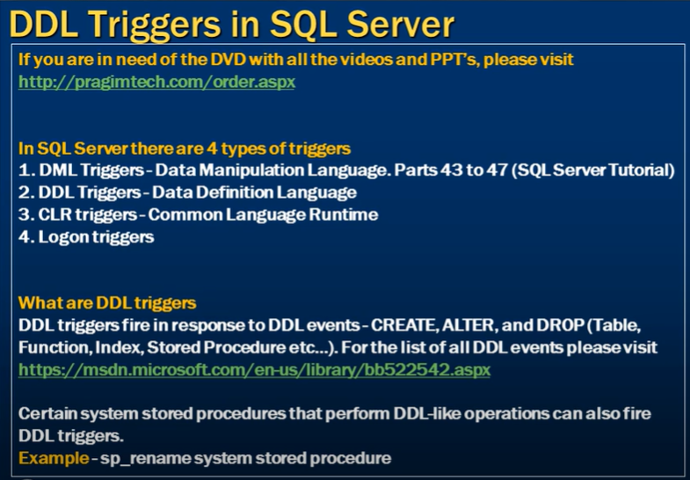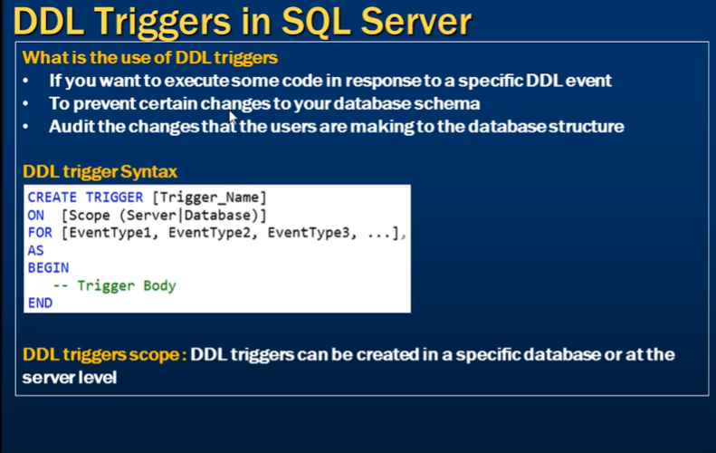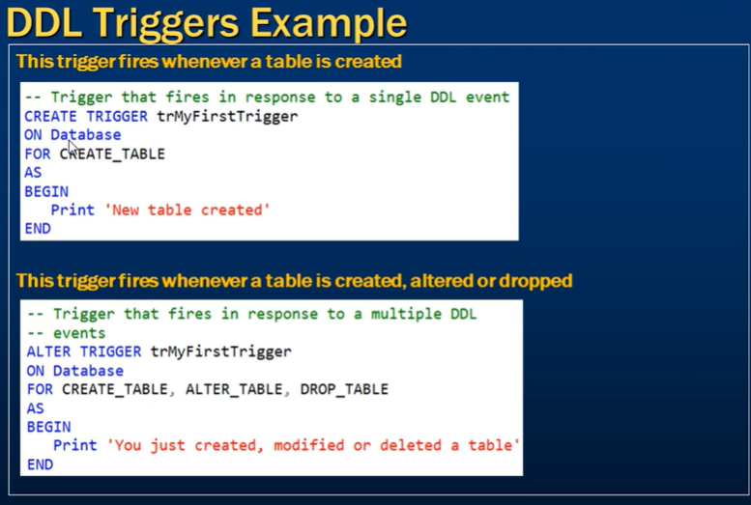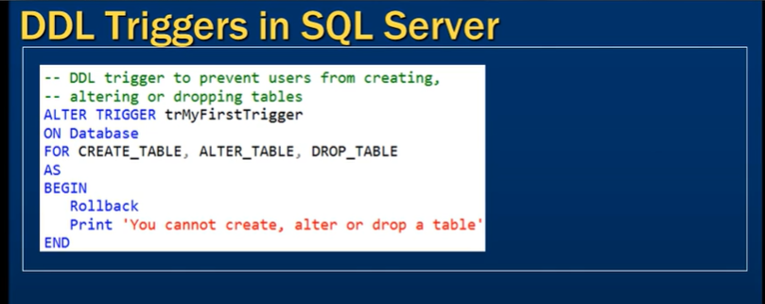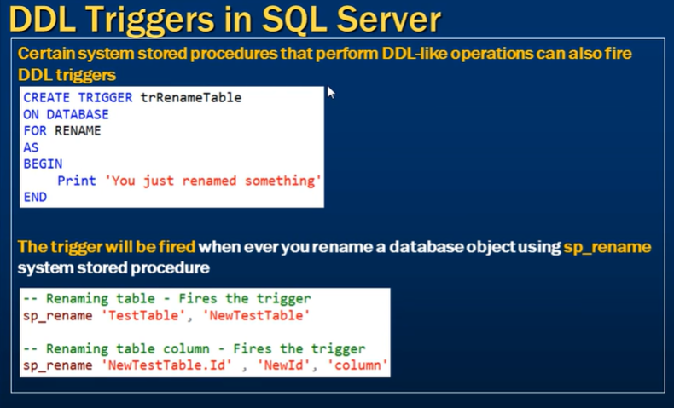

A DDL (Data Definition Language) trigger in SQL Server is a type of trigger that executes in response to DDL events like CREATE, ALTER, and DROP statements. DDL triggers can be useful for auditing, enforcing rules, or preventing certain schema changes.

Here’s an example of how to create a DDL trigger that logs any changes to the database schema:

**Example: Logging DDL Changes to a Table**

CREATE TABLE SchemaChangesLog (

EventData XML,

EventTime DATETIME DEFAULT GETDATE()

);

CREATE TRIGGER LogDDLChanges

ON DATABASE

FOR CREATE_TABLE, ALTER_TABLE, DROP_TABLE

AS

BEGIN

INSERT INTO SchemaChangesLog (EventData)

VALUES (EVENTDATA());

END;

GO

**Explanation:**

**SchemaChangesLog**: A table where the XML event data from the DDL operations will be stored.

**LogDDLChanges**: A trigger that responds to CREATE, ALTER, and DROP table events.

**EVENTDATA()**: A function that returns detailed information about the event in XML format.

**Scope of DDL Triggers:**

**ON DATABASE**: Applies the trigger at the database level.

**ON ALL SERVER**: Applies the trigger at the server level (for all databases).

DDL triggers can help enforce control over database schema changes, ensuring they align with business or security policies. Let me know if you want to dive deeper into any specific aspect!

**Server scoped ddl triggers**

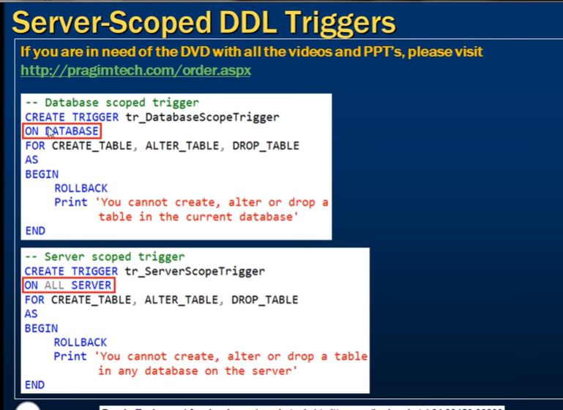

**sql server trigger execution order**

by default the order of execution of trigger is in which they are created(based on trigger creation order)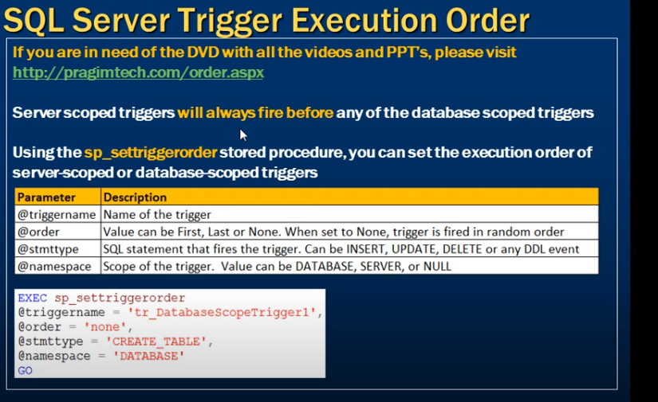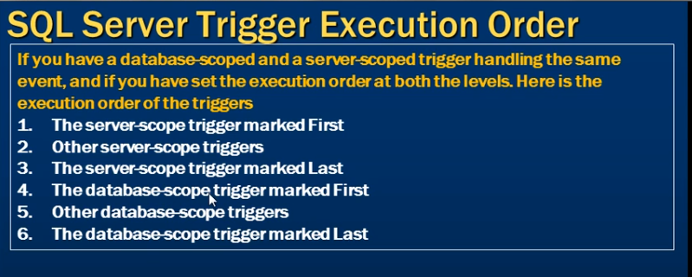

Audit table changes in SQL Server   
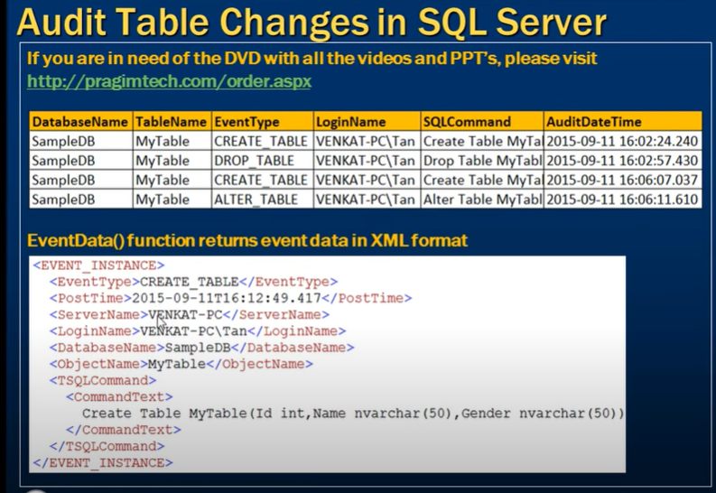 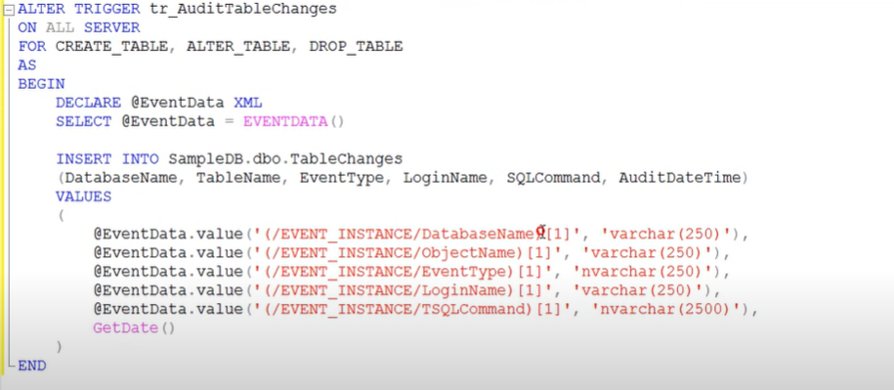

LOGON TRIGGER

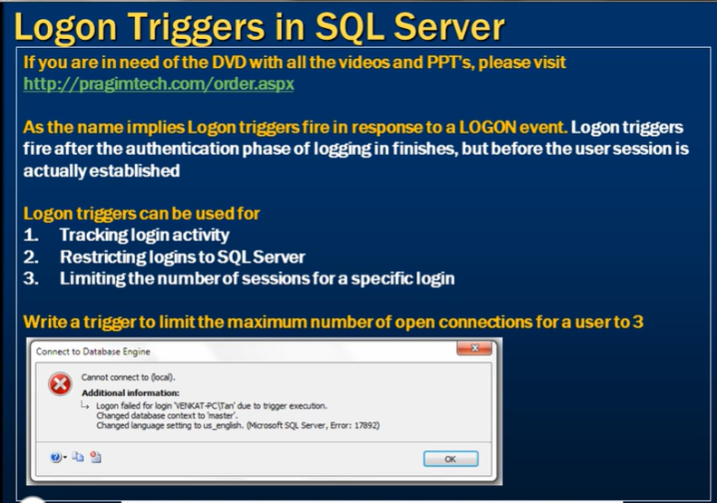 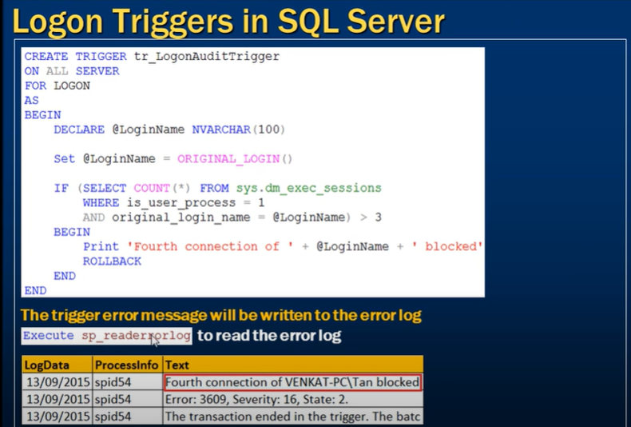

A **logon trigger** in SQL Server is a special type of trigger that is executed **automatically in response to a LOGON event**—when a user session is established. Logon triggers can be useful for enforcing rules, logging activity, or restricting access based on various conditions like time, user roles, or even the number of active sessions.

**Common Use Cases:**

**Restricting the Number of Sessions** per user.

**Logging login activities**.

**Enforcing login time restrictions**.

**Blocking specific users or roles** from logging in.

**Syntax of a Logon Trigger:**

CREATE TRIGGER trigger_name

ON ALL SERVER

FOR LOGON

AS

BEGIN

-- Trigger logic here

END;

**ON ALL SERVER**: The logon trigger applies to the entire server.

**FOR LOGON**: Specifies that the trigger is fired when a logon event occurs.

**Example 1: Restricting the Number of Active Sessions Per User**

This logon trigger limits users to only 1 active session at a time:

CREATE TRIGGER LimitSessionTrigger

ON ALL SERVER

FOR LOGON

AS

BEGIN

-- Check the number of sessions for the current user

IF (SELECT COUNT(*)

FROM sys.dm_exec_sessions

WHERE login_name = ORIGINAL_LOGIN()) > 1

BEGIN

-- If the user has more than 1 active session, block the login

ROLLBACK;

END;

END;

In this example:

**sys.dm_exec_sessions**: This dynamic management view is used to get session information. It checks how many active sessions the current user has.

**ORIGINAL_LOGIN()**: This function returns the original login name of the session.

**Example 2: Log Login Attempts**

This logon trigger logs every login attempt into a custom table.

**Create a Table to Log Logins**:

CREATE TABLE LogonAudit (

LoginTime DATETIME,

LoginName NVARCHAR(100),

HostName NVARCHAR(100),

IPAddress NVARCHAR(100)

);

**Create the Logon Trigger**:

CREATE TRIGGER LogonAuditTrigger

ON ALL SERVER

FOR LOGON

AS

BEGIN

DECLARE @LoginName NVARCHAR(100),

@HostName NVARCHAR(100),

@IPAddress NVARCHAR(100);

SET @LoginName = ORIGINAL_LOGIN();

SET @HostName = HOST_NAME();

SET @IPAddress = (SELECT client_net_address

FROM sys.dm_exec_connections

WHERE session_id = @@SPID);

-- Insert the login details into the log table

INSERT INTO LogonAudit (LoginTime, LoginName, HostName, IPAddress)

VALUES (GETDATE(), @LoginName, @HostName, @IPAddress);

END;

In this example:

**ORIGINAL_LOGIN()**: Returns the username of the user trying to log in.

**HOST_NAME()**: Returns the name of the computer the user is connecting from.

**client_net_address**: Returns the client’s IP address, from the sys.dm_exec_connections view.

**Example 3: Block Specific Users from Logging In**

This logon trigger blocks a specific user from logging in:

CREATE TRIGGER BlockUserTrigger

ON ALL SERVER

FOR LOGON

AS

BEGIN

IF ORIGINAL_LOGIN() = 'blocked_user'

BEGIN

-- Block the login for the user "blocked_user"

ROLLBACK;

END;

END;

**Important Considerations:**

**Permissions**: You must have ALTER ANY LOGIN or CONTROL SERVER permissions to create a logon trigger.

**Be Careful with ROLLBACK**: A ROLLBACK in a logon trigger cancels the login attempt.

**Testing**: Always test logon triggers carefully, as incorrect logic can lock out users (including administrators).

**Disabling Logon Triggers**: You can disable a logon trigger if needed.

sql

Copy code

DISABLE TRIGGER trigger_name ON ALL SERVER;

**Dropping a Logon Trigger**:

sql

Copy code

DROP TRIGGER trigger_name ON ALL SERVER;

Logon triggers are powerful but need to be used cautiously to avoid unintended consequences like locking out users or causing performance issues due to unnecessary overhead.

**ORDER OF EXCECUTION**

1.FROM

2.WHERE

3.GROUP BY

4.HAVING

5.WINDOW FUNCTION

6.SELECT

7.DISTINCT

8.UNION

9.ORDER BY

10.LIMIT AND OFFSET

**STORE PROCEDURE**

To declare the variable use declare keyword.

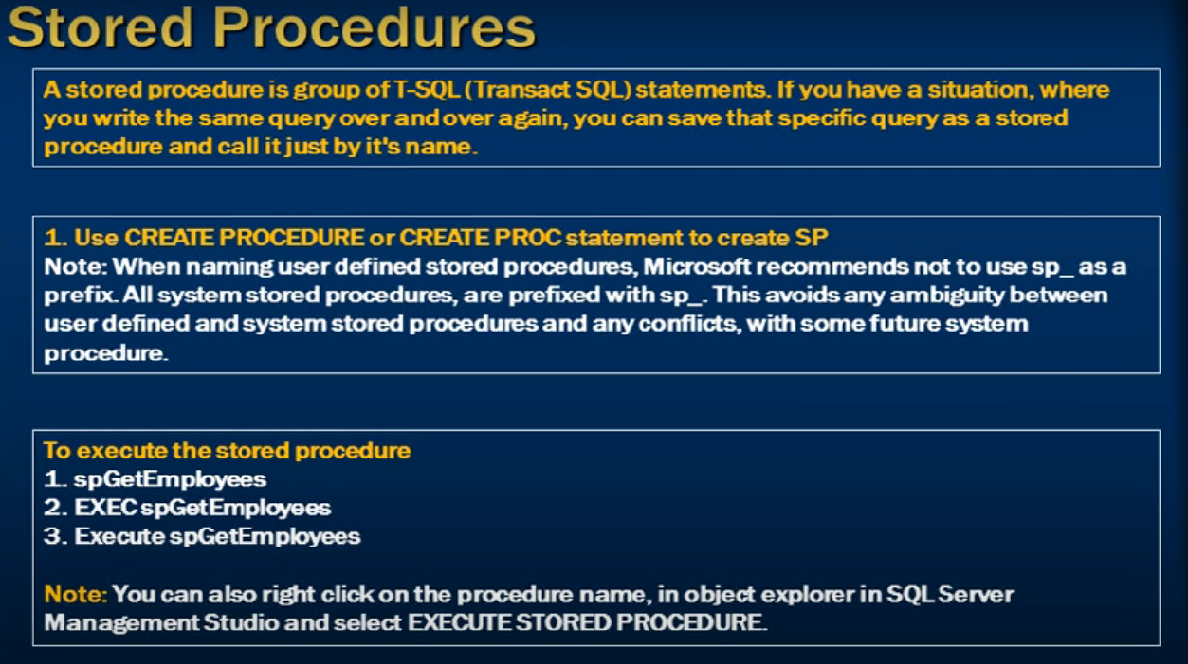

**Store procedure with input parameter.**

Syntax creating store procedure with parameter.

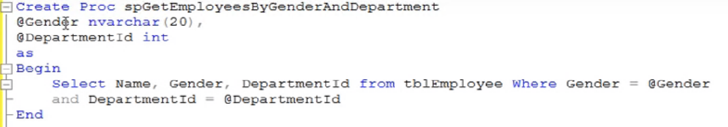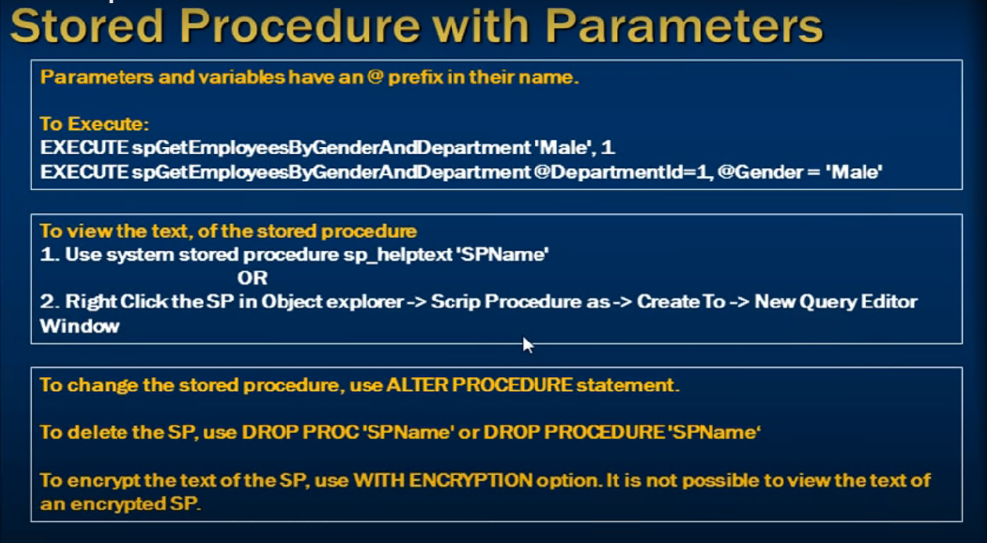

Encryption of store procedure.

You are not able to see the text\content of the procedure. To do that we use WITH ENCRIPTION

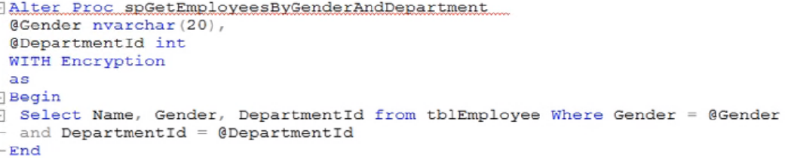

Store procedure with output parameter.

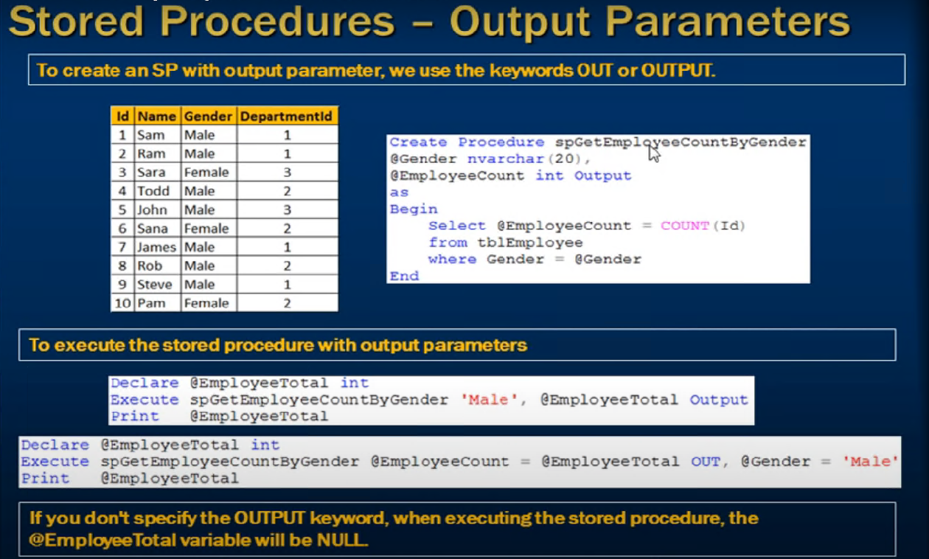

Useful system store procedure.

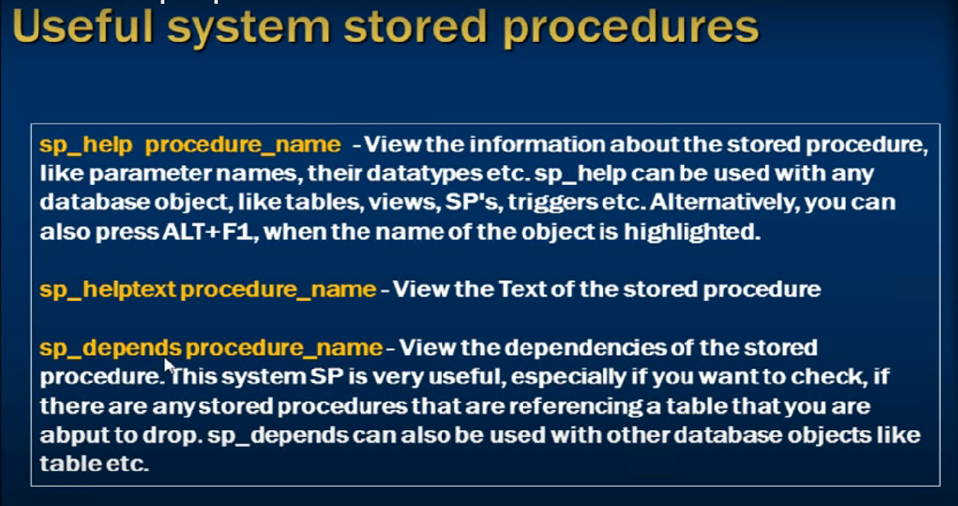

1)IMP EX

CREATE PROCEDURE CreateMyTableType

AS

BEGIN

-- Create the user-defined table type

CREATE TYPE dbo.MyTableType AS TABLE

(

Column1 INT,

Column2 VARCHAR(50)

-- Add more columns as needed

)

end

EXEC CreateMyTableType;

--------------------------------------------------------------------

CREATE PROCEDURE MyProcedure

@TableVariable dbo.MyTableType READONLY

AS

BEGIN

-- Use the @TableVariable within the stored procedure

SELECT *

FROM @TableVariable;

END;

-----------------------------------------------------------

DECLARE @MyTable dbo.MyTableTypet;

-- Populate the @MyTable table variable with data

INSERT INTO @MyTable (Column1, Column2)

VALUES (1, 'Value 1'), (2, 'Value 2');

-- Call the stored procedure with the table variable as a parameter

EXEC MyProcedure @TableVariable = @MyTable;

**2)IMP EX**

If the calculations have the same formula but are performed on different data within the same stored procedure, you can create a separate stored procedure that encapsulates the common calculation logic. You can then call this stored procedure multiple times within your parent stored procedure, passing in the relevant data as parameters.

Here's an example of how you can achieve this:

Create a stored procedure for the common calculation logic:

CREATE PROCEDURE CalculateValue

@InputData INT,

@Result INT OUTPUT

AS

BEGIN

-- Perform the common calculation logic using @InputData

-- Set the result in the @Result output parameter

SET @Result = /* Perform the calculation */;

END

In your parent stored procedure, call the CalculateValue procedure multiple times with different input data:

CREATE PROCEDURE ParentProcedure

AS

BEGIN

-- Declare variables to hold the result of each calculation

DECLARE @Result1 INT, @Result2 INT, @Result3 INT;

-- Perform other operations

-- Call the CalculateValue procedure with different input data

EXEC CalculateValue @InputData = 10, @Result = @Result1 OUTPUT;

EXEC CalculateValue @InputData = 20, @Result = @Result2 OUTPUT;

EXEC CalculateValue @InputData = 30, @Result = @Result3 OUTPUT;

-- Use the results for further processing

-- ...

END

By encapsulating the common calculation logic in a separate stored procedure, you can avoid repeating the same calculation code multiple times in your parent procedure. This approach can help improve code maintainability and readability.

**Using return in procedure.**

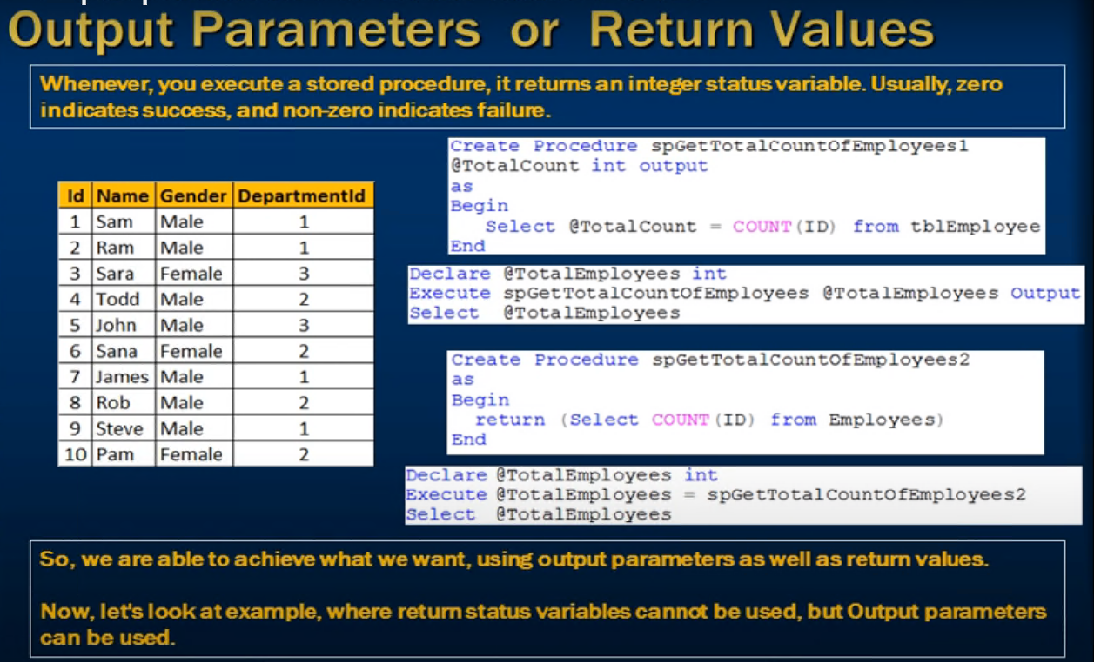

Return can only return the integer value only if you try to return the other datatype it throw an error.

Because the return value in a procedure is meant to indicate:

* **Status codes**
* **Error/success signals**,  
  not actual data results.

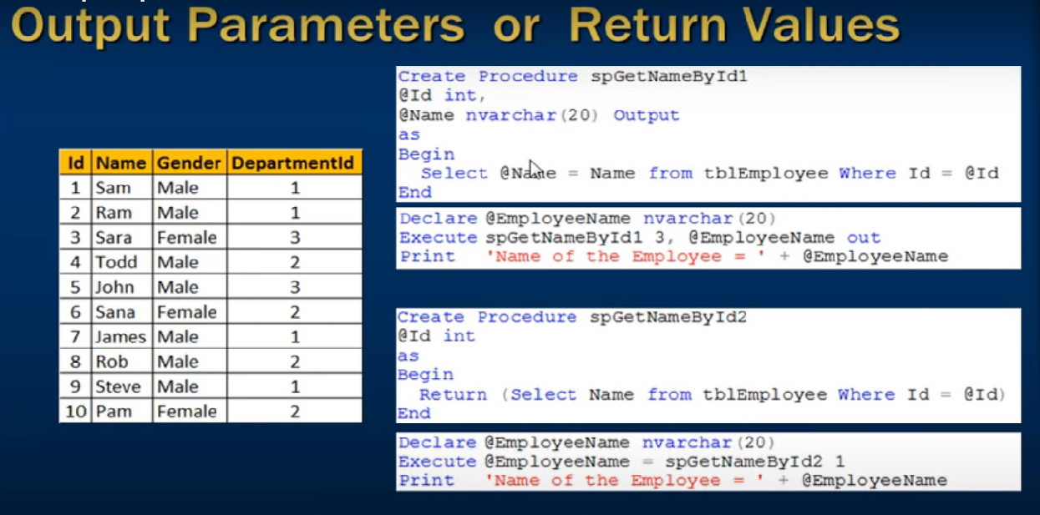

IMP EX :-

create table value_store1(value1 int ,value2 int)

create table value_store2(value1 int ,value2 int)

create or alter procedure sp_for_calculation

as

begin

set nocount on

declare @value1 int,

@value2 int ,

@value3 int

,@var1 int

,@var2 int

set @value1=11

set @value2=22

set @value3=33

declare @result1 int,@result2 int

exec sp_calculation @par1=@value1,@par2=@value2,@par3=@value3,@o_par1=@result1 output ,@o_par2=@result2 output

select @var1=@result1,@var2=@result2

insert into value_store1 values( @var1,@var2)

select @value1=null, @value2=null ,@value3=null,@var1=null,@var2=null

set @value1=111

set @value2=222

set @value3=333

exec sp_calculation @par1=@value1,@par2=@value2,@par3=@value3,@o_par1=@result1 output ,@o_par2=@result2 output

select @var1=@result1 , @var2=@result2

insert into value_store2 values (@var1,@var2)

end

------------------------------------------------------

create or alter procedure sp_calculation

@par1 int

,@par2 int

,@par3 int

,@o_par1 int output

,@o_par2 int output

as

begin

declare @var1 int,

@var2 int

create table #var_store (value1 int, value2 int)

set @var1= @par1 + @par2

set @var2 = @par2 + @par3

select @o_par1=@var1 ,@o_par2=@var2

insert into #var_store values(@var1,@var2)

--select * from #var_store

declare @result1 int

,@result2 int

end

exec sp_for_calculation

select * from value_store1

select * from value_store2

delete from value_store1

delete from value_store2

Difference between output parameter and return

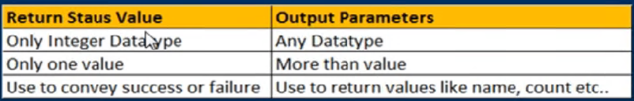

Advantage of store procedure

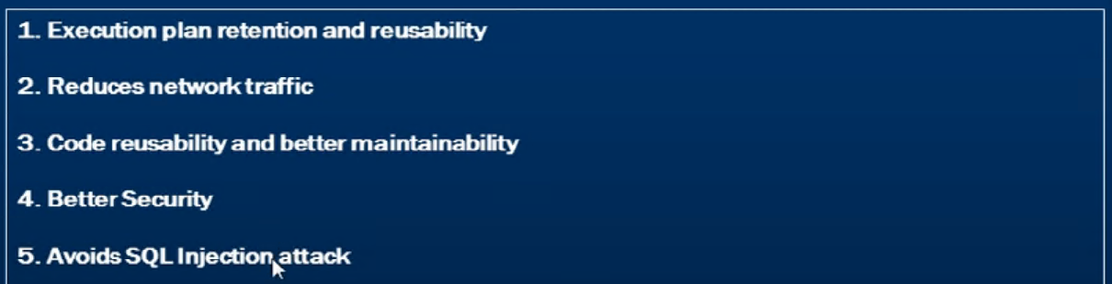

Store procedure with both parameter and variable

**CREATE PROCEDURE MyStoredProcedure**

**@param1 INT,**

**@param2 VARCHAR(50)**

**AS**

**BEGIN**

**-- Declare variables**

**DECLARE @var1 INT;**

**DECLARE @var2 VARCHAR(50);**

**-- Set values for variables**

**SET @var1 = 100;**

**SET @var2 = 'Hello';**

**-- Your logic using parameters and variables goes here**

**END**

**Optional parameters in sql server stored procedures**

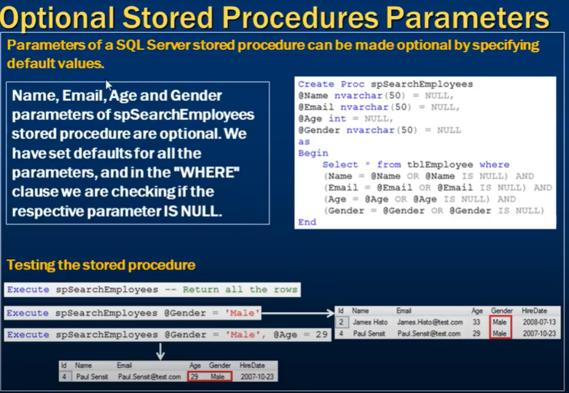 **CURSORS**

**What is a cursor in SQL Server?**

In SQL Server, a cursor is a database object that allows you to retrieve and manipulate rows from a result set one at a time. Cursors are useful when you need to perform operations on each row of a result set rather than on the set as a whole.

There are several types of cursors in SQL Server, including:

Forward-only cursors: These cursors allow you to move through a result set only in the forward direction, from the first row to the last row.

Static cursors: These cursors create a static copy of the result set in tempdb, which can be useful when you need to perform multiple operations on the same data.

Dynamic cursors: These cursors update their result set as changes occur to the underlying data.

Keyset-driven cursors: These cursors are similar to dynamic cursors, but they maintain a keyset that defines the rows in the result set, which can improve performance.

**What is the lifecycle of a cursor?**

Cursors are database objects, created and executed on the database server itself. A cursor's lifecycle involves the following steps:

**Declare a cursor:**A cursor is declared by defining a SQL statement.

**Open a cursor:**A cursor is opened for storing data retrieved from the result set.

**Fetch a cursor:**When a cursor is opened, rows can be fetched from the cursor one by one or in a block to manipulate data.

**Close a cursor:**The cursor should be closed explicitly after data manipulation.

**Deallocate a cursor:**CA cursor should be deallocated to delete the cursor definition and release all the system resources associated with the cursor.

**SQL Cursor Syntax**

DECLARE cursor_name CURSOR [ LOCAL | GLOBAL ]

[ FORWARD_ONLY | SCROLL ]

[ STATIC | KEYSET | DYNAMIC | FAST_FORWARD ]

[ READ_ONLY | SCROLL_LOCKS | OPTIMISTIC ]

[ TYPE_WARNING ] FOR select_statement

[ FOR UPDATE [ OF column_name [ ,...n ] ] ] [;]

Cursor SQL Example

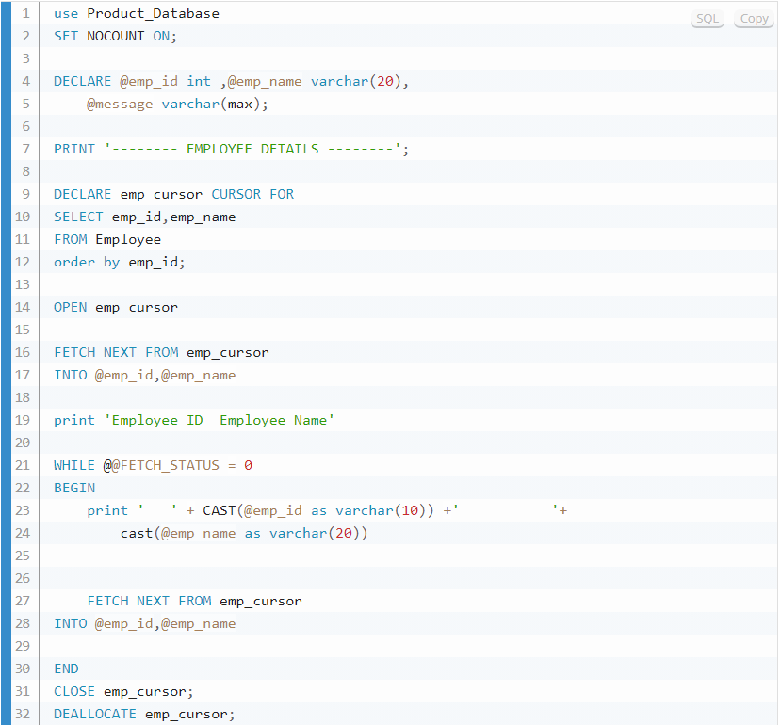

**cursor-based solutions and set-based solutions which is better**

cursor-based solutions :-

create PROCEDURE cur_using

AS

BEGIN

DECLARE @cursor_variable NVARCHAR(100)

DECLARE @sql NVARCHAR(MAX)

DECLARE cur_variable CURSOR FOR

SELECT name

FROM sys.tables

WHERE name LIKE '%DRG Weight%'

AND name NOT LIKE '%xlnm#%'

AND name NOT LIKE 'DRG Weight'

OPEN cur_variable

FETCH NEXT FROM cur_variable INTO @cursor_variable

WHILE @@FETCH_STATUS = 0

BEGIN

SET @sql = N'INSERT INTO [dbo].[DRG Weight] ([Payer Plan], [MS-DRG], [Medicare Weights], [Payment Type], Rate) ' +

N'SELECT DISTINCT [Payer Plan], [MS-DRG], [Medicare Weights], [Payment Type], Rate ' +

N'FROM ' + QUOTENAME(@cursor_variable)

EXEC sp_executesql @sql

FETCH NEXT FROM cur_variable INTO @cursor_variable

END

CLOSE cur_variable

DEALLOCATE cur_variable

END

set-based solutions :-

create PROCEDURE cur_using

CREATE TABLE #TempDRGWeight

(

ID int identity(1,1)

,table_name varchar(100)

)

INSERT INTO #TempDRGWeight (table_name)

(select name from sys.tables where name like '%DRG Weight%' AND name NOT LIKE '%xlnm#%' AND name NOT LIKE 'DRG Weight')

DECLARE @DRG_Weight_Start_Value INT = 1

DECLARE @DRG_Weight_End_Value INT

SET @DRG_Weight_End_Value = (SELECT COUNT(1) FROM #TempDRGWeight)

TRUNCATE TABLE [dbo].[DRG Weight]

WHILE @DRG_Weight_Start_Value <= @DRG_Weight_End_Value

BEGIN

DECLARE @DRG_Weight_Table_Name NVARCHAR(500), @DRG_Weight_DynamicSQL NVARCHAR(4000)

SET @DRG_Weight_Table_Name = (SELECT table_name FROM #TempDRGWeight WHERE ID = @DRG_Weight_Start_Value)

SET @DRG_Weight_Table_Name = '[' + @DRG_Weight_Table_Name + ']'

SET @DRG_Weight_DynamicSQL = N'INSERT INTO [dbo].[DRG Weight] ([Payer Plan],[MS-DRG],[Medicare Weights],[Payment Type],Rate) SELECT DISTINCT [Payer Plan],[MS-DRG], [Medicare Weights], [Payment Type], Rate FROM ' + @DRG_Weight_Table_Name

-- print @DRG_Weight_DynamicSQL

EXEC (@DRG_Weight_DynamicSQL)

SET @DRG_Weight_Start_Value = @DRG_Weight_Start_Value + 1

END

**cursor-based solutions and set-based solutions difference**

Both cursor-based solutions and set-based solutions (like the one you provided) have their own advantages and considerations. The choice between them often depends on the specific scenario, data volume, performance requirements, and maintainability of the code.

The code you provided is a set-based solution that iterates over rows and performs operations using SQL statements. In comparison to cursors, set-based solutions are generally preferred in SQL because they take advantage of the database engine's optimizations and can process multiple rows at once.

Regarding performance, the set-based solution you provided is likely to be more efficient than using a cursor. Cursors can be slower due to their iterative nature, especially when dealing with large datasets. However, the actual performance difference would depend on factors like the size of the data, the number of iterations, indexing, and the complexity of the operations being performed.

In your provided code, you are generating dynamic SQL for deletion and executing it. While dynamic SQL can be flexible, it can also introduce complexity and security concerns if not handled properly. Make sure to validate and sanitize input to prevent SQL injection vulnerabilities.

Here are some considerations for both approaches:

Set-Based Solution:

Generally more efficient for larger datasets.

Leverages the power of the database engine's optimizations.

Reduces context switches between the application and the database.

Cursor-Based Solution:

Can be slower due to the iterative nature.

May be necessary for more complex scenarios that involve procedural logic.

Might be easier to understand and maintain for some developers.

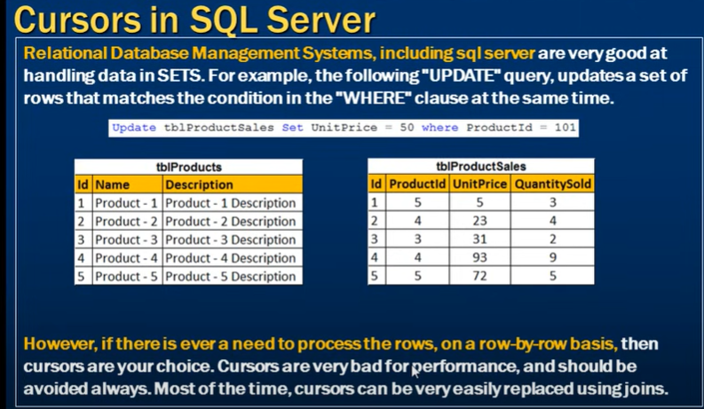 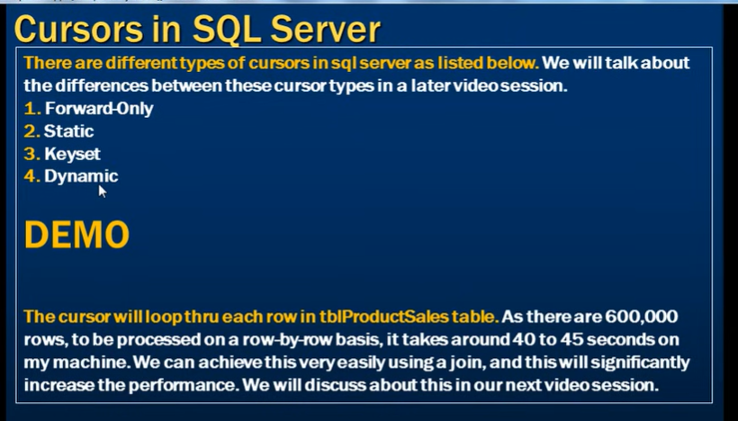 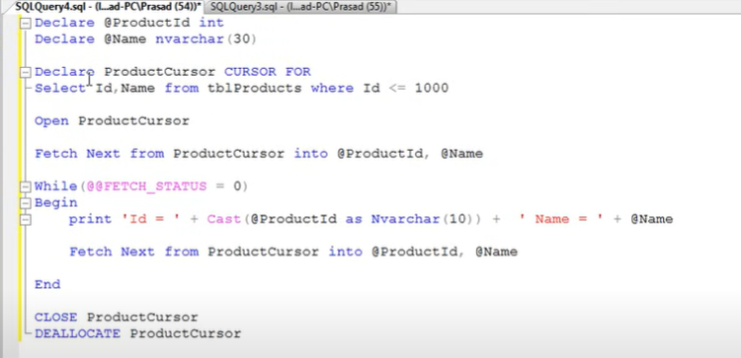

Replacing cursor using join

Join is much faster than cursors.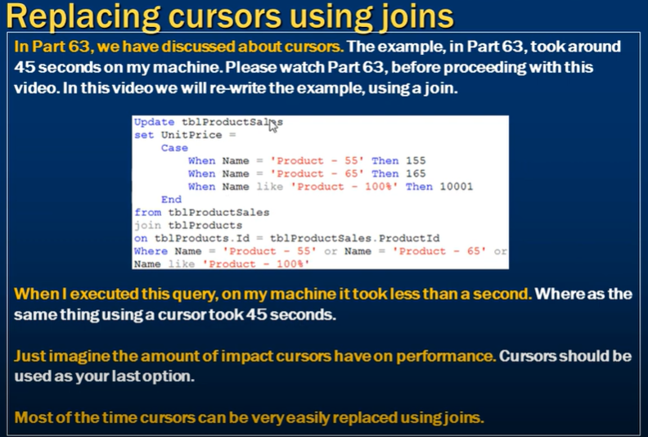

**RECURSIVE SQL QUARY**

A recursive SQL common table expression (CTE) is a query that continuously references a previous result until it returns an empty result. It’s best used as a convenient way to extract information from hierarchical data. It’s achieved using a CTE, which in SQL is known as a “with” statement. output of the first\cte use as

input for the second query .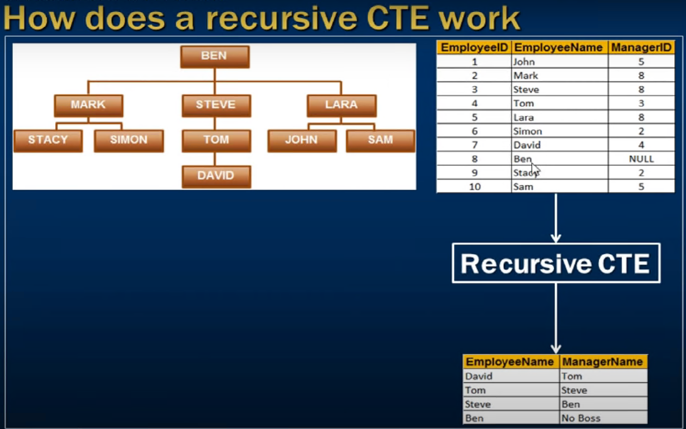

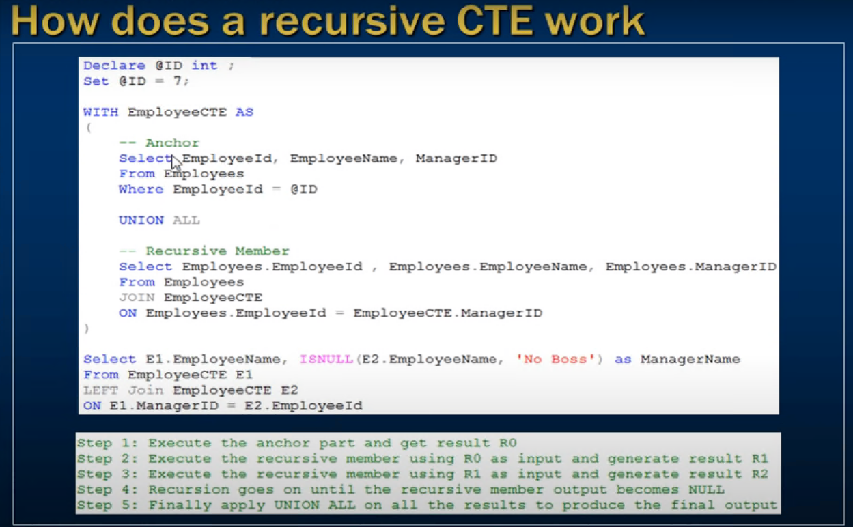

Frist It excecute Anchor quary and the output of Anchor quary is use as input for Recursive quary then output of that Recursive quary is use as input for Recursive quary again till the input of Recursive quary become null.

Some of use cases :-

Q1.Display the no 1 to 10.

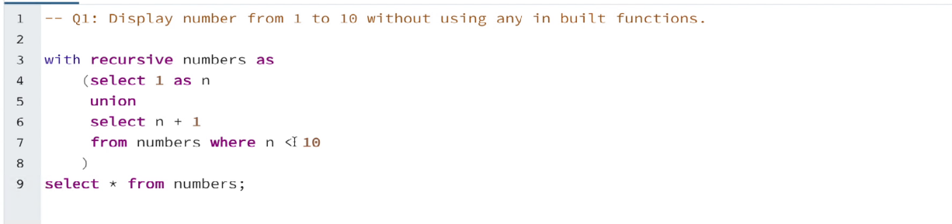

Q2.Find the hierarchy of employee under the give manager ‘Asha’

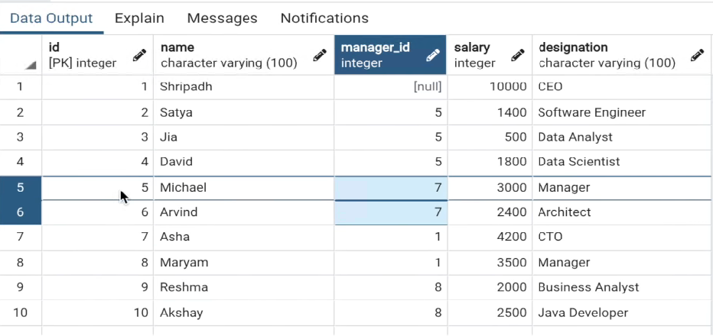

Quary :-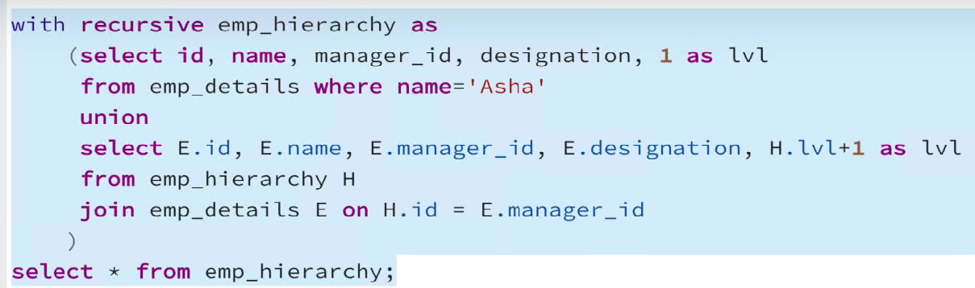

Output :- 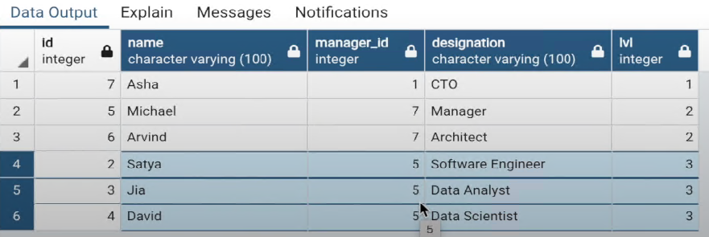

Q3.Find the hierarchy of managers for the given employee ‘david’

Quary : Only changes is name=’david’ and H.manager_id=E.id

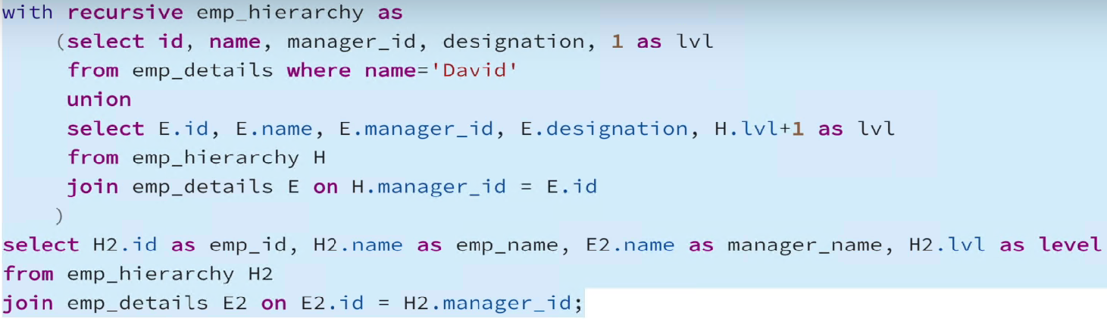

Output : 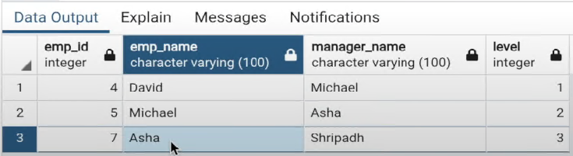

**Subquery**

Nested Subqueries Versus Correlated Subqueries :

With a normal nested subquery, the inner **SELECT** query runs first and executes once, returning values to be used by the main query. A correlated subquery, however, executes once for each candidate row considered by the outer query. In other words, the inner query is driven by the outer query.

Note:- the each value of outer quaery is use to do the row by row process of inner query.in correlated subquery we always compare the outer query table with inner query table in where condition of the subquery.

Ex:- select salary from employee t1 where 2 = (select count(distinct salary) from employee t2 WHERE T1.SALARY <= T2.SALARY); # we can either compare same table or different table. In these we create the same table.

In single or multirow query :- first execute inner query then excecute outer query.

In correlated subquery :- in these we compare the every outer query row to each of the inner query row one by one.

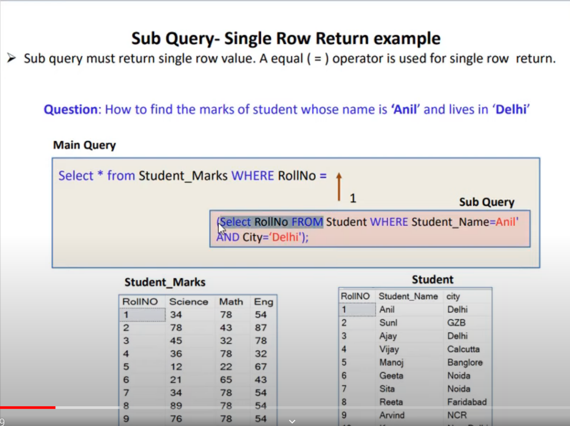

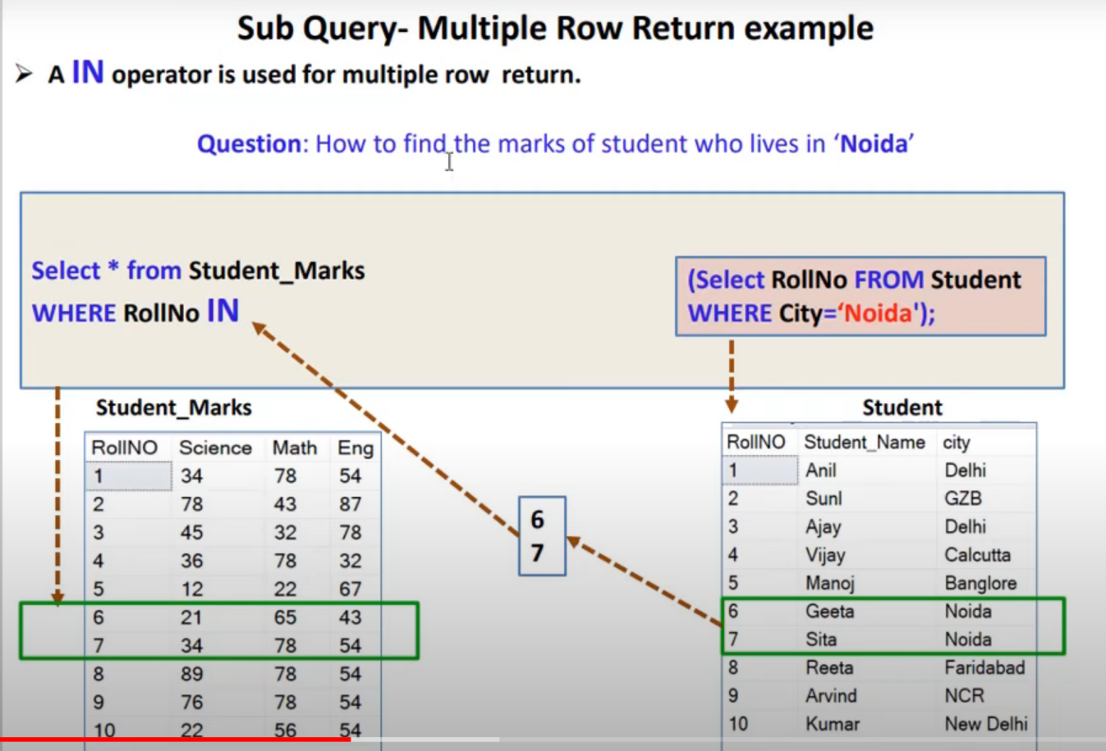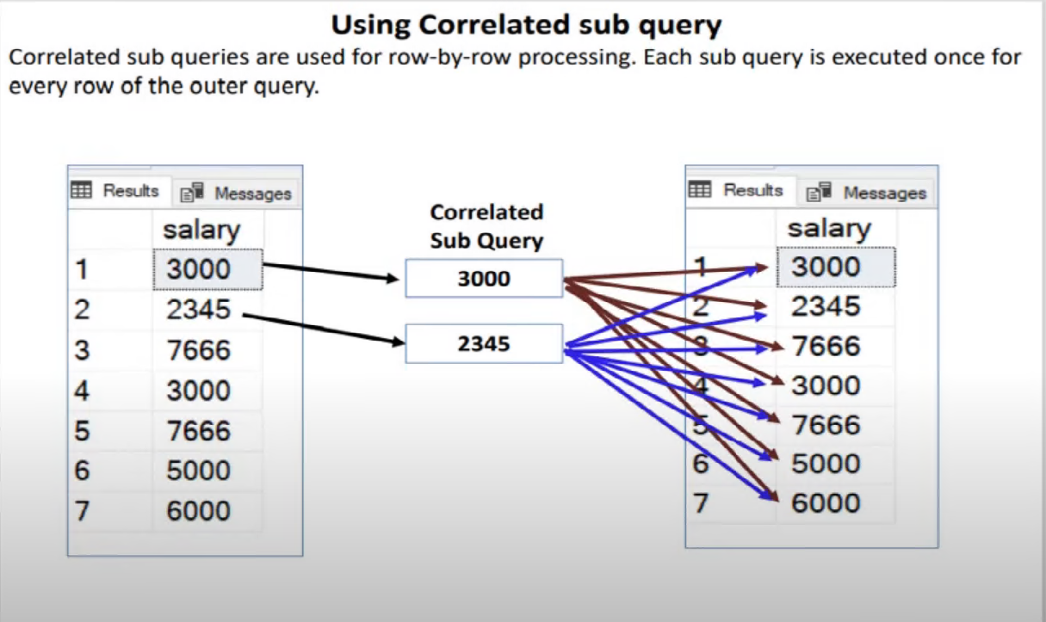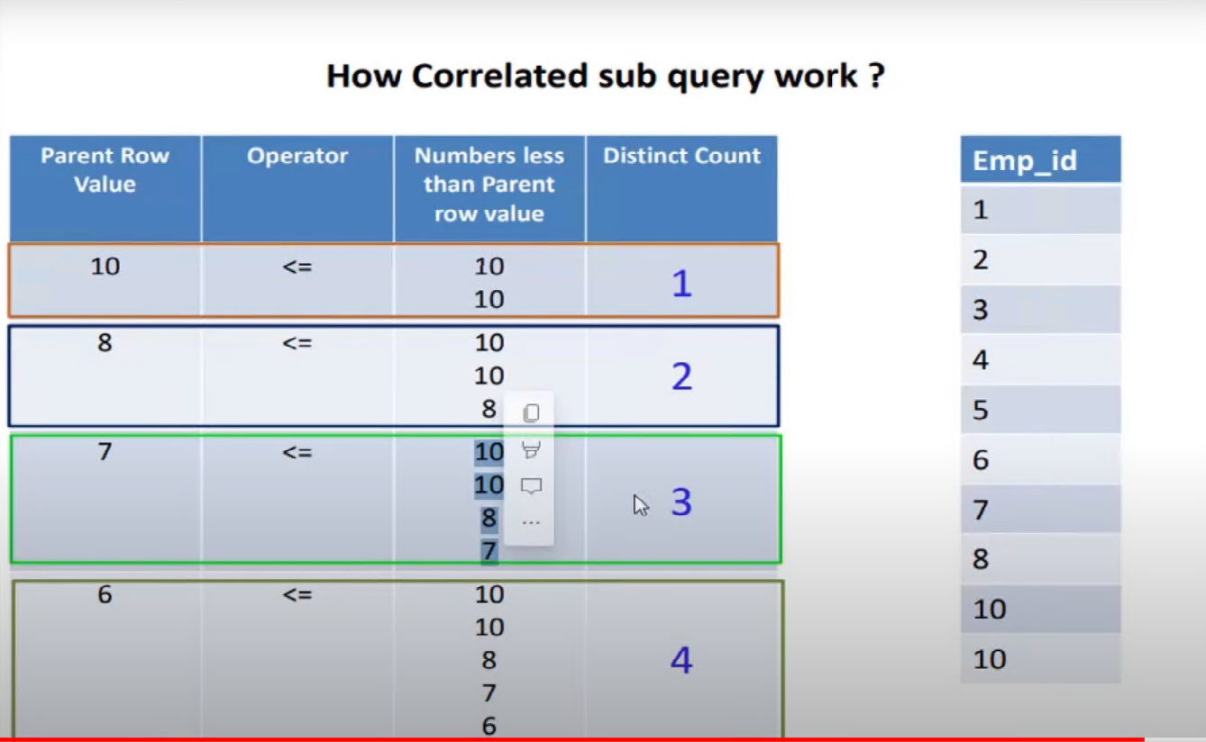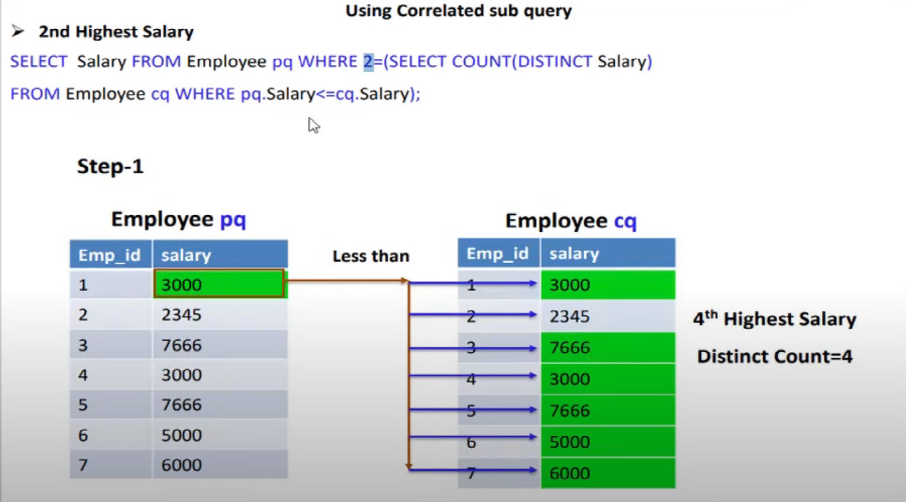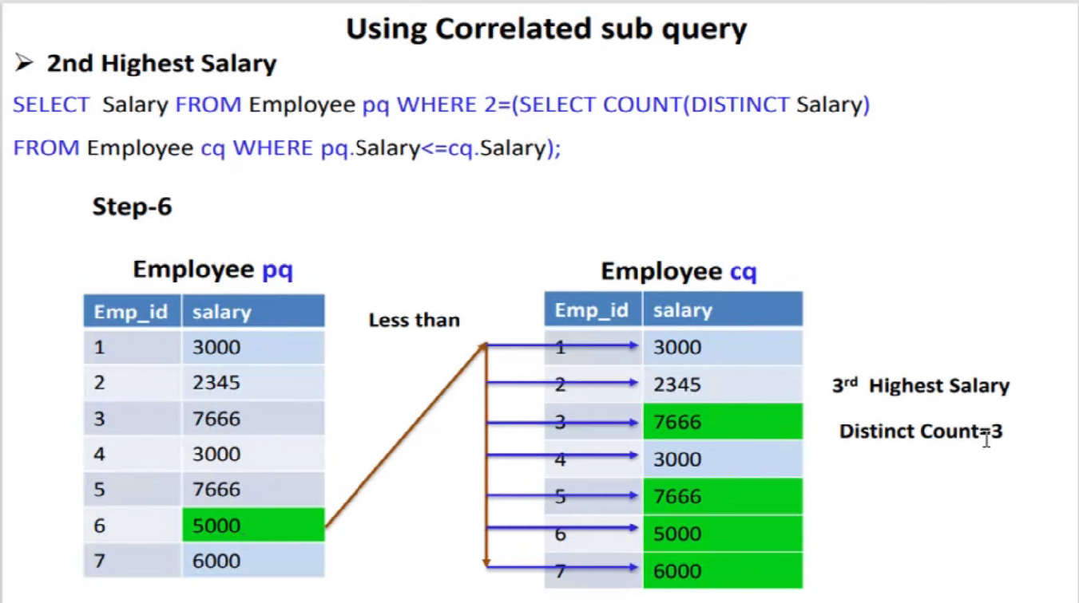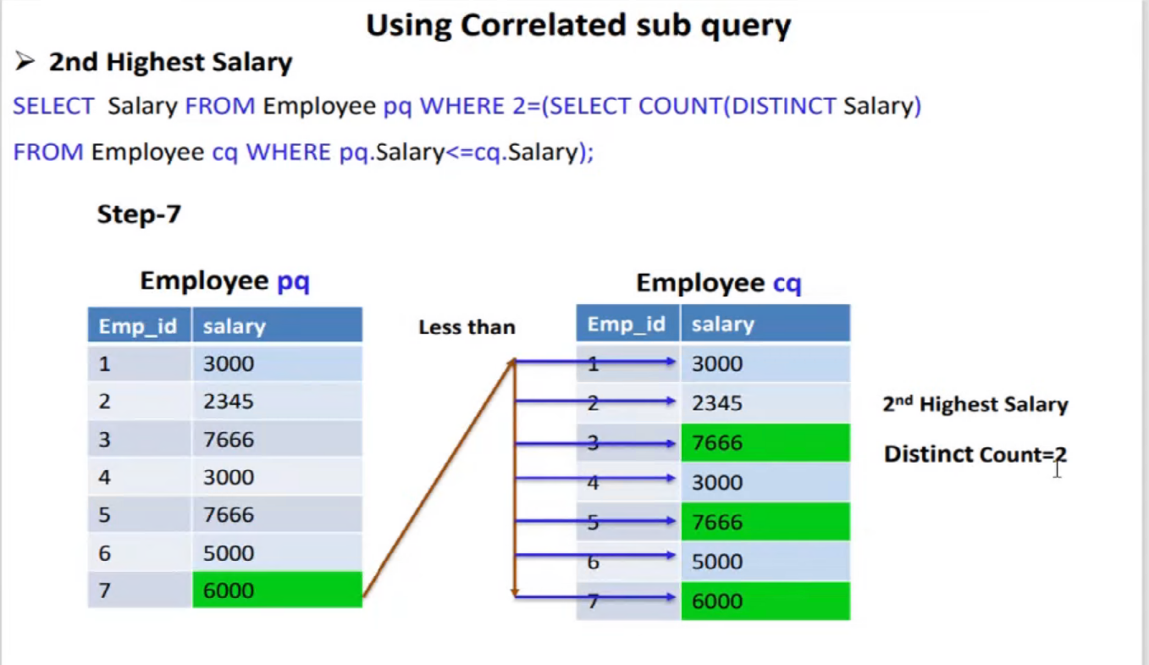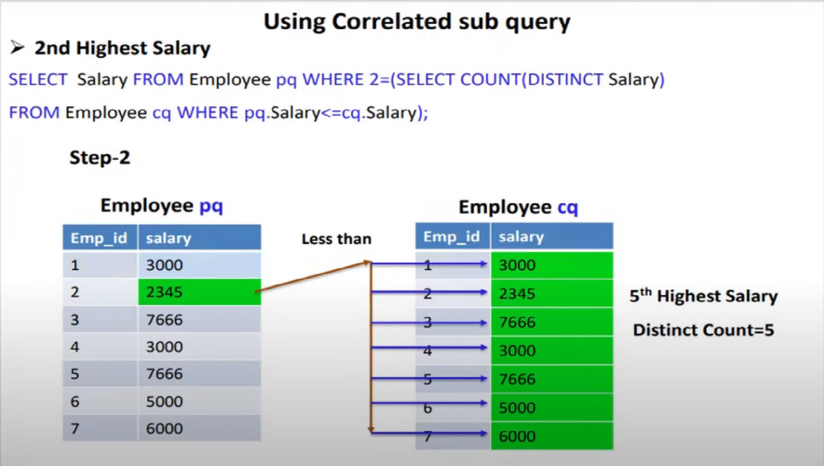

Difference between subquery,correlated subquery and join

https://www.youtube.com/watch?v=bonJEipf3VU

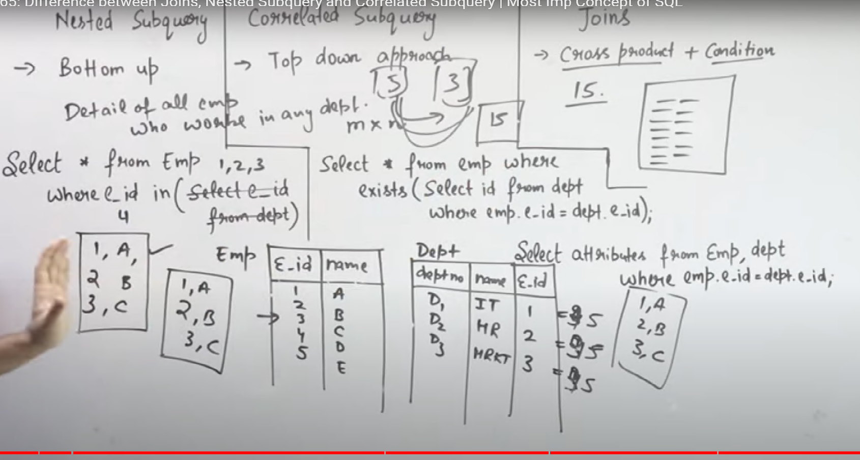

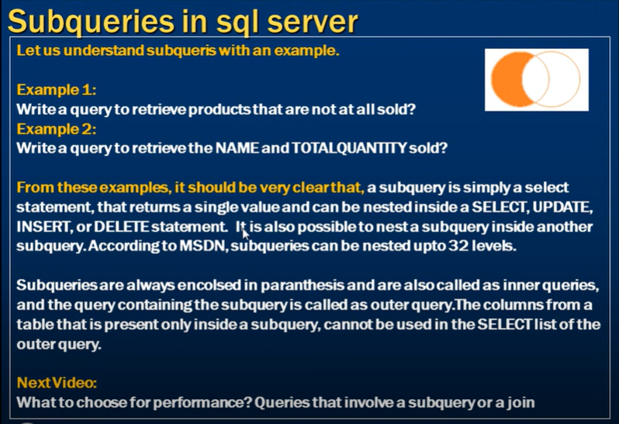

Correlated subquery

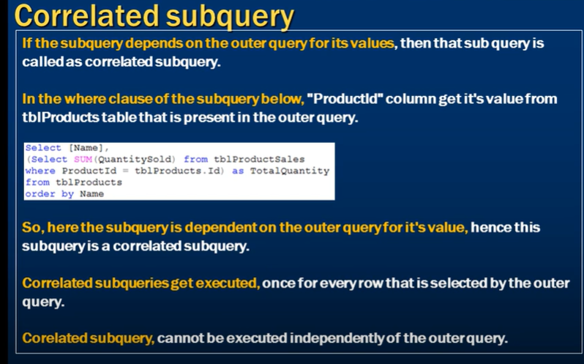

common table expression **or CTE**

A **common table expression**, or CTE, is a temporary named result set created from a simple SELECT statement that can be used in a subsequent SELECT statement. Each SQL CTE is like a **named query**, whose result is stored in a virtual table (a CTE) to be referenced later in the main query.

**Case when**

When results need to have some logic applied 'on the fly' one can use CASE statement to implement it.

SELECT CASE WHEN Col1 < 50 THEN 'under' ELSE 'over' END threshold

FROM TableName

also can be chained

SELECT

CASE WHEN Col1 < 50 THEN 'under'

WHEN Col1 > 50 AND Col1 <100 THEN 'between'

ELSE 'over'

END threshold

FROM TableName

one also can have CASE inside another CASE statement

SELECT

CASE WHEN Col1 < 50 THEN 'under'

ELSE

CASE WHEN Col1 > 50 AND Col1 <100 THEN Col1

ELSE 'over' END

END threshold

**Full Text Search**

Use for searching text data inside extension text data stored electronicallly and turning result that contain some or all the word from the query in traditional search.

In SQL server, for faster quary excecution we genrally use clustered and non clustered indexes. But these indexes have their set of limitation.

For ex:= a like operator force SQL server to analyse entire table for value to overcome this issue we use full text search.

Imp :- what it does := It build an index of every word in the coloum you specify and link that back to the coloum on which create the unique index.

Procedure to do the full text search

To check if you have a fulltext install := SELECT FULLTEXTSERVICEPROPERTY('IsFullTextInstalled')

1)Create the catolog : this catalog is created to manage the full text index and store the full text index.

Syntax := CREATE FULLTEXT CATALOG practice_full_text_catalog

2) first create not null column

First insure that the column on which you are going create index does not contain the null value

Syntax:= ALTER TABLE table_name ALTER COLUMN column_name datatype NOT NULL

4) Create unique index on the column

Syntax:= CREATE UNIQUE INDEX fts_index2 ON full_text_table(column_name)

5) create full text index

Syntax:= CREATE FULLTEXT INDEX ON full_text_table(column_name)

KEY INDEX fts_index1 ON practice_full_text_catalog

Different method of searching in fulltext search

FREETEXT: Suppose we have a table called **Products** with a full-text indexed column **Description**. We want to search for products related to the term "red shirt".

Example:

sqlCopy code

SELECT * FROM Products WHERE FREETEXT(Description, 'red shirt')

Input: The search query is "red shirt".

Output: This query will return rows from the **Products** table where the column **Description** contains the words "red" and "shirt" in a linguistically relevant manner, considering word forms, synonyms, and inflections.

CONTAIN: Using the same table and search query as before, let's demonstrate the CONTAIN predicate.

Example:

sqlCopy code

SELECT * FROM Products WHERE CONTAIN(Description, 'red AND shirt')

Input: The search query is "red AND shirt".

Output: This query will return rows from the **Products** table where the column **Description** contains both the word "red" and the word "shirt", satisfying the logical AND condition.

**FREETEXTTABLE**:

**What is FREETEXTTABLE in SQL Server?**

FREETEXTTABLE is a **Full-Text Search function** that returns a table of matches based on *meaning* rather than *exact wording*.

It’s used to find rows that **match the meaning or concept** of your search term in a text column — not just exact words (unlike LIKE or =).

Continuing with the same **Products** table, let's use the FREETEXTTABLE function to retrieve ranked results.

**How SQL Server Finds “Meaning” (Without the Internet)**

**1️⃣ Word Breaker and Stemmer**

SQL Server’s **Full-Text Engine** includes language-specific components called:

* **Word breakers** → break text into words (“analysis” → “analyze”)
* **Stemmers** → understand word variations (“run”, “running”, “ran”)

So, if you search for database, it can also match databases or data-based etc.

**2️⃣ Stopwords**

It ignores very common words (like “is”, “the”, “of”, etc.) using **stopword lists** to improve relevance.

**3️⃣ Thesaurus Files**

SQL Server has **optional XML thesaurus files** that define **synonyms** and related terms.

👉 Example:  
If your thesaurus file defines that  
"car" = "automobile", "vehicle", "motorcar"  
then a FREETEXTTABLE search for *car* will also match rows containing *automobile* or *vehicle*.

You can edit these thesaurus files to teach SQL Server your own domain-specific meanings.

**Path example (for English):**

C:\Program Files\Microsoft SQL Server\MSSQL15.MSSQLSERVER\MSSQL\FTData\thesaurus\tsenu.xml

**4️⃣ Ranking Algorithm**

When SQL Server finds matches, it calculates a **RANK score** based on:

* Frequency of matches
* Proximity of words
* Importance of terms

So rows that use more relevant words or closer word groupings get higher scores.

Example:

SELECT * FROM FREETEXTTABLE(Products, Description, 'red shirt') AS FT ORDER BY FT.RANK DESC

Input: The search query is "red shirt".

Output: This query will return the rows from the **Products** table along with a rank value indicating the relevance of each result. The results will be sorted in descending order based on the rank value.

**CONTAINSTABLE**:

Lastly, we'll use the CONTAINSTABLE function on the **Products** table to get ranked results.

Example:

SELECT * FROM CONTAINSTABLE(Products, Description, 'red AND shirt') AS CT ORDER BY CT.RANK DESC

Input: The search query is "red AND shirt".

Output: This query will return the rows from the **Products** table along with a rank value indicating the relevance of each result. The results will be sorted in descending order based on the rank value.

In both FREETEXTTABLE and CONTAINSTABLE examples, the output will include additional columns such as **[KEY]** (representing the row key), **[RANK]** (representing the rank value), and any other columns specified in the SELECT statement.

These examples illustrate how FREETEXT, CONTAIN, FREETEXTTABLE, and CONTAINSTABLE can be used to search for text in a full-text indexed column and retrieve the matching results with or without rank values for relevance. The specific output will depend on the data in your table and the search query provided.

**Operator In full text search**

NEAR

Here's an example of using the proximity operator in a T-SQL query within SSMS:

SELECT * FROM table_name WHERE CONTAINS(column_name, 'term1 NEAR term2')

The "NEAR" proximity operator is used in the CONTAINS predicate to search for rows where the terms "term1" and "term2" are within the default proximity distance (which is typically 8 words) of each other.

ISABOUT

In SQL Server's full-text search (FTS), the concept of "ISABOUT" is used as a keyword in the CONTAINS predicate to perform a weighted search based on a set of terms or concepts.

The syntax for using "ISABOUT" in a CONTAINS predicate is as follows:

CONTAINS (column_name, 'ISABOUT(term1 weight1, term2 weight2, ...)')

Here's an example to illustrate the usage of "ISABOUT" in FTS:

SELECT * FROM table_name WHERE CONTAINS(column_name, 'ISABOUT("term1" WEIGHT(0.8), "term2" WEIGHT(0.5))')

In this example, the CONTAINS predicate is searching for rows where the specified column contains the terms "term1" and "term2". The "WEIGHT" clause assigns a weight to each term, indicating their relative importance in the search.

By using "ISABOUT" and assigning weights to the terms, you can control the relevance and ranking of search results based on the specified weights. Terms with higher weights will contribute more to the ranking of search results.

It's important to note that the "ISABOUT" keyword and weighted search functionality are specific to the CONTAINS predicate in FTS and allow for more fine-grained control over the search relevance and ranking.

To check on which table you created the full text index and for that which unique index you use

Step:-

First expand the database

Inbuilt function in sql

BIT :- it is a datatype. In SQL Server, the **BIT** data type represents a boolean value that can have three states: **0** (false), **1** (true), or **NULL**. It is commonly used to store binary or boolean values where only two possible states are required.

**Important function**

**MERGE** :- Use to do the upsert operation . "Upsert" is a database operation that combines the concepts of "update" and "insert." The term "upsert" is a portmanteau of these two words. An upsert operation performs an update on a record if it exists in the database, and if the record doesn't exist, it inserts a new record.

In other words, upsert is a way to handle a data record by checking its existence in a database table. If the record already exists, it is updated with new values. If the record does not exist, a new record is inserted with the provided values.

The upsert operation is useful when you want to modify existing records or add new records in a single operation, without the need to explicitly check for existence before performing the update or insert.

Many database management systems provide specific SQL statements or extensions to achieve upsert functionality. Here are a few examples:

**MERGE statement (SQL Server, Oracle, PostgreSQL):** The **MERGE** statement combines the update and insert operations in a single statement, allowing you to define the conditions for updates and inserts based on certain criteria.

Example :- CREATE TABLE Employees (

EmployeeID INT PRIMARY KEY,

FirstName NVARCHAR(50),

LastName NVARCHAR(50),

Department NVARCHAR(50)

);

MERGE Employees AS target

USING (

VALUES

(1, 'John', 'Doe', 'Sales'),

(2, 'Jane', 'Smith', 'Marketing'),

(3, 'Adam', 'Johnson', 'IT')

) AS source (EmployeeID, FirstName, LastName, Department)

ON (target.EmployeeID = source.EmployeeID)

WHEN MATCHED THEN

UPDATE SET

FirstName = source.FirstName,

LastName = source.LastName,

Department = source.Department

WHEN NOT MATCHED THEN

INSERT (EmployeeID, FirstName, LastName, Department)

VALUES (source.EmployeeID, source.FirstName, source.LastName, source.Department);

## Here the condition is target.EmployeeID = source.EmployeeID if this condition matched then update

Else insert.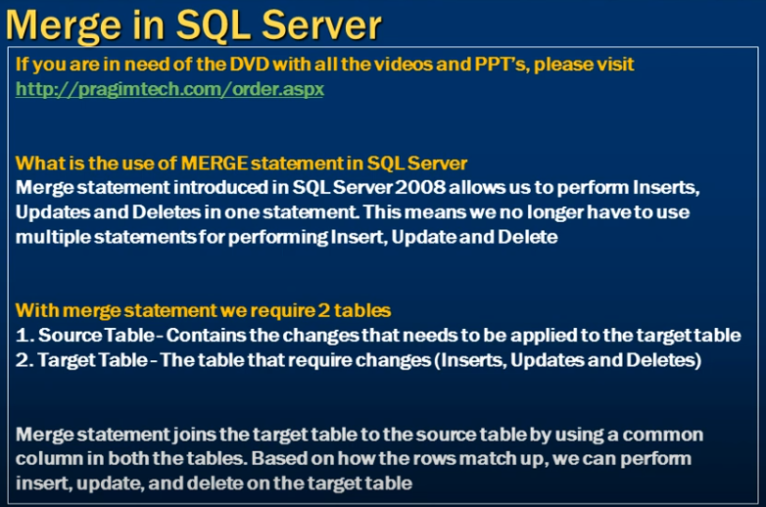 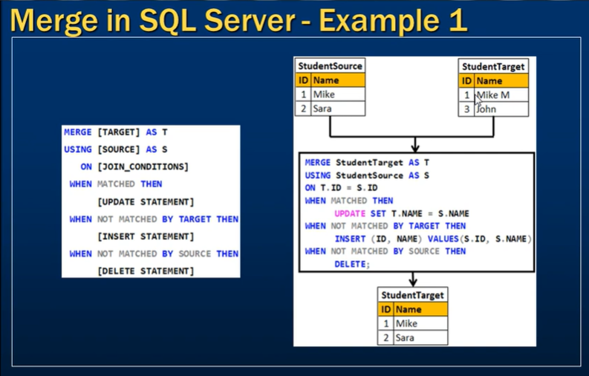 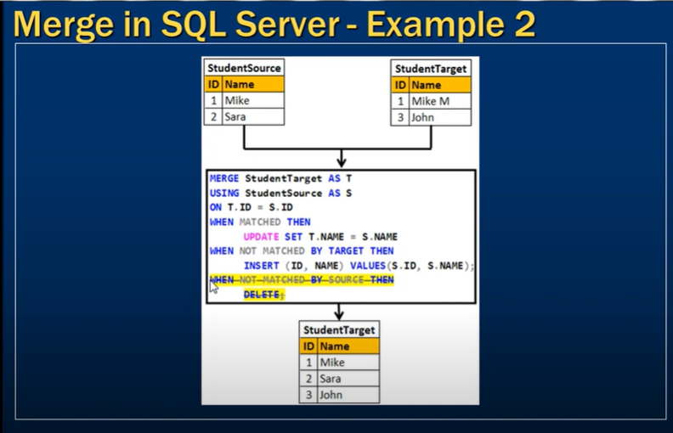

EXCEPT OPERATOR

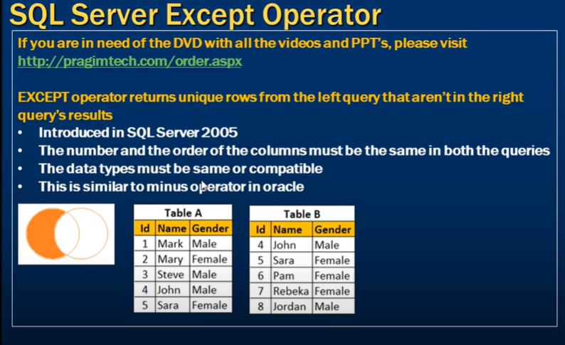 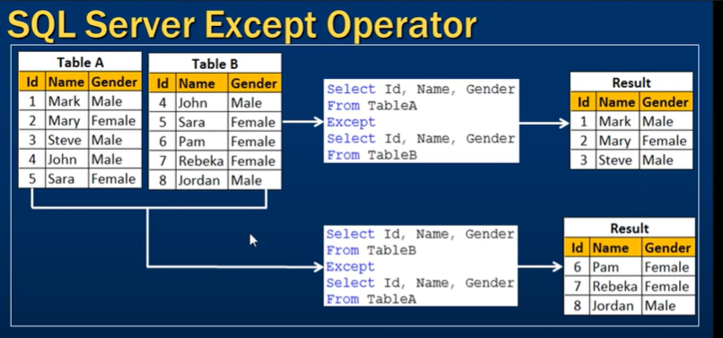 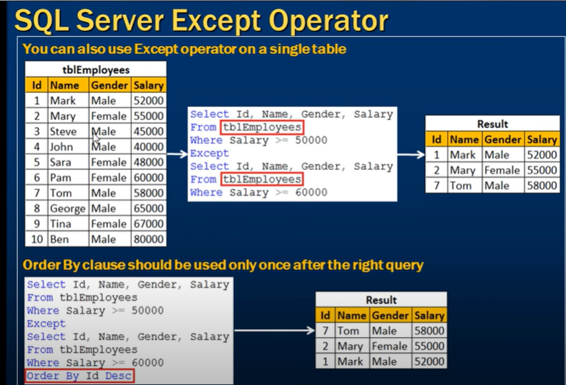

**Difference between except and not in**

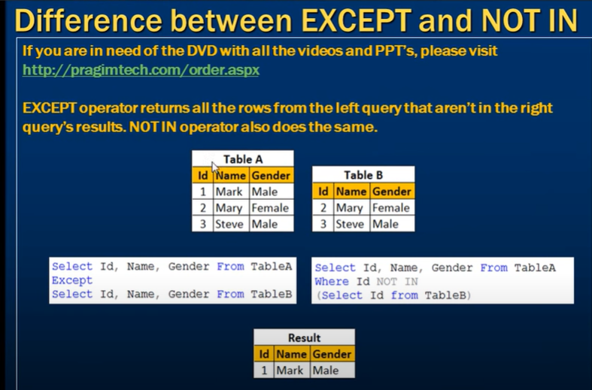

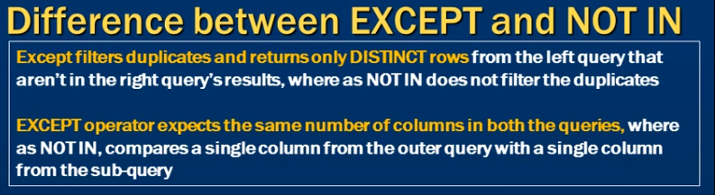

INTERSECT OPERATOR

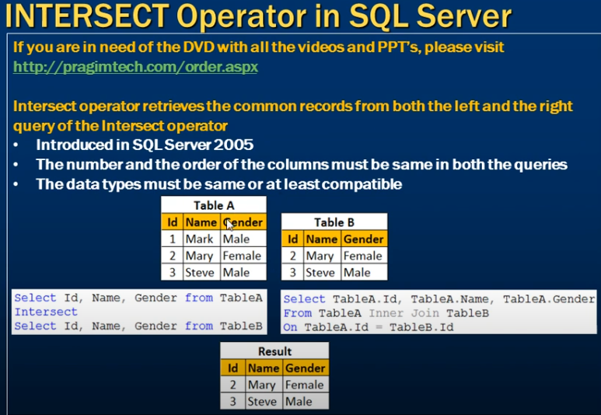

difference between INTERSECT AND INNER JOIN

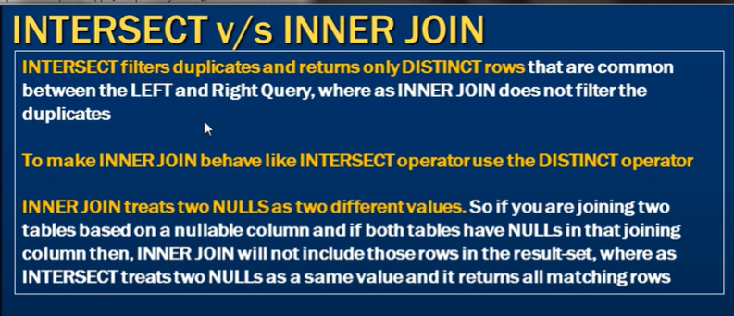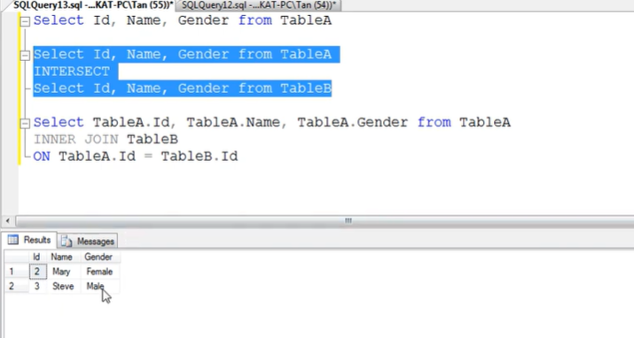 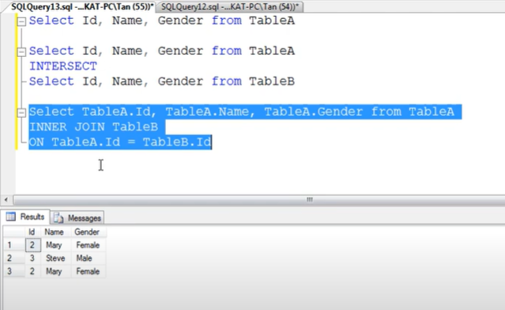

For null

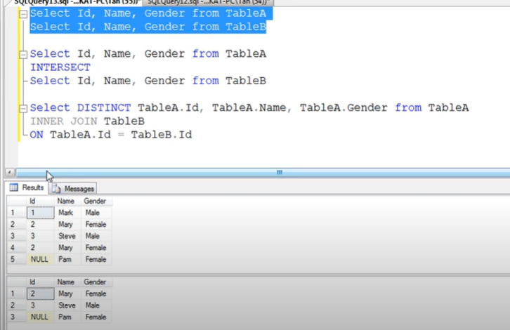 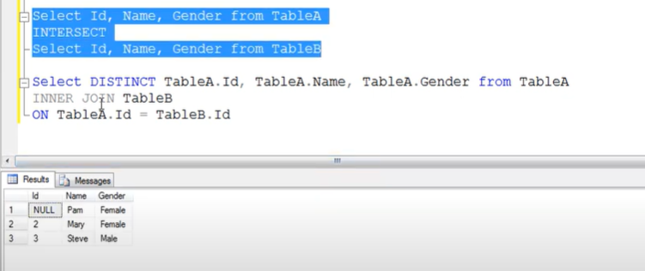 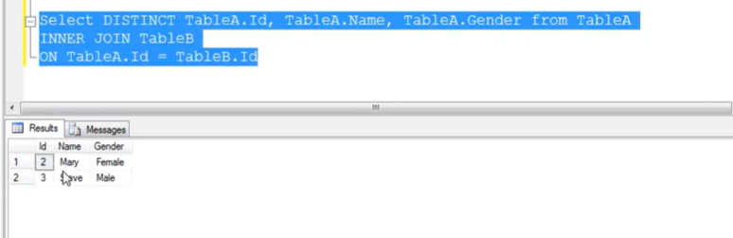

**Difference between union, intersect and except**

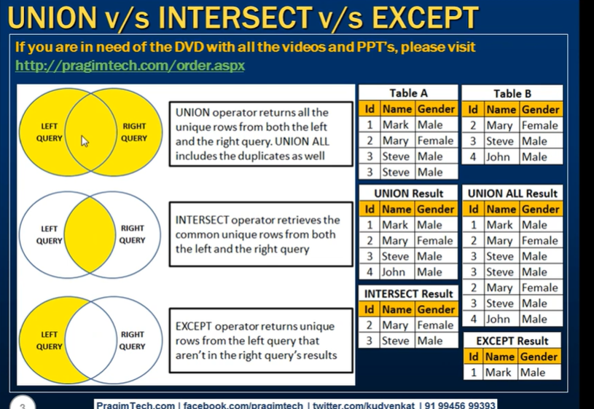

SUBSTRING

In SQL Server, the **SUBSTRING** function is used to extract a substring from a string value. It allows you to specify the starting position and length of the substring to extract.

The syntax of the **SUBSTRING** function is as follows:

sqlCopy code

SUBSTRING(input_string, start_position, length)

**input_string** is the string from which you want to extract the substring.

**start_position** specifies the position within the string where the extraction should begin. The first character in the string is at position 1.

**length** is an optional parameter that specifies the number of characters to extract. If the length is not specified, the **SUBSTRING** function will extract all characters from the start position to the end of the string.

Here's an example that demonstrates the usage of the **SUBSTRING** function:

sqlCopy code

SELECT SUBSTRING('Hello World', 7, 5) AS SubstringResult;

Output:

World

In the above example, the **SUBSTRING** function extracts a substring starting from position 7 in the string 'Hello World' and with a length of 5 characters. As a result, it retrieves the substring 'World'.

Note that the positions in the **SUBSTRING** function are 1-based, meaning the first character is at position 1.

PATINDEX

In SQL Server, the **PATINDEX** function is used to search for a pattern within a string and return the starting position of the first occurrence of that pattern. It is similar to the **CHARINDEX** function but allows the use of wildcard characters in the pattern.

The syntax of the **PATINDEX** function is as follows:

sqlCopy code

PATINDEX (pattern, expression)

**pattern** is the pattern or wildcard expression you want to search for.

**expression** is the string expression in which you want to search for the pattern.

The **PATINDEX** function returns an integer value representing the starting position of the first occurrence of the pattern within the expression. If no match is found, it returns 0.

Here's an example that demonstrates the usage of the **PATINDEX** function:

**sqlCopy code**

**SELECT PATINDEX('%world%', 'Hello world!') AS Position;**

Output:

7

In the above example, the **PATINDEX** function searches for the pattern '%world%' within the string 'Hello world!'. The '%' wildcard characters allow for any characters before and after the word 'world'. As a result, it returns the starting position 7, which is where the word 'world' starts in the given string.

Note that the **PATINDEX** function is case-insensitive, so it will match patterns regardless of the case of the characters in the string and pattern.

**CHARINDEX**

In SQL Server, the **CHARINDEX** function is used to search for a specific character or substring within a string and return the starting position of its first occurrence.

The syntax of the **CHARINDEX** function is as follows:

sqlCopy code

CHARINDEX(expression_to_find, expression_to_search, start_position)

**expression_to_find** is the character or substring you want to find within the **expression_to_search**.

**expression_to_search** is the string or column where you want to search for the character or substring.

**start_position** is an optional parameter that specifies the position within the **expression_to_search** at which the search should start. If not specified, the search will start from the beginning of the string.

The **CHARINDEX** function returns an integer value representing the starting position of the first occurrence of the character or substring within the expression. If the character or substring is not found, it returns 0.

Here's an example that demonstrates the usage of the **CHARINDEX** function:

SELECT CHARINDEX('world', 'Hello world!') AS Position;

Output: 7

In the above example, the **CHARINDEX** function searches for the substring 'world' within the string 'Hello world!'. It returns the starting position 7, which is where the substring 'world' starts in the given string.

Note that the **CHARINDEX** function is case-sensitive, so it will consider the case of the characters in the string and substring when searching for a match.

**Stuff()**

It seems like you're asking about the **STUFF** function in SQL Server Management Studio (SSMS). However, I'd like to clarify that the **STUFF** function is a SQL function that is used in Transact-SQL (T-SQL) queries within SQL Server, and it's not directly related to SQL Server Management Studio (SSMS). SSMS is the integrated environment used to manage and interact with SQL Server databases.

The **STUFF** function is used to replace a specified portion of a string with another string at a specific starting point. Its syntax is as follows:

sqlCopy code

STUFF(string_expression, start, length, replacement_expression)

**string_expression**: The original string where you want to perform the replacement.

**start**: The starting position in the **string_expression** where you want to begin replacing characters.

**length**: The number of characters to replace.

**replacement_expression**: The string that will replace the specified portion of the original string.

Here's an example of how the **STUFF** function can be used in a T-SQL query:

sqlCopy code

SELECT STUFF('Hello World', 7, 5, 'Universe') AS NewString;

select STUFF(

(SELECT ', ' + '''' + name + ''''

FROM sys.tables

FOR XML PATH(''), TYPE

).value('.', 'NVARCHAR(MAX)'), 1, 2, '');

In this example, the result of the query would be: **Hello Universe**. The **STUFF** function replaced the portion "World" (starting at position 7 and with a length of 5 characters) with "Universe".

**String_agg()**

The **STRING_AGG** function is a powerful SQL aggregation function that's used to concatenate values from multiple rows into a single string, with optional delimiters between the values. This function is particularly useful when you want to aggregate and display data in a more human-readable format.

Here's the basic syntax of the **STRING_AGG** function:

sqlCopy code

STRING_AGG(expression, delimiter)

**expression**: The column or expression you want to aggregate and concatenate.

**delimiter**: The delimiter that separates the concatenated values in the resulting string.

For example, let's say you have a table named **Fruits** with a column **Name**, and you want to concatenate all the fruit names with commas:

sqlCopy code

SELECT STRING_AGG(Name, ', ') AS ConcatenatedFruits FROM Fruits;

Assuming the **Fruits** table contains rows with names like "Apple," "Banana," and "Orange," the result of this query might be: **Apple, Banana, Orange**.

**Cast vs Convert vs Format**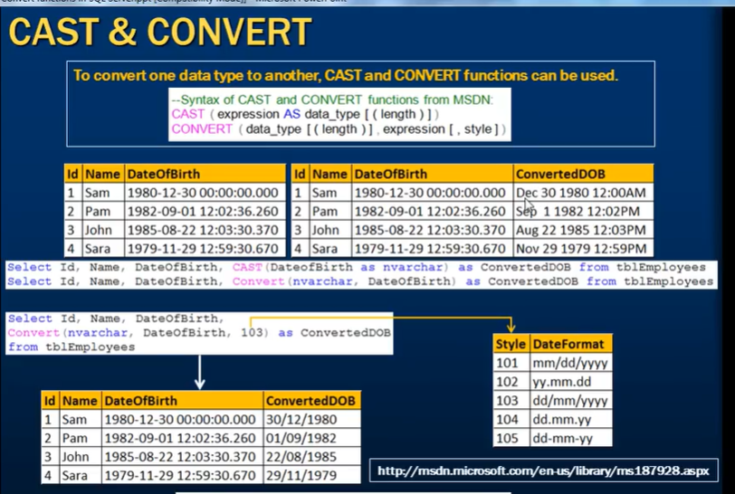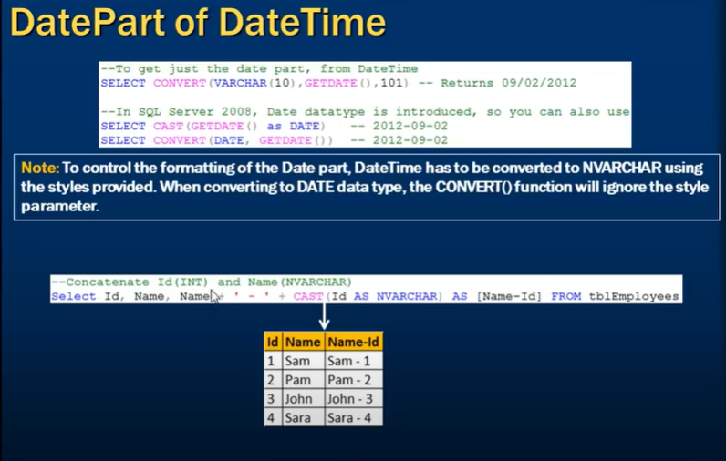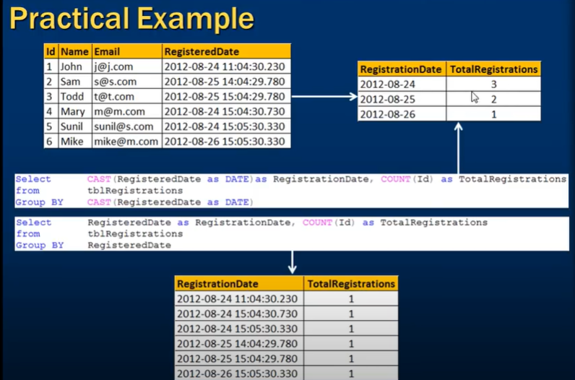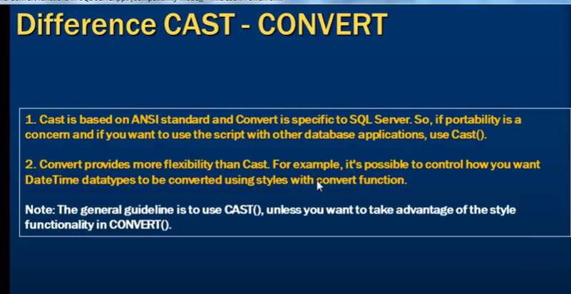

CAST:

Purpose: The CAST function is used to explicitly convert a value from one data type to another. It is mainly used for data type conversion.

Syntax:

CAST(expression AS new_data_type)

Portability: CAST is ANSI SQL-compliant and has consistent syntax across different database systems, making it more portable.

Example:

SELECT CAST('42' AS INT) AS ConvertedValue;

CONVERT:

Purpose: The CONVERT function is used for data type conversion, similar to CAST. In addition to data type conversion, it allows for optional formatting of date and time values using style codes.

Syntax:

CONVERT(new_data_type, expression [, style])

Portability: CONVERT is specific to Microsoft SQL Server and may not work in other database systems without modification. The optional style argument is SQL Server-specific.

Example (with formatting):

SELECT CONVERT(VARCHAR, GETDATE(), 120) AS FormattedDate;

FORMAT:

Purpose: The FORMAT function is used exclusively for formatting date and time values as strings according to a specified format pattern. It is not used for data type conversion.

Syntax:

FORMAT(date_expression, format_string)

Portability: FORMAT is specific to Microsoft SQL Server and some other databases. It is not part of the ANSI SQL standard and may not be available in all database systems.

Example (date formatting):

SELECT FORMAT(GETDATE(), 'yyyy-MM-dd HH:mm:ss') AS FormattedDate;

Difference Between Cast , Format And Convert Function In SSMS

In SQL Server (SSMS), CAST, CONVERT, and FORMAT are used for data type conversion and formatting, but they serve different purposes and have different capabilities. Here's a breakdown of each:

**1. CAST**

**Purpose**: CAST is used to convert a value from one data type to another. It is ANSI SQL standard, making it more portable across different database systems.

**Syntax**:

CAST(expression AS target_data_type)

**Example**:

SELECT CAST(123.45 AS INT); -- Converts 123.45 to 123 (integer)

**2. CONVERT**

**Purpose**: CONVERT is also used to convert a value from one data type to another, similar to CAST. However, CONVERT is specific to SQL Server and provides additional formatting options, especially for date and time conversions.

**Syntax**:

sql

Copy code

CONVERT(target_data_type, expression, style)

The style argument is optional and is mainly used for formatting dates and times.

**Example**:

sql

Copy code

SELECT CONVERT(VARCHAR, GETDATE(), 103); -- Converts the current date to a string in the format 'dd/mm/yyyy'

**Style 103**: For the format dd/mm/yyyy.

**3. FORMAT**

**Purpose**: FORMAT is used for formatting a value as a string in a specific format. It is useful for converting dates, numbers, and other data types to strings in a customized format. FORMAT is more flexible than CAST and CONVERT when it comes to formatting.

**Syntax**:

FORMAT(value, format_string, culture)

value: The value to format.

format_string: The .NET format string that defines the format (e.g., "yyyy-MM-dd").

culture: Optional; defines the culture (e.g., "en-US").

**Example**:

SELECT FORMAT(GETDATE(), 'yyyy-MM-dd'); -- Formats the current date as '2024-08-13'

**Key Differences:**

**Portability**:

CAST is ANSI SQL standard, making it more portable across different database systems.

CONVERT and FORMAT are SQL Server-specific.

**Functionality**:

CAST is used purely for data type conversion.

CONVERT can convert data types and apply formatting (especially for dates and times).

FORMAT is primarily used for formatting values into specific string representations, especially dates and numbers.

**Performance**:

CAST and CONVERT are generally faster because they are native functions.

FORMAT might be slower because it uses the .NET framework's formatting capabilities.

**Use Cases**:

Use CAST when you need a simple data type conversion.

Use CONVERT when you need to convert data types and apply specific formatting, particularly with dates and times.

Use FORMAT when you need to format data into a specific string representation, especially for display purposes.

**Example Comparison:**

**CAST**:

sql

Copy code

SELECT CAST(123.45 AS INT); -- Result: 123

**CONVERT**:

sql

Copy code

SELECT CONVERT(VARCHAR, GETDATE(), 103); -- Result: '13/08/2024'

**FORMAT**:

sql

Copy code

SELECT FORMAT(GETDATE(), 'MMMM dd, yyyy'); -- Result: 'August 13, 2024'

**Mathematical functions**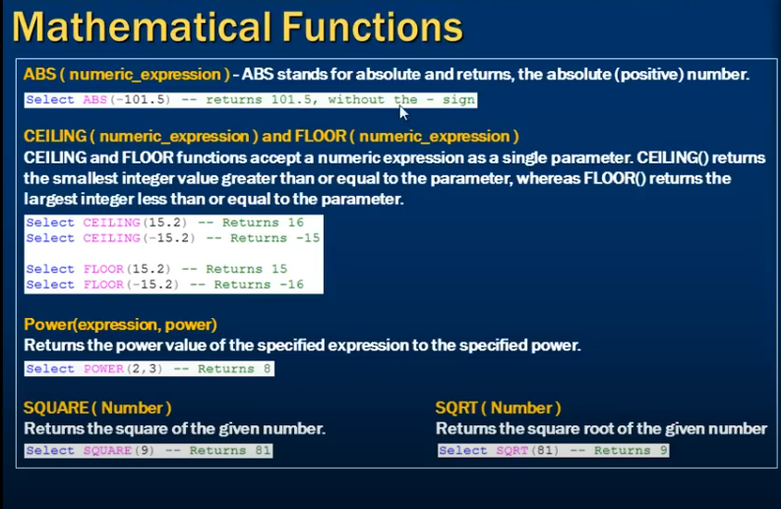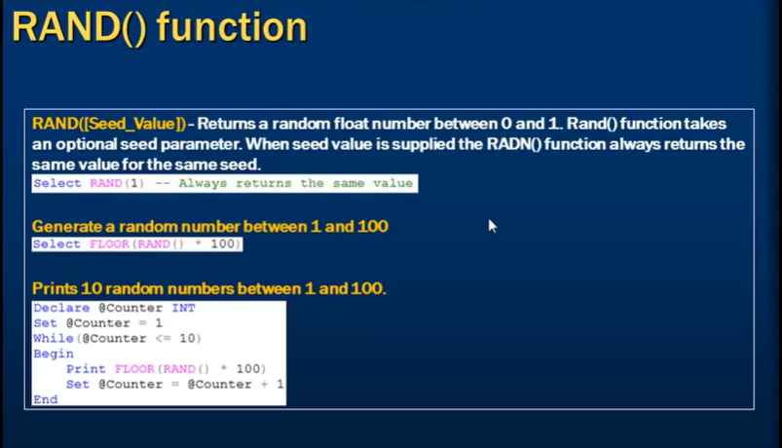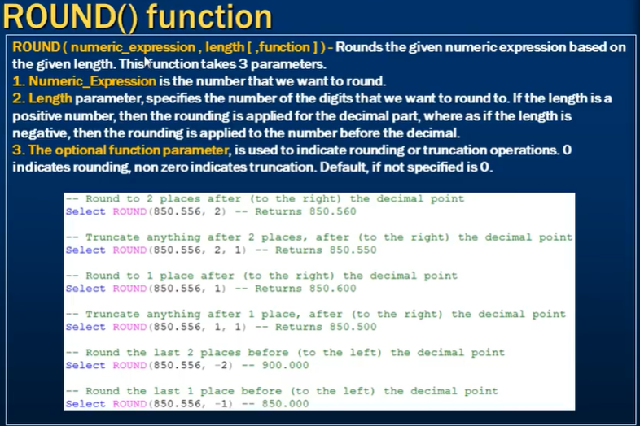

**T-SQL**

T-SQL, short for Transact-SQL, is a proprietary procedural language used by Microsoft SQL Server and Azure SQL Database. It is an extension of the SQL (Structured Query Language) and includes additional features and capabilities for working with SQL Server databases.

**Default SSMS database**

Master Database: The master database is the system database that records all the system-level information for a SQL Server instance. It contains information about database objects, logins, endpoints, system configurations, and other system metadata. The master database is crucial for the proper functioning of the SQL Server instance.

Tempdb Database: The tempdb database is a system database used to store temporary user objects, intermediate query results, work tables, and other temporary data required during SQL Server operations. It is recreated every time the SQL Server instance restarts, and it is shared among all users connected to the instance.

These databases cannot be changed or deleted in SQL Server Management Studio (SSMS) as they are essential for the functioning of the SQL Server instance. They are automatically created during the SQL Server installation process.

Other system databases in SQL Server include model and msdb:

Model Database: The model database is used as a template for creating new user databases. When you create a new database, SQL Server copies the contents of the model database to create the new database, including default settings, objects, and permissions.

Msdb Database: The msdb database is used by SQL Server Agent for managing scheduled jobs, alerts, operators, and other related information. It also stores backup and restore history, maintenance plans, and other SQL Server Agent operations.

These system databases play critical roles in the operation and management of a SQL Server instance. It is generally recommended not to make any modifications directly to these databases unless you have a specific and valid reason to do so.

**Normalization in database**

In database design, normalization is the process of organizing data in a database to eliminate redundancy and improve data integrity. It involves breaking down a database into multiple tables and defining relationships between them to ensure each piece of data is stored only once and dependencies are properly maintained.

Normalization is usually carried out using a set of rules known as normal forms. The most commonly used normal forms are:

First Normal Form (1NF): Ensures that each column contains only atomic values and there are no repeating groups or arrays within a row.

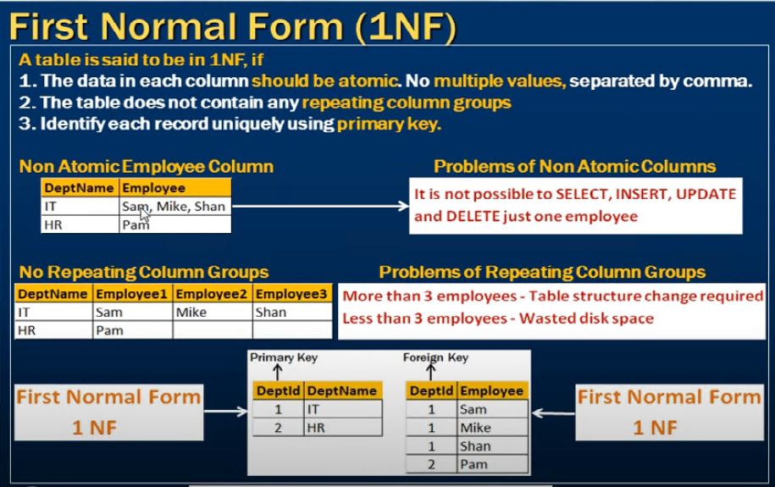

Second Normal Form (2NF): Builds upon 1NF by ensuring that all non-key attributes are dependent on the entire primary key and not just a part of it.

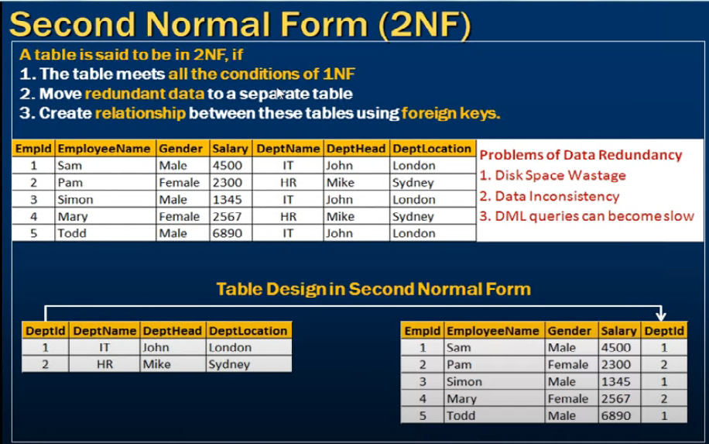

Third Normal Form (3NF): Further refines the design by removing transitive dependencies, meaning that non-key attributes should not depend on other non-key attributes.

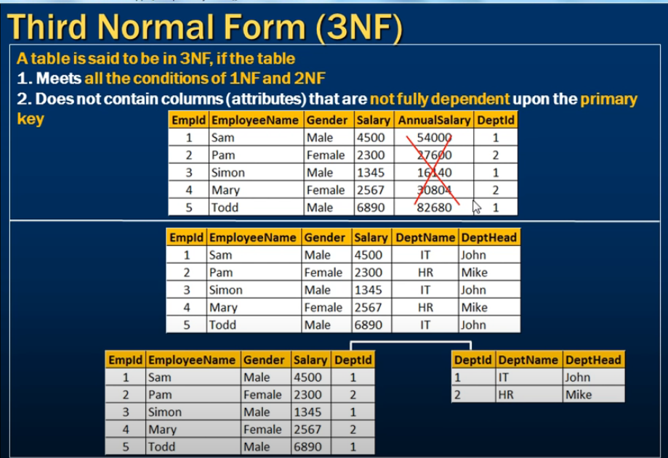

There are higher normal forms beyond 3NF, such as Boyce-Codd Normal Form (BCNF) and Fourth Normal Form (4NF), which deal with more complex dependencies and ensure even stricter data integrity.

The goal of normalization is to reduce data redundancy, improve data consistency, and make the database structure more efficient and maintainable. By organizing data into separate tables and defining relationships, normalization helps prevent data anomalies and inconsistencies that can occur when data is duplicated or improperly linked.

**BCNF**

To be in **Boyce-Codd Normal Form (BCNF)**:

For every **functional dependency (X → Y)**,  
**X must be a superkey** (i.e., X uniquely identifies the row).

**Compound and candidate key**

Candidate key refers to a set of attributes (or columns) within a table that can uniquely identify each row in the table. It means that no two rows can have the same combination of values for the candidate key attributes. In other words, a candidate key is a minimal set of attributes that can uniquely identify a record.

A compound key, on the other hand, is a candidate key that consists of two or more attributes. It means that multiple attributes together form a unique identifier for each row in the table. The combination of these attributes is necessary to ensure uniqueness, but individually they may not be unique.

For example, let's consider a table of employees. The employee ID alone may not be sufficient to uniquely identify each employee if there are multiple employees with the same ID. In this case, a compound key consisting of the employee ID and the department ID could be used as a candidate key, as the combination of these two attributes will uniquely identify each employee.

So, while a compound key is a type of candidate key, not all candidate keys are compound keys.

**ANSI Standard**

* **ANSI** = **American National Standards Institute**
* It’s a **private, non-profit organization** in the U.S.
* ANSI’s job is to **develop, coordinate, and approve standards** across different industries (technology, engineering, manufacturing, databases, etc.).

**In the context of databases / SQL**

* ANSI maintains the **SQL standard** (called **ANSI SQL**).
* This defines how SQL should work — the core commands like:
  + SELECT
  + INSERT
  + UPDATE
  + DELETE
  + CREATE TABLE
  + JOIN operations
* By having a standard, SQL code can (in theory) work across different database systems: Oracle, MySQL, SQL Server, PostgreSQL, etc.

👉 But:  
Each database vendor adds **extensions** beyond ANSI SQL (for example, TOP in SQL Server vs. LIMIT in MySQL). That’s why queries sometimes aren’t portable between systems.

**Why ANSI standards matter**

1. **Consistency** → Different tools and systems can work together.
2. **Portability** → Code written in ANSI-compliant SQL runs on multiple RDBMS with little or no change.
3. **Interoperability** → Different software and hardware can communicate more easily.

✅ **Simple analogy**:  
Think of ANSI like setting **grammar rules** for English. Everyone speaks the same “base language” (ANSI SQL), but different regions (SQL Server, Oracle, MySQL) have their own **dialects**.

**UNICODE STRING**

Unicode is a character encoding standard that assigns a unique numerical value (code point) to every character across different writing systems and languages. It is designed to support a wide range of characters from various scripts, including Latin, Greek, Cyrillic, Arabic, Chinese, Japanese, and many more.

The Unicode standard provides a consistent way of representing and processing text data, regardless of the platform, programming language, or operating system. It allows for the representation of characters beyond the traditional ASCII character set, which only includes characters from the English alphabet and basic symbols.

Unicode uses a fixed-length encoding scheme, where each character is represented by a unique code point. The most commonly used encoding for Unicode is UTF-8 (8-bit Unicode Transformation Format), which allows for efficient storage and transmission of text data.

By using Unicode, applications and systems can handle text in different languages, facilitate multilingual communication, and ensure proper rendering and processing of text data across different platforms and environments.

**Type in SSMS**

In SQL Server Management Studio (SSMS), the object types are represented by different codes or abbreviations. Here are some commonly used object type codes in SSMS:

U: User Table (e.g., regular table)

V: View

P: Stored Procedure

FN: Scalar-valued Function

IF: Inline Table-valued Function

TF: Table-valued Function

TR: Trigger

S: System Table

UQ: Unique Constraint

PK: Primary Key Constraint

F: Foreign Key Constraint

X: Extended Stored Procedure

TT: Table Type (user-defined table type)

RF: Replication Filter Procedure

S: System Base Table

SQ: Service Queue

RF: Replication Filter Stored Procedure

F: Assembly (CLR)

IT: Internal Table

D: Default Constraint

N : for unicode charector

Query to get the type

SELECT name, type_desc

FROM sys.objects

WHERE type IN ('U', 'V', 'P', 'FN', 'IF', 'TF', 'TR', 'S', 'UQ', 'PK', 'F', 'X', 'TT', 'RF', 'SQ', 'RF', 'F', 'IT', 'D')

ORDER BY name;

Query To find out if table present in the database or not

select * from INFORMATION_SCHEMA.TABLES WHERE TABLE_NAME='ssis_table'

pivot in SSMS :- Converting row value into the column.

Fro ex :- 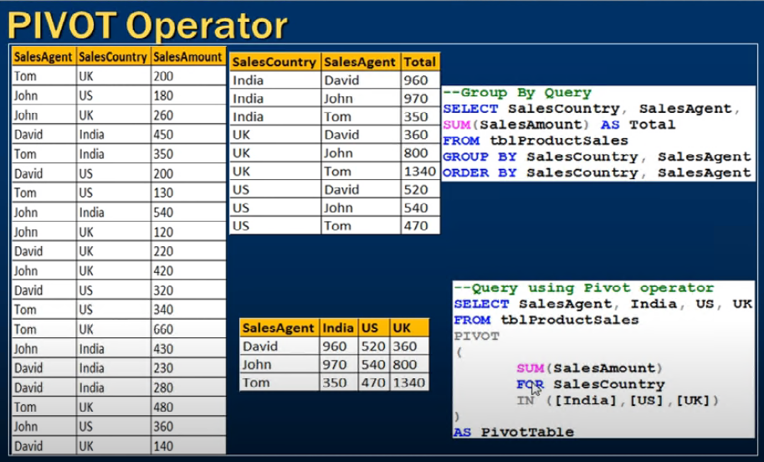

But if you have more column then it doesn’t work like for table 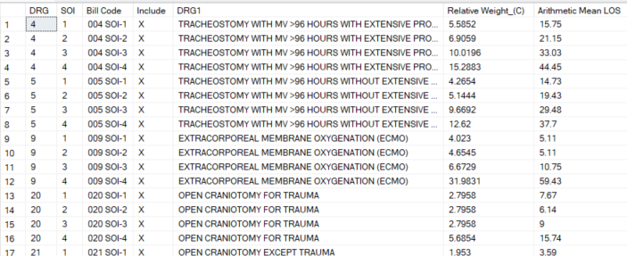

In this case the query will be like

In below example first we create the three column table which is SourceTable the perform pivot on that table.

SELECT DRG1, [1], [2], [3], [4]

FROM (

SELECT DRG1, SOI, [Relative Weight_(C)]

FROM [dbo].[Sheet1$]

) AS SourceTable

PIVOT (

SUM([Relative Weight_(C)])

FOR SOI IN ([1], [2], [3], [4])

) AS PivotTable;

The result of the query is

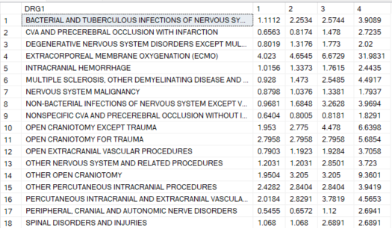

UNPIVOT IN SSMS :- Converting column into row. Now we convert the 1,2,3,4 column to row . query is like

SELECT DRG1, SOI, [Relative Weight_(C)]

FROM (

SELECT DRG1, [1], [2], [3], [4]

FROM PivotTable

) AS SourceTable

UNPIVOT (

[Relative Weight_(C)]

FOR SOI IN ([1], [2], [3], [4])

) AS UnpivotedTable;

Result is shown below

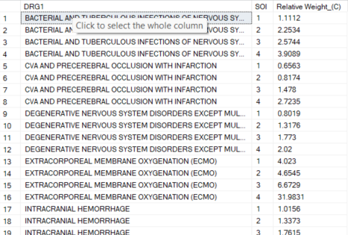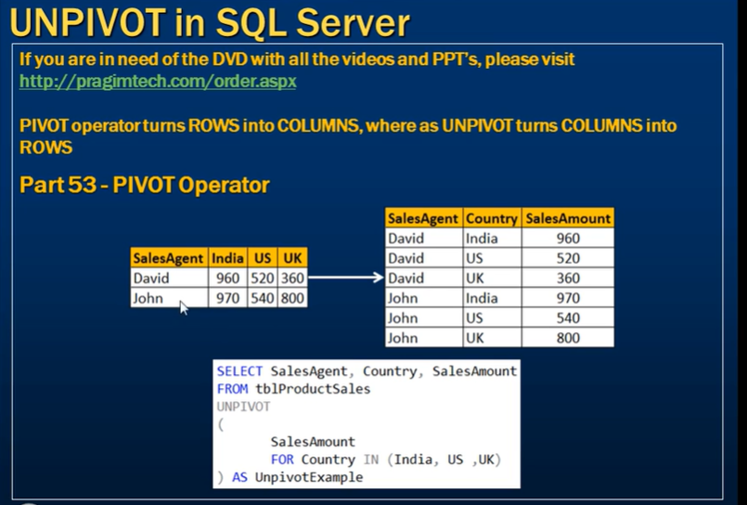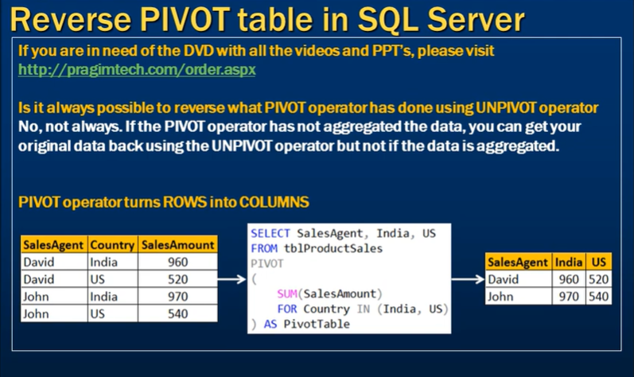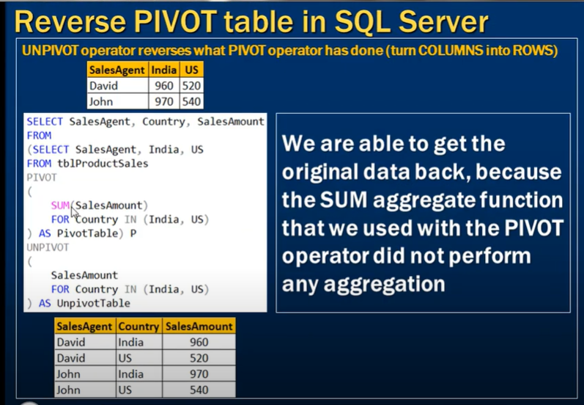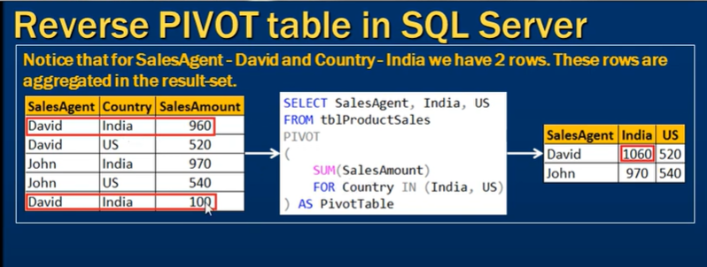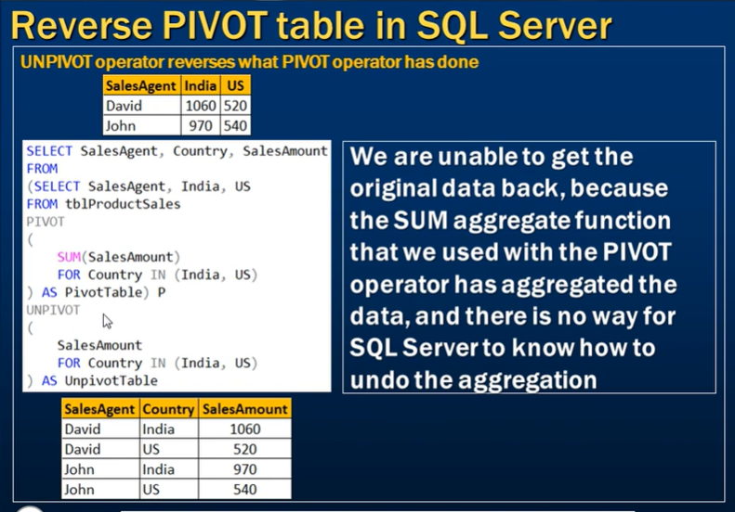

ERROR HANDLING IN SQL SERVER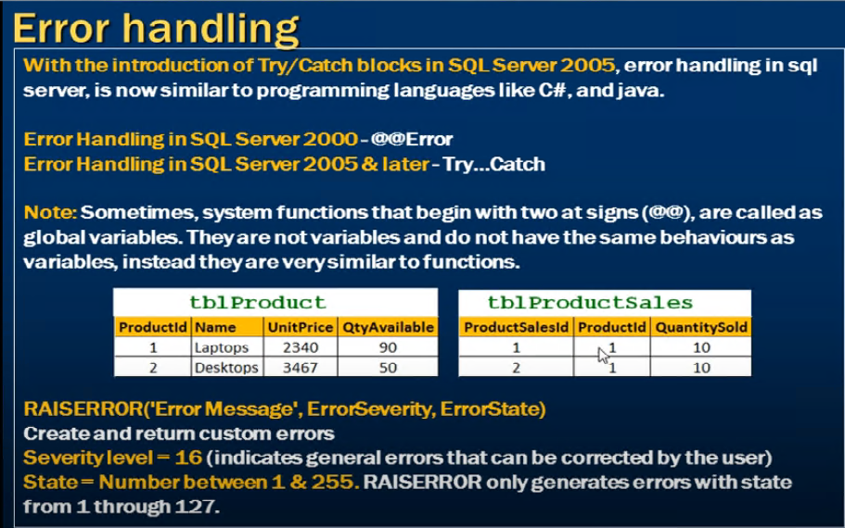

**@@ERROR** 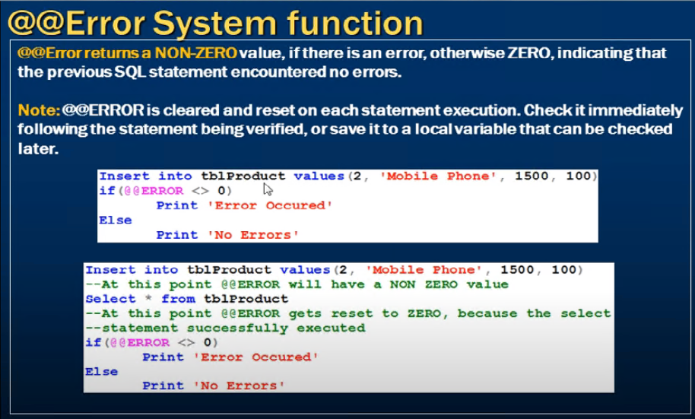

Ex :- create table error_hand_tbl (id int primary key,name varchar(22))

alter procedure error_hand

@id int,

@name varchar(22)

as

begin

if (@id<=(select max(id) from error_hand_tbl))

begin

raiserror('primary key voilation',16,1) --if there is error then this massage is raise

end

insert into error_hand_tbl values(@id,@name)

if (@@ERROR <>0) --check if there any error is present in previous statement HERE is INSERT Statement and give non zero value if error is present

begin

print 'error'

end

else

print 'no error'

end

In SQL Server, the RAISERROR function allows you to raise an error and specify its severity and state. These parameters provide additional context about the error:

**Severity**:

The severity level indicates the type and seriousness of the error.

It ranges from 0 to 25.

Common severity levels include:

**0-10**: Informational messages and warnings.

**11-16**: User-defined errors. These levels are often used in application code to indicate different types of errors.

**17-19**: Software errors that indicate a problem within SQL Server, but not severe enough to stop the instance.

**20-25**: Fatal errors that indicate severe problems. These levels usually result in the termination of the current connection or session.

Example:

RAISERROR ('An error occurred', 16, 1);

**State**:

The state is an integer value between 0 and 255.

It indicates the point in the code where the error occurred.

It helps in identifying the specific part of the procedure or batch that raised the error, especially when the same error message could be raised in multiple places.

It is often used for troubleshooting and debugging purposes.

Example:

RAISERROR ('An error occurred', 16, 1);

Here's an example that raises an error with specific severity and state:

CREATE PROCEDURE ExampleStoredProcedureWithCustomError

AS

BEGIN

-- Start the transaction

BEGIN TRANSACTION;

BEGIN TRY

-- Example operation

INSERT INTO Table1 (Column1, Column2)

VALUES ('Value1', 'Value2');

-- Explicitly raise an error with custom severity and state

RAISERROR ('An explicit error occurred', 16, 1);

-- Commit the transaction if all operations succeed (this won't be reached)

COMMIT TRANSACTION;

END TRY

BEGIN CATCH

-- Rollback the transaction if any error occurs

ROLLBACK TRANSACTION;

-- Handle the error (optional)

DECLARE @ErrorMessage NVARCHAR(4000);

DECLARE @ErrorSeverity INT;

DECLARE @ErrorState INT;

SELECT

@ErrorMessage = ERROR_MESSAGE(),

@ErrorSeverity = ERROR_SEVERITY(),

@ErrorState = ERROR_STATE();

-- Raise the error with the original error message, severity, and state

RAISERROR (@ErrorMessage, @ErrorSeverity, @ErrorState);

END CATCH

END;

In this example, the RAISERROR function raises an error with a severity of 16 and a state of 1. The CATCH block captures this error, rolls back the transaction, and re-raises the error with its original details.

Example of severity and state

create procedure error_handling (

@value int

)

as

begin

if @value = 0

begin

raiserror('invalid no' ,16, 1)

end

if @value < 0

begin

raiserror('invalid no' ,16, 2)

end

end

exec error_handling -1

output:-

Msg 50000, Level 16, State 2, Procedure error_handling, Line 14 [Batch Start Line 17]

invalid no

exec error_handling 0

Msg 50000, Level 16, State 1, Procedure error_handling, Line 9 [Batch Start Line 17]

invalid no

Storing error value in variable

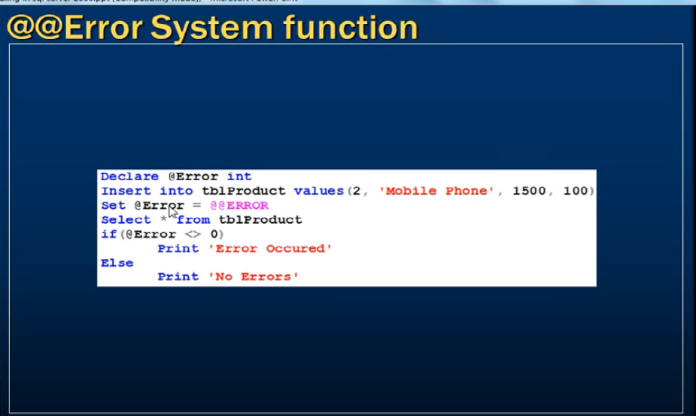

**ERROR HANDLING USING TRY AND CATCH**

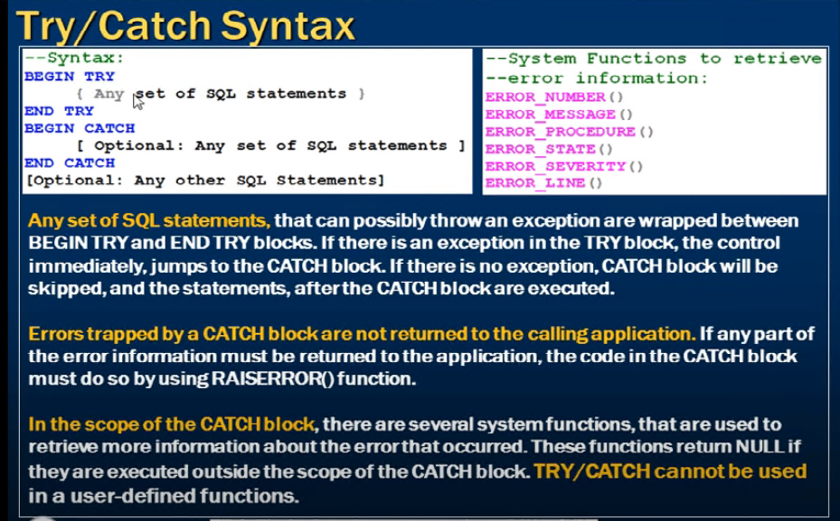

EX :-

Alter procedure error_hand

@id int,

@name varchar(22)

as

BEGIN

BEGIN TRY

if (@id<=(select max(id) from error_hand_tbl))

begin

raiserror('primary key voilation',16,1) --if there is error then this massege is raise

end

insert into error_hand_tbl values(@id,@name)

END TRY

BEGIN CATCH

SELECT

ERROR_NUMBER() AS ERRORNUMBER,

ERROR_LINE() AS ERRORLINE,

ERROR_PROCEDURE() AS PROCEDURENAME,

ERROR_SEVERITY() AS ERRORSEVERITY,

ERROR_MESSAGE() AS ERRORMSG

END CATCH

END

**Throw**

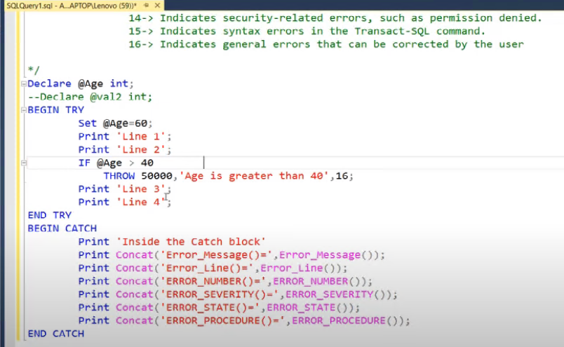

**DIFFERENCE BETWEEN THROW AND RAISEERROR**

Throw can not be use without try catch block but raiseerror can be used with or without try catch block.

**Analytical \ Window function**

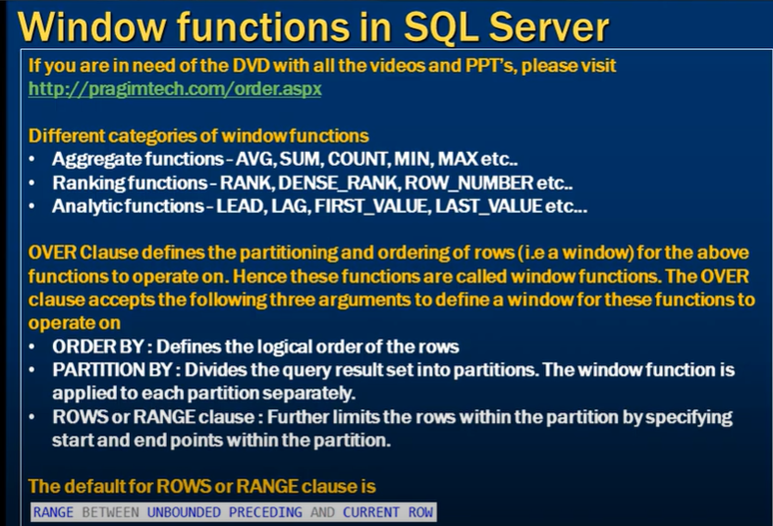

Rank() :- It skip the number.

Dense_rank() :- it will not skip the record.

Row_number() :- apart from Rank() and Dense_rank() the difference is that the row with the same value receive different row number.

Lag()

Lead()

Frist_value()

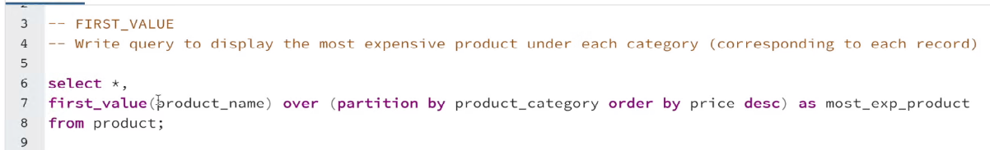

Last_value()

Default frame is [range between unbounded preceding and current row] 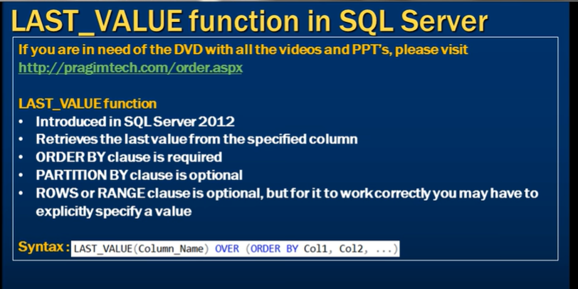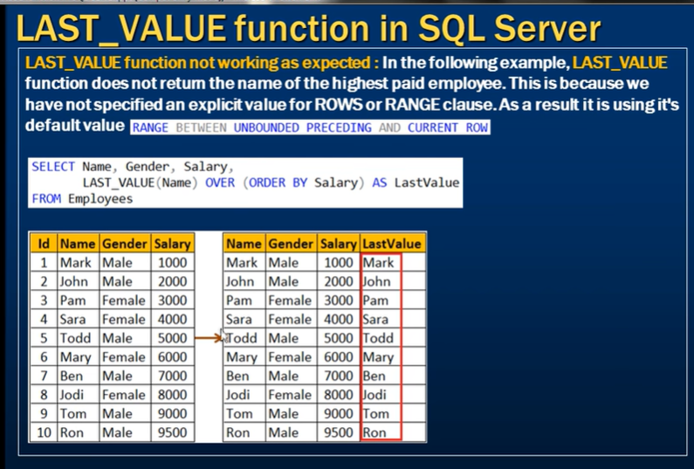

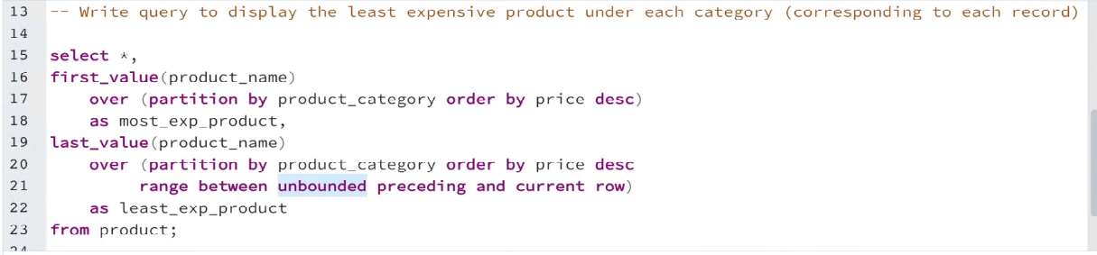

Modified frame 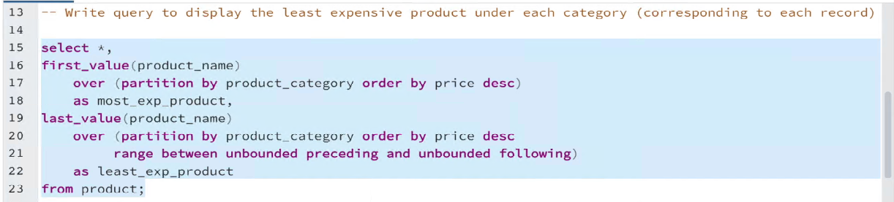

Modified frame

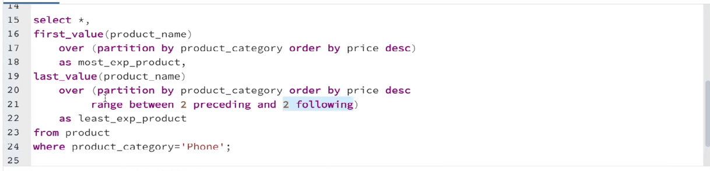

Nth_value

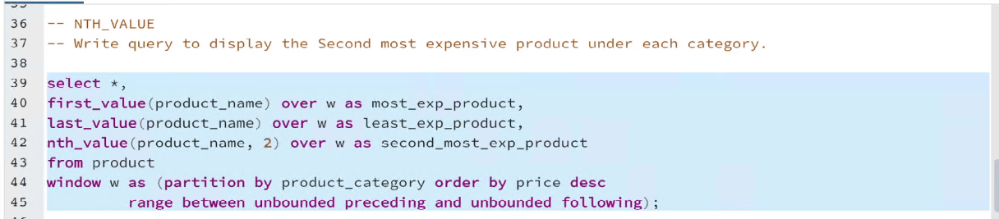

Ntile() :- Ntile(no of buckets)

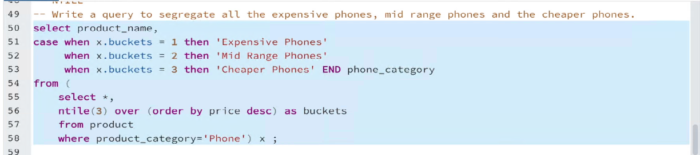

CUME_DIST() :- Formula to calculate the CUME_DIST() is (total no of row)/(row no)

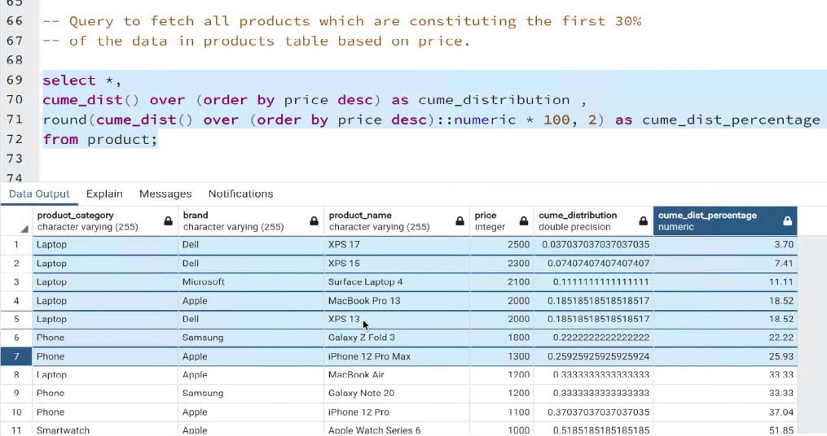

PERCENT_RANK()

**windows**

In SQL, the concepts of "unbounded preceding" and "unbounded following" are typically used in conjunction with window functions to define the range over which a window function should operate. Window functions allow you to perform calculations across a set of rows related to the current row within a specified window or frame. The frame can be defined using the window specification, which includes the window's partitioning and ordering, as well as the frame's boundaries.

**Unbounded Preceding:** This refers to all rows that come before the current row in the ordering of the window frame. In other words, it includes all rows from the start of the partition up to and including the current row.

**Unbounded Following:** This refers to all rows that come after the current row in the ordering of the window frame. It includes all rows from the current row up to the end of the partition.

Using these concepts, you can create different types of window frames for window functions. Here are some common combinations:

**ROWS BETWEEN UNBOUNDED PRECEDING AND CURRENT ROW:** This includes all rows from the start of the partition up to and including the current row.

**ROWS BETWEEN CURRENT ROW AND UNBOUNDED FOLLOWING:** This includes the current row and all rows that come after it in the partition.

**ROWS BETWEEN UNBOUNDED PRECEDING AND UNBOUNDED FOLLOWING:** This includes all rows within then. Essentially, it covers the entire partition.

**ROWS BETWEEN x PRECEDING AND y FOLLOWING:** In this case, you can specify a certain number of rows before and after the current row to be included in the window frame. **x** and **y** can be positive integers representing row offsets.

**RANGE BETWEEN UNBOUNDED PRECEDING AND CURRENT ROW:** This is used when your window is ordered based on non-consecutive values (e.g., dates). It includes all rows from the partition where the ordering values are less than or equal to the current row's ordering value.

**RANGE BETWEEN CURRENT ROW AND UNBOUNDED FOLLOWING:** Similar to the previous case, but it includes all rows where the ordering values are greater than or equal to the current row's ordering value.

**RANGE BETWEEN UNBOUNDED PRECEDING AND UNBOUNDED FOLLOWING:** This covers the entire partition, just like the rows-based equivalent.

These combinations can be used to tailor the behavior of window functions to your specific analytical needs. Different databases might have variations in syntax and support for these constructs, so it's a good practice to refer to the documentation of the specific database you're working with for exact details.

**Difference between range and rows using befor the between** 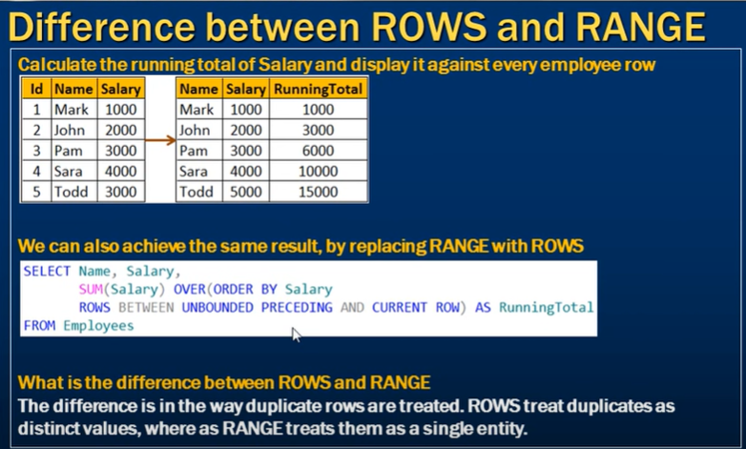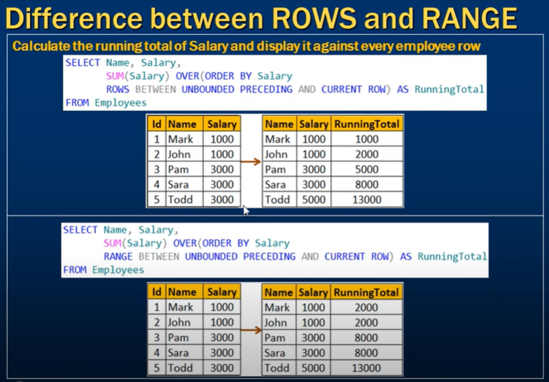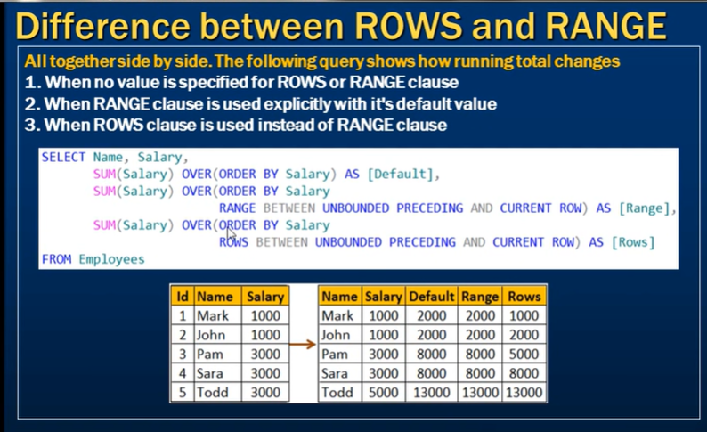

Range

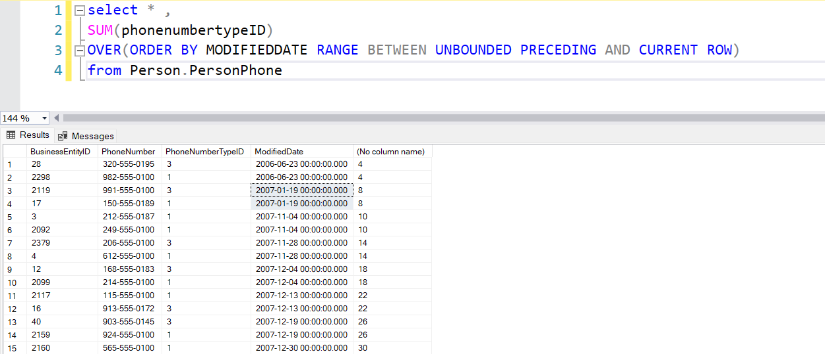

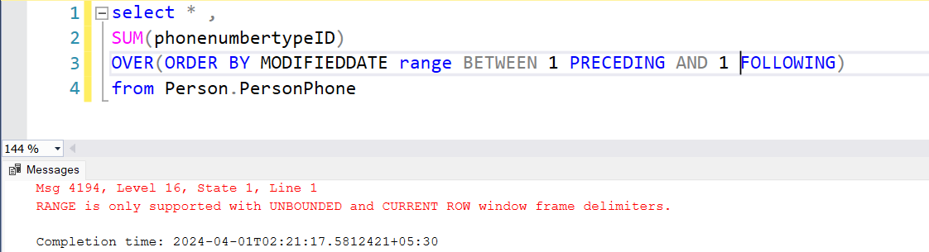

Rows 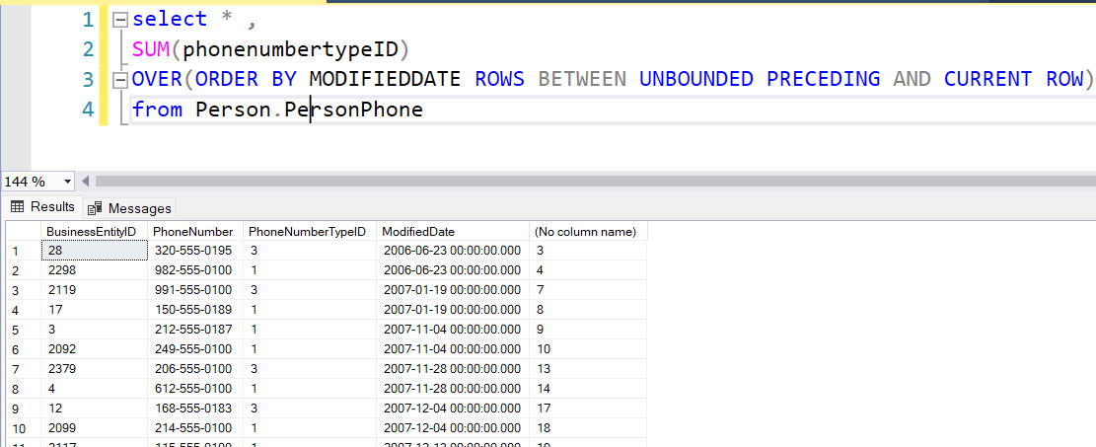

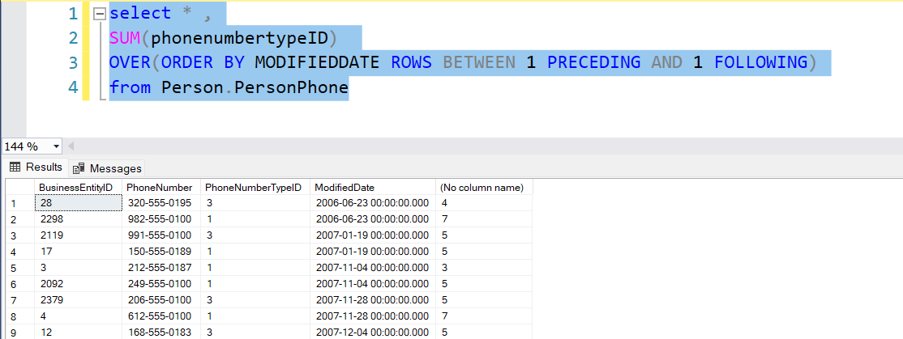

IMP 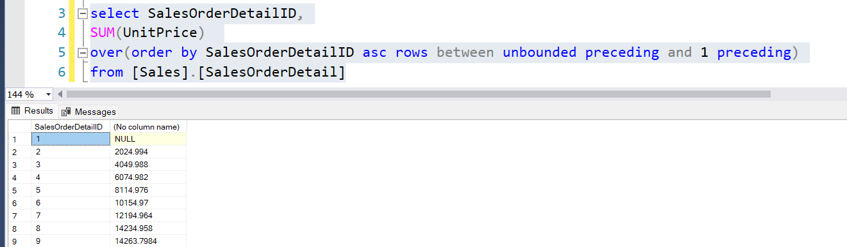

**Row-based Window Frame:** When you use a row-based window frame, you are specifying a fixed number of rows relative to the current row. This means that the window frame includes a specific number of rows before and after the current row, regardless of the actual values in the ordering column.

For example, if you define a row-based window frame as "ROWS BETWEEN 2 PRECEDING AND 2 FOLLOWING," it means that the window frame will always include a total of 5 rows: the current row, plus two rows before and two rows after the current row, regardless of the ordering values.

**Range-based Window Frame:** Range-based window frames consider the actual values in the ordering column rather than a fixed number of rows. This means that the window frame includes all rows whose ordering values fall within a specified range relative to the ordering value of the current row.

For example, if you define a range-based window frame as "RANGE BETWEEN 10 PRECEDING AND 10 FOLLOWING," it means that the window frame will include all rows whose ordering values are within 10 units (according to the ordering column) of the ordering value of the current row. This can be useful when the ordering values are not evenly spaced.

In summary:

**Row-based Window Frame:** Defines a fixed number of rows before and after the current row, regardless of the ordering values.

**Range-based Window Frame:** Defines a range of rows based on the actual ordering values, accommodating unevenly spaced values in the ordering column.

ANY AND ALL

However, the use of **ANY** and **ALL** operators can be particularly useful in scenarios where you're working with sets of values returned by subqueries. Let's delve into some scenarios where **ANY** and **ALL** provide distinct functionality:

**Comparing Against a Set of Values**:

When you use **ANY** or **ALL**, you're comparing your column value against a set of values returned by the subquery. This can be useful when you want to compare against multiple values rather than a single value.

Using regular comparison operators (**>**, **<**, etc.) works when you're comparing against a single value, but **ANY** and **ALL** allow you to evaluate against a set of values.

**Subqueries with Multiple Results**:

If your subquery can return multiple results, **ANY** and **ALL** help you perform a comparison for each result. This can lead to more versatile comparisons.

Regular comparison operators might raise an error if your subquery returns more than one value.

**Distinct Conditions for Each Value**:

You might need to apply distinct conditions for different values in a set. **ANY** and **ALL** allow you to perform separate evaluations for each value.

Using a single comparison operator applies the same condition to all values, which might not be suitable in all cases.

**Subqueries with Aggregations**:

When working with subqueries involving aggregations (e.g., MAX, MIN), **ANY** and **ALL** help you apply conditions based on aggregate results.

**Constran in SQL**

1)foreign key

In database design, relationships between tables can be defined using various options, including cascading delete behavior. Cascading delete is a feature that automatically propagates the deletion of a row in a parent table to its related rows in child tables. This helps maintain data integrity by ensuring that dependent data in related tables is also removed when a parent record is deleted. Apart from cascading delete, there are other types of relationships as well:

**Cascading Delete (On Delete Cascading)**:

When a row in the parent table is deleted, corresponding rows in the child table are automatically deleted.

This is useful when the relationship represents a hierarchical structure or when the child data is dependent on the parent data.

**Cascading Update (On Update Cascading)**:

Similar to cascading delete, but it propagates updates to the parent's primary key to the child's foreign key.

This maintains the consistency of data when primary key values change in the parent table.

**Restrict (No Action)**:

Prevents the deletion of a parent record if there are dependent child records.

An attempt to delete a parent record will fail if related child records exist.

**Set Null (On Delete Set Null, On Update Set Null)**:

Sets the foreign key column value in the child table to NULL when the corresponding parent record is deleted or updated.

Useful when you want to keep the child record but remove the reference to the parent.

**Set Default (On Delete Set Default, On Update Set Default)**:

Similar to set null, but sets the foreign key to its default value rather than NULL.

**No Action (Restrict)**:

Similar to the restrict option, it prevents the deletion of a parent record if related child records exist.

**No Action (No Action)**:

This option is similar to the "No Action" option for foreign keys. It doesn't propagate any changes or deletions between parent and child tables.

**Merge (SQL Server)**:

In SQL Server, the MERGE statement allows you to perform insert, update, or delete operations on a target table based on a source table. While not a direct relationship type, MERGE can be used to perform multiple actions in a single statement.

These relationship options offer flexibility in managing data integrity and referential integrity in your database design. Depending on your use case and requirements, you can choose the appropriate relationship type to ensure that your data remains consistent and accurate.

SYNTAX FOR foreign key

Certainly! Here are the SQL syntax examples for defining different types of relationship actions in SQL Server Management Studio (SSMS):

**Cascading Delete**: This example shows how to create a foreign key relationship with cascading delete behavior:

CREATE TABLE ParentTable (

ParentID INT PRIMARY KEY

);

CREATE TABLE ChildTable (

ChildID INT PRIMARY KEY,

ParentID INT,

FOREIGN KEY (ParentID) REFERENCES ParentTable(ParentID) ON DELETE CASCADE

);

**Cascading Update**: This example shows how to create a foreign key relationship with cascading update behavior:

CREATE TABLE ParentTable (

ParentID INT PRIMARY KEY

);

CREATE TABLE ChildTable (

ChildID INT PRIMARY KEY,

ParentID INT,

FOREIGN KEY (ParentID) REFERENCES ParentTable(ParentID) ON UPDATE CASCADE

);

**Set Null**: This example shows how to create a foreign key relationship with set null behavior:

CREATE TABLE ParentTable (

ParentID INT PRIMARY KEY

);

CREATE TABLE ChildTable (

ChildID INT PRIMARY KEY,

ParentID INT NULL,

FOREIGN KEY (ParentID) REFERENCES ParentTable(ParentID) ON DELETE SET NULL

);

**Set Default**: This example shows how to create a foreign key relationship with set default behavior:

CREATE TABLE ParentTable (

ParentID INT PRIMARY KEY

);

CREATE TABLE ChildTable (

ChildID INT PRIMARY KEY,

ParentID INT DEFAULT 0,

FOREIGN KEY (ParentID) REFERENCES ParentTable(ParentID) ON DELETE SET DEFAULT

);

**Restrict (No Action)**: This example shows how to create a foreign key relationship with restrict (no action) behavior:

CREATE TABLE ParentTable (

ParentID INT PRIMARY KEY

);

CREATE TABLE ChildTable (

ChildID INT PRIMARY KEY,

ParentID INT,

FOREIGN KEY (ParentID) REFERENCES ParentTable(ParentID) ON DELETE NO ACTION

);

Please note that these examples assume that the referenced tables (**ParentTable** and **ChildTable**) have additional columns not shown in the examples. Make sure to adapt these examples to your specific table structure and requirements.

Code to enable database diagram :-

ALTER AUTHORIZATION ON DATABASE::[AdventureWorks2019] TO [GHSAdmin];

**Database developer**

**ROWGUIDCOL**

**ROWGUIDCOL is a column property in Microsoft SQL Server that designates a column as a unique identifier for each row in a table. This property is used to ensure that each row has a globally unique identifier (GUID), even across different tables and databases. The ROWGUIDCOL property is often used in scenarios where data needs to be synchronized between different databases or systems.**

**Here are some key points about ROWGUIDCOL:**

**Purpose: The ROWGUIDCOL property is typically used to ensure that rows in a table have a unique identifier that remains constant even if the data is replicated, synchronized, or moved between databases.**

**Data Type: The column with the ROWGUIDCOL property is usually of the uniqueidentifier data type, which stores a 128-bit number that is guaranteed to be globally unique across all computers and networks.**

**Automatic Generation: When a new row is inserted into a table with a ROWGUIDCOL column, SQL Server automatically generates a unique GUID value for that column.**

**Uniqueness: The values in a ROWGUIDCOL column are guaranteed to be unique across all rows in the table, helping to prevent conflicts or duplication during data synchronization.**

**No Manual Updates: In general, ROWGUIDCOL columns are not meant to be manually updated. Changing the value of a ROWGUIDCOL column would defeat the purpose of maintaining a constant identifier for each row.**

**Primary Key: While a ROWGUIDCOL column is often used as a primary key, it's not a strict requirement. You can have a ROWGUIDCOL column without it being the primary key of the table.**

**Foreign key naming convention**

**FK_Person_BusinessEntity_BusinessEntityID**

**FK**: This prefix indicates that it's a foreign key constraint. It's a common practice to start foreign key constraint names with "FK" to easily identify them as relationships between tables.

**Person**: This is the name of the table that contains the foreign key column. In this case, it's likely a table named "Person."

**BusinessEntity**: This is the name of the referenced table that the foreign key points to. In this case, it's likely a table named "BusinessEntity."

**BusinessEntityID**: This is the column in the "Person" table that serves as the foreign key, referencing the "BusinessEntity" table's primary key column.

**Difference between SQL and NoSQL**

SQL (Structured Query Language) databases and NoSQL (Not Only SQL) databases differ in their data models, storage mechanisms, querying languages, and use cases. Here's a breakdown of the key differences between the two:

**1. Data Model:**

SQL: SQL databases use a structured data model based on tables with rows and columns. Each table has a predefined schema that specifies the types and relationships of data.

NoSQL: NoSQL databases offer various data models, such as document-based, key-value, column-family, and graph. These models allow for more flexibility in handling unstructured or semi-structured data.

**2. Schema:**

SQL: SQL databases enforce a rigid schema where the structure of the data is defined in advance. Any changes to the schema can be complex and require careful planning.

NoSQL: NoSQL databases typically have flexible or dynamic schemas. New attributes or fields can be added to documents or records without requiring changes to the entire database schema.

**3. Query Language:**

SQL: SQL databases use the SQL language for querying and manipulating data. SQL provides a standardized way to perform complex queries, aggregations, joins, and transactions.

NoSQL: Each type of NoSQL database may have its own query language or API for retrieving and manipulating data. These languages often focus on the specific data model they support and might not provide the same level of querying complexity as SQL.

**4. Scaling:**

SQL: Traditional SQL databases (relational databases) are typically vertically scalable, which means you can increase their performance by upgrading hardware. Horizontal scaling can be complex and might require sharding (splitting the database) or replication.

NoSQL: Many NoSQL databases are designed for horizontal scaling. They distribute data across multiple nodes, making it easier to handle large amounts of data and traffic. This can lead to better performance and availability as the system grows.

**5. Consistency and Availability:**

SQL: SQL databases typically provide strong consistency and ACID transactions, ensuring data integrity even in the face of failures. However, this might impact availability and scalability in distributed systems.

NoSQL: NoSQL databases often offer eventual consistency, prioritizing availability and partition tolerance over immediate consistency. This makes them well-suited for highly available and distributed environments.

**6. Use Cases:**

SQL: SQL databases are suitable for applications with well-defined schemas, complex queries, and transactions, such as e-commerce platforms, financial systems, and content management systems.

NoSQL: NoSQL databases are ideal for scenarios involving rapidly changing data, unstructured or semi-structured data, high write and read throughput, and the need for scalability, such as social media platforms, real-time analytics, and Internet of Things (IoT) applications.

In summary, the choice between SQL and NoSQL databases depends on your application's requirements. SQL databases are often preferred for structured data and complex queries, while NoSQL databases are favored for dynamic, rapidly evolving data with high scalability and availability needs.

**Vertical scalability and horizontal scalability**

Vertical scalability and horizontal scalability are terms used to describe different approaches to increasing the performance, capacity, or resources of a system, typically a database or a server.

**Vertical Scalability:** Vertical scalability, also known as scaling up or scaling vertically, involves increasing the capacity of a single server or machine by adding more resources, such as CPU, memory, storage, or network bandwidth. This is done by upgrading the existing hardware components of the server. For example, you might replace a dual-core CPU with a quad-core CPU, or you might increase the RAM from 8 GB to 16 GB.

Pros of vertical scalability:

Simplicity: Upgrading hardware components is often straightforward.

Reduced complexity in management and maintenance.

Cons of vertical scalability:

Limited scalability: Eventually, you'll hit the physical limitations of the hardware, which can result in a bottleneck.

Higher cost: High-end hardware components can be expensive.

Risk of downtime: Upgrading hardware might require downtime or service interruptions.

**Horizontal Scalability:** Horizontal scalability, also known as scaling out or scaling horizontally, involves adding more machines or servers to the system to distribute the workload. This approach is often used in distributed systems where the workload can be split into smaller tasks that can be processed concurrently on different machines.

Pros of horizontal scalability:

Better scalability: As you add more machines, you can handle larger workloads by distributing tasks.

Cost-effective: Instead of investing in expensive high-end hardware, you can use commodity hardware.

Improved fault tolerance: If one machine fails, others can continue to handle the workload.

Higher availability: Redundancy across multiple machines can improve system availability.

Cons of horizontal scalability:

Increased complexity: Managing a cluster of machines can be more complex than managing a single powerful server.

Network communication overhead: Distributed systems require effective communication mechanisms, which can introduce latency.

Data consistency challenges: Ensuring consistent data across multiple nodes can be more complex in distributed environments.

**Choosing Between Vertical and Horizontal Scalability:** The choice between vertical and horizontal scalability depends on your specific needs and the characteristics of your application or system. If your system's performance requirements can be met by upgrading existing hardware for a while, vertical scalability might be a simpler solution. However, if your system needs to handle a rapidly increasing amount of data and traffic, or if you want to ensure high availability and fault tolerance, horizontal scalability is often a better fit. In practice, many systems combine both approaches to achieve the desired performance and availability goals.

**Logs in SSMS**

In the context of SQL Server Management Studio (SSMS), "logs" typically refer to the various types of logs maintained by SQL Server to record important events and activities. These logs are crucial for monitoring and troubleshooting the health, performance, and security of the SQL Server instance. There are several types of logs in SQL Server:

**Error Log:** The SQL Server error log records error messages, warnings, and informational messages generated by the SQL Server Database Engine. It provides details about issues that occurred during startup, during query execution, or in other aspects of the SQL Server instance's operation. The error log is an important tool for diagnosing and troubleshooting errors.

**Transaction Log:** The transaction log records all changes made to the database, allowing for recovery and rollback of transactions. It plays a critical role in maintaining data integrity and consistency. The transaction log is used for point-in-time recovery, replication, and high availability features.

**SQL Server Agent Error Log:** SQL Server Agent maintains its own error log, separate from the main SQL Server error log. This log records information about job execution, alerts, and other events related to SQL Server Agent tasks.

**SQL Server Agent Log:** This log records information about SQL Server Agent activities, including job execution status, schedules, and other Agent-related events.

**Extended Events:** Extended Events is a powerful feature that allows you to capture detailed information about specific events within SQL Server. It provides a flexible mechanism for monitoring and troubleshooting.

**Profiler Trace:** SQL Server Profiler allows you to capture and analyze events occurring within the SQL Server instance. You can configure and customize the trace to capture specific activities and troubleshoot performance issues.

**Windows Event Logs:** SQL Server also logs events to the Windows Event Logs. These logs can include information about SQL Server startup, shutdown, and other operational events.

**External table**

An **external table** in SQL Server (or Azure SQL Database) is a **virtual table** that references data outside your current database.

You can use **external tables** to connect:

* From **Azure SQL → another Azure SQL database** (via Elastic Query)
* From **SQL Server → external sources (via PolyBase)** such as:
  + Another SQL Server (on-prem)
  + Azure Blob / Data Lake
  + Hadoop, etc.

You can query it using T-SQL like a normal table, but the data physically resides:

* On another SQL Server database
* In Azure SQL Database
* Or in external data sources (like Azure Blob, Synapse, etc.)

**⚙️ 2️⃣ Prerequisites**

Before you can create an external table, you need:

* A **Master Key**
* A **Database Scoped Credential**
* An **External Data Source**
* (Optional) An **External File Format** — if you’re using external storage like Azure Blob.

**🧠 3️⃣ Example — External Table to Another SQL Server**

Let’s say you have:

* Local database: SalesDB
* Remote database: HRDB on another SQL Server (or Azure SQL)

You want to query Employees from HRDB inside SalesDB.

**✅ Step 1: Create a Master Key**

CREATE MASTER KEY ENCRYPTION BY PASSWORD = 'My$ecureP@ssword';

**✅ Step 2: Create a Database Scoped Credential**

This stores the login info for the remote server.

CREATE DATABASE SCOPED CREDENTIAL RemoteSqlCred

WITH IDENTITY = 'remote_user', -- remote SQL login

SECRET = 'RemoteUserPassword';

**✅ Step 3: Create External Data Source**

This tells SQL Server *where* the external data lives.

CREATE EXTERNAL DATA SOURCE RemoteSqlServer

WITH

(

TYPE = RDBMS,

LOCATION = 'tcp:remoteserver.database.windows.net,1433',

DATABASE_NAME = 'HRDB',

CREDENTIAL = RemoteSqlCred

);

**✅ Step 4: Create External Table**

Now define the external table structure.

CREATE EXTERNAL TABLE EmployeesExternal

(

EmployeeID INT,

FirstName NVARCHAR(50),

LastName NVARCHAR(50),

Department NVARCHAR(50)

)

WITH

(

DATA_SOURCE = RemoteSqlServer

);

**✅ Step 5: Query it!**

SELECT * FROM EmployeesExternal;

Boom 💥 — you’re now reading data from another SQL Server (or Azure SQL) as if it were a local table.

**🧩 4️⃣ Alternative — Use PolyBase for External Tables to Files**

If your data is in **Azure Blob Storage**, **Data Lake**, or **Hadoop**, you’d instead define:

* An **External File Format**
* And use **PolyBase** to read the files.

Example:

CREATE EXTERNAL FILE FORMAT MyFileFormat

WITH (FORMAT_TYPE = DELIMITEDTEXT, FORMAT_OPTIONS (FIELD_TERMINATOR = ',', STRING_DELIMITER = '"'));

CREATE EXTERNAL DATA SOURCE MyAzureBlob

WITH (TYPE = HADOOP, LOCATION = 'wasbs://mycontainer@myaccount.blob.core.windows.net/');

CREATE EXTERNAL TABLE SalesData (

SaleID INT, Product NVARCHAR(50), Amount DECIMAL(10,2)

)

WITH (DATA_SOURCE = MyAzureBlob, FILE_FORMAT = MyFileFormat, LOCATION = '/sales/');

**🧾 Summary**

| **Step** | **Purpose** |
| --- | --- |
| 1 | Create Master Key |
| 2 | Create Scoped Credential |
| 3 | Create External Data Source |
| 4 | Create External Table |
| 5 | Query data like normal |

**Linked service**

A **Linked Server** in SQL Server allows one instance of SQL Server to execute commands against another SQL Server (or even Oracle, MySQL, etc.) as if it were local.

**Linked Service** belongs to **Azure Data Factory (ADF)**, not SQL Server or Azure SQL itself.

A **connection definition** used by ADF pipelines to connect to data sources (SQL, Blob, API, etc.).

✅ You can use **linked services** to connect:

* From ADF → **On-prem SQL Server**
* From ADF → **Azure SQL Database**
* From ADF → **any other supported source**

So **linked services are used for data movement / ETL**, not for querying within SQL.

| **Step** | **Action** | **Example** |
| --- | --- | --- |
| 1 | Create linked server | sp_addlinkedserver |
| 2 | Add credentials | sp_addlinkedsrvlogin |
| 3 | Query remote data | [LinkedServer].[DB].[Schema].[Table] |
| 4 | Drop if needed | sp_dropserver |

**Elastic Query**

An **Elastic Query** is an Azure SQL **feature** that enables you to:

* Query across multiple Azure SQL databases
* Combine data from *different* external tables or databases
* Use **External Tables** behind the scenes

Elastic Query = External Tables + External Data Sources + Query Federation

**When You Create an External Table in Azure SQL Database**

You are **using the Elastic Query feature** of Azure SQL —  
because **Elastic Query is the underlying engine** that enables external tables to fetch data from another database.

**How to see the logs on SQL Server**

In SQL Server Management Studio (SSMS), you can view different types of logs related to your SQL Server instance through various interfaces and tools. Here's how you can access and view these logs:

**Error Log:** To view the SQL Server error log, follow these steps:

In SSMS, connect to your SQL Server instance.

In the Object Explorer, expand the "Management" node.

Right-click on "SQL Server Logs" and select "View SQL Server Log."

**Transaction Log:** The transaction log is managed internally by SQL Server and is not directly accessible through SSMS. It's used primarily for recovery and management purposes.

**SQL Server Agent Error Log:** To view the SQL Server Agent error log, follow these steps:

In SSMS, connect to your SQL Server instance.

In the Object Explorer, expand the "SQL Server Agent" node.

Right-click on "Error Logs" and select "View SQL Server Agent Error Log."

**SQL Server Agent Log:** The SQL Server Agent log can be accessed within SSMS:

In SSMS, connect to your SQL Server instance.

In the Object Explorer, expand the "SQL Server Agent" node.

Right-click on "Error Logs" under the specific SQL Server Agent instance and select "View Agent Log."

**Extended Events and Profiler Trace:** Extended Events and Profiler Traces can be accessed and configured within SSMS, but they require more advanced setup and usage. You can access these features through the "Management" section or by using the "Tools" menu in SSMS.

**Windows Event Logs:** Windows Event Logs related to SQL Server can be accessed through the Event Viewer on your Windows machine. These logs are found in the "Application" and "System" logs under "Windows Logs."

Remember that access to certain logs might require administrative privileges. Also, the exact steps might vary based on the version of SQL Server you're using and the permissions you have on the system. It's a good practice to regularly review these logs to ensure the health, performance, and security of your SQL Server instance.

**Log deletion**

. Unfortunately, directly deleting records from the SQL Server error log isn't supported by SQL Server, as the error log is managed internally by the system. You can only view and read the error log using the **xp_readerrorlog** stored procedure, but you can't directly delete entries from it.

The SQL Server error log is a vital source of information for diagnosing issues and troubleshooting problems, so it's not recommended to modify or delete its content directly. The error log's retention policy and log cycling can be configured through SQL Server's settings, allowing older logs to be rotated out automatically.

If you're looking to manage the size and retention of the error log, you can adjust the settings in SQL Server's properties or configuration. You can control how many log files are kept, how often they are cycled, and more. These settings are usually accessed through the SQL Server Configuration Manager or SQL Server Management Studio.

Please be cautious when dealing with the error log and follow recommended practices to ensure that you maintain a reliable and traceable history of system events.

**data architecting**

**Schema Design:** This involves planning the overall structure of the database, including deciding what types of data will be stored and how they will be organized. This often includes determining the number of tables, their names, and the fields (columns) within each table.

**Table Definition:** Data architects define tables by specifying the columns they will contain, along with the data types of those columns. They also designate primary keys (unique identifiers) for each table and determine which columns should be indexed for improved data retrieval performance.

**Data Integrity:** Data architecting in SQL involves setting up constraints to ensure data integrity. These constraints might include primary key constraints, foreign key constraints (to establish relationships between tables), unique constraints, and check constraints.

**Normalization:** Data architects consider the principles of database normalization to eliminate redundancy and maintain data consistency. This involves breaking down data into smaller, related tables to reduce data duplication.

**Data Relationships:** Establishing relationships between tables is a crucial aspect of data architecting. This is achieved through foreign key constraints, which link data in one table to data in another, creating logical connections between related information.

**Indexing:** Indexes are created on specific columns to speed up data retrieval operations. Data architects decide which columns should be indexed based on the types of queries that will be frequently executed on the database.

**Performance Optimization:** Data architects work on optimizing the database's performance by selecting appropriate data types, designing efficient queries, and using indexing strategies effectively.

**Security and Access Control:** Data architects play a role in defining user roles and access privileges to ensure that only authorized individuals or applications can interact with the data.

**Data Migration:** If an existing database is being redesigned, data architects need to plan and execute data migration strategies to move data from the old schema to the new one.

**Documentation:** Proper documentation is essential for the long-term maintenance of the database. Data architects document the schema design, relationships, constraints, and other important aspects to aid developers, administrators, and other stakeholders.

**Joins in sql**

Self Join: A self join is used to combine rows from a single table when there is a need to create relationships between rows within the same table. It is typically used when a table has a hierarchical or parent-child structure, and you want to compare or retrieve information about related records within that same table.

Cross Join: A cross join, also known as a Cartesian join, is used to combine all rows from one table with all rows from another table. It results in a Cartesian product, where every row from the first table is combined with every row from the second table. Cross joins are used when you want to create all possible combinations of rows between two tables.

natural join: A **natural join** in MySQL is a type of join that automatically matches columns between the two tables being joined based on their common column names and data types. In a natural join, MySQL will find columns with the same names in both tables and use them as the basis for the join condition, returning only the rows where these columns have matching values.

Note :-

1) what happened in natural join if i have the no same column name

If you perform a **natural join** between two tables that do not have any column names in common, the result will be a **Cartesian product** of the two tables.

Here's why:

A **natural join** automatically matches columns between the two tables based on their names and performs an inner join on those columns.

If no matching column names exist, there is no natural key to join on, so the join effectively behaves like a **cross join**, where every row from the first table is combined with every row from the second table.

2) what happened if natural join has more than one same columns

When a **NATURAL JOIN** is performed between two tables that have more than one column with the same name, the join will use **all** columns with the same name to match rows between the tables.

**How it works:**

The NATURAL JOIN automatically finds columns with the same name in both tables.

It then matches rows based on equality across all those common columns.

Only rows where all the values in the shared columns are equal will appear in the result.

**Example:**

Suppose you have two tables:

**Table A**:

| **id** | **name** | **department** |
| --- | --- | --- |
| 1 | Alice | HR |
| 2 | Bob | IT |
| 3 | Carol | IT |

**Table B**:

| **id** | **department** | **salary** |
| --- | --- | --- |
| 1 | HR | 50000 |
| 2 | IT | 60000 |
| 4 | IT | 55000 |

In this case, both tables have two columns with the same names: id and department.

If you perform a NATURAL JOIN:

SELECT *

FROM TableA

NATURAL JOIN TableB;

The result will be:

| **id** | **name** | **department** | **salary** |
| --- | --- | --- | --- |
| 1 | Alice | HR | 50000 |
| 2 | Bob | IT | 60000 |

**Explanation:**

The NATURAL JOIN in this example matches rows where both the id and department columns have the same values in both tables.

Only rows that satisfy this condition will be included in the result.

Rows where only one of the columns matches (but not all) will not be included.

**Considerations:**

If the common columns have different data types, a NATURAL JOIN will fail.

Be careful when using NATURAL JOIN with tables that have multiple common columns, as it may unintentionally filter out rows if any of the columns don't match perfectly.

**INNER JOIN**

**Description**: Combines rows from two tables where there is a match in the specified columns.

**Syntax**:

SELECT columns

FROM table1 INNER JOIN table2

ON table1.column = table2.column;

LEFT JOIN (or LEFT OUTER JOIN)

**Description**: Returns all rows from the left table and the matched rows from the right table. Unmatched rows from the right table result in NULL values.

**Syntax**:

SELECT columns

FROM table1

LEFT JOIN table2

ON table1.column = table2.column;

**RIGHT JOIN (or RIGHT OUTER JOIN)**

**Description**: Returns all rows from the right table and the matched rows from the left table. Unmatched rows from the left table result in NULL values.

**Syntax**:

SELECT columns

FROM table1

RIGHT JOIN table2

ON table1.column = table2.column;

**FULL JOIN (or FULL OUTER JOIN)**

**Description**: Returns all rows when there is a match in either the left or right table. Unmatched rows result in NULL values from the table without a match.

**Syntax**:

SELECT columns

FROM table1

FULL JOIN table2

ON table1.column = table2.column;

**ANTI JOIN** (Not a SQL keyword but conceptually important)

**Description**: Returns rows from the left table where there are no matching rows in the right table. Implemented using LEFT JOIN combined with WHERE table2.column IS NULL.

**Syntax**:

SELECT columns

FROM table1

LEFT JOIN table2

ON table1.column = table2.column

WHERE table2.column IS NULL;

**SEMI JOIN** (Not a SQL keyword but conceptually important)

**Description**: Returns rows from the left table where there is at least one matching row in the right table. Implemented using EXISTS.

**Syntax**:

SELECT columns

FROM table1

WHERE EXISTS (

SELECT 1

FROM table2

WHERE table1.column = table2.column

);

**Cross Apply**

**We can not join table value function using inner join or any other join. To join table value function we use cross apply.**

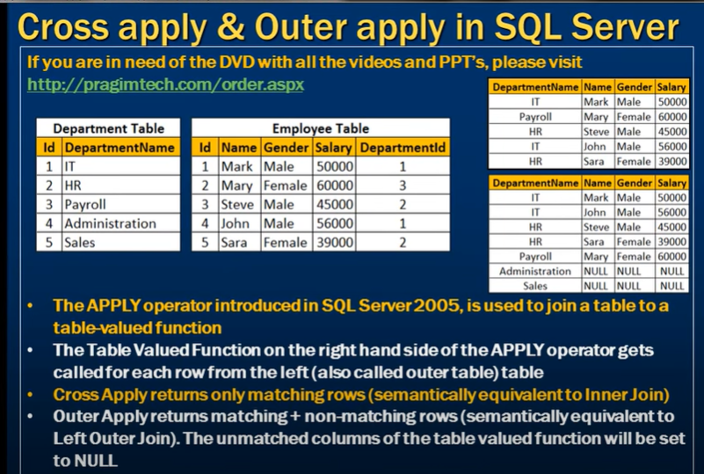 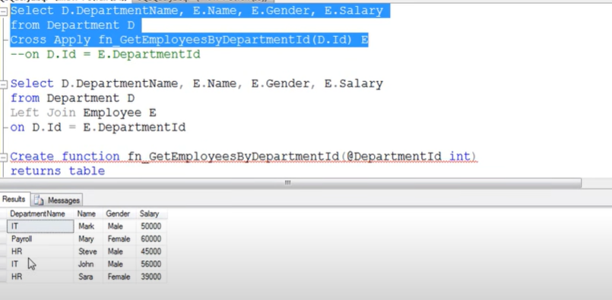

EXAMPLE TO TEST ALL THE JOINS

To test all the different types of joins, you can use the following SQL scripts to create two sample tables: employees and departments.

**Table 1: employees**

sql

Copy code

CREATE TABLE employees (

employee_id INT PRIMARY KEY,

first_name VARCHAR(50),

last_name VARCHAR(50),

department_id INT,

salary DECIMAL(10, 2)

);

INSERT INTO employees (employee_id, first_name, last_name, department_id, salary) VALUES

(1, 'John', 'Doe', 1, 60000),

(2, 'Jane', 'Smith', 2, 75000),

(3, 'Emily', 'Jones', 3, 50000),

(4, 'Michael', 'Brown', 4, 65000),

(5, 'Sarah', 'Davis', NULL, 55000),

(6, 'David', 'Wilson', 2, 70000);

**Table 2: departments**

sql

Copy code

CREATE TABLE departments (

department_id INT PRIMARY KEY,

department_name VARCHAR(50),

location VARCHAR(50)

);

INSERT INTO departments (department_id, department_name, location) VALUES

(1, 'HR', 'New York'),

(2, 'IT', 'San Francisco'),

(3, 'Finance', 'Chicago'),

(4, 'Marketing', 'Los Angeles'),

(5, 'Sales', 'Boston');

**Testing Joins**

Here’s how you can use these tables to test each type of join:

**1. INNER JOIN**

SELECT e.employee_id, e.first_name, e.last_name, d.department_name, d.location

FROM employees e

INNER JOIN departments d ON e.department_id = d.department_id;

**2. LEFT JOIN**

SELECT e.employee_id, e.first_name, e.last_name, d.department_name, d.location

FROM employees e

LEFT JOIN departments d ON e.department_id = d.department_id;

**3. RIGHT JOIN**

SELECT e.employee_id, e.first_name, e.last_name, d.department_name, d.location

FROM employees e

RIGHT JOIN departments d ON e.department_id = d.department_id;

**4. FULL JOIN**

SELECT e.employee_id, e.first_name, e.last_name, d.department_name, d.location

FROM employees e

FULL JOIN departments d ON e.department_id = d.department_id;

**5. CROSS JOIN**

SELECT e.employee_id, e.first_name, e.last_name, d.department_name, d.location

FROM employees e

CROSS JOIN departments d;

**6. NATURAL JOIN**

(Note: This join works only if there is a column with the same name in both tables. Since both tables have a department_id column, it can be used.)

SELECT e.employee_id, e.first_name, e.last_name, d.department_name, d.location

FROM employees NATURAL JOIN departments;

**7. SELF JOIN**

SELECT e1.employee_id, e1.first_name, e1.last_name, e2.employee_id AS manager_id, e2.first_name AS manager_first_name, e2.last_name AS manager_last_name

FROM employees e1

LEFT JOIN employees e2 ON e1.department_id = e2.department_id AND e1.salary < e2.salary;

**8. ANTI JOIN (Using LEFT JOIN and WHERE)**

SELECT e.employee_id, e.first_name, e.last_name

FROM employees e

LEFT JOIN departments d ON e.department_id = d.department_id

WHERE d.department_id IS NULL;

**9. SEMI JOIN (Using EXISTS)**

SELECT e.employee_id, e.first_name, e.last_name

FROM employees e

WHERE EXISTS (

SELECT 1

FROM departments d

WHERE e.department_id = d.department_id

);

These scripts should provide a comprehensive way to test all the different types of joins in SQL.

**DIFFERENCE BETWEEN SEMI JOIN and a LEFT JOIN**

A **SEMI JOIN** and a **LEFT JOIN** are conceptually different, and they do not produce the same result. Here's how they differ:

**LEFT JOIN:**

**Purpose**: Returns all rows from the left table, and the matched rows from the right table. If there is no match, the result will include NULL values for columns from the right table.

**Result**: The result set includes all columns from both tables.

**Example:**

SELECT e.employee_id, e.first_name, e.last_name, d.department_name

FROM employees e

LEFT JOIN departments d ON e.department_id = d.department_id;

**SEMI JOIN:**

**Purpose**: Returns all rows from the left table where there is at least one matching row in the right table. Unlike LEFT JOIN, a SEMI JOIN only returns the columns from the left table and does not duplicate rows from the right table.

**Result**: The result set only includes columns from the left table and excludes unmatched rows. It checks for existence, typically implemented using the EXISTS clause.

**Example:**

SELECT e.employee_id, e.first_name, e.last_name

FROM employees e

WHERE EXISTS (

SELECT 1

FROM departments d

WHERE e.department_id = d.department_id

);

**Key Differences:**

**Result Set**: A LEFT JOIN returns all rows from the left table, along with matched data from the right table or NULL if there’s no match. A SEMI JOIN only returns rows from the left table where there is a match in the right table.

**Column Selection**: A LEFT JOIN includes columns from both tables, while a SEMI JOIN only includes columns from the left table.

**Duplicate Handling**: A LEFT JOIN can result in duplicate rows if multiple matches exist, while a SEMI JOIN does not duplicate rows.

**Conclusion:**

A SEMI JOIN is **not** the same as a LEFT JOIN. The LEFT JOIN is used to retrieve all rows from the left table and optionally matched rows from the right table. In contrast, a SEMI JOIN is used to filter rows from the left table based on the existence of a match in the right table.

Self Join: In a self join, you need to use table aliases to distinguish between the same table when it appears more than once in the query. The syntax typically involves using aliases for the same table and specifying the join condition based on the relationship between different rows within that table.

SELECT A.column1, B.column2

FROM table_name A, table_name B

WHERE A.relationship_column = B.relationship_column;

Cross Join: A cross join does not require any join conditions because it combines all rows from both tables. The syntax simply lists the tables you want to cross join.

sql

Copy code

SELECT *

FROM table1

CROSS JOIN table2;

Result:

Self Join: The result of a self join is a combination of rows from the same table where the join condition is satisfied. It allows you to retrieve related information from different rows within the same table.

Cross Join: The result of a cross join is a Cartesian product of the two tables involved. It generates all possible combinations of rows from both tables, which can result in a very large result set if the tables are large.

Use Cases:

Self Join: Self joins are used for scenarios where you need to work with hierarchical data or compare records within the same table, such as in organizational charts, bill of materials, or when modeling relationships like parent-child or employee-manager.

Cross Join: Cross joins are less common and are typically used when you explicitly need all possible combinations between two tables. They are used sparingly because they can lead to large result sets and are often unnecessary.

In summary, self joins are used to relate rows within the same table, while cross joins combine all rows from one table with all rows from another table without any specific relationship between them. The choice between the two depends on your specific data and query requirements.

what is difference between Database and DBMS

The terms "database" and "DBMS" (Database Management System) are related but refer to different concepts in the context of information technology and data management:

**Database:**

A database is a structured collection of data organized and stored for efficient retrieval, manipulation, and management. It is designed to support the storage and retrieval of information according to predefined schemas or data models.

In simpler terms, a database is a container that holds data in an organized manner, allowing users and applications to store, retrieve, update, and manage data efficiently.

Examples of databases include MySQL, PostgreSQL, Microsoft SQL Server, Oracle Database, MongoDB, etc.

**DBMS (Database Management System):**

A DBMS is software that facilitates the creation, maintenance, and use of databases. It provides an interface for users and applications to interact with the database, allowing them to perform various operations such as data entry, querying, updating, and administration.

The primary functions of a DBMS include data definition (creating and managing database schemas), data manipulation (inserting, updating, deleting data), data retrieval (querying data), and data administration (security, backup, recovery).

DBMS software manages the underlying data storage, indexing, transaction management, concurrency control, and other aspects of database management.

Examples of DBMS include MySQL, PostgreSQL, Microsoft SQL Server, Oracle Database, MongoDB, SQLite, etc.

In summary, a database is the actual repository of structured data, while a DBMS is the software system that provides tools, functions, and services to manage and interact with the database effectively. Without a DBMS, managing and utilizing databases efficiently would be challenging, as it provides a layer of abstraction and automation for database-related tasks.

**Transaction control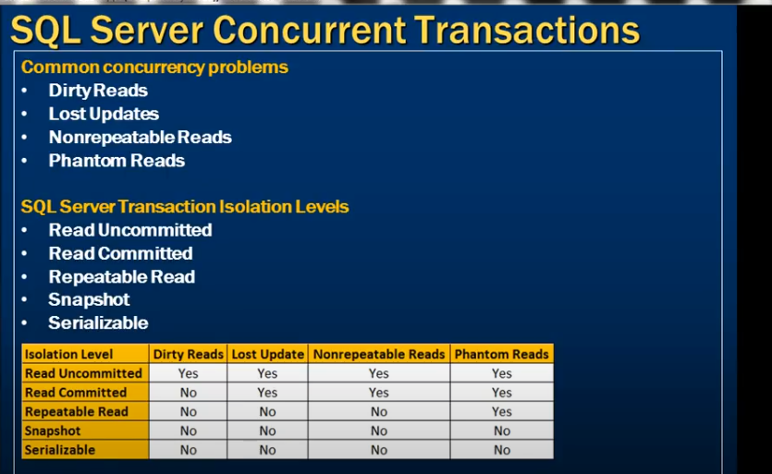sql server dirty read**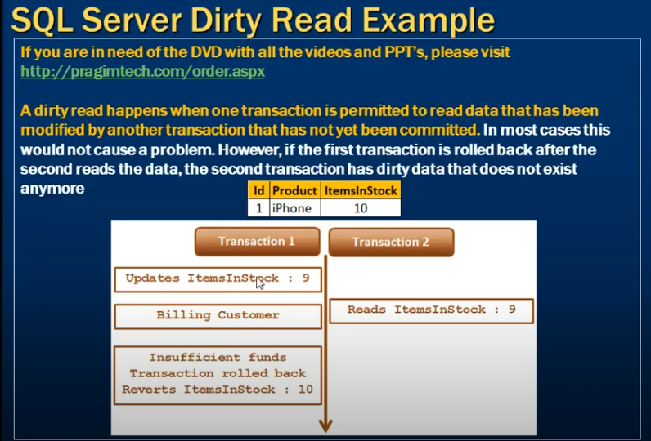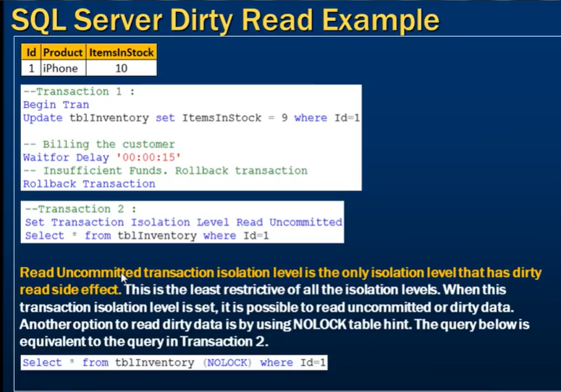

**sql server lost update**

https://www.youtube.com/watch?v=jD0c4X0tSc8&list=PL08903FB7ACA1C2FB&index=73

no other transaction modify or delete the data that first transaction read

note :- in repeatable read isolation level other transaction can insert the records only update and delete is block.

process :-

step 1 :- transaction 1 read the data

step 2 :- transaction 2 read the data

step 3 :- transaction 2 sell two item and update to the 8.

step 4 :- transaction 1 sell 1 item and update to the 9.

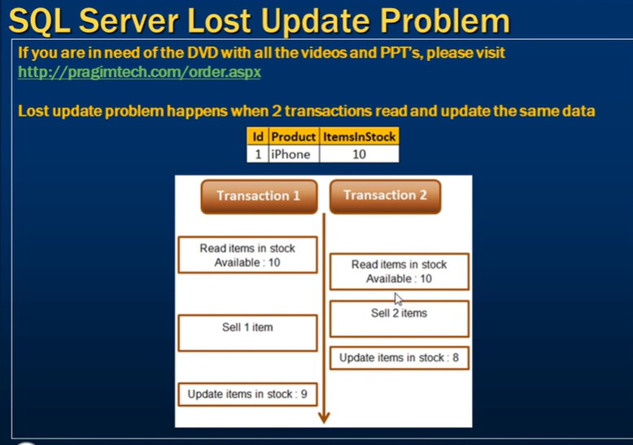

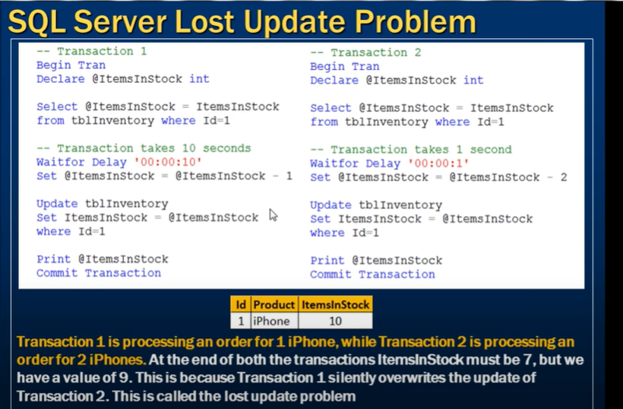

You can see it in example

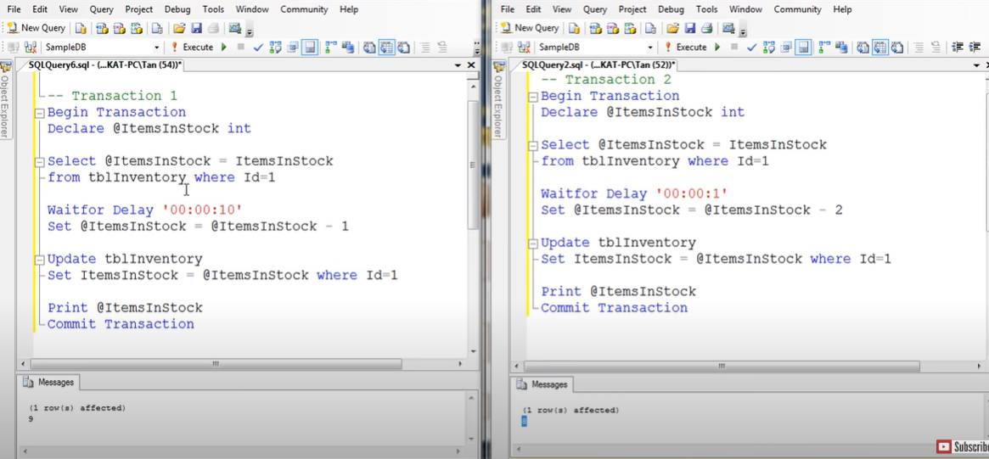To tackel this problem we use repeatable read level

In this transaction 2 is block to do the update and delete opration on the data which is read by the first transaction.like if some transaction read same data then you can not perform the update or delete operation on that data

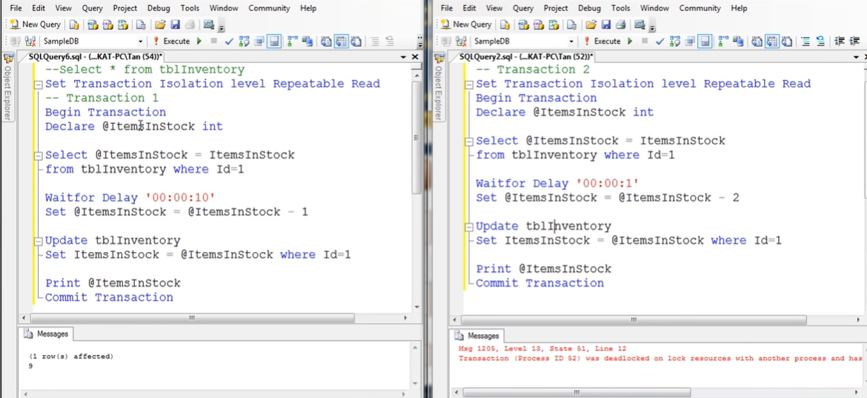

But below query run fine because we are updating the two different rows like id = 2 in transaction 2 and transaction 1 read the id =1.

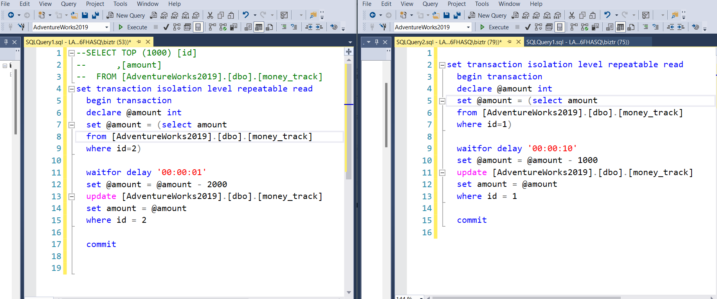

Non repeatable read

In non repeatable read the problem is like we are getting the different output after read in transaction as shown below

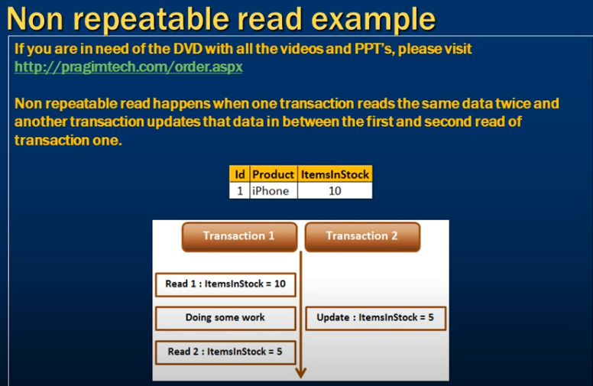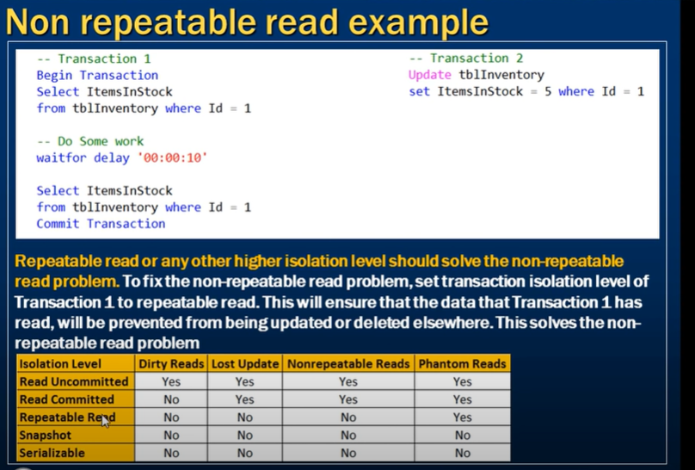

Ex :- 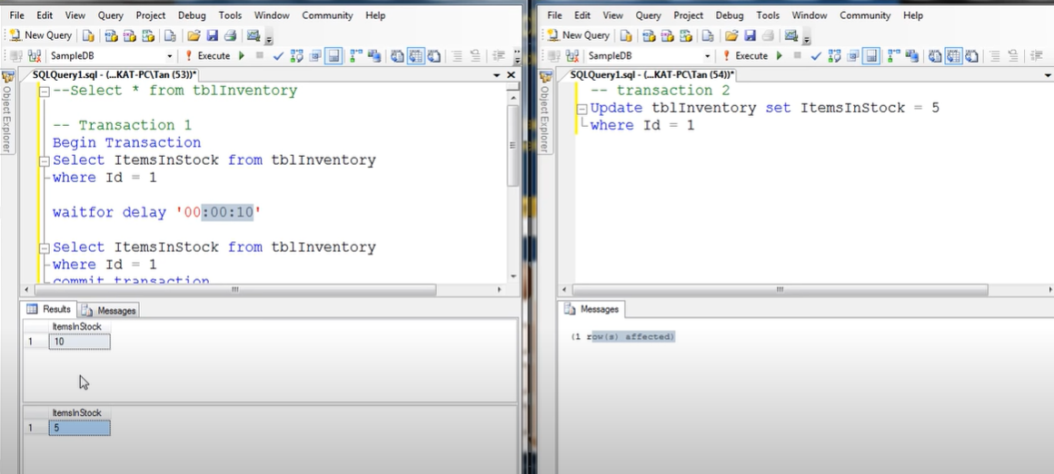

So to tackel this we can use the repeatable read as we done in lost update problem.in below the transaction 2 happened after the transaction 1 completed.

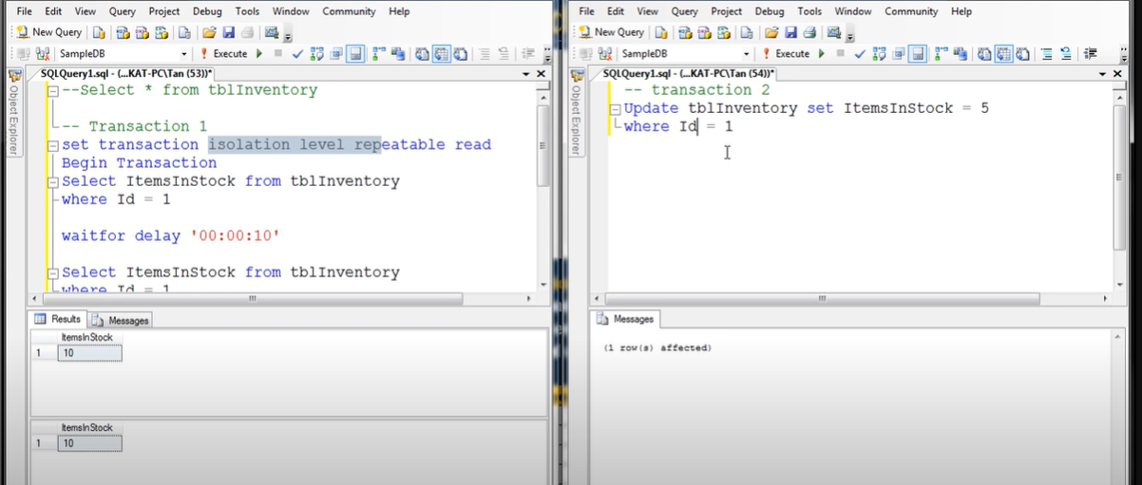

**Phantom reads**

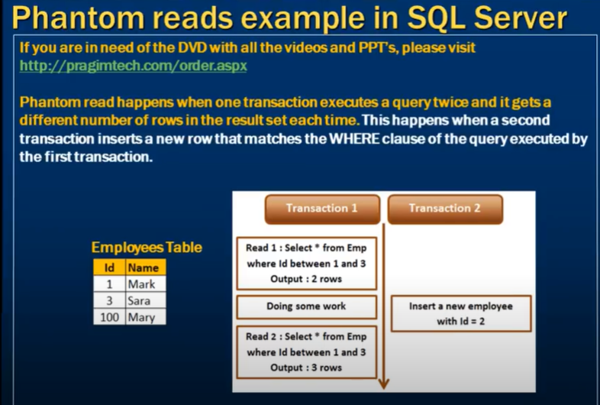without isolation level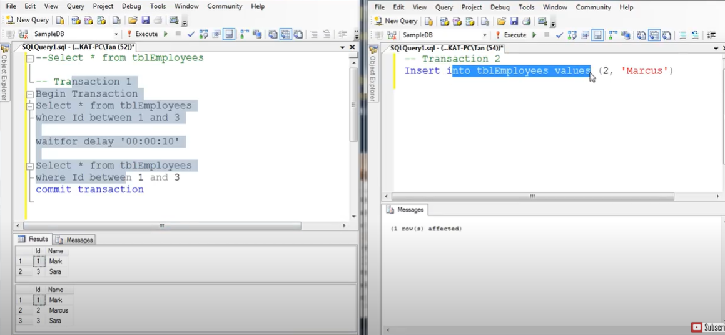to fix this use 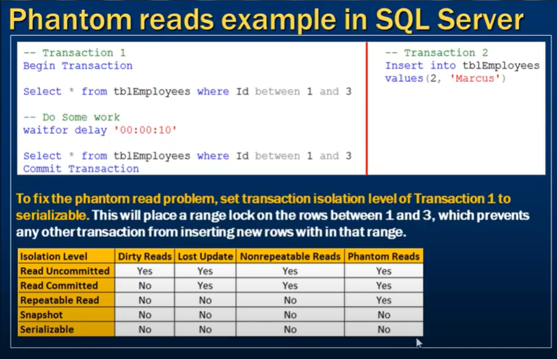

After isolation level

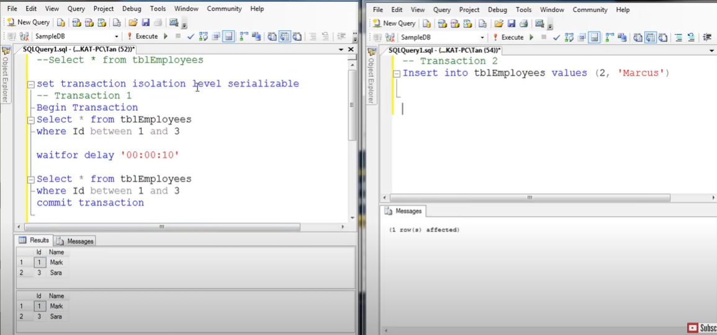how it fix the problem

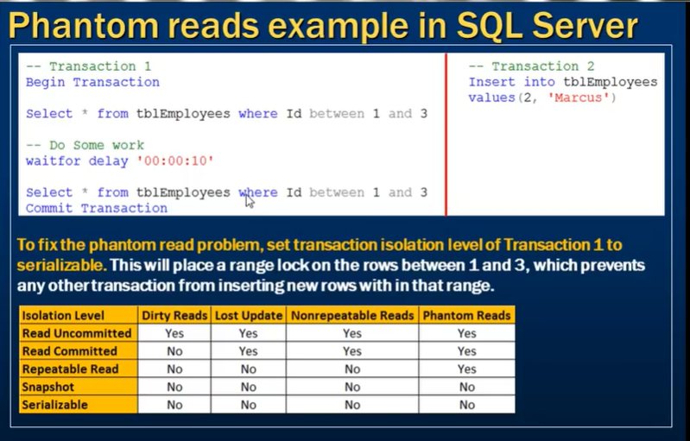

Difference between repeatable read and serializable

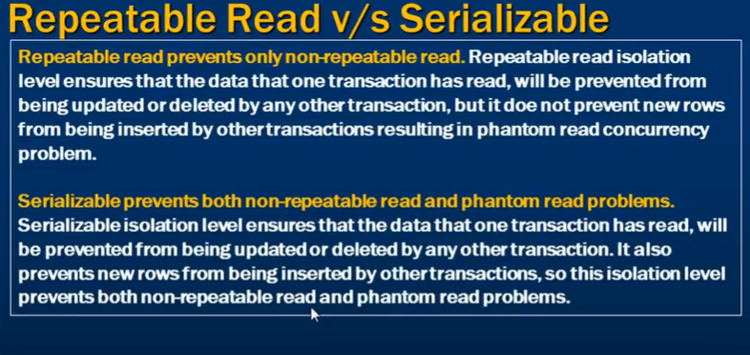

**Snapshot isolation level**

When we use the isolation level it will not only prevent other record to update/delete the selected data in another transaction but also prevent the transaction to select the data if another transaction is updating\deleting the data.

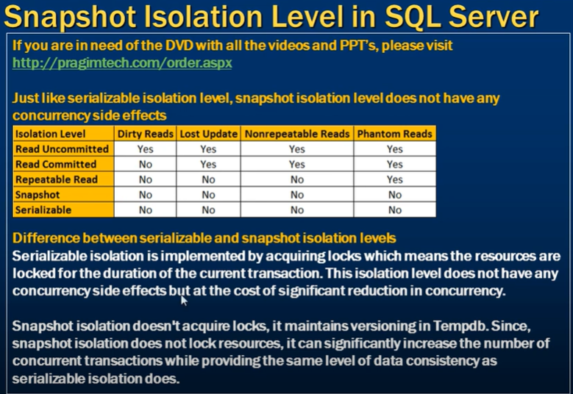

Using serializable isolation level

Its blocking other transactions to perform the operation on data which is transaction 1 using.

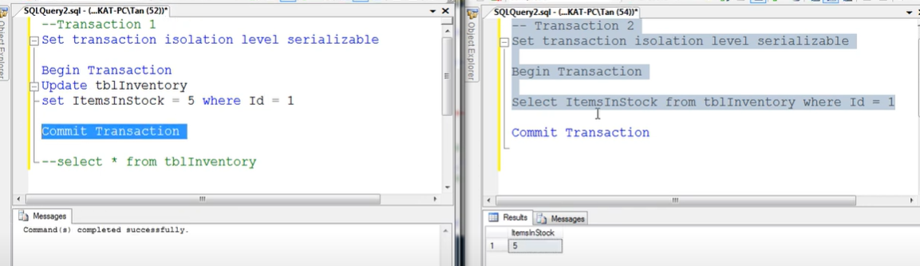

Using snapshot isolation

In this example transaction 2 read the commited data and its not blocking the transaction as well.what happened here is that the original copy of data is store in the temp db and that copy of data is now use by the transaction 2.

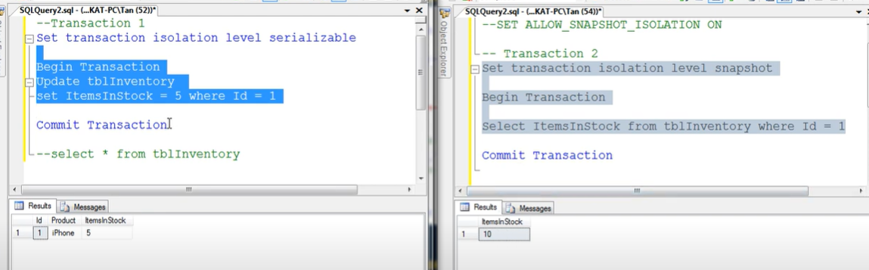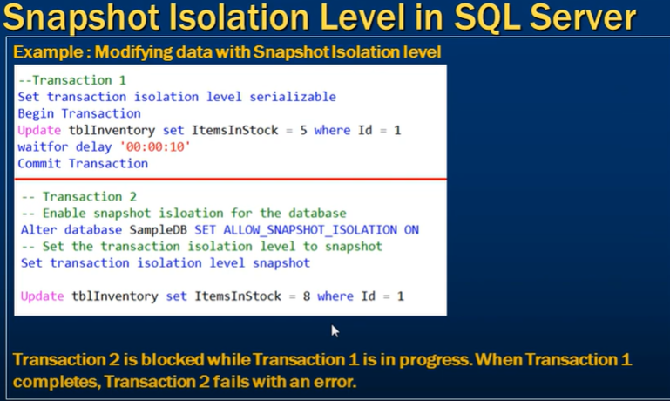

Note :- when we use snapshot isolation level and try to update the data which another transaction is updating then the transaction will be blocked and it will block untile transaction 1 is completed and after commiting the transaction 1 , transaction 2 will fail with error message. 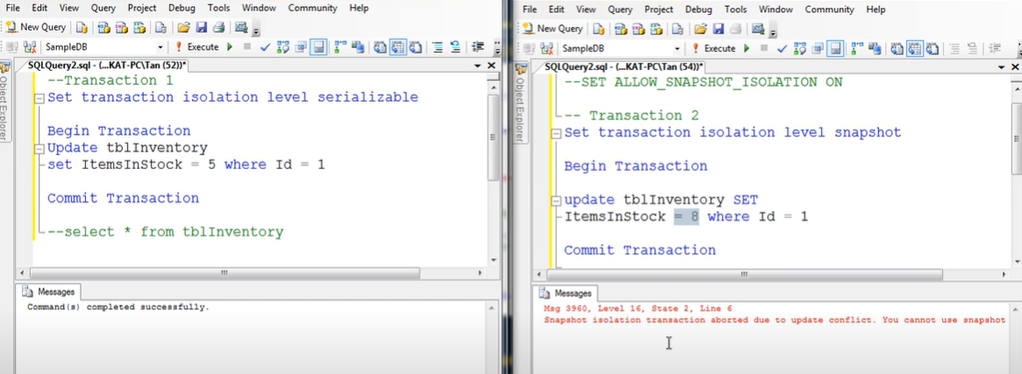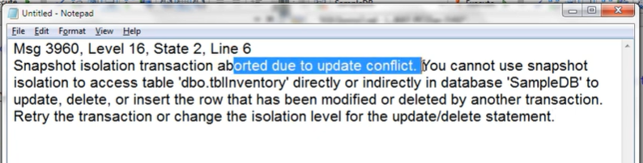

**Read committed snapshot isolation level**

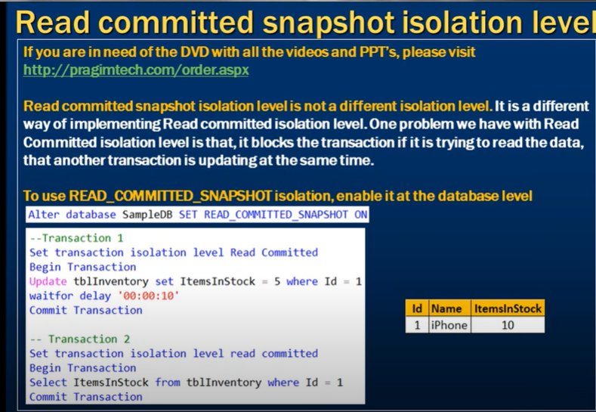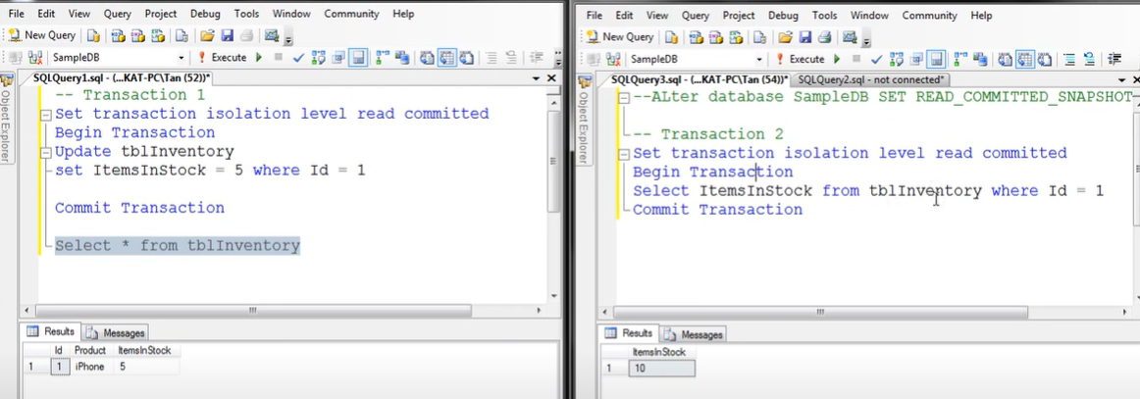

Achieving same using snapshot isolation level

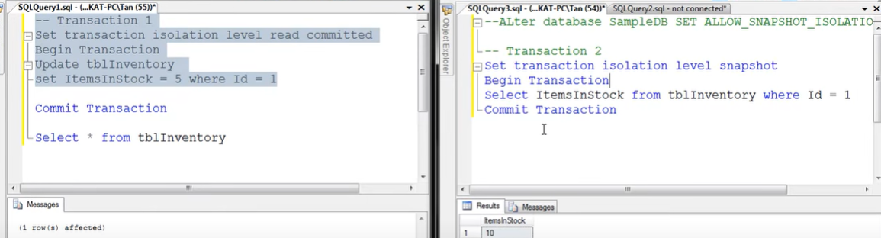

**Difference between snapshot isolation and read committed snapshot**

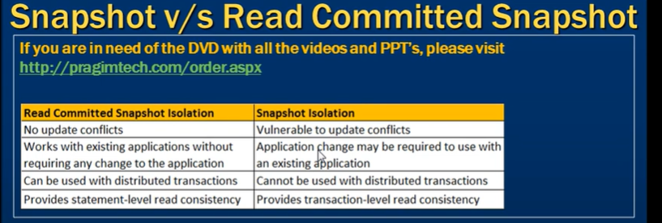Top of Form

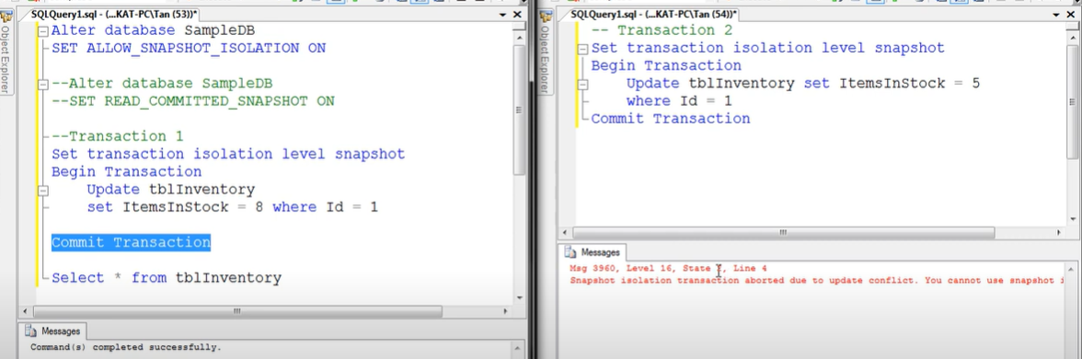 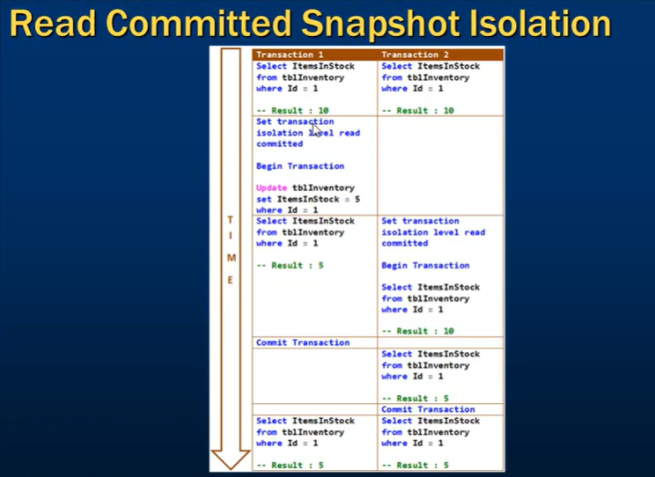 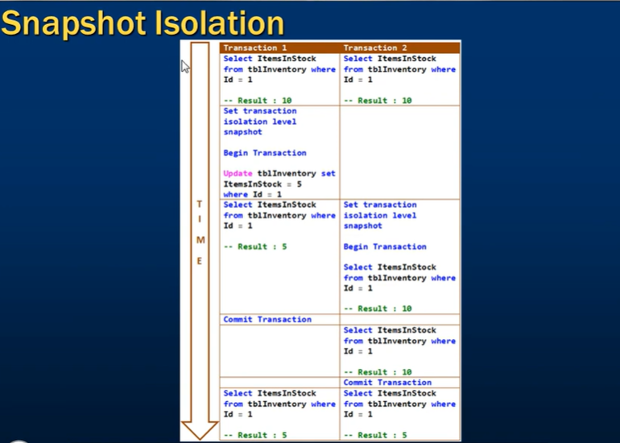

Deadlock in SQL Server

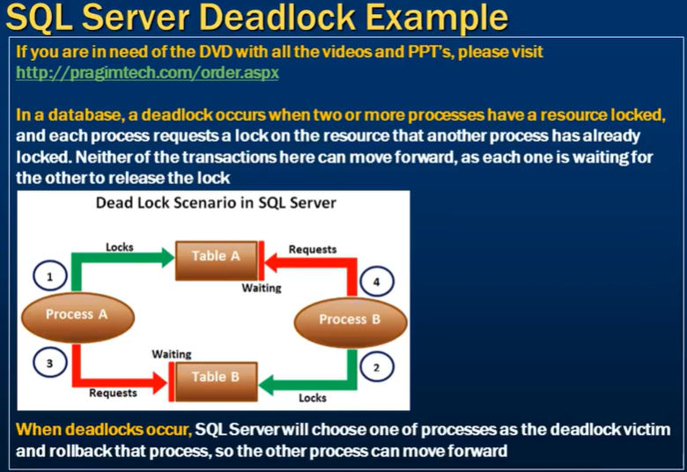

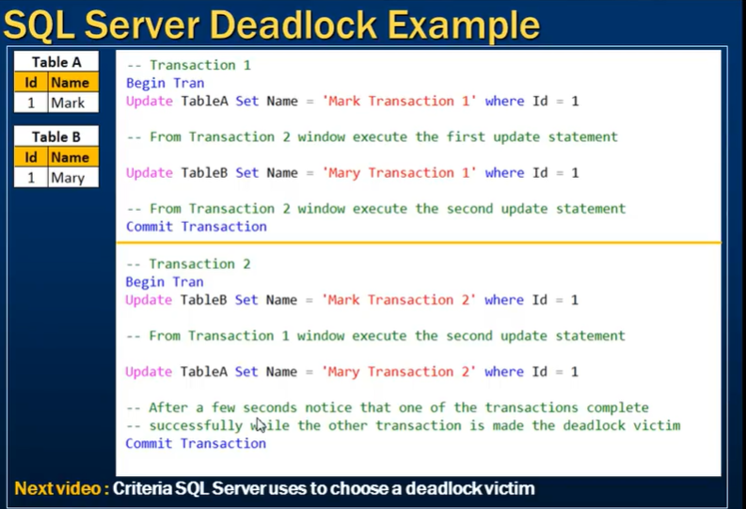

Deadlock victim selection

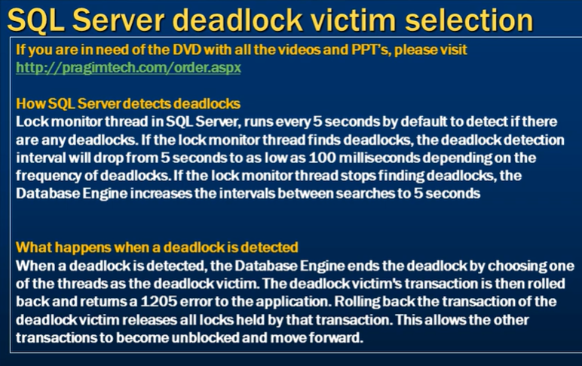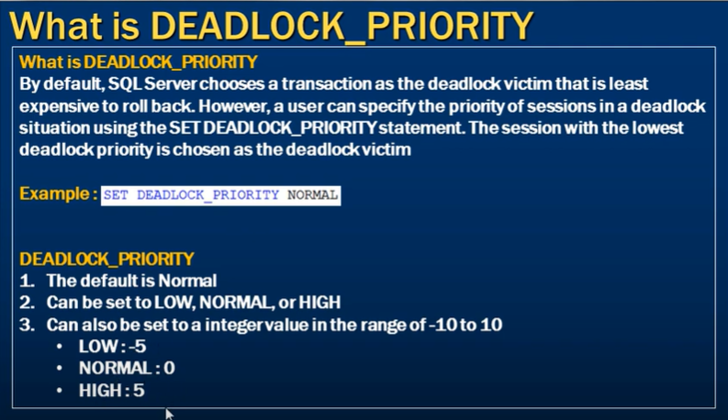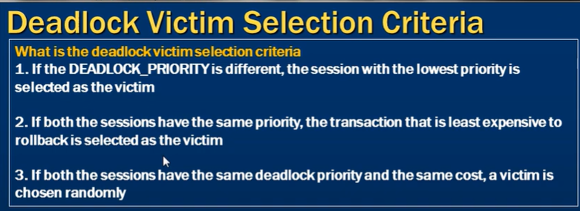

Without defining the transaction priority

Transaction 2 Is chosen as victim because it is least expensive to rollback as it need to rollback only one updated row.

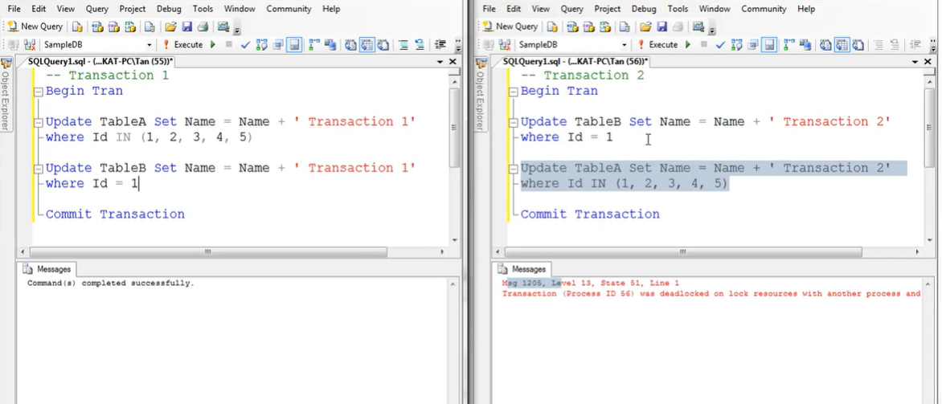

After setting deadlock priority

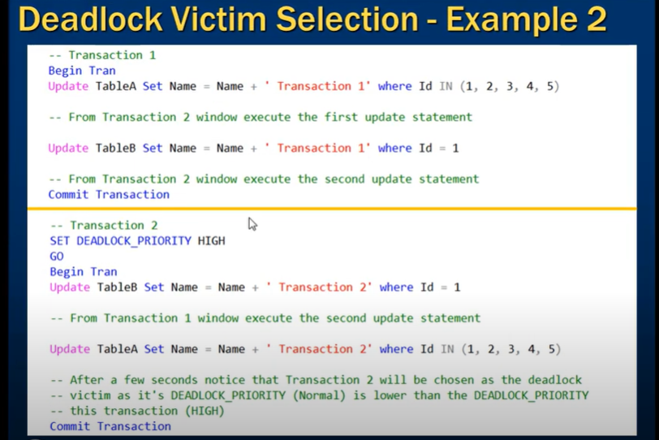

Logging deadlock in SQL Server

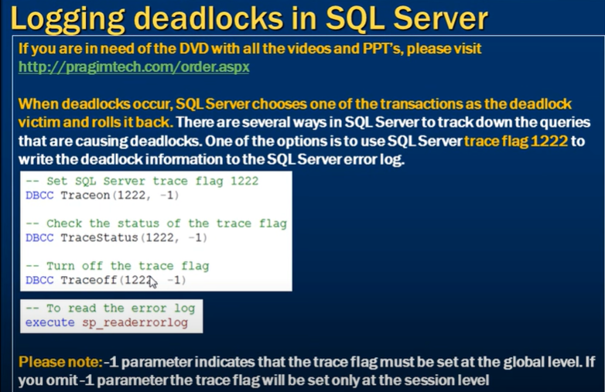

Store procedure to cause deadlock 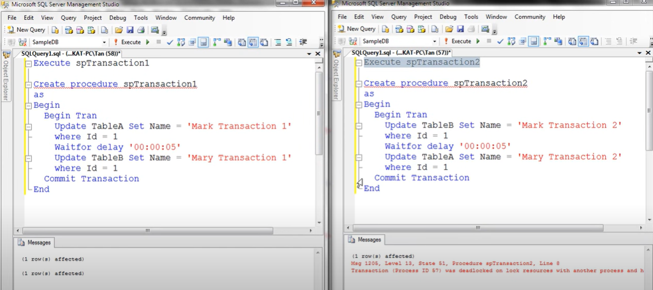

Read error log 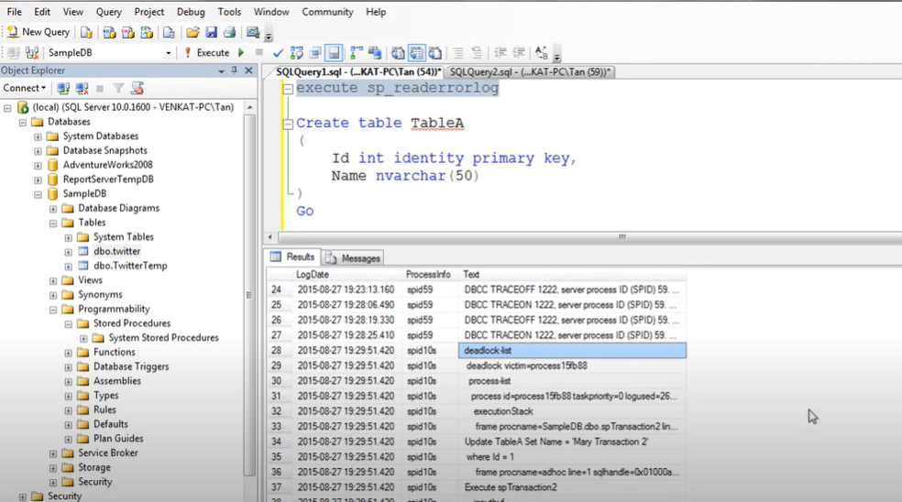

**SQL Server deadlock analysis and prevention** 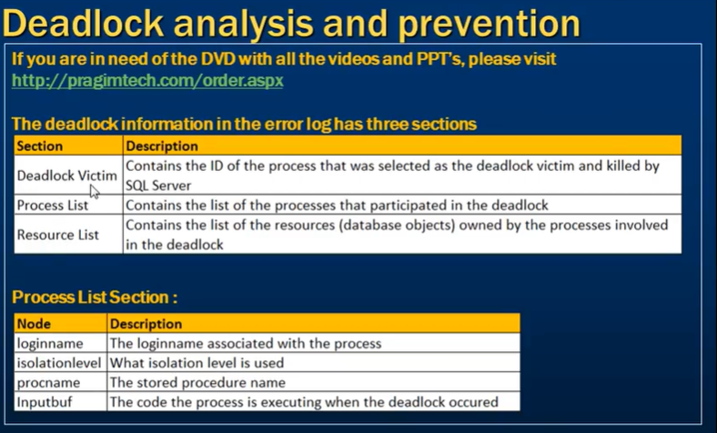

**Capturing deadlocks in sql profiler**

to start the deadlock profile go to

tools 🡪 SQL Server Profiler 🡪 select the connection 🡪 genral 🡪 use the template 🡪 Blank 🡪 Event selection 🡪 lock 🡪 deadlock graph

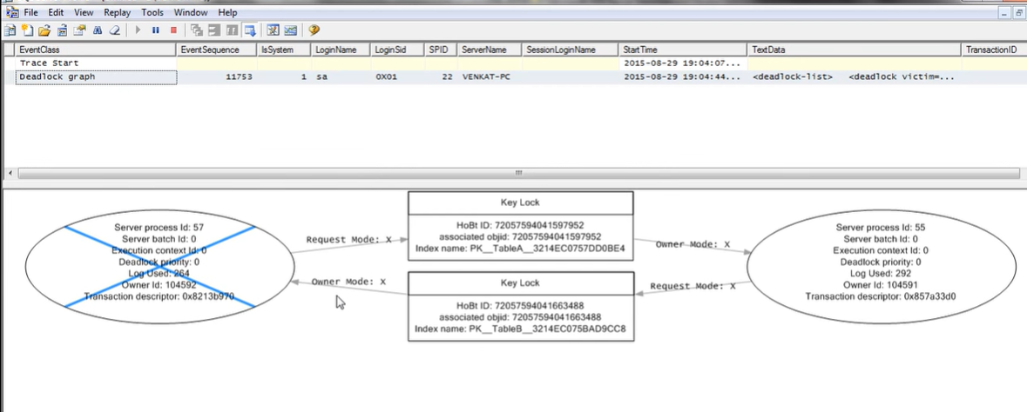

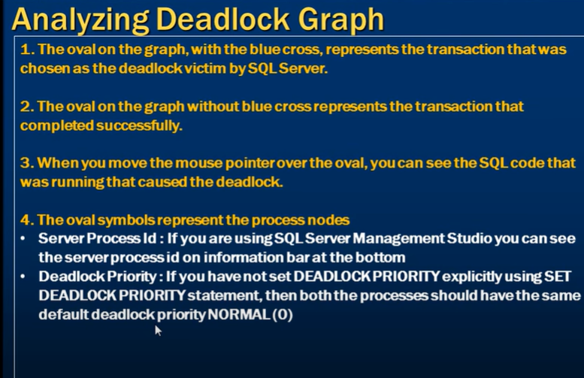 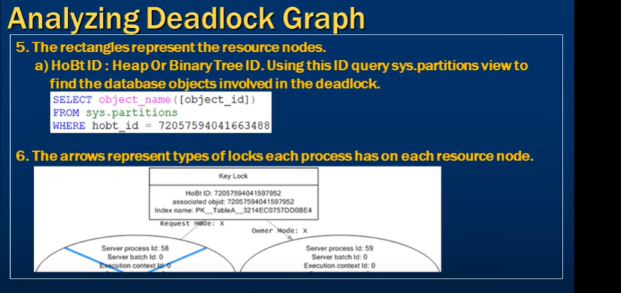

How to find the blocking queries

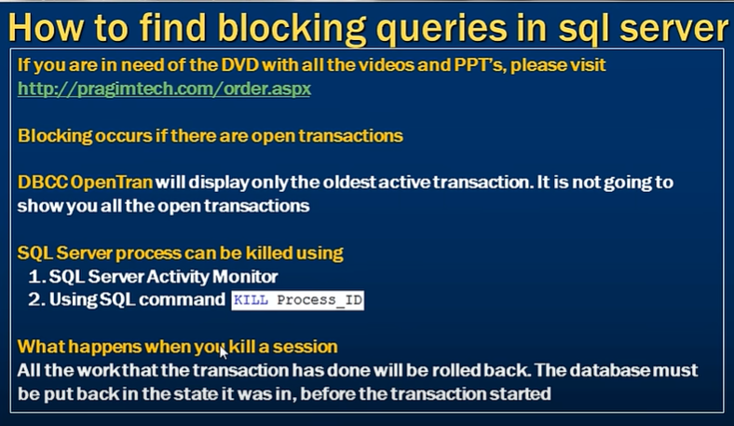

**How to Prevent Deadlocks**

Deadlocks can’t always be 100% eliminated, but with consistent locking order, short transactions, and proper indexing, you can reduce them to near zero.

**1️⃣ Access Resources in the Same Order**

Always ensure transactions touch tables (or rows) in a consistent order across your app.

Example:

-- Always lock AccountID 1 before AccountID 2

UPDATE Accounts SET ... WHERE AccountID = 1;

UPDATE Accounts SET ... WHERE AccountID = 2;

**2️⃣ Keep Transactions Short**

Avoid holding locks for long.  
✅ Do only what’s necessary inside a transaction.  
❌ Don’t include user input, long calculations, or waits inside a transaction.

**3️⃣ Use Lower Isolation Levels (when safe)**

Default = READ COMMITTED.  
If possible, use:

SET TRANSACTION ISOLATION LEVEL READ COMMITTED;

or even:

SET TRANSACTION ISOLATION LEVEL READ UNCOMMITTED;

(reads dirty data, so only use if safe)

Or, better: use **READ COMMITTED SNAPSHOT** (RCSI) to reduce lock contention:

ALTER DATABASE YourDB SET READ_COMMITTED_SNAPSHOT ON;

**4️⃣ Add Proper Indexes**

Deadlocks often occur when SQL Server scans large tables and locks many rows.

✅ Create indexes so queries can find and lock *only* what’s needed.

**5️⃣ Avoid User Interaction in Transactions**

Don’t pause or wait for user input between statements inside a transaction — this keeps locks open longer and increases deadlock risk.

**6️⃣ Use Try-Catch + Retry Logic**

Even with prevention, deadlocks can still happen occasionally.

Wrap logic in a retry block:

DECLARE @retry INT = 0;

WHILE @retry < 3

BEGIN

BEGIN TRY

BEGIN TRAN;

-- Your logic here

COMMIT;

BREAK; -- success, exit loop

END TRY

BEGIN CATCH

IF ERROR_NUMBER() = 1205

BEGIN

SET @retry += 1;

PRINT 'Deadlock detected, retrying...';

END

ELSE

BEGIN

THROW; -- rethrow other errors

END

END CATCH

END

**7️⃣ Use Locking Hints Carefully**

Sometimes you can prevent escalation or reduce conflicts with:

SELECT ... FROM Table WITH (ROWLOCK, UPDLOCK);

…but use them carefully — overuse can cause performance issues.

**8️⃣ Monitor and Analyze Deadlocks**

You can capture deadlocks via:

* **SQL Server Profiler** → Deadlock Graph
* **Extended Events** → xml_deadlock_report
* **System Health Session** (built-in)

Then analyze which queries and resources are involved.

**🧭 Summary Table**

| **Cause** | **Prevention** |
| --- | --- |
| Different resource order | Access in consistent order |
| Long transactions | Keep them short |
| High isolation level | Use snapshot or lower |
| Missing indexes | Add proper indexes |
| Lock escalation | Use smaller transactions or hints |
| Random occurrence | Add retry logic |

**Replacing null values**

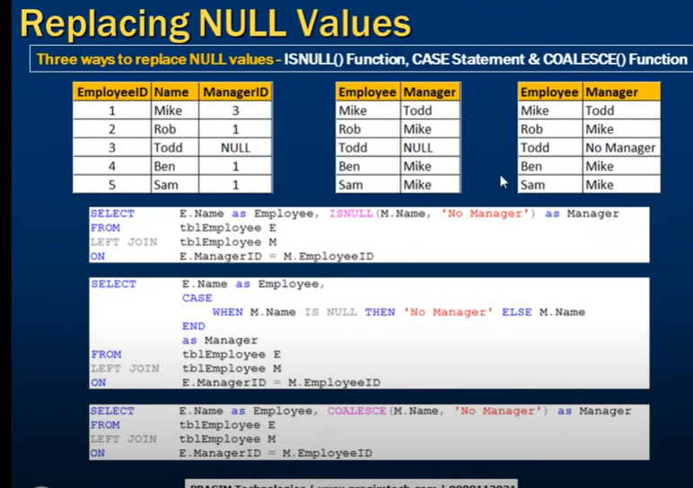

**Temporary table**

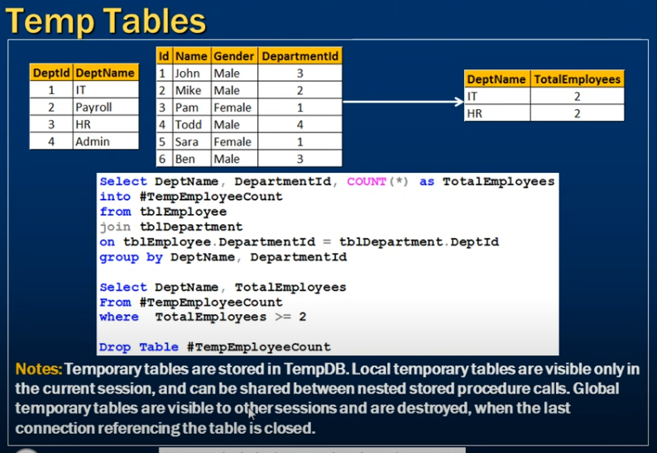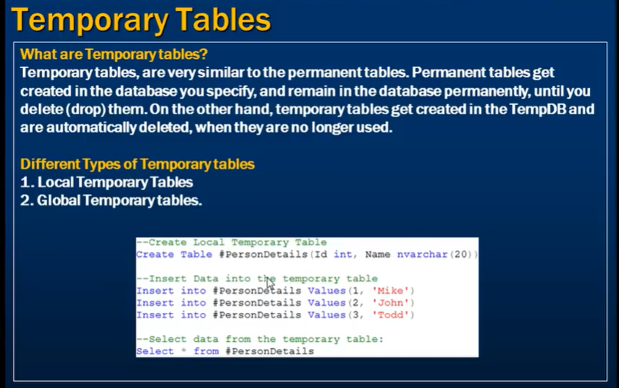 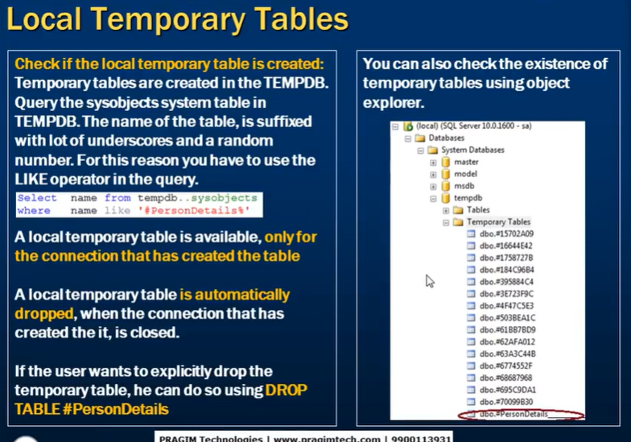 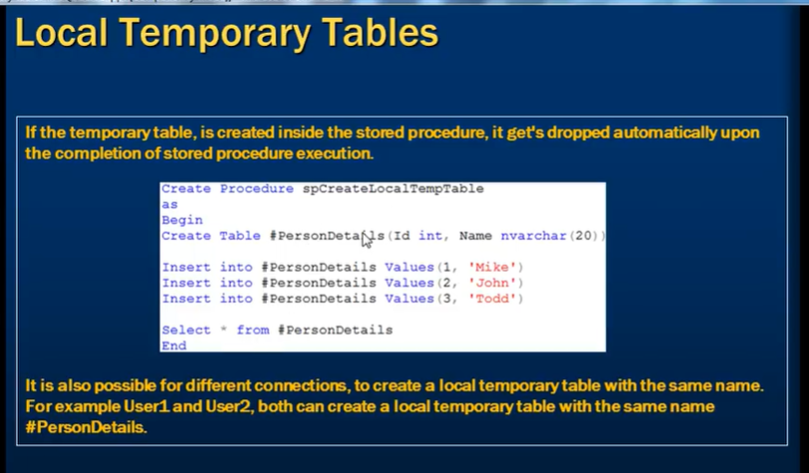 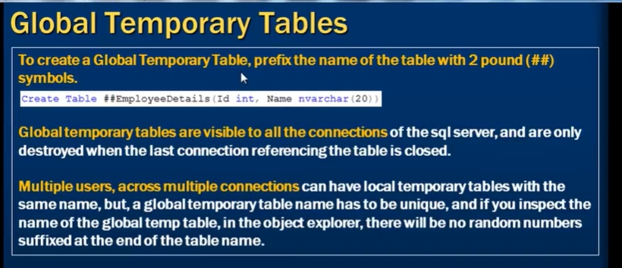 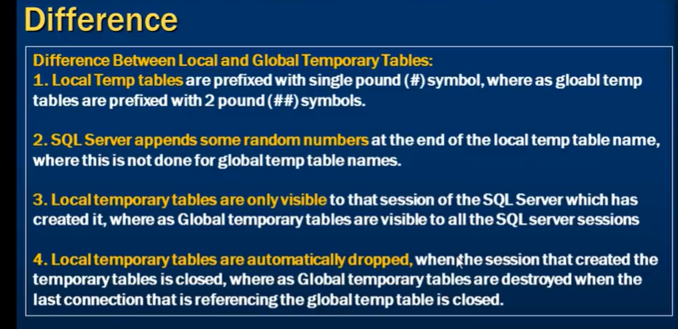

**TABLE VARIABLE**

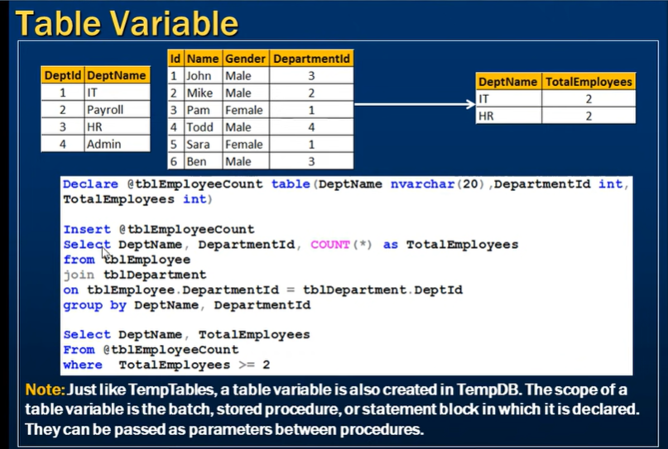

DERIVED TABLE

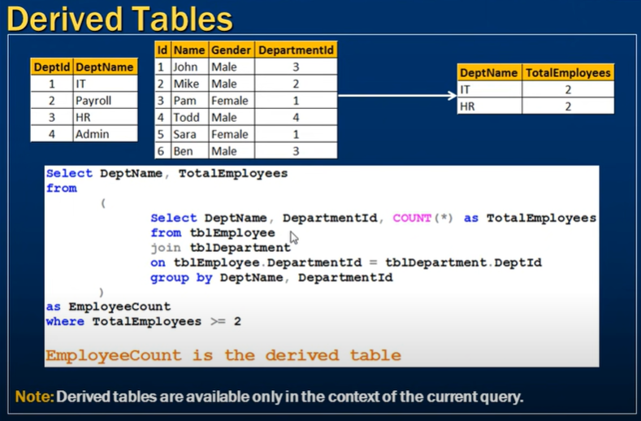

**CTE**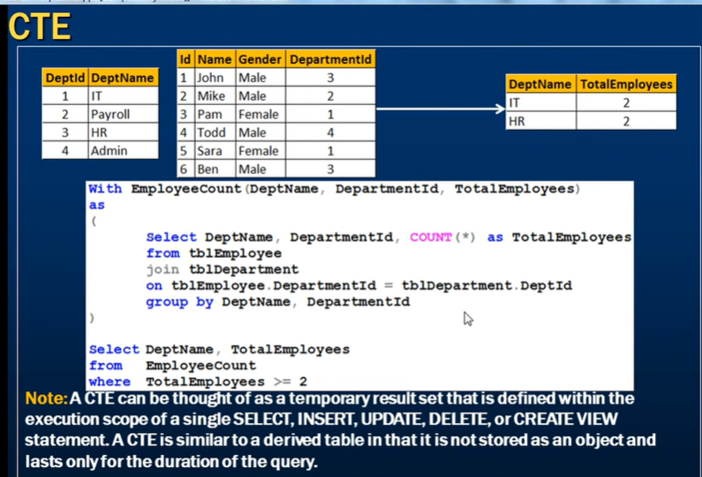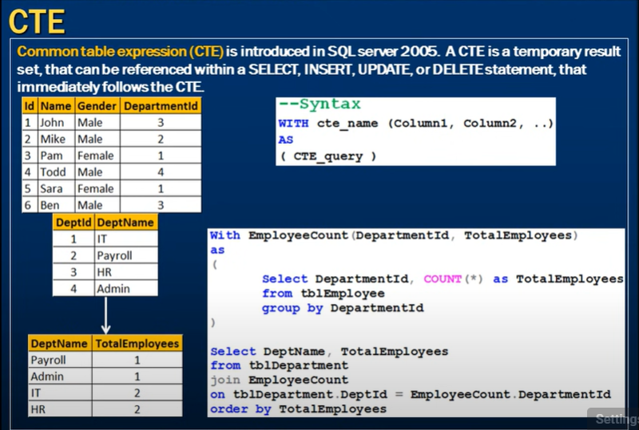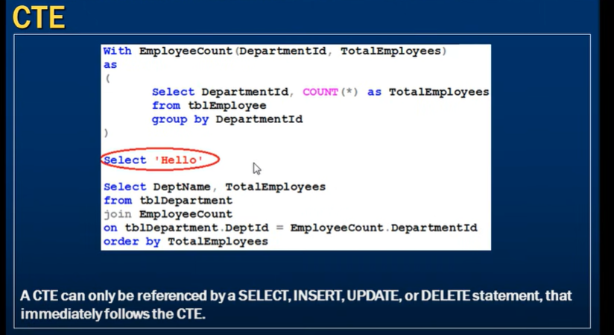

**UPDATABLE CTE**

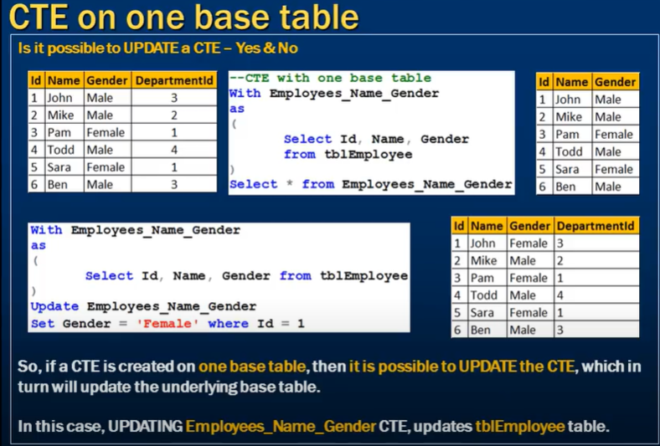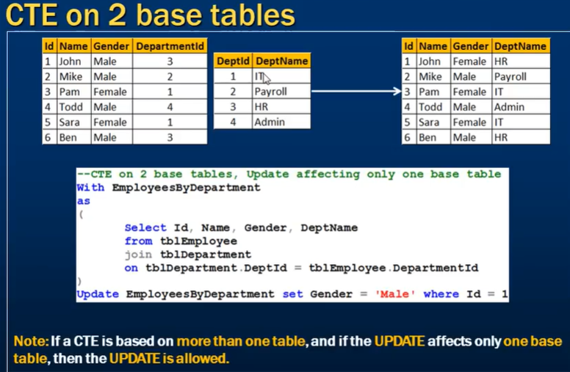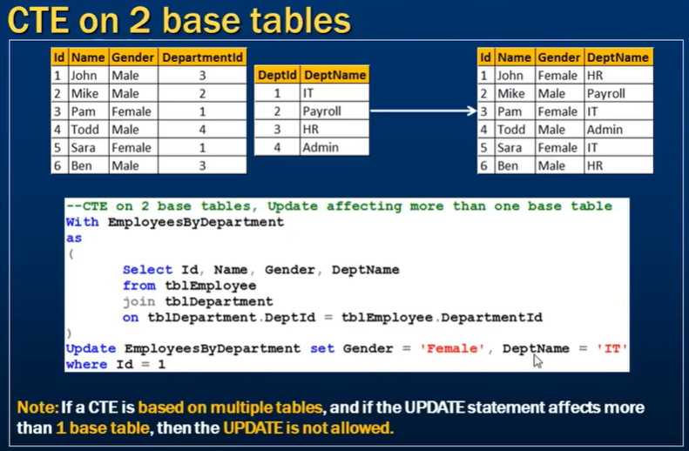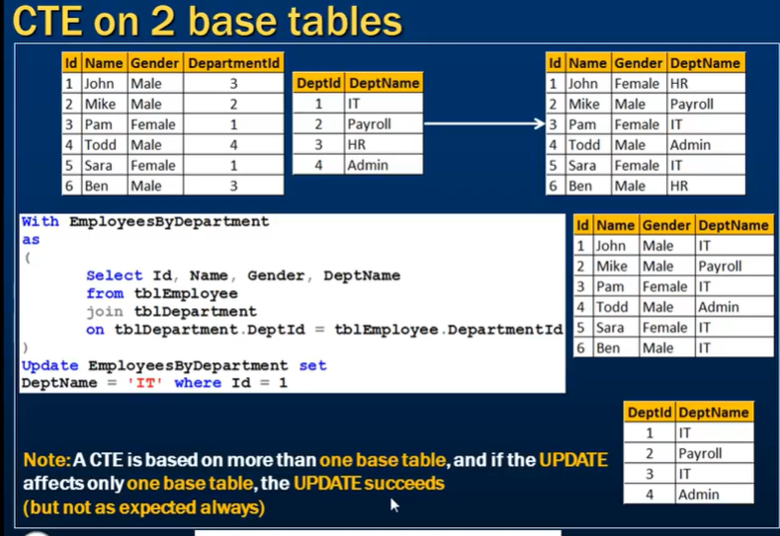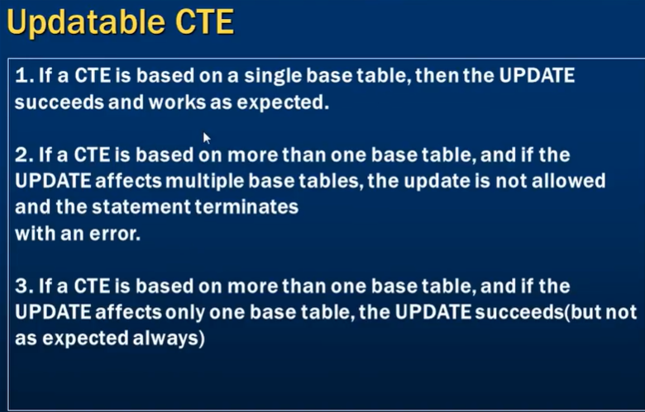Genrating random number between given numbers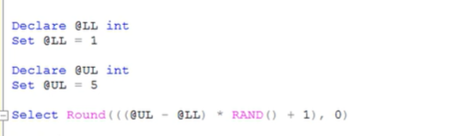

**What to choose for performance SubQuery or Joins**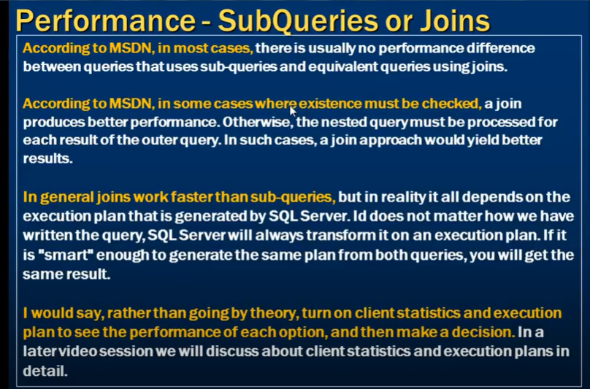

**List all tables in a sql server database using a query**

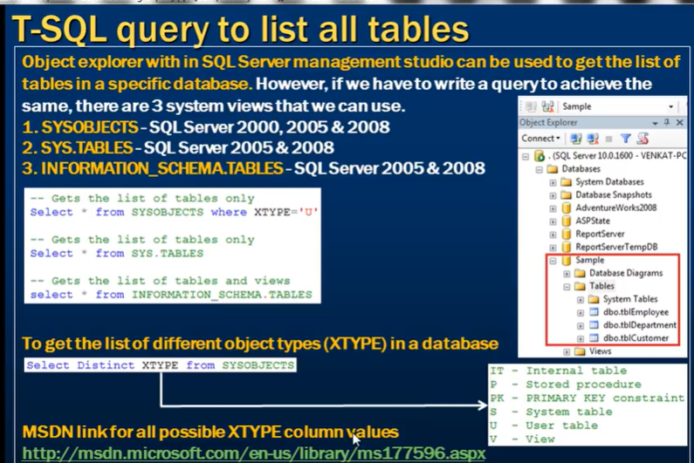**Writing re runnable sql server scripts 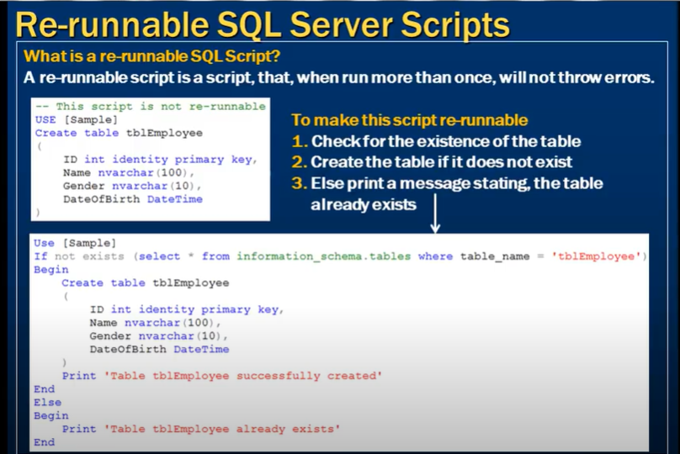** 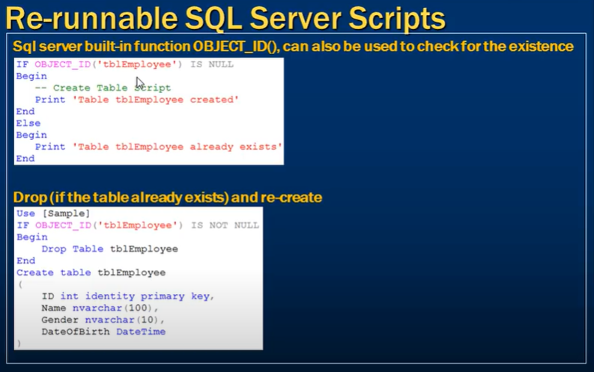 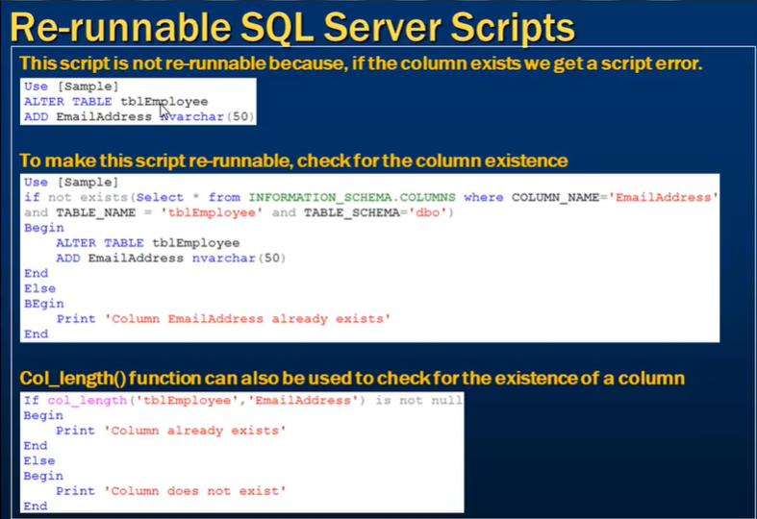

**Grouping Sets in SQL Server**

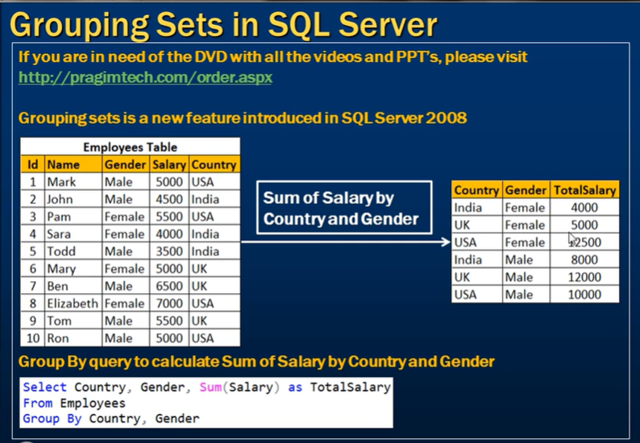 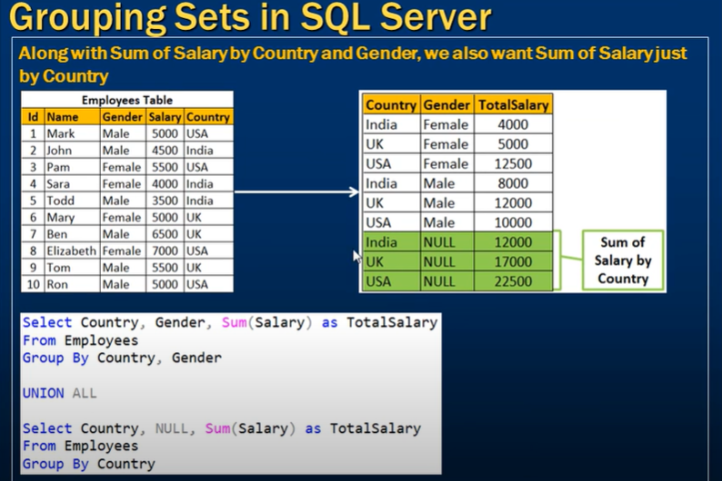 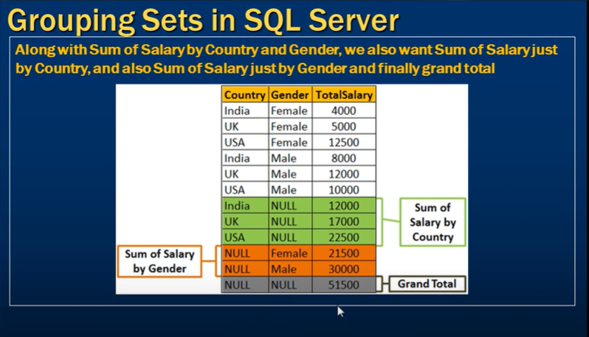 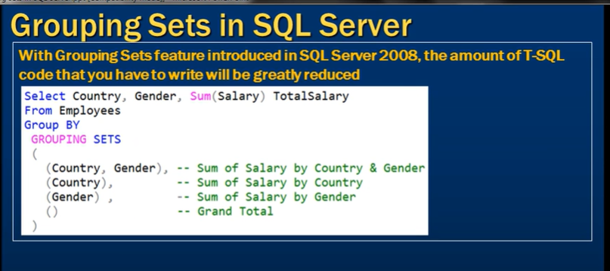**Rollup in SQL Server**

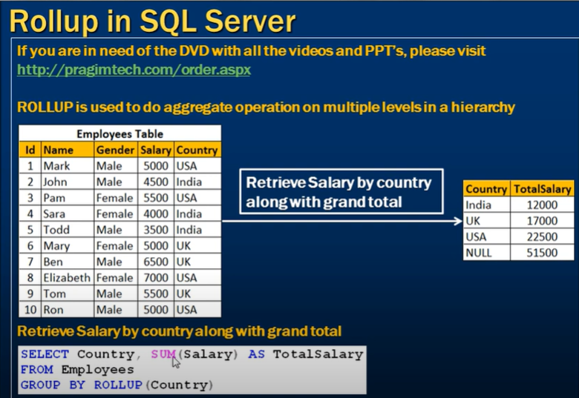 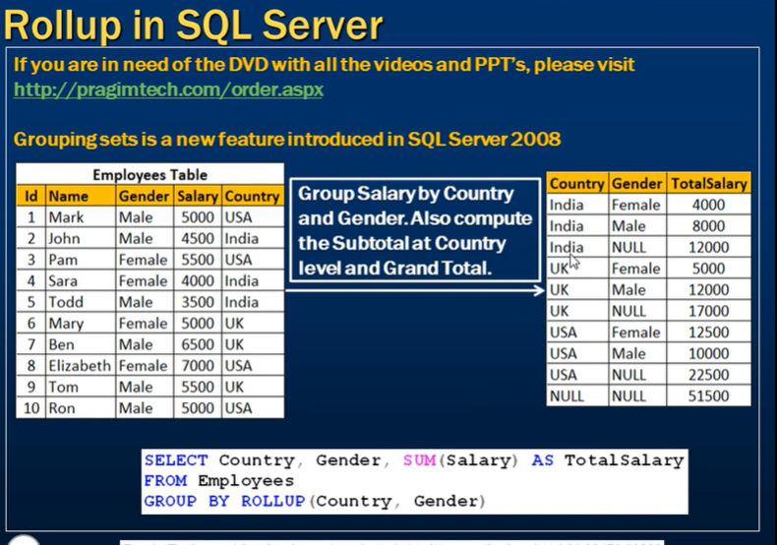

**Cube in SQL Server**

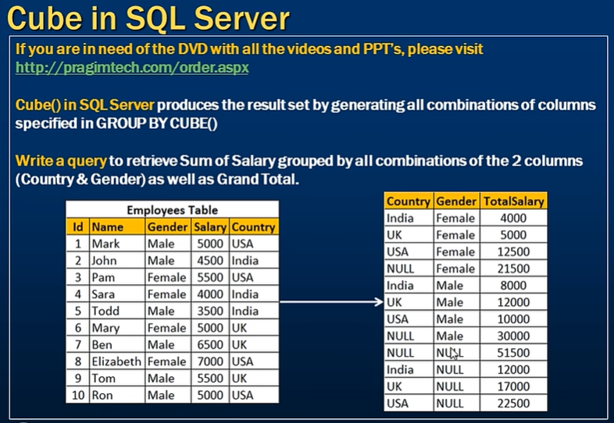 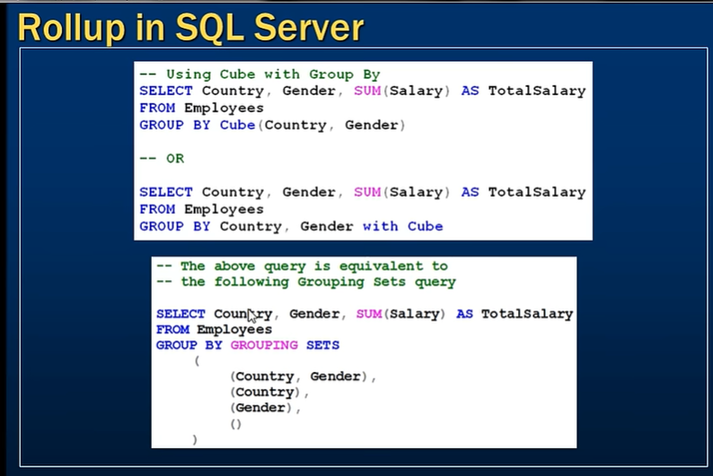

**Difference between cube and rollup in SQL Server**

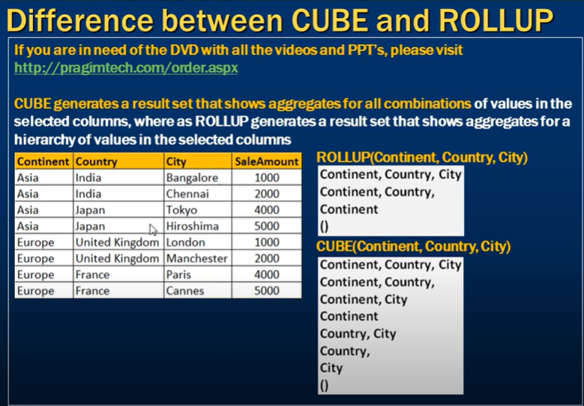 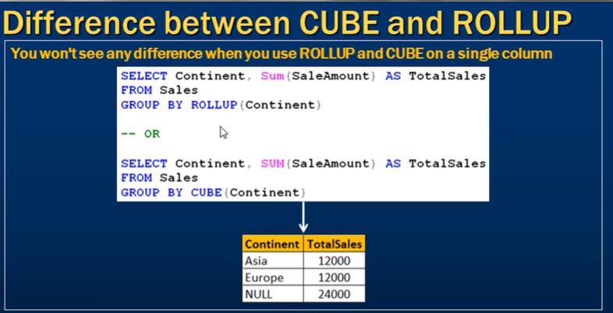

**Grouping function in SQL Server**

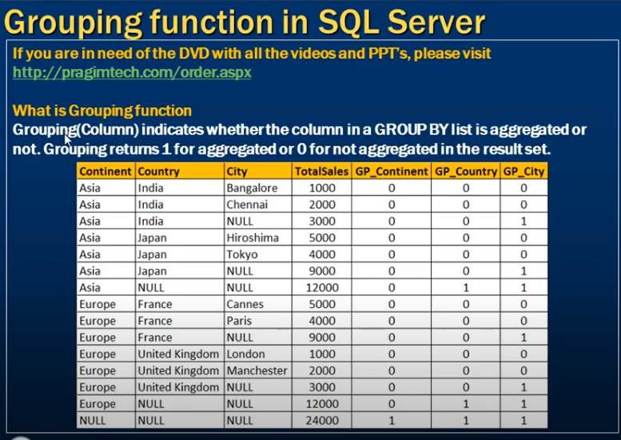 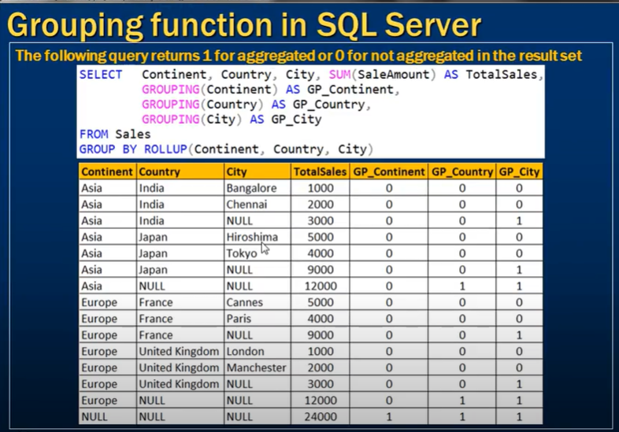 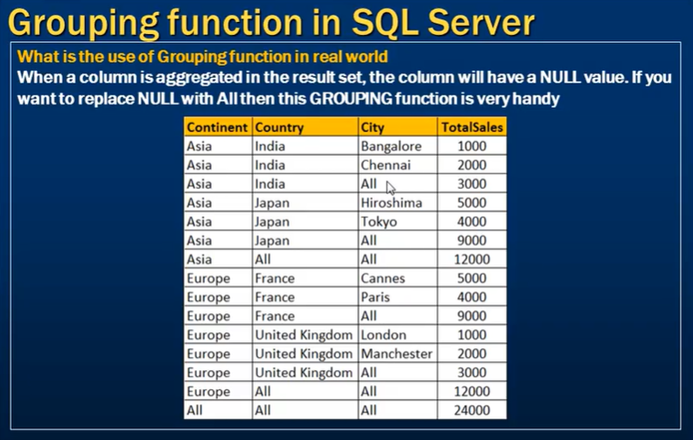 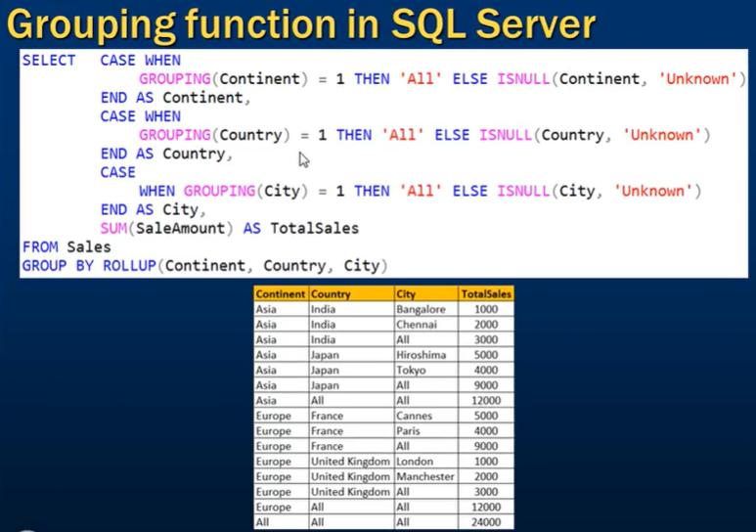

Note :- Reasone to use Grouping function instead of ISNULL is that if column contain null value then data is aggergated based on that null column like ( asia, india, null) but because we use ISNULL it will convert that into ALL which is not right and we will misslead that like it has aggergated for all city in asia continent and india country.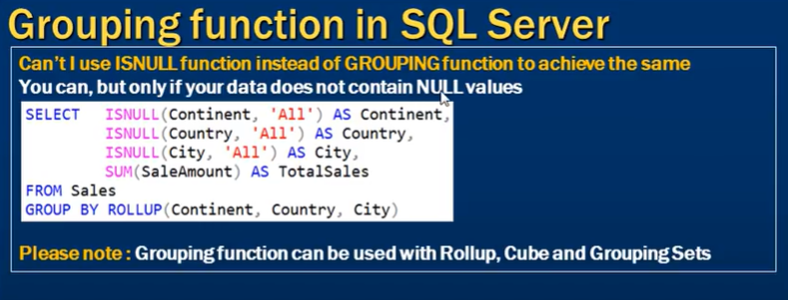

**GROUPING ID function in SQL Server**

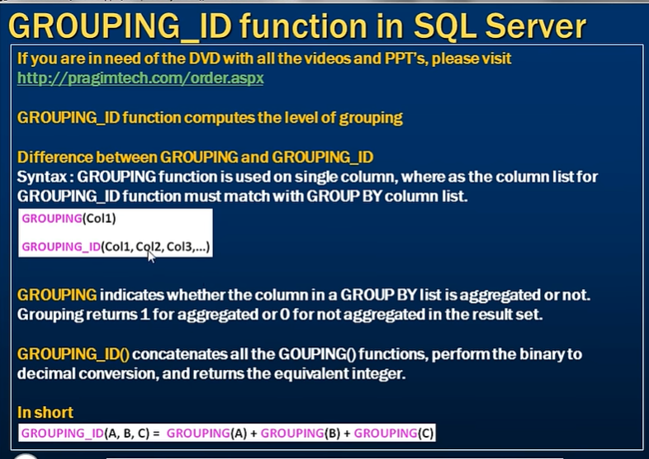 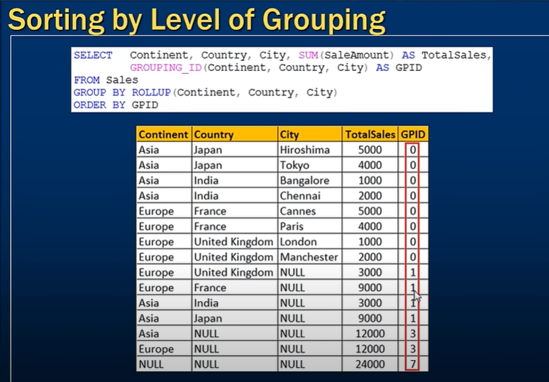 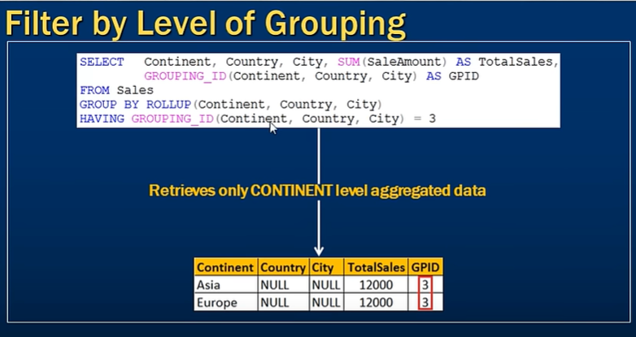

**What is difference between express and developer, enterprise and standard edition**

Microsoft SQL Server comes in several editions, each with different features and limitations, depending on the target audience, workload, and use cases. Here's a comparison between **Express**, **Developer**, **Standard**, and **Enterprise** editions of SQL Server:

**1. SQL Server Express Edition**

* **Target Audience**: Free for small applications, learning, and basic local databases.
* **Features**:
  + Free to use, with **limited feature set**.
  + Maximum database size: **10 GB** per database.
  + Limited to **1 GB RAM** per instance.
  + Supports **up to 4 cores** for CPU usage.
  + Lacks advanced features like **T-SQL debugging**, **high availability**, **SQL Server Agent**, etc.
  + No **Analysis Services**, **Integration Services**, or **Reporting Services**.
  + Often used for lightweight applications, local databases, and development of smaller-scale projects.
* **Use Case**: Ideal for small-scale applications or development environments that don’t require heavy processing.

**2. SQL Server Developer Edition**

* **Target Audience**: Free for development, testing, and learning.
* **Features**:
  + **Full functionality** of the Enterprise Edition but restricted to **non-production use**.
  + **No size or feature limitations** like Express Edition.
  + Includes support for **T-SQL debugging**, **SQL Server Agent**, **In-Memory OLTP**, **Advanced Analytics** (R, Python), **Data Encryption** (TDE), **Always On Availability Groups**, and **Partitioning**.
  + **Unlimited RAM** and CPU usage, depending on the hardware.
  + Can be used for **developing and testing applications**, **learning** the full suite of SQL Server features, but not in production environments.
* **Use Case**: Best for developers and testers who need the full power of SQL Server without licensing costs.

**3. SQL Server Standard Edition**

* **Target Audience**: Small to medium-sized businesses.
* **Features**:
  + **Limited feature set** compared to Enterprise but more powerful than Express.
  + Supports **up to 128 GB of RAM**.
  + **Limited CPU cores** based on server capacity (maximum 24 cores).
  + Includes **basic high availability** features like **Failover Clustering** but no **Always On Availability Groups** with multiple secondary replicas.
  + Includes **basic BI tools**: **Reporting Services**, **Integration Services**, and **Basic Machine Learning**.
  + Lacks **advanced data warehousing**, **data compression**, **partitioning**, **advanced analytics**, and **data encryption** features available in the Enterprise Edition.
* **Use Case**: Suitable for small to mid-sized businesses that need more than the Express Edition offers but don’t require advanced Enterprise features.

**4. SQL Server Enterprise Edition**

* **Target Audience**: Large enterprises and mission-critical applications.
* **Features**:
  + The **most feature-rich** and **expensive** edition.
  + Supports **unlimited database size**.
  + Can use **all available memory** and **CPU cores** of the underlying hardware.
  + Includes **all advanced features** such as:
    - **Always On Availability Groups** (up to multiple secondary replicas).
    - **In-Memory OLTP** for optimizing heavy workloads.
    - **Advanced security features** like **Transparent Data Encryption (TDE)**, **Row-level security**, and **Dynamic Data Masking**.
    - **Data partitioning**, **data compression**, and **resource governance**.
    - Full suite of **Business Intelligence (BI) tools**: **Reporting Services**, **Analysis Services**, **Integration Services**, **Data Mining**, and **Advanced Analytics** (R and Python integration).
  + **Best performance** for large transactional databases and complex data analytics.
* **Use Case**: Ideal for large enterprises needing the highest scalability, security, and availability for **mission-critical applications** and **big data** workloads.

**Summary of Key Differences**

| **Feature** | **Express** | **Developer** | **Standard** | **Enterprise** |
| --- | --- | --- | --- | --- |
| **Cost** | Free | Free (non-production) | Paid (mid-range) | Paid (high-end) |
| **Use Case** | Small apps, lightweight dev | Full development and testing | Small to medium businesses | Large enterprises, mission-critical apps |
| **Max Database Size** | 10 GB | Unlimited | Unlimited | Unlimited |
| **Max RAM Usage** | 1 GB | Unlimited (for testing) | 128 GB | All available RAM |
| **Max CPU Cores** | 4 cores | Unlimited (for testing) | 24 cores | All available cores |
| **High Availability (HA)** | No HA | Full (for dev/test only) | Basic HA (Failover Cluster) | Advanced HA (Always On, multiple replicas) |
| **T-SQL Debugger** | No | Yes | Yes | Yes |
| **SQL Server Agent** | No | Yes | Yes | Yes |
| **In-Memory OLTP** | No | Yes | No | Yes |
| **Data Partitioning** | No | Yes | No | Yes |
| **Encryption (TDE)** | No | Yes | No | Yes |
| **Advanced BI (SSAS, SSIS, SSRS)** | No | Yes | Basic | Full |

**Conclusion**

* **Express Edition**: Best for small-scale applications or personal projects that require minimal resources.
* **Developer Edition**: Great for developers needing the full SQL Server suite without production use.
* **Standard Edition**: Fits small to mid-size businesses needing more power and features than Express without the cost of Enterprise.
* **Enterprise Edition**: For large-scale, mission-critical, high-performance workloads with full feature support.

**Choose function in SQL Server**

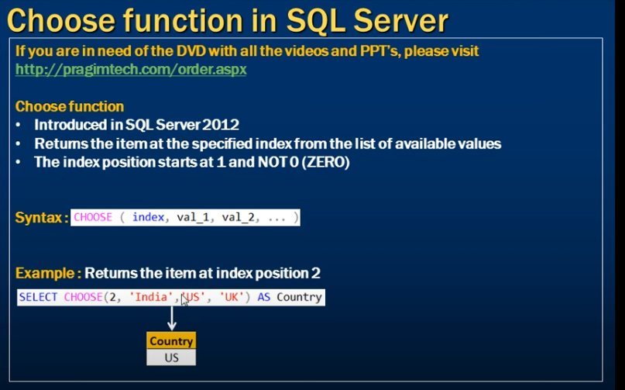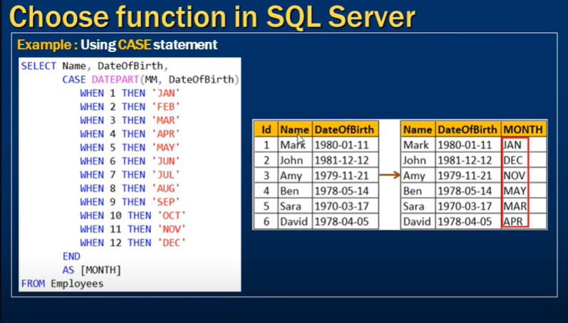but instead of writing that much code we can use choose function like 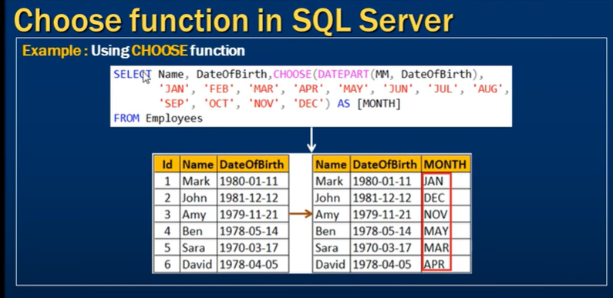

**IIF function in SQL Server**

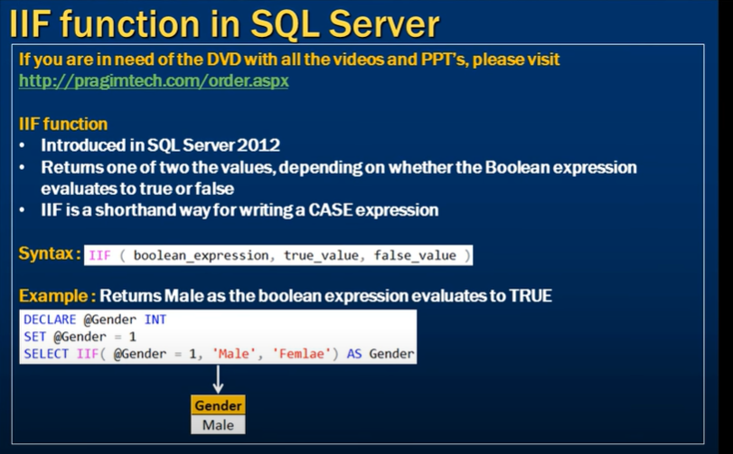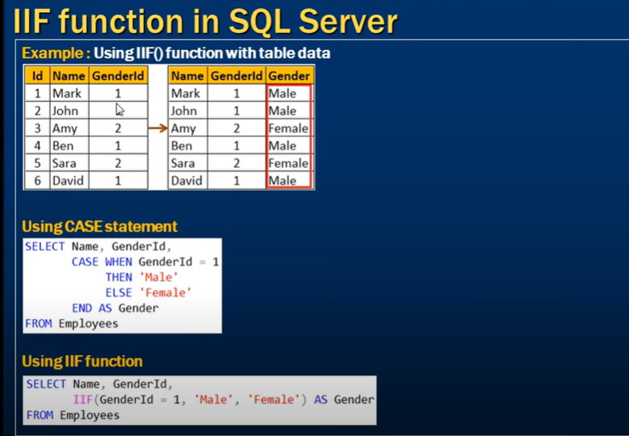

**TRY PARSE function in SQL Server**

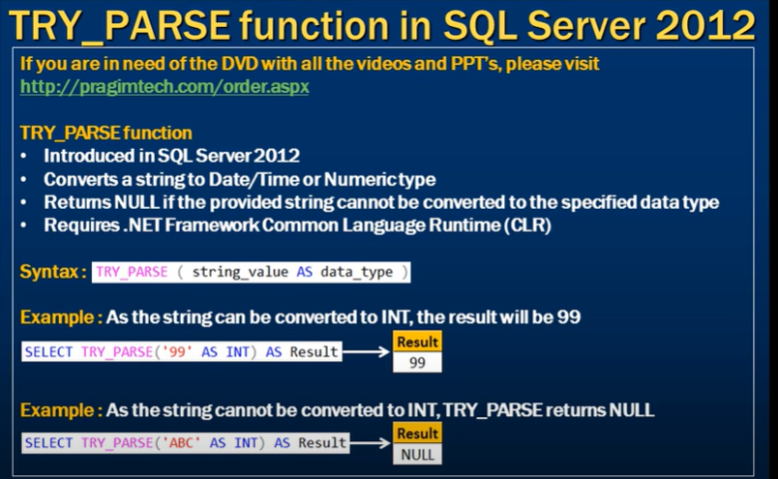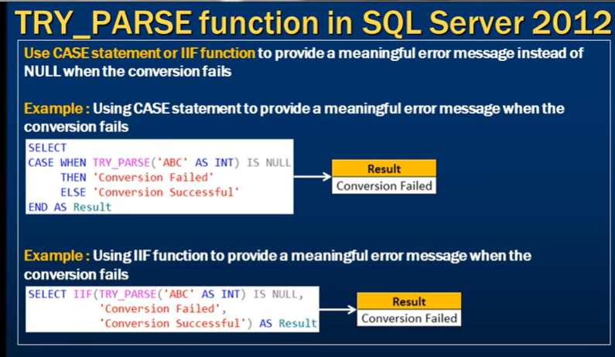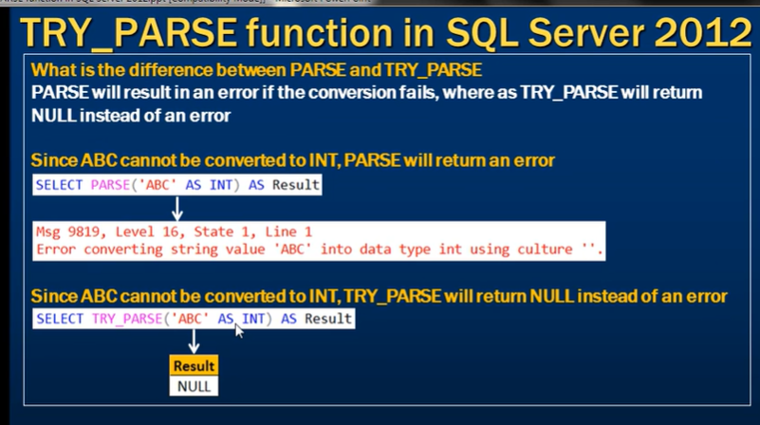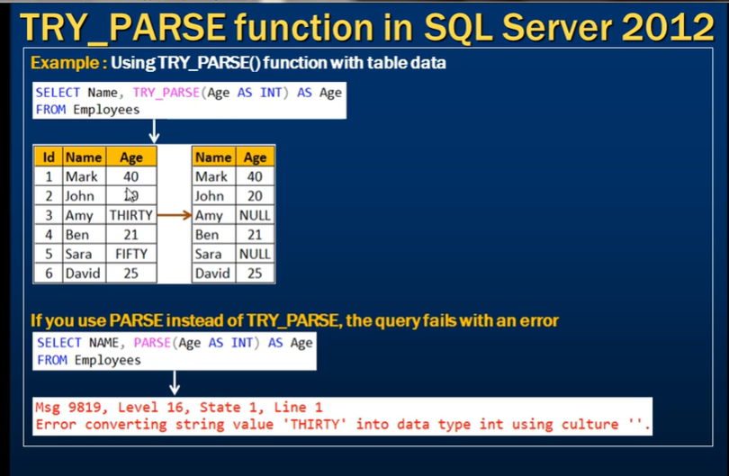

**TRY CONVERT function in SQL Server**

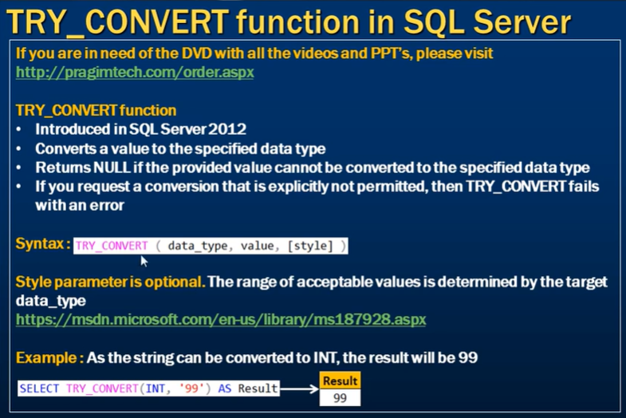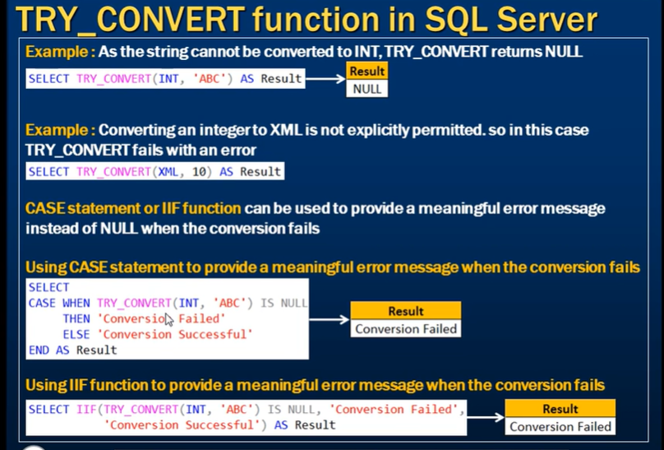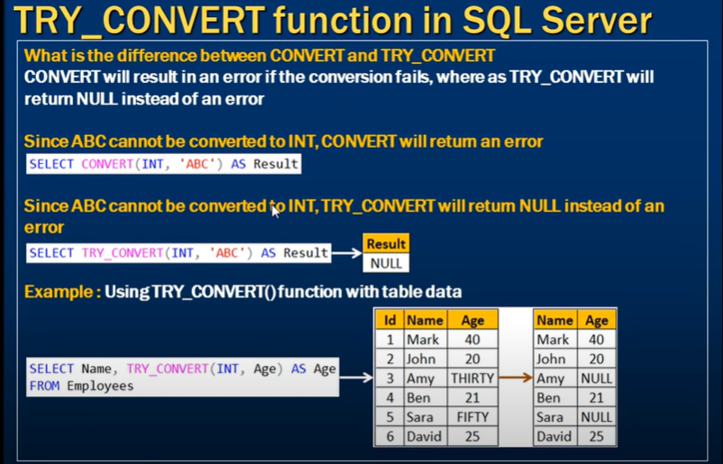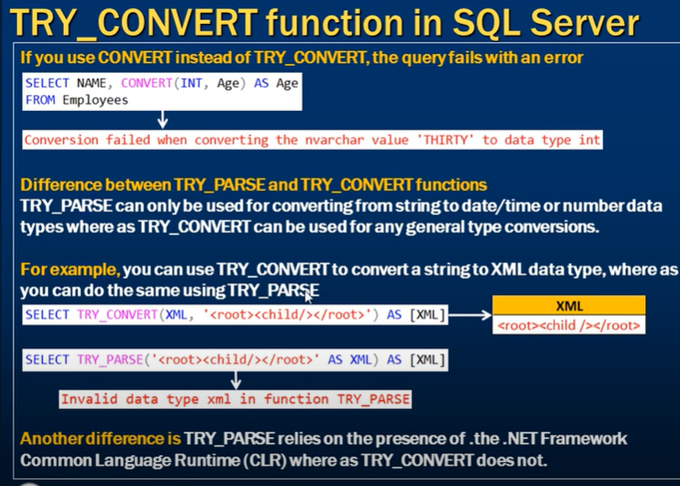

**EOMONTH function in SQL Server**

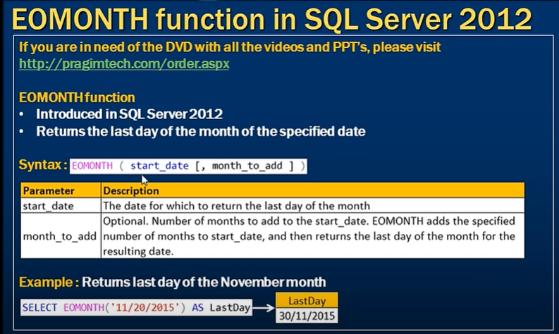

**DATEFROMPARTS function in SQL Server**

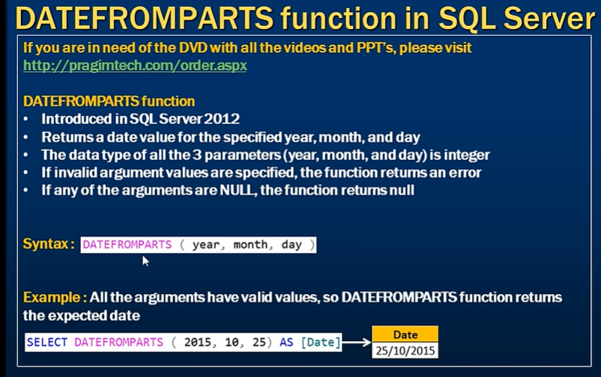

**Difference between DateTime and SmallDateTime in SQL Server**

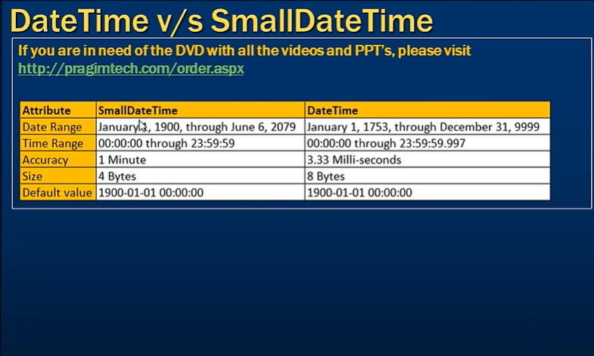

**DateTime2FromParts function in SQL Server 2012**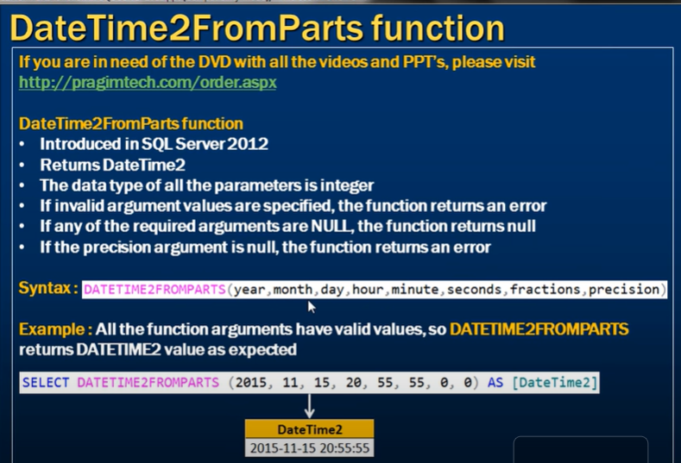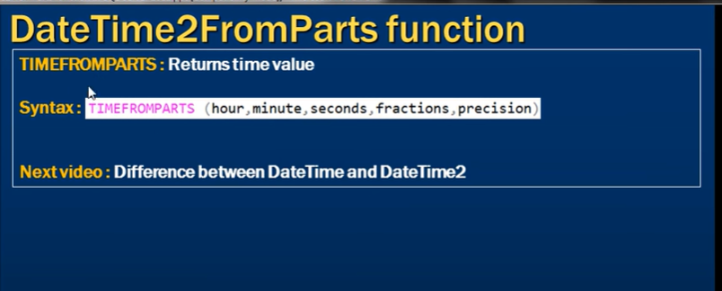

**Difference between DateTime and DateTime2 in SQL Server**

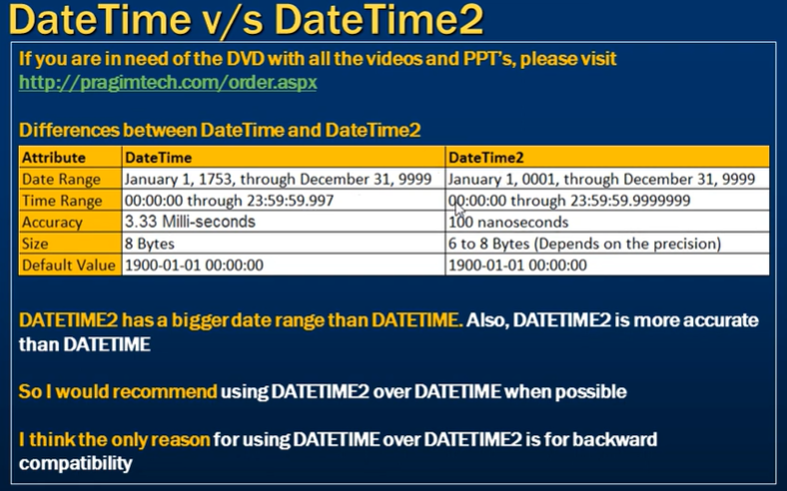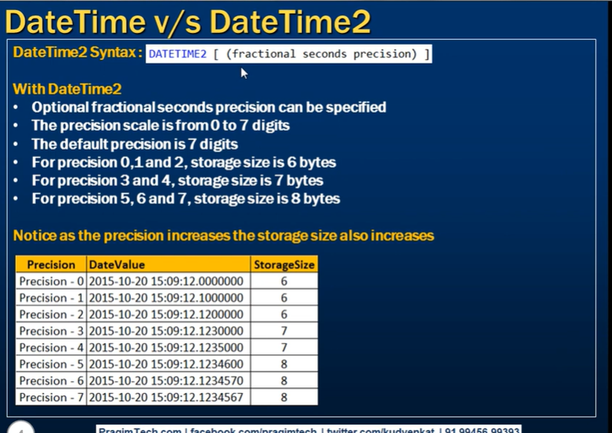

**Offset fetch next in SQL Server 2012**

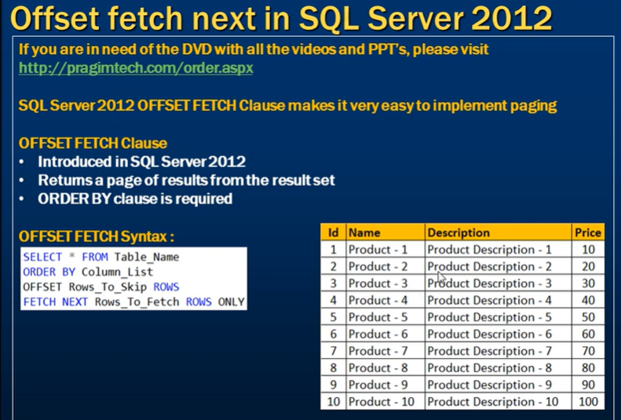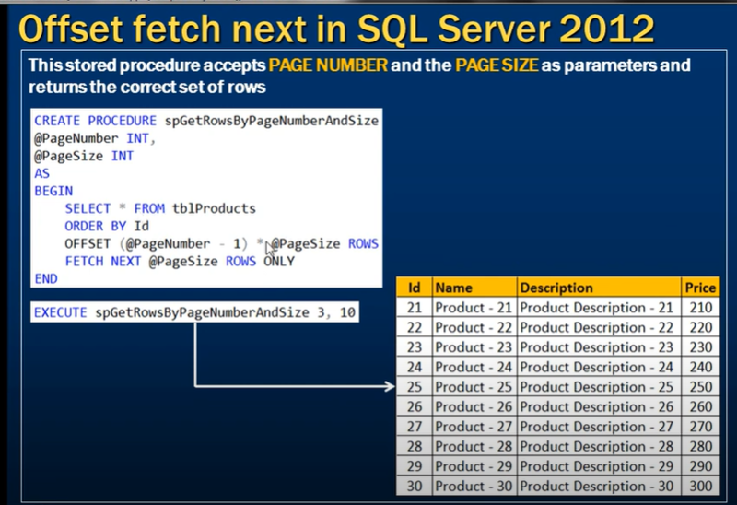

**sys dm sql referencing/dependency entities in SQL Server**

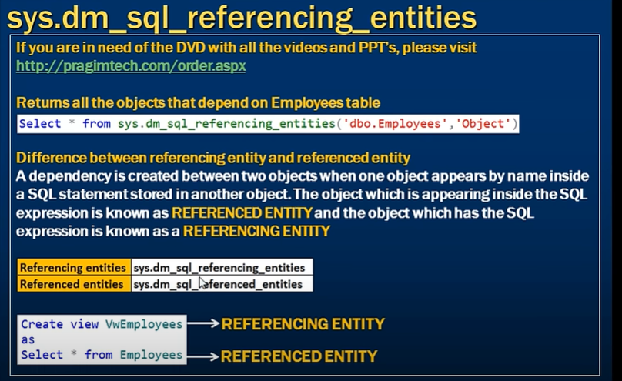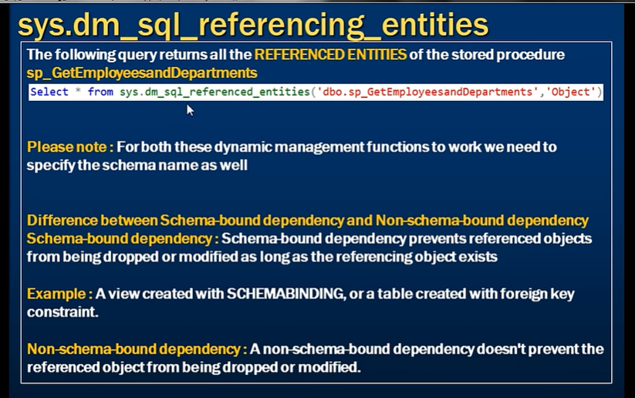

**sp depends in SQL Server**

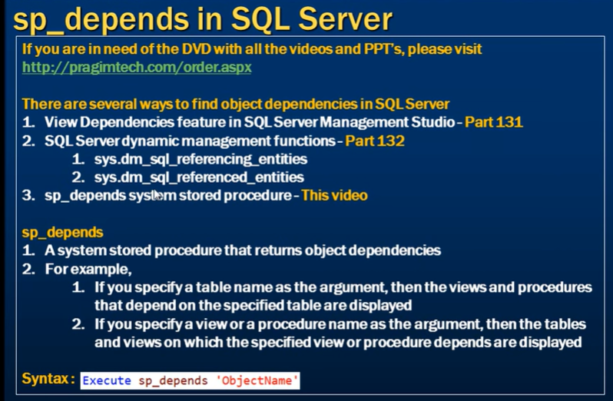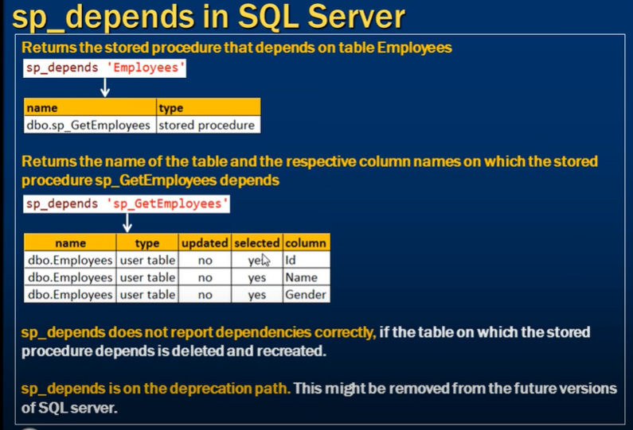

**Difference between sequence and identity in SQL Server**

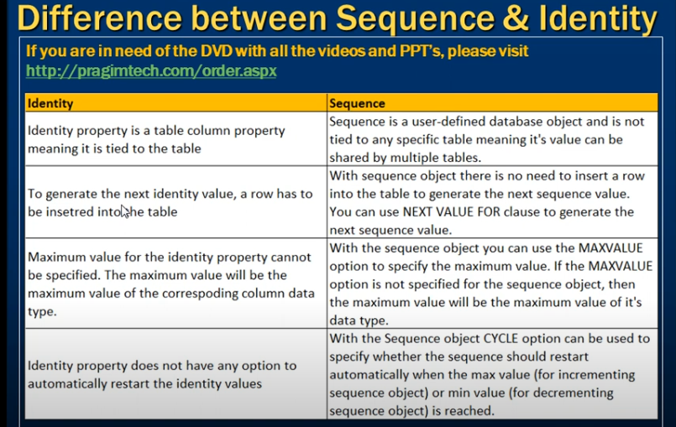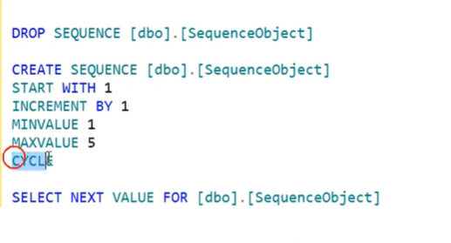a

**Guid in SQL Server**

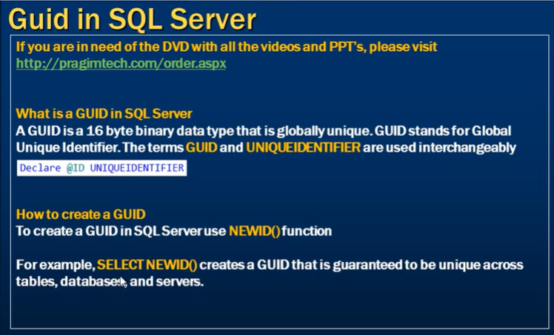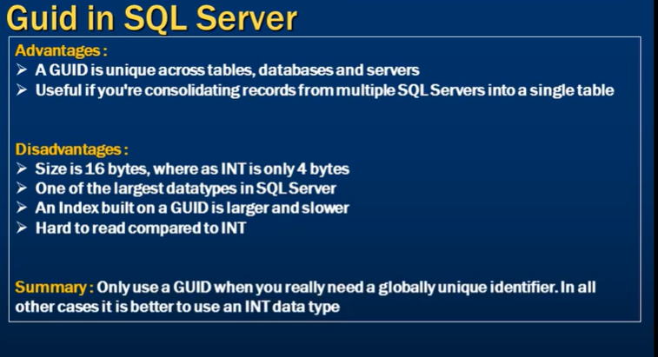Great question! The confusion comes from the difference between **how GUIDs are displayed** (in human-readable format) and **how GUIDs are stored** (in raw binary form).

**Explanation:**

1. **Storage**:
   * A **GUID** (or uniqueidentifier in SQL Server) is stored as a **128-bit (16-byte)** value.
   * The 16 bytes represent the GUID in binary form, not as text.
2. **Display (Text Representation)**:
   * When you see a GUID like 550e8400-e29b-41d4-a716-446655440000, it's a hexadecimal representation of the actual binary value.
   * Each character in this format represents **4 bits** (half a byte), and the hyphens (-) are just for readability, not actually stored in the binary form.

**Breakdown:**

* The GUID string 550e8400-e29b-41d4-a716-446655440000 contains 32 hexadecimal characters.
  + Each hexadecimal character represents **4 bits**.
  + So, 32 characters × 4 bits = **128 bits** = **16 bytes**.
* The hyphens (-) are just visual separators in the textual representation (total 4 hyphens), making it easier to read, but they are not stored in the raw binary form.

**Summary:**

* The **actual storage** of the GUID in SQL Server is **16 bytes** in binary form.
* The **displayed string** (like 550e8400-e29b-41d4-a716-446655440000) is a **36-character** string that includes the hexadecimal representation of the 16-byte value along with hyphens for formatting.

Let me know if you need further clarification!

**Step-by-Step Breakdown of Binary to Hexadecimal Conversion:**

1. **Binary and Hexadecimal Basics**:
   * **Binary** is base-2 (uses digits 0 and 1).
   * **Hexadecimal (Hex)** is base-16 (uses digits 0-9 and letters A-F).
   * A single **hexadecimal digit** represents **4 binary bits** because 24=162^4 = 1624=16.
2. **Grouping Binary to Hex**:
   * When converting binary to hex, group every 4 bits of binary together and convert them to the corresponding hexadecimal digit.

**Example: Converting Binary to Hexadecimal**

Let's walk through converting a 16-bit binary number into hexadecimal:

**Binary: 1101011001101001**

**Step 1: Group the binary digits into 4-bit chunks (starting from the right)**:

1101 0110 0110 1001

**Step 2: Convert each 4-bit group to its corresponding hex digit**:

* 1101 = D
* 0110 = 6
* 0110 = 6
* 1001 = 9

**Resulting Hexadecimal**: D669

**GUID Conversion**

Let's now apply this to a GUID. We'll break down a 128-bit GUID into binary, convert that to hexadecimal, and then show how it's formatted.

**Example GUID: 550e8400-e29b-41d4-a716-446655440000**

This GUID represents **128 bits** (16 bytes). Each byte (8 bits) is represented as two hexadecimal digits. We'll take it byte by byte to show how binary converts into hexadecimal.

1. **550e8400** (first 4 bytes):
   * Convert each hexadecimal digit into its 4-bit binary equivalent:
   * 5 = 0101
   * 5 = 0101
   * 0 = 0000
   * e = 1110
   * 8 = 1000
   * 4 = 0100
   * 0 = 0000
   * 0 = 0000

So, 550e8400 in hexadecimal translates to the binary string:

0101 0101 0000 1110 1000 0100 0000 0000

1. **e29b** (next 2 bytes):
   * Convert:
   * e = 1110
   * 2 = 0010
   * 9 = 1001
   * b = 1011

Resulting binary:

1110 0010 1001 1011

1. **41d4** (next 2 bytes):
   * Convert:
   * 4 = 0100
   * 1 = 0001
   * d = 1101
   * 4 = 0100

Resulting binary:

0100 0001 1101 0100

1. **a716** (next 2 bytes):
   * Convert:
   * a = 1010
   * 7 = 0111
   * 1 = 0001
   * 6 = 0110

Resulting binary:

1010 0111 0001 0110

1. **4466** (next 2 bytes):
   * Convert:
   * 4 = 0100
   * 4 = 0100
   * 6 = 0110
   * 6 = 0110

Resulting binary:

0100 0100 0110 0110

1. **5544** (next 2 bytes):
   * Convert:
   * 5 = 0101
   * 5 = 0101
   * 4 = 0100
   * 4 = 0100

Resulting binary:

0101 0101 0100 0100

1. **0000** (last 2 bytes):
   * Convert:
   * 0 = 0000
   * 0 = 0000
   * 0 = 0000
   * 0 = 0000

Resulting binary:

0000 0000 0000 0000

**Putting It All Together:**

After converting all hexadecimal groups to binary, you get the **128-bit binary representation** of the GUID.

**Recap of the Process:**

1. **Binary to Hex**: Group binary in 4-bit chunks and convert each group to its hex equivalent.
2. **GUID Format**: The GUID is stored as 16 bytes (128 bits) and is displayed in a hexadecimal string with hyphens for readability (like 550e8400-e29b-41d4-a716-446655440000).

The actual **storage** of the GUID is **16 bytes** (in binary form), and each hexadecimal character in the GUID string represents 4 bits.

**Dynamic SQL in SQL Server**

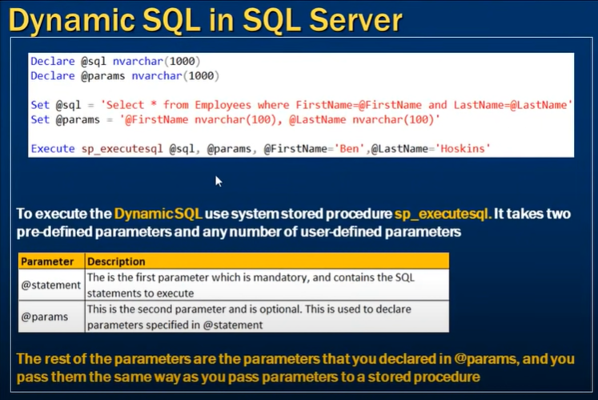

Null values Handling :-

|  |  |  |  |
| --- | --- | --- | --- |
| AND | TRUE | FALSE | UNKNOWN |
| TRUE | TRUE  (Row are selected) | FALSE  (Rows are rejected) | UNKNOWN  (Rows are rejected) |
| FALSE | FALSE  (Rows are rejected) | FALSE  (Rows are rejected) | FALSE  (Rows are rejected) |
| UNKNOWN | UNKNOWN  (Rows are rejected) | FALSE  (Rows are rejected) | UNKNOWN  (Rows are rejected) |

Note : SELECT TOP (1000) [id] ,[name]

FROM [AdventureWorks2019].[dbo].[demo1]

where not (1=2 and 1 = null)

This query return the rows and reasone is 1=2 (FALSE) AND 1=null (FALSE) THEN (FALSE AND FALSE) = FALSE

Then the final condition is not(FALSE) Which means TRUE and because of that it will return the rows.

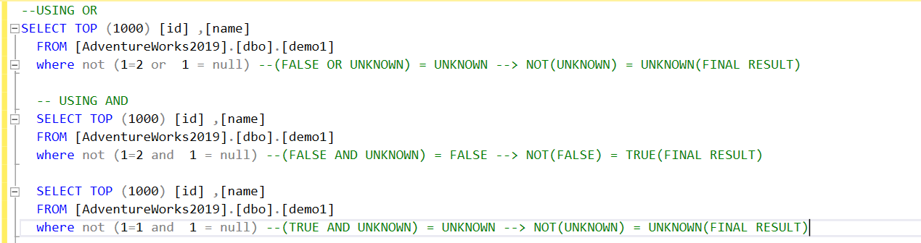

|  |  |  |  |
| --- | --- | --- | --- |
| OR | TRUE | FALSE | UNKNOWN |
| TRUE | TRUE  (Row are selected) | TRUE  (Row are selected) | TRUE  (Row are selected) |
| FALSE | TRUE  (Row are selected) | FALSE  (Rows are rejected) | UNKNOWN  (Rows are rejected) |
| UNKNOWN | TRUE  (Row are selected) | UNKNOWN  (Rows are rejected) | UNKNOWN  (Rows are rejected) |

|  |  |
| --- | --- |
| (Expression) | NOT (Expression) |
| True | False |
| False | True |
| Unknown | Unknow |

declare @var1 varchar(100) = 'gaurav'

declare @var2 varchar(100) = null

select 1 where @var1 = 'gaurav' and @var2 != 'p' -- give nothing

select 1 where @var1 = 'gaurav' or @var1 = @var2

select 1 where @var2 != 'p' -- give nothing

SET OPERATION

1) Intersect :-

insert into demo1(id) values(1),(2),(3),(4)

insert into demo2 (id) values(1),(5),(3)

select id FROM demo1

intersect

select id FROM demo2

out:

1

3

2) Minus or Except in ssms

select id FROM demo1

except

select id FROM demo2

Out:

2

4

3) Union

4) Union ALL

Agg function handling

NOTE :- in SSMS if you try to apply aggregate functions except COUNT on type varchar column it will throw the error but in my sql it will not.

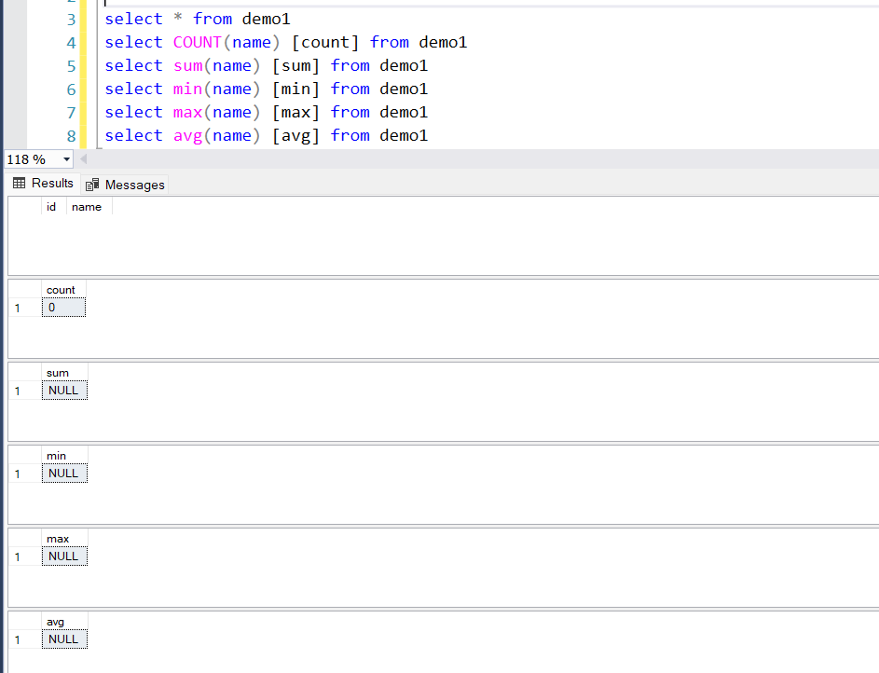

If you have the null value only

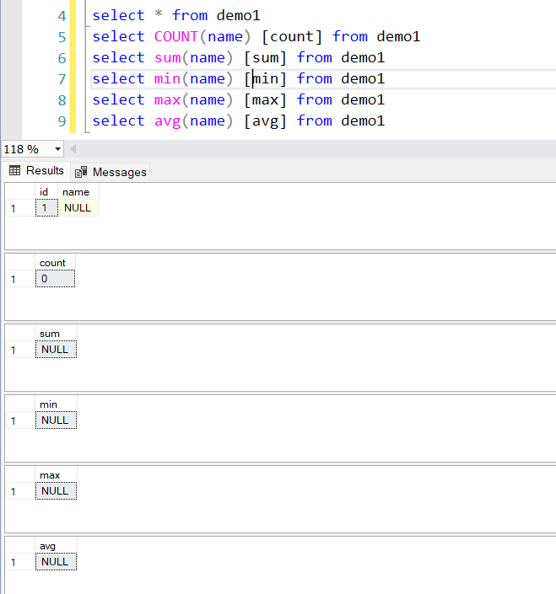

Handling Null in sql

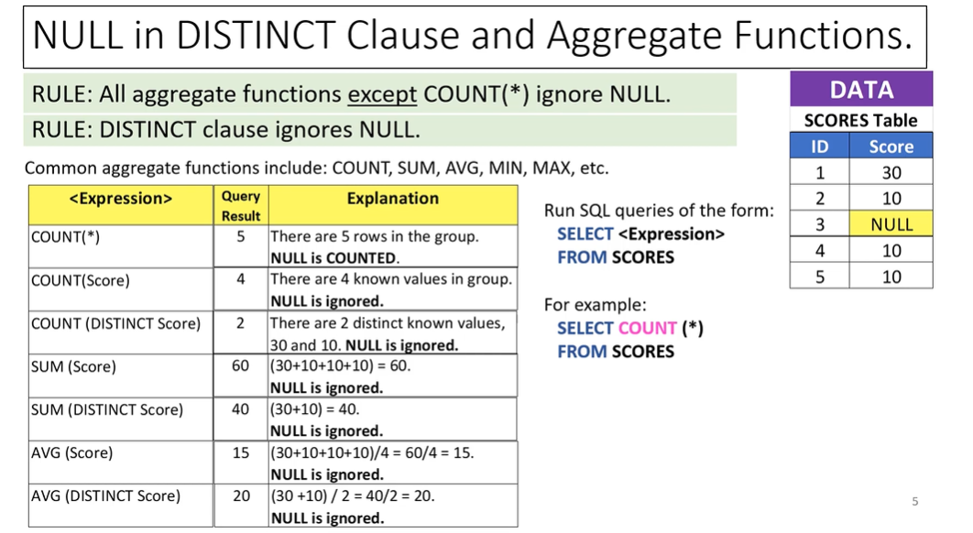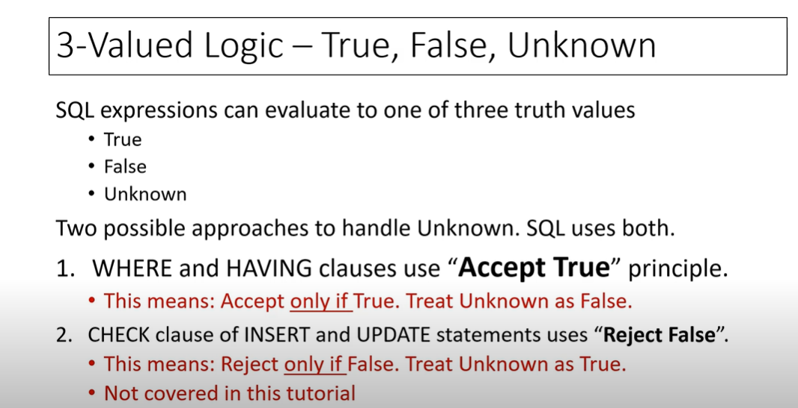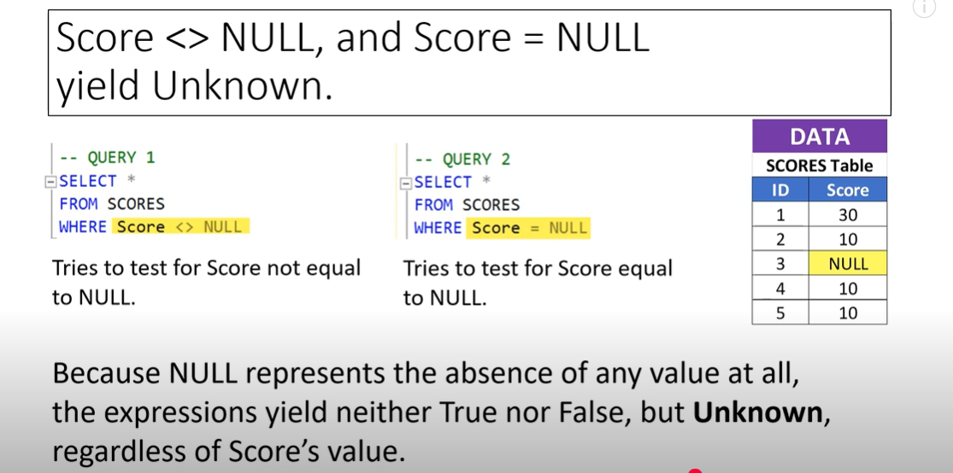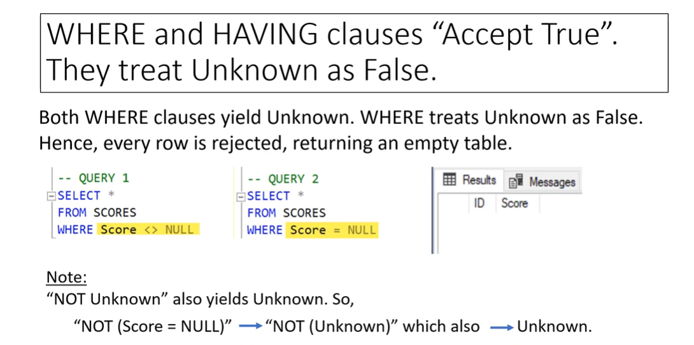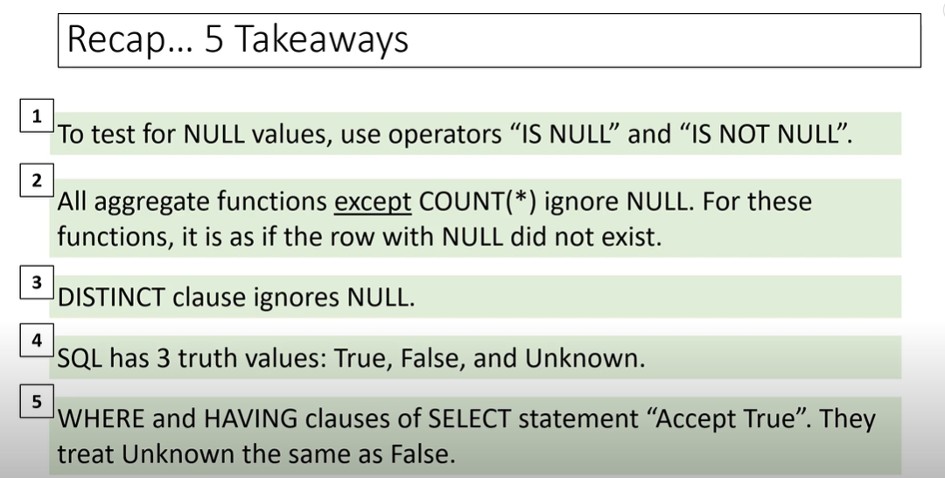

Partitioning

A range type (either LEFT or RIGHT), specifies how the boundary values of the partition function will be put into the resulting partitions:

* A LEFT range specifies that the boundary value belongs to the left side of the boundary value interval when interval values are sorted by the database engine in ascending order from left to right. In other words, the highest bounding value will be included within a partition.
* A RIGHT range specifies that the boundary value belongs to the right side of the boundary value interval when interval values are sorted by the database engine in ascending order from left to right. In other words, the lowest bounding value will be included in each partition.

**CODE FOR PARTITIONING**

FOR INDEX PARTITION

CREATE PARTITION FUNCTION pf_CompanyId2 (INT)

AS RANGE LEFT FOR VALUES (0, 1, 2, 3,4); -- Example CompanyId ranges

CREATE PARTITION SCHEME ps_CompanyId2

AS PARTITION pf_CompanyId2

ALL TO ([PRIMARY]);

CREATE NONCLUSTERED INDEX IX_MemberProfile_LabelCode1

ON person.person (EmailPromotion)

ON ps_CompanyId (EmailPromotion); -- must match partitioning column

**Benefits of partitioning**

Partitioning large tables or indexes can have the following manageability and performance benefits.

* You can transfer or access subsets of data quickly and efficiently, while maintaining the integrity of a data collection. For example, an operation such as loading data from an OLTP to an OLAP system takes only seconds, instead of the minutes and hours the operation takes when the data isn't partitioned.
* You can perform maintenance or data retention operations on one or more partitions more quickly. The operations are more efficient because they target only these data subsets, instead of the whole table. For example, you can choose to compress data in one or more partitions, rebuild one or more partitions of an index, or truncate data in a single partition. You may also switch individual partitions out of one table and into an archive table.
* You may improve query performance, based on the types of queries you frequently run. For example, the query optimizer can process equijoin queries between two or more partitioned tables faster when the partitioning columns are the same as the columns on which the tables are joined. See [Queries](https://learn.microsoft.com/en-us/sql/relational-databases/partitions/partitioned-tables-and-indexes?view=sql-server-ver17#queries) below for further information.

You can improve performance by enabling lock escalation at the partition level instead of a whole table. This can reduce lock contention on the table. To reduce lock contention by allowing lock escalation to the partition, set the LOCK_ESCALATION option of the ALTER TABLE statement to AUTO.

**Examples**

**A. Creating a RANGE LEFT partition function on an int column**

The following partition function will partition a table or index into four partitions.

SQLCopy

CREATE PARTITION FUNCTION myRangePF1 (int)

AS RANGE LEFT FOR VALUES (1, 100, 1000);

The following table shows how a table that uses this partition function on partitioning column **col1** would be partitioned.

Expand table

| **Partition** | **1** | **2** | **3** | **4** |
| --- | --- | --- | --- | --- |
| **Values** | **col1** <= 1 | **col1** > 1 AND **col1** <= 100 | **col1** > 100 AND **col1** <=1000 | **col1** > 1000 |

**B. Creating a RANGE RIGHT partition function on an int column**

The following partition function uses the same values for *boundary_value* [ **,***...n* ] as the previous example, except it specifies RANGE RIGHT.

SQLCopy

CREATE PARTITION FUNCTION myRangePF2 (int)

AS RANGE RIGHT FOR VALUES (1, 100, 1000);

The following table shows how a table that uses this partition function on partitioning column **col1** would be partitioned.

Expand table

| **Partition** | **1** | **2** | **3** | **4** |
| --- | --- | --- | --- | --- |
| **Values** | **col1** < 1 | **col1** >= 1 AND **col1** < 100 | **col1** >= 100 AND **col1** < 1000 | **col1** >= 1000 |

**C. Creating a RANGE RIGHT partition function on a datetime column**

The following partition function partitions a table or index into 12 partitions, one for each month of a year's worth of values in a **datetime** column.

SQLCopy

CREATE PARTITION FUNCTION [myDateRangePF1] (datetime)

AS RANGE RIGHT FOR VALUES ('20030201', '20030301', '20030401',

'20030501', '20030601', '20030701', '20030801',

'20030901', '20031001', '20031101', '20031201');

The following table shows how a table or index that uses this partition function on partitioning column **datecol** would be partitioned.

Expand table

| **Partition** | **1** | **2** | **...** | **11** | **12** |
| --- | --- | --- | --- | --- | --- |
| **Values** | **datecol** < February 1, 2003 | **datecol** >= February 1, 2003 AND **datecol** < March 1, 2003 |  | **datecol** >= November 1, 2003 AND **col1** < December 1, 2003 | **datecol** >= December 1, 2003 |

**D. Creating a partition function on a char column**

The following partition function partitions a table or index into four partitions.

SQLCopy

CREATE PARTITION FUNCTION myRangePF3 (char(20))

AS RANGE RIGHT FOR VALUES ('EX', 'RXE', 'XR');

The following table shows how a table that uses this partition function on partitioning column **col1** would be partitioned.

Expand table

| **Partition** | **1** | **2** | **3** | **4** |
| --- | --- | --- | --- | --- |
| **Values** | **col1** < EX... | **col1** >= EX AND **col1** < RXE... | **col1** >= RXE AND **col1** < XR... | **col1** >= XR |

**E. Creating 15,000 partitions**

The following partition function partitions a table or index into 15,000 partitions.

SQLCopy

--Create integer partition function for 15,000 partitions.

DECLARE @IntegerPartitionFunction nvarchar(max) =

N'CREATE PARTITION FUNCTION IntegerPartitionFunction (int)

AS RANGE RIGHT FOR VALUES (';

DECLARE @i int = 1;

WHILE @i < 14999

BEGIN

SET @IntegerPartitionFunction += CAST(@i as nvarchar(10)) + N', ';

SET @i += 1;

END

SET @IntegerPartitionFunction += CAST(@i as nvarchar(10)) + N');';

EXEC sp_executesql @IntegerPartitionFunction;

GO

**F. Creating partitions for multiple years**

The following partition function partitions a table or index into 50 partitions on a **datetime2** column. There is one partition for each month between January 2007 and January 2011.

SQLCopy

--Create date partition function with increment by month.

DECLARE @DatePartitionFunction nvarchar(max) =

N'CREATE PARTITION FUNCTION DatePartitionFunction (datetime2)

AS RANGE RIGHT FOR VALUES (';

DECLARE @i datetime2 = '20070101';

WHILE @i < '20110101'

BEGIN

SET @DatePartitionFunction += '''' + CAST(@i as nvarchar(10)) + '''' + N', ';

SET @i = DATEADD(MM, 1, @i);

END

SET @DatePartitionFunction += '''' + CAST(@i as nvarchar(10))+ '''' + N');';

EXEC sp_executesql @DatePartitionFunction;

GO

**Difference between a partitioned table and a partitioned index**

Great question — understanding the **difference between a partitioned table and a partitioned index** is crucial for designing scalable SQL Server or Azure SQL solutions. Here's a clear breakdown:

**🧩 Conceptual Difference**

| **🔍 Feature** | **Partitioned Table** | **Partitioned Index** |
| --- | --- | --- |
| **What is partitioned?** | The *base table* (i.e., the data rows themselves) | Only the *index structure* (i.e., how SQL Server locates rows) |
| **Affects all data access?** | ✅ Yes | ❌ No — only affects queries using that index |
| **Helps with large data loads** | ✅ Yes — rows are physically stored across multiple partitions | ❌ Not directly — helps only when the index is used in a query |
| **Required for partitioned table** | A partitioned **clustered index** or **heap** | Can exist on any table (partitioned or not) |
| **$PARTITION returns values?** | ✅ Yes | ✅ Yes (if index is partitioned) |

**💾 Example**

**Suppose you have this table:**

sql

CopyEdit

CREATE TABLE Sales (

SaleId INT IDENTITY,

RegionId INT,

SaleAmount MONEY

);

**📌 Case 1: Table is partitioned**

* A **clustered index** is created **on RegionId**, using a **partition scheme**.
* **All data rows** are stored across different partitions based on RegionId.

**Benefits**:

* You can **switch out entire partitions** (e.g., archiving).
* Parallelism across partitions is possible.
* All indexes can align with partitioning.

**📌 Case 2: Table is not partitioned, but an index is**

* Table remains on one filegroup (e.g., PRIMARY).
* You create a **partitioned nonclustered index** on RegionId.

**Behavior**:

* Table data is stored in one place.
* **Index structure** is split across partitions — helps **read** queries that use this index.
* **Writes** still go to the entire table — no partition benefit on insert/delete.

**🔄 Practical Implications**

| **Action** | **Table Partitioned** | **Index Partitioned** |
| --- | --- | --- |
| SELECT using partition key | Fast | Fast if using partitioned index |
| INSERT | Split by partition | Always into base table (single place if table not partitioned) |
| DELETE by partition | ✅ Possible | ❌ Not efficient (table not partitioned) |
| TRUNCATE PARTITION | ✅ Possible | ❌ Not allowed |
| Maintenance (e.g., rebuild) | Can rebuild partition-wise | Can rebuild partition-wise |

**✅ Summary**

| **Question** | **Answer** |
| --- | --- |
| Can you partition just an index? | ✅ Yes |
| Is it the same as partitioning the table? | ❌ No |
| Which is more powerful for managing data? | ✅ Table partitioning |

**🧠 Final Thought**

**Partitioning a table** is about **data storage** optimization.  
**Partitioning an index** is about **query performance** for indexed reads.

Would you like a visual diagram or a script to **convert your non-partitioned table into a fully partitioned table**?

**SQL Server Agent**

— it’s the built-in job scheduler and automation tool in SQL Server.

**What is SQL Server Agent?**

* SQL Server Agent is a **Windows service** that runs in the background.
* It allows you to **automate** tasks like:
  + Backups
  + Index maintenance
  + Running stored procedures or scripts
  + ETL processes
  + Sending alerts/notifications

Basically, it’s SQL Server’s version of a **cron job scheduler**.

**🔹 Components of SQL Server Agent**

1. **Jobs**
   * A job = a container for one or more steps.
   * Example: A backup job might have steps → run backup script → verify → cleanup old files.
2. **Job Steps**
   * Each step is an action (T-SQL, PowerShell, SSIS package, CmdExec, etc.).
3. **Schedules**
   * Define when and how often a job runs (daily, weekly, hourly, etc.).
4. **Alerts**
   * Triggered by specific SQL Server events or error numbers (e.g., if database log is 90% full).
5. **Operators**
   * People (with email/pager) to be notified when jobs succeed/fail.

**🔹 Example: Creating a Job**

**Using T-SQL**

USE msdb;

GO

EXEC sp_add_job

@job_name = N'Daily Full Backup';

EXEC sp_add_jobstep

@job_name = N'Daily Full Backup',

@step_name = N'Backup Step',

@subsystem = N'TSQL',

@command = N'BACKUP DATABASE AdventureWorks2019

TO DISK = ''C:\Backup\AdventureWorks2019_Full.bak'' WITH INIT;';

EXEC sp_add_schedule

@schedule_name = N'Daily 2AM',

@freq_type = 4, -- daily

@freq_interval = 1, -- every 1 day

@active_start_time = 020000; -- 2:00 AM

EXEC sp_attach_schedule

@job_name = N'Daily Full Backup',

@schedule_name = N'Daily 2AM';

EXEC sp_add_jobserver

@job_name = N'Daily Full Backup';

**🔹 Example: Creating a Job (GUI in SSMS)**

1. In **SSMS**, expand **SQL Server Agent**.
2. Right-click **Jobs → New Job**.
3. Add job **steps** (e.g., run backup query).
4. Add a **schedule** (e.g., every day at 2 AM).
5. Save. SQL Server Agent will now run it automatically.

**🔹 Common Use Cases**

* **Automated backups** (daily/weekly/monthly).
* **Index rebuilds/reorganize** jobs.
* **Cleanup jobs** (delete old logs or data).
* **Data import/export** jobs (SSIS packages).
* **Monitoring jobs** (send email when errors happen).

**🔹 Permissions**

* Only members of **SQLAgentUserRole**, **SQLAgentReaderRole**, or **SQLAgentOperatorRole** (in msdb database) can create/manage jobs.
* Typically, DBAs or sysadmins manage Agent jobs.

✅ **Summary**  
SQL Server Agent = SQL Server’s task scheduler.

* Jobs → contain steps.
* Steps → actual tasks (T-SQL, PowerShell, SSIS).
* Schedules → when jobs run.
* Alerts/Operators → monitoring + notifications.

👉 Do you want me to show you a **sample backup + index maintenance job** script that you could directly schedule in SQL Server Agent?

**EncryptByKey**

**What Is EncryptByKey?**

EncryptByKey is a **T-SQL function** used to **encrypt data** using a **symmetric key** that you’ve created and opened in your database.

It’s used for **column-level encryption** — meaning you can store **encrypted data** (like credit card numbers, passwords, etc.) securely inside your tables.

**🧠 Concept Overview**

In SQL Server, encryption can be done at different levels:

* **Transparent Data Encryption (TDE)** → encrypts entire database files.
* **Always Encrypted** → encrypts columns, handled by client driver.
* **Column-level encryption** → you control encryption/decryption manually using functions like EncryptByKey and DecryptByKey.

**⚙️ How It Works**

Here’s the basic flow:

1. **Create a Master Key** (once per database)
2. **Create a Certificate**
3. **Create a Symmetric Key** (encrypted by the certificate)
4. **Open the Key**
5. **Use EncryptByKey** to encrypt data
6. **Use DecryptByKey** to read it back

**🧩 Step-by-Step Example**

**1️⃣ Create a Master Key**

CREATE MASTER KEY ENCRYPTION BY PASSWORD = 'StrongPassword123!';

**2️⃣ Create a Certificate**

CREATE CERTIFICATE MyCert

WITH SUBJECT = 'Data Encryption Certificate';

**3️⃣ Create a Symmetric Key**

CREATE SYMMETRIC KEY MySymmetricKey

WITH ALGORITHM = AES_256

ENCRYPTION BY CERTIFICATE MyCert;

**4️⃣ Open the Key Before Use**

OPEN SYMMETRIC KEY MySymmetricKey

DECRYPTION BY CERTIFICATE MyCert;

**5️⃣ Encrypt Data**

INSERT INTO Users (UserName, EncryptedPassword)

VALUES (

'JohnDoe',

EncryptByKey(Key_GUID('MySymmetricKey'), 'MySecretPassword')

);

* Key_GUID('MySymmetricKey') gets the unique ID of the key.
* EncryptByKey() encrypts the plaintext value using that key.
* The result is **binary data (varbinary)**, not readable directly.

**6️⃣ Decrypt Data**

SELECT

UserName,

CONVERT(varchar, DecryptByKey(EncryptedPassword)) AS DecryptedPassword

FROM Users;

✅ You get the decrypted (original) password.

**7️⃣ Close the Key**

CLOSE SYMMETRIC KEY MySymmetricKey;

**🧾 Summary**

| **Function** | **Purpose** |
| --- | --- |
| EncryptByKey() | Encrypts data using a symmetric key |
| DecryptByKey() | Decrypts data that was encrypted using EncryptByKey() |
| Key_GUID('key_name') | Returns key’s unique ID |
| OPEN SYMMETRIC KEY | Makes key available for use |
| CLOSE SYMMETRIC KEY | Closes it after use |

**⚠️ Notes**

* Encrypted data is **binary**, so store it in a varbinary column.
* Encryption is **case-sensitive** and **key-dependent** — you must use the same key to decrypt.
* Always **back up your keys and certificates** securely — if lost, encrypted data can’t be recovered.

**✅ Example Summary Query**

-- View encrypted data

SELECT * FROM Users;

-- View decrypted data

OPEN SYMMETRIC KEY MySymmetricKey DECRYPTION BY CERTIFICATE MyCert;

SELECT UserName, CONVERT(varchar, DecryptByKey(EncryptedPassword)) AS Password

FROM Users;

CLOSE SYMMETRIC KEY MySymmetricKey;

**XML**

**What is XML?**

**XML** stands for **Extensible Markup Language**.  
It’s a **text-based format** used to **store and transfer structured data** — similar to HTML, but designed for **data**, not display.

**💡 Think of XML like a way to represent data in a tree (hierarchical) structure:**

<Students>

<Student id="1">

<Name>John</Name>

<Course>Math</Course>

</Student>

<Student id="2">

<Name>Alice</Name>

<Course>Science</Course>

</Student>

</Students>

**🔹 XML Structure Breakdown**

| **Element** | **Meaning** |
| --- | --- |
| <Students> | Root element — the top-level container |
| <Student> | Child element — one item in the list |
| id="1" | Attribute — provides extra info about the element |
| <Name> and <Course> | Sub-elements — actual data fields |
| </Student> | Closing tag — ends the element |

✅ Everything must be **well-formed** — meaning:

* Every opening tag must have a closing tag
* Elements must be properly nested
* There must be exactly **one root element**

**🔹 Why XML Exists**

Before JSON became popular, XML was the **standard way** to exchange data between:

* Systems
* Applications
* Databases
* Web services (SOAP, etc.)

**🔹 Difference Between XML and JSON**

| **Feature** | **XML** | **JSON** |
| --- | --- | --- |
| Format | Tag-based | Key-value pairs |
| Readability | More verbose | Simpler |
| Data structure | Hierarchical (tree) | Object-based |
| Comments | Supported | Supported |
| Data type support | Text only | Native types (number, boolean, null) |
| Example usage | Configs, Web Services, SQL Server, Office Docs | APIs, modern apps |

**🔹 Why XML is Important in SQL Server**

SQL Server supports an **XML data type**, meaning:

* You can **store XML** directly in a table or variable.
* You can **query** parts of XML using **XQuery** (a mini query language inside SQL).
* You can **generate XML** from relational data using FOR XML.
* You can **modify** XML using .modify().

So, XML acts as a **bridge between structured SQL data and semi-structured documents**.

**Convert Table Data → XML**

SQL Server provides the FOR XML clause for this.

**🔹 Option 1: FOR XML AUTO**

Automatically converts rows to elements and columns to attributes.

SELECT EmpID, Name, Department, Salary

FROM Employees

FOR XML AUTO;

**Output:**

<Employees EmpID="1" Name="John" Department="HR" Salary="50000"/>

<Employees EmpID="2" Name="Alice" Department="IT" Salary="60000"/>

<Employees EmpID="3" Name="Bob" Department="Finance" Salary="55000"/>

**🔹 Option 2: FOR XML PATH**

Gives you **more control** — columns become sub-elements.

SELECT EmpID, Name, Department, Salary

FROM Employees

FOR XML PATH('Employee'), ROOT('Employees');

**Output:**

<Employees>

<Employee>

<EmpID>1</EmpID>

<Name>John</Name>

<Department>HR</Department>

<Salary>50000</Salary>

</Employee>

<Employee>

<EmpID>2</EmpID>

<Name>Alice</Name>

<Department>IT</Department>

<Salary>60000</Salary>

</Employee>

<Employee>

<EmpID>3</EmpID>

<Name>Bob</Name>

<Department>Finance</Department>

<Salary>55000</Salary>

</Employee>

</Employees>

💡 **Tip:** ROOT('Employees') wraps everything in a top-level element.

**XML Functions**

**Extracting Data (Querying XML)**

**➤ Using .value() — Get a single value**

SELECT

@xmlData.value('(/Employees/Employee[@id="1"]/Name/text())[1]', 'NVARCHAR(50)') AS EmployeeName;

🧠 **Note:**

* () selects the node path
* [1] picks the first occurrence

**➤ Using .query() — Returns XML fragment**

SELECT @xmlData.query('/Employees/Employee[Dept="IT"]');

✅ Output:

<Employee id="2">

<Name>Alice</Name>

<Dept>IT</Dept>

</Employee>

**➤ Using .nodes() — Convert XML nodes into rows**

This is useful when you want to shred XML into tabular form.

SELECT

Emp.value('@id', 'INT') AS EmployeeID,

Emp.value('(Name/text())[1]', 'NVARCHAR(50)') AS Name,

Emp.value('(Dept/text())[1]', 'NVARCHAR(50)') AS Department

FROM @xmlData.nodes('/Employees/Employee') AS X(Emp);

🧩 .nodes() breaks XML into a rowset (one per <Employee>).

**Generating XML from a Query**

**➤ Convert table data to XML**

SELECT EmployeeID, Name, Department

FROM Employees

FOR XML AUTO;

**➤ More readable format**

SELECT EmployeeID, Name, Department

FROM Employees

FOR XML PATH('Employee'), ROOT('Employees');

Output:

<Employees>

<Employee>

<EmployeeID>1</EmployeeID>

<Name>John</Name>

<Department>HR</Department>

</Employee>

</Employees>

**Modifying XML (XML DML)**

You can **insert**, **update**, or **delete** XML nodes using .modify().

**➤ Insert**

SET @xmlData.modify('

insert <Employee id="3"><Name>Bob</Name><Dept>Finance</Dept></Employee>

into (/Employees)[1]

');

**➤ Update**

SET @xmlData.modify('

replace value of (/Employees/Employee[@id="1"]/Dept/text())[1]

with "Admin"

');

**➤ Delete**

SET @xmlData.modify('

delete /Employees/Employee[@id="2"]

');

**Validating XML Schema (Optional)**

You can bind XML to a schema for validation:

CREATE XML SCHEMA COLLECTION EmpSchema AS

N'<xsd:schema xmlns:xsd="http://www.w3.org/2001/XMLSchema">

<xsd:element name="Employees">

<xsd:complexType>

<xsd:sequence>

<xsd:element name="Employee" maxOccurs="unbounded">

<xsd:complexType>

<xsd:sequence>

<xsd:element name="Name" type="xsd:string"/>

<xsd:element name="Dept" type="xsd:string"/>

</xsd:sequence>

<xsd:attribute name="id" type="xsd:int" use="required"/>

</xsd:complexType>

</xsd:element>

</xsd:sequence>

</xsd:complexType>

</xsd:element>

</xsd:schema>';

Then create a table:

CREATE TABLE EmployeeXML (

Id INT,

EmpData XML(EmpSchema)

);

**✅ Summary**

| **Operation** | **Method** | **Description** |
| --- | --- | --- |
| Store XML | XML data type | Keep XML in a variable or column |
| Extract value | .value() | Get specific scalar data |
| Extract fragment | .query() | Get XML snippet |
| Shred XML | .nodes() | Convert XML nodes into rows |
| Modify XML | .modify() | Insert, update, or delete |
| Generate XML | FOR XML | Convert table → XML |
| Validate XML | XML Schema Collection | Enforce structure |

**JSON**

**What is JSON?**

**JSON (JavaScript Object Notation)** is a lightweight, text-based format for representing structured data.  
It’s used widely in APIs and web applications.

**SQL Server JSON Functions**

| **Function** | **Purpose** |
| --- | --- |
| FOR JSON, FOR JSON PATH | Generate JSON output from a query |
| OPENJSON | Parse JSON text into a table |
| JSON_VALUE | Extract a single scalar value |
| JSON_QUERY | Extract an object or array |
| JSON_MODIFY | Update values inside JSON text |
| ISJSON | Check if a string is valid JSON |

**EAV**

**What is EAV (Entity–Attribute–Value) Data Model?**

**EAV** stands for **Entity–Attribute–Value** — a data modeling technique used to store **flexible, variable attributes** for entities when different records can have different sets of properties.

**Integration**

| **Integration Type** | **Use Case** | **Tool** |
| --- | --- | --- |
| Azure Data Factory | Cloud ETL / Migration | Azure Portal |
| Linked Server (ODBC) | Query MongoDB from SQL Server | SQL Server Management Studio |
| Python / C# Script | Programmatic ETL | App-level |
| PolyBase | Query external NoSQL data | SQL Server 2019+ |

**Bulk Insert**

**BULK INSERT is a T-SQL command used to import large volumes of data from a text file (CSV, TSV, etc.) into a SQL Server table — directly and efficiently.**

**It’s often used for:**

* **ETL (Extract-Transform-Load) operations**
* **Data migration from flat files**
* **Log or batch data imports**

**It’s much faster than INSERT INTO for large data because it bypasses the transaction log partially and minimizes parsing overhead.**

**⚙️ 2. Basic Syntax**

**BULK INSERT TableName**

**FROM 'C:\Data\mydata.csv'**

**WITH (**

**FIELDTERMINATOR = ',',**

**ROWTERMINATOR = '\n',**

**FIRSTROW = 2**

**);**

**Explanation:**

| **Option** | **Meaning** |
| --- | --- |
| **FROM** | **Path to the data file** |
| **FIELDTERMINATOR** | **Character separating columns (, for CSV, \t for tab)** |
| **ROWTERMINATOR** | **Character marking end of row (\n or \r\n)** |
| **FIRSTROW** | **Skips header row if needed** |
| **DATAFILETYPE** | **Format ('char' for text, 'native' for binary)** |
| **TABLOCK** | **Improves performance by locking the entire table** |
| **KEEPIDENTITY** | **Keeps identity values from the file instead of generating new ones** |

**🧾 3. Example: Import CSV File**

**Suppose you have this file:  
📄 C:\Data\employees.csv**

**EmpID,Name,Department,Salary**

**1,John,IT,55000**

**2,Alice,HR,60000**

**3,David,Finance,52000**

**Create the table:**

**CREATE TABLE Employees (**

**EmpID INT,**

**Name NVARCHAR(50),**

**Department NVARCHAR(50),**

**Salary INT**

**);**

**Bulk insert data:**

**BULK INSERT Employees**

**FROM 'C:\Data\employees.csv'**

**WITH (**

**FIELDTERMINATOR = ',',**

**ROWTERMINATOR = '\n',**

**FIRSTROW = 2**

**);**

**✅ Output:**

**(3 rows affected)**

**🧠 4. Permissions**

**To use BULK INSERT, you need one of the following:**

* **ADMINISTER BULK OPERATIONS permission**
* **BULKADMIN server role**
* **sysadmin role**

**If you’re using Azure SQL Database, you can use BULK INSERT with BLOB STORAGE instead of local files.**

**☁️ 5. Bulk Insert from Azure Blob Storage**

**For Azure SQL Database, data can’t come from your local drive.  
You use a Shared Access Signature (SAS) and an external data source.**

**Example:**

**CREATE DATABASE SCOPED CREDENTIAL MyAzureBlobCredential**

**WITH IDENTITY = 'SHARED ACCESS SIGNATURE',**

**SECRET = 'sv=2024-01-01&ss=b&srt=sco&sp=rl&sig=XXXX';**

**CREATE EXTERNAL DATA SOURCE MyAzureBlob**

**WITH (**

**TYPE = BLOB_STORAGE,**

**LOCATION = 'https://myaccount.blob.core.windows.net/mycontainer',**

**CREDENTIAL = MyAzureBlobCredential**

**);**

**BULK INSERT Employees**

**FROM 'employees.csv'**

**WITH (**

**DATA_SOURCE = 'MyAzureBlob',**

**FIELDTERMINATOR = ',',**

**ROWTERMINATOR = '\n',**

**FIRSTROW = 2**

**);**

**🚀 6. Performance Tips**

| **Tip** | **Description** |
| --- | --- |
| **Use TABLOCK** | **Locks table for faster inserts** |
| **Disable indexes** | **Disable indexes before loading, rebuild later** |
| **Batch insert** | **Use BATCHSIZE = 50000 to control log size** |
| **Minimal logging** | **Set database to SIMPLE recovery mode during bulk load** |

**⚠️ 7. Common Errors**

| **Error** | **Reason** |
| --- | --- |
| ***“Cannot bulk load because the file could not be opened”*** | **SQL Server service account doesn’t have file permissions** |
| ***“Row terminator not found”*** | **Wrong row delimiter (Windows uses \r\n)** |
| ***“Conversion failed”*** | **Data type mismatch in target table** |

**🧩 8. Alternatives to BULK INSERT**

| **Method** | **Description** |
| --- | --- |
| **bcp utility** | **Command-line bulk import/export tool** |
| **OPENROWSET(BULK…)** | **Read file contents as a table source** |
| **SSIS (Integration Services)** | **ETL workflows with transformations** |
| **Azure Data Factory** | **Cloud-based bulk data loading** |

**Memory Optimization**

**Memory Optimization in SQL Server refers to features and techniques designed to improve performance by keeping data in-memory instead of disk — reducing I/O bottlenecks and increasing transaction speed.**

**🧠 1. What Is Memory Optimization?**

**Normally, SQL Server stores tables on disk — reading/writing involves disk I/O, which is slow.  
With memory-optimized tables, data is stored directly in memory (RAM), and changes are written to disk asynchronously for durability.**

**So:**

* **Reads are faster (no disk access).**
* **Writes are faster (no latching or locking).**
* **It’s great for high-performance OLTP systems.**

**⚙️ 2. Core Features of Memory Optimization**

| **Feature** | **Description** |
| --- | --- |
| **Memory-Optimized Tables** | **Tables fully stored in memory. Two types: *Durable* (data saved to disk) and *Non-durable* (data lost on restart).** |
| **Natively Compiled Stored Procedures** | **Stored procedures compiled to native machine code for in-memory tables — much faster than interpreted T-SQL.** |
| **Hash Indexes** | **Fast lookups for equality searches.** |
| **Range Indexes** | **Efficient for range queries.** |
| **Checkpoint File Pairs (Data & Delta Files)** | **Used to persist durable table data to disk.** |

**🧩 3. Example — Creating a Memory-Optimized Table**

**Step 1: Enable Memory Optimization**

**ALTER DATABASE TestDB**

**ADD FILEGROUP TestDB_mod CONTAINS MEMORY_OPTIMIZED_DATA;**

**ALTER DATABASE TestDB**

**ADD FILE (NAME='TestDB_mod1', FILENAME='C:\Data\TestDB_mod1')**

**TO FILEGROUP TestDB_mod;**

**Step 2: Create a Memory-Optimized Table**

**USE TestDB;**

**GO**

**CREATE TABLE dbo.Employee_MemOpt**

**(**

**EmpID INT NOT NULL PRIMARY KEY NONCLUSTERED HASH WITH (BUCKET_COUNT = 1000),**

**EmpName NVARCHAR(100),**

**Salary INT**

**)**

**WITH (MEMORY_OPTIMIZED = ON, DURABILITY = SCHEMA_AND_DATA);**

**Step 3: Insert and Query**

**INSERT INTO dbo.Employee_MemOpt VALUES (1, 'Amit', 50000);**

**SELECT * FROM dbo.Employee_MemOpt;**

**⚡ 4. Types of Durability**

| **Durability Option** | **Description** |
| --- | --- |
| **SCHEMA_AND_DATA** | **Data is persisted (saved to disk).** |
| **SCHEMA_ONLY** | **Data is not persisted — faster, but lost after restart.** |

**🧩 5. Natively Compiled Stored Procedure Example**

**CREATE PROCEDURE dbo.InsertEmployee**

**WITH NATIVE_COMPILATION, SCHEMABINDING**

**AS**

**BEGIN ATOMIC**

**WITH (TRANSACTION ISOLATION LEVEL = SNAPSHOT, LANGUAGE = N'us_english')**

**INSERT INTO dbo.Employee_MemOpt VALUES (2, 'Ravi', 60000);**

**END**

**🧠 6. Benefits**

**✅ 5–10x performance gain in OLTP workloads  
✅ Eliminates locking/latching overhead  
✅ Lower latency and higher throughput  
✅ Works well with real-time and IoT data systems**

**Query Optimization**

**1. UPDATE STATISTICS**

Statistics = “data about your data.”

SQL Server uses **statistics** to estimate:

* How many rows a query will return
* Which **index** to use
* The most efficient **join order**
* Whether to **seek** or **scan**

If statistics are **old or stale**, SQL Server can:

* Misestimate row counts,
* Choose a **slow execution plan**,
* Cause unnecessary scans or joins.

**2. REBUILD INDEX**

Indexes get **fragmented** over time because:

* Data pages split due to inserts/updates/deletes
* Physical order of rows no longer matches logical order

Fragmentation slows down:

* Range scans
* Page reads
* I/O performance

**✅ Example:**

ALTER INDEX ALL ON Orders REBUILD;

This:

* Recreates the entire index from scratch
* Defragments pages (removes fragmentation)
* Updates index **statistics automatically (with FULLSCAN)**
* Can also **reclaim space**

**🔍 When to use:**

* Index fragmentation > 30%
* You want maximum performance on read-heavy tables

**What Is Fragmentation in SQL Server?**

**Fragmentation** means that the **data pages** or **index pages** of a table are **not stored in a continuous (ordered) way** on disk or in memory.